***Offertory Donations:***

Sunday 21st: €645.



Thanks for all your contributions.

**Bohola/Shraheens Newsletter**

**Stephen O’Mahony PP – 094-9384115/086-8226405 –** [**boholaparish@gmail.com**](mailto:boholaparish@gmail.com) **(email for newsletter)**

<https://www.mayo.ie/news/category/connect/parish-news/bohola-parish-news/>

**First Sunday of Advent – 28th November 2021**

###### Masses for the Week

|  |  |  |
| --- | --- | --- |
| **Saturday, November 27th.** | **7.00pm Vigil*\**** | **Michael Horan, Carraward.** |
| **Sunday, November 28th.** | **9.30am*\****  **11.30am** | **Holy Souls.**  **For all the People.** |
| **Monday, November 29th.** | **10.00am** | **Holy Souls.** |
| **Tuesday, November 30th.** |  | **No Mass.** |
| **Wednesday, December 1st.** | **10.00am**  **6.00 – 8.00pm** | **Private Intention. (*Adoration follows until 11.30am)***  **Exposition of the Blessed Sacrament (private prayer).** |
| **Thursday, December 2nd..** | **10.00am** | **Private Intention.** |
| **Friday, December 3rd.** | **8.00pm** | **Private Intention.** |
| **Saturday, December 4th.** | **7.00pm Vigil *\**** | **Mary & Martin Lyons, Lismirrane & sons, John, Joe & William and deceased family, Lismirrane.** |
| **Sunday, December 5th.** | **9.30am*\****  **11.30am** | **For all the People.**  **Private Intention.** |
| ***The 9.30am Sunday Mass will be live-streamed on the Bohola Post Facebook Page every Sunday.***  ***Any other Masses are put online when requested. (Marked with * above)***  ***All Masses will be broadcast on the 105.5 FM Radio channel.*** | | |

***Recent Death:*** Please pray for the happy repose of the soul of *Gerry Moloney*, Santry, Dublin who died on Monday last, 22nd November and whose funeral took place in Dublin on Friday. He was the husband of Mary McGowan, Carroward and the brother-in-law of John, Carroward, Tom, Carrowkeel, Jimmy, Kiltimagh and Peter, Swords. May he rest in peace.

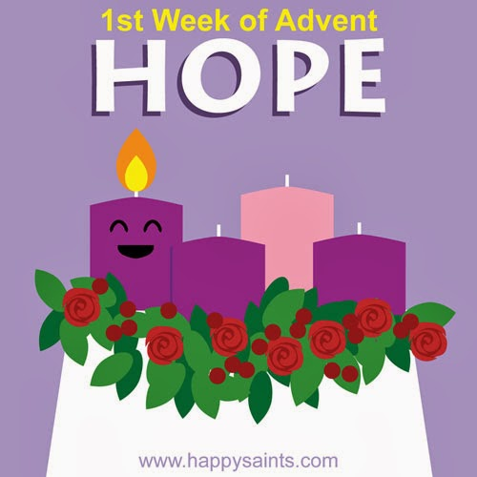***The 2021 Online Advent Calendar:*** The first day of Advent heralds the beginning of the Catholic Church’s New Year. Advent (from ‘ad-venire’ in Latin or “to come to”) is the Church season encompassing the four Sundays and weekdays leading up to the celebration of Christmas. Advent is a time of spiritual preparation for the Lord’s coming at Christmas. Advent also prepares us for the second coming of Christ at the end of time.

The Irish Bishops website, [*www.catholicbishops.ie*](http://www.catholicbishops.ie/), is delighted to bring you their Digital Advent Calendar again this year. It goes live today, the First Sunday of Advent. Now in its eighth year, it is offering resources for the parish, school and the home which are available behind a virtual door each day during the Season of Advent. Behind each door there will be content aimed at assisting people to pray and to reflect on how best we can keep Christ at the centre of our Christmas preparations during this special liturgical season.

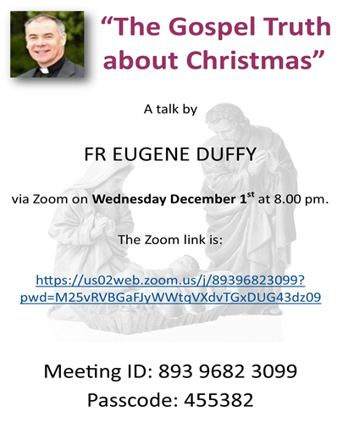The theme of the Advent Calendar this year is Hope. It has been a difficult year for so many people as we faced the ongoing consequences of a global pandemic. We are inviting people to journey with us this Advent Season by #SharingHope through acts of kindness and charity that all of us are encouraged to undertake during the month of December.

Note: The virtual doors cannot be opened ahead of their actual date. All content will go live in the early hours of each morning.

***New Pilgrim Path Website of the Week, November 28th:*** *Advent Online Retreats …*… The season of Advent – for Christians of many denominations - is a time of light amid deep darkness, a time of waiting in hope and preparing ourselves to receive Christ into our hearts and our lives. New Pilgrim Path offers a range of wonderful online retreats – from Catholic and Anglican traditions - designed to help participants come to know Christ in a new and deeper way as we journey through the season of Advent, preparing to welcome the Light of the World, Jesus Christ, at Christmas. The retreats vary in duration, from half a day to several days. To access these rich spiritual resources, visit [***www.newpilgrimpath.ie***](http://www.newpilgrimpath.ie).

***Adoration:*** Please note the change of time for Wednesday morning Adoration – it will now end at 11.30am. The usual Wednesday evening Adoration continues from 6.00 to 8.00pm. We encourage you in this Advent season to spend some quiet time with the Lord in preparation for the great feast of Christmas.

***The Pastoral Council*** met on Wednesday evening last. Because the Covid situation had worsened since our previous meeting, the return of public Mass in Shraheens continues to be put on hold. It was not possible to make any decision regarding Christmas Masses as we can yet only speculate on what restrictions might be introduced before then. We will keep you posted as soon as the situation becomes clearer, if it ever does!

***Bohola Parish Calendar:*** It’s hard to believe that 2022 is just around the corner and time to order the Parish Calendar. If anybody wants to suggest changes, add or remove information on it, please let the priest know immediately, if not sooner!

***St Vincent de Paul Annual Collection:*** Because of the uncertainty around Covid, the St Vincent de Paul Annual Collection will be by envelope donation only. In the coming week, envelopes will be left in church and those who wish to contribute can put their contribution in an envelope and return it in the same way as offertory envelopes. Please support this worthy cause.

***Lectio Divina Reflections on the Advent and Christmas Gospels:*** The Priory Institute is delighted to offer a Free of Charge online retreat which is a repeat of the popular Advent Retreat we ran in 2018. Visit our website [*prioryinstitute.com*](https://prioryinstitute-dot-yamm-track.appspot.com/Redirect?ukey=15PldniMs0iKL6bfXTDyUf_viZOEZyw7xtDVydKVOVd8-0&key=YAMMID-1637597751307&link=http://prioryinstitute.com/) or click on this link [*https://bit.ly/3DWrTkx*](https://bit.ly/3DWrTkx) to register/find out more.

***Nine Day Rosary Novena for Ireland:*** We are inviting you to join in a **9 Day Rosary Novena** beginning on Tuesday, 30th November and ending on Wednesday, 8th December. People all over Ireland will pray the Rosary together each evening at 9pm. On the final evening at 9pm on Radio Maria, the Primate of All Ireland, Archbishop Eamon Martin will lead the final Rosary live. If you are gathering to pray in groups we encourage you to gather safely, adhering to local Covid-19 regulations.

***Online Theology Open Evening:*** Is this for you? The Priory Institute provides online Theology courses to degree level. Attend Saturday lectures in Tallaght or from the comfort of your own home. Email *enquiries@prioryinstitute.com* to find out more about the Online Open Evening on *Thursday, 2nd December at 7pm*.

This is the link to register for the Open Evening: [*https://prioryinstitute.com/events/priory-institute-open-evening*](https://prioryinstitute.com/events/priory-institute-open-evening).

***Lough Derg Online Shop*** offers unique Christmas Cards, featuring scenes of the Island from across the centuries and bespoke Gifts including a limited edition Lough Derg Christmas Candle. Christmas Mass Bouquet Cards are also available – Fr La, Prior, will offer a triduum of Masses beginning on Christmas Eve for all those who are enrolled. Visit [***www.loughderg.live/shop***](http://www.loughderg.live/shop). Telephone *071-9861518*. *Delivery nationwide and Click & Collect Service available.*

***The Village Inn Christmas Market*** takes place on Sunday, 12th December from 2.00 to 6.00pm. Indoor and outdoor market with unique stalls and local makers. Free entry and live music at 8.00pm. Please support local initiatives.

***Knock Market @ the Plaza*** (weather permitting, otherwise please note it will be at the Community Centre) takes place this Sunday, 28th November from 10am to 3pm. A wonderful day is in store with lots of beautifully hand-crafted gifts, hand-made by local crafters. Adjacent to Knock Shrine, wheelchair accessible, car park, restaurants, gift shops and toilet facilities close by. We look forward to seeing you on the day. Market @ the Plaza takes place on the last Sunday of each month.

Please note the following dates for Knock Christmas Market: Saturday, 18th & Sunday, 19th December. Time: 11am to 4pm. Venue: Pope Francis Plaza, Knock. For bookings contact Leonie on *086-8486924* or Email: [*leoniekilroy@gmail.com*](mailto:leoniekilroy@gmail.com). Follow our Facebook page @ Knock Market & Events.

***Mayo PPN – Virtual Community Information Evening*** takes place tomorrow evening, Monday 29th at 7.00pm. The evening includes: Funding Opportunities available to Community Groups, PPN FREE Training & Events, Talk on Staying Safe in our Communities by Community Garda, Mayo PPN 2022 Budget and Work plan and to round off the evening – a presentation on your Mental Health and Wellness. B**ooking essential –** to register visit:[***www.mayoppn.ie***](http://www.mayoppn.ie/).

***Free Computer Training Course in Castlebar:*** Blended Learning means you can learn from home for two days a week using a FREE laptop (for the duration of the course) and learn in a supported Training Centre for two days a week. This programme enables you to gain: **QQI Level 5 Office Administration** **or Information Technology, New ICDL Modules – Remote Working, Cloud Computing. Modules include: Business Administration, Payroll, Bookkeeping, Web Authoring, Database Methods, Spreadsheets, Work Experience and more. *There is a strong focus on gaining skills to obtain employment or self-employment in the computer/administration sector.***

If you would benefit from being in a supported learning environment, are registered with the Department of Social Protection, and are 17 or over you could be entitled to **FREE** Training through the National Learning Network. Payment protected, those under 26 years may receive extra, and you might get help with transport. If you are interested and would like to know more please contact Sharon at NLN on *087-2909064*.

***North West STOP*** offers a *free counselling* service with no waiting lists. Please phone or text *086-7772009* to arrange an appointment.

***COVID-19 Support Line for Older People:***Professional staff are available to answer queries and give advice and reassurance where necessary. The support line is open seven days a week, 8am to 8pm. The contact number is ***0818-222024***.

***I’m trying to get into the Christmas spirit but I can’t open the bottle!***