***Offertory Donations:***

Sunday 28th: €1,570.



Thanks for all your contributions.

**Bohola/Shraheens Newsletter**

**Stephen O’Mahony PP – 094-9384115/086-8226405 –** [**boholaparish@gmail.com**](mailto:boholaparish@gmail.com) **(email for newsletter)**

<https://www.mayo.ie/news/category/connect/parish-news/bohola-parish-news/>

**Second Sunday of Advent – 5th December 2021**

###### Masses for the Week

|  |  |  |
| --- | --- | --- |
| **Saturday, December 4th.** | **7.00pm Vigil*\**** | **Mary & Martin Lyons, Lismirrane & sons, John, Joe & William and deceased family, Lismirrane.** |
| **Sunday, December 5th.** | **9.30am*\****  **11.30am** | **For all the People.**  **Private Intention.** |
| **Monday, December 6th.** |  | **No Mass.** |
| **Tuesday, December 7th.** | **7.00pm*\**** | **Vigil for Feast of the Immaculate Conception.** |
| **Wednesday, December 8th.** | **10.00am*\****  **6.00 – 8.00pm** | **Feast of the Immaculate Conception. (*Adoration follows until 11.30am)***  **Exposition of the Blessed Sacrament (private prayer).** |
| **Thursday, December 9th.** |  | **Wedding.** |
| **Friday, December 10th.** | **8.00pm** | **Private Intention.** |
| **Saturday, December 11th.** | **7.00pm Vigil** | **Private Intention.** |
| **Sunday, December 12th.** | **9.30am*\****  **11.30am** | **Michael & Catherine Brennan, their son-in-law, Jimmy Mullaney & grandson, Kieran.**  **For all the People.** |
| ***The 9.30am Sunday Mass will be live-streamed on the Bohola Post Facebook Page every Sunday.***  ***Any other Masses are put online when requested. (Marked with * above)***  ***All Masses will be broadcast on the 105.5 FM Radio channel.*** | | |

***Recent Death:*** Please pray for the happy repose of the soul of *Tommy Ryan*, Treenduff, who died on Sunday last, 28th November and whose funeral took place in Bohola on Wednesday. May he rest in peace.

***Wedding Bells!*** Congratulations to *Gary McNicholas*, Lismirrane, and *Jessica Cullen*, Baltinglass, who were married in Wicklow on this Saturday, December 4th. We wish them every blessing and many happy years of married life.

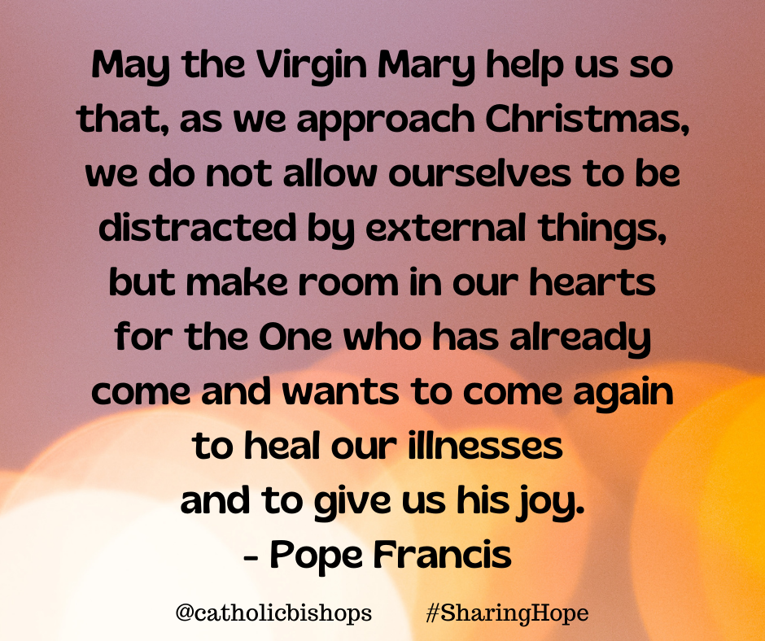***The Feast of the Immaculate Conception*** is on Wednesday next. The Vigil Mass will be at 7.00pm on Tuesday evening with morning Mass on Wednesday at 10.00am. Both Masses will be live-streamed.

**Adoration** will take place as usual on Wednesday – after Mass until 11.30am and in the evening from 6.00 to 8.00pm. It is an opportunity to spend some quiet time with the Lord in preparation for the great feast of Christmas.

***The 2021 Online Advent Calendar*** is available again this year on the website of the Irish Bishops, [*www.catholicbishops.ie*](http://www.catholicbishops.ie/). It offers resources for the parish, school and the home which are available behind a virtual door each day during the Season of Advent. Behind each door there will be content aimed at assisting people to pray and to reflect on how best we can keep Christ at the centre of our Christmas preparations during this special liturgical season.

***New Pilgrim Path Website of the Week, December 5th:*** *An Advent Calendar with a Difference …*… This Advent, join Loyola Press for a special online Advent experience. Following a traditional Advent calendar format, the experience invites you to slow down this season and discover the quiet moments of Advent hope. Each day reveals a new online Advent resource and theme – ranging from ‘Creativity and Healing in Advent’ to ‘Silent Prayer in Advent’ and many, many more. This is a beautiful way to nurture your spirituality daily at this busy time of year. Access the Advent Calendar at [***www.newpilgrimpath.ie***](http://www.newpilgrimpath.ie). New Pilgrim Path also has an inspiring daily musical resources at *Daily Sacred Music for Advent*.

***Covid Restrictions:*** As you undoubtedly know, the re-introduction of some restrictions was announced on Friday to take effect from Tuesday next. At the time of going to print it is not clear if any of these apply to religious services. Regardless of that, we encourage you to keep up the good practices of hand sanitisation, wearing of face masks and keeping socially distant as far as is possible. Sincere thanks for your ongoing co-operation in these matters.

***Bohola Post:* The 49th edition of this publication has arrived ahead of schedule and is now on sale in all the usual outlets. Castle St Bookshop, Castlebar is also selling it online at** [***www.mayobooks.ie***](http://www.mayobooks.ie)**. Well done to all those who once again have brought it to fruition.**

***Bambinelli Sunday, December 12th:*** For the past several decades, each year on Gaudete Sunday, the Third Sunday of Advent, children (and adults) bring their Baby Jesus figures from the crib at their homes to St. Peter’s Square where the Pope blesses both the people and the figurines during the Angelus. This year we will celebrate “Bambinelli Sunday” at all Masses next weekend, December 11th and 12th. All are invited to bring the Baby Jesus figure from their homes for blessing at Mass. Families can even make their own “bambinelli” if they want. It is suggested that following the blessing, you take your “bambinelli” home and place it in a gift box, wrap it, and save it for Christmas. Let this be the first gift your family opens at Christmas, when together you place your Baby Jesus figure in the crib, and have a home blessing of the Nativity for your whole family. This initiative is promoted by the Catholic Grandparents Association.

***St Vincent de Paul Annual Collection:*** Because of the uncertainty around Covid, the St Vincent de Paul Annual Collection will be by envelope donation only. Envelopes are now available in the church and those who wish to contribute can put their contribution in an envelope and return it in the same way as offertory envelopes. Please support this worthy cause.

***The Castlebar Rotary Club Christmas Tree of Remembrance*** will run online again this year throughout the month of December in partnership with Western Care Association. You can access the Tree of Remembrance here [*https://visufund.com/2021-mayo-tree-of-remembrance*](https://visufund.com/2021-mayo-tree-of-remembrance).

***Lectio Divina Reflections on the Advent and Christmas Gospels:*** The Priory Institute is delighted to offer a Free of Charge online retreat which is a repeat of the popular Advent Retreat we ran in 2018. Visit our website [*prioryinstitute.com*](https://prioryinstitute-dot-yamm-track.appspot.com/Redirect?ukey=15PldniMs0iKL6bfXTDyUf_viZOEZyw7xtDVydKVOVd8-0&key=YAMMID-1637597751307&link=http://prioryinstitute.com/) or click on this link [*https://bit.ly/3DWrTkx*](https://bit.ly/3DWrTkx) to register/find out more.

***Lough Derg Online Shop*** offers unique Christmas Cards, featuring scenes of the Island from across the centuries and bespoke Gifts including a limited edition Lough Derg Christmas Candle. Christmas Mass Bouquet Cards are also available – Fr La, Prior, will offer a triduum of Masses beginning on Christmas Eve for all those who are enrolled. Visit [***www.loughderg.live/shop***](http://www.loughderg.live/shop). Telephone *071-9861518*. *Delivery nationwide and Click & Collect Service available.*

***Medjugorje Irish Centre Pilgrimages April - October 2022:*** 7 Nights Apartment B&B and return Airport transfer from Dubrovnik or Split from €315 per person sharing. Guaranteed airport transfer price for any flight. Contact us for details and book the dates that suit you. Tel. *01-4434510* or email [*reservations@med-irishcentre.com*](mailto:reservations@med-irishcentre.com).

***Moy Davitts 50/50 Draw:*** Congratulations to Áine Healy on winning €360 in the Moy Davitts 50/50 draw last Saturday morning. A huge thank you to everyone who supported last week's draw, it is greatly appreciated. Tickets are available in the usual retail outlets and by clicking [*https://smartlotto.ie/Bohola-moy-davitts*](https://l.facebook.com/l.php?u=https%3A%2F%2Fsmartlotto.ie%2FBohola-moy-davitts%3Ffbclid%3DIwAR2-SMSQVJnLPM1gbMk8VYcVq5QSNWsE5b18UD-SHwPhuifGrX08SNDlJc8&h=AT0MiLZlj4q4DBPOl03vVXSokuVERXZawyK8tGPOdkMD6iUtbbGAIDrP1wUMXoHHwBpf8OCfEYLll7lUaWyYzni7elqLyyDX1hxrkiRT4iLddt75pWrUPCYemDN43SvOspaI&__tn__=-UK-R&c%5b0%5d=AT1bnP92vRmesJAH-zh16Oyc956taFyWxM0_3VLfj4QSf9SmpZw5cpQ61Vc5tvJdChYPj7SPty0LDMmT-1CuL0y1Dj6Ia-SpXR1Lif8cNpBMb3zmcNd83NlOLtCy4LEd6sxibGw9D72uG7DGqfgmtrvFR5ZcIPXTwnc_aJIQcIYHHlU6GWM4y_sHX7uH).

***Bohola Christmas Market*** in aid of the **Bohola Community Park** takes place this Sunday, December 5th from 6pm to 9pm in the Bohola Community Centre. Please come and support.

***The Village Inn Christmas Market*** takes place on Sunday, 12th December from 2.00 to 6.00pm. Indoor and outdoor market with unique stalls and local makers. Free entry and live music at 8.00pm. Please support local initiatives.

***Knock Christmas Market @ the Plaza*** takes place on Saturday, 18th & Sunday, 19th December from 11am to 4pm at Pope Francis Plaza, Knock. Lots of beautifully hand crafted gifts, hand made by local crafters. Adjacent to Knock Shrine, wheelchair accessible, car park, restaurants, gift shops and toilet facilities close by. For bookings contact Leonie on *086-8486924* or Email: [*leoniekilroy@gmail.com*](mailto:leoniekilroy@gmail.com). Follow our Facebook page @ Knock Market & Events. Market @ the Plaza takes place on the last Sunday of each month.

***National Learning Network:*** New International Computer Driving Licence training in Castlebar, Achill and Belmullet and also a free Computer Training Course in Castlebar. Contact Sharon on *087-2909064*. Eligibility criteria applies.

***Free online Living Well Programmes 2022:*** *Living Well* is a free online group programme delivered over six workshops (2.5 hrs x 6) on the Zoom platform. It is delivered by trained leaders, most of whom are also living with a long-term health condition. You will develop self-management skills and confidence to live well with your health conditions.*Next programmes commence in 2022 on the following dates: Thursday, 20th January, Monday, 7th February, Tuesday, 1st March and Wednesday, 9th* March. You must register in advance as places are limited to 10/12 participants. Please note you do not have to disclose your health condition on the programme. Please contact Liam Gildea on *087-3490393* or by email at [*liam.gildea@mayocil.ie*](mailto:liam.gildea@mayocil.ie)*.* Please see the following link for more information about the course: [*www.hse.ie/livingwell*](http://www.hse.ie/livingwell).

***North West STOP*** offers a *free counselling* service with no waiting lists. Please phone or text *086-7772009* to arrange an appointment.

***COVID-19 Support Line for Older People:***Professional staff are available to answer queries and give advice and reassurance where necessary. The support line is open seven days a week, 8am to 8pm. The contact number is ***0818-222024***.

***Does Santa call his elves “subordinate clauses”?***