KILLASSER/CALLOW

PARISH NEWSLETTER

TO THE PARISH & THE WORLD
Our webcam should be working for the next Saturday evening’s Mass. You need to type the words ‘Killasser Parish Webcam” or “All Saints Church Killasser Webcam”.
Once it is working we will be broadcasting at mass times to the Parish and the world. The very many Killasser people all over the world will be able to hear & see the Mass and all other celebrations in the Church. We look forward to providing this service to you in the days ahead. May God bless our efforts to bring Gods Word to the Parish & the World!

Fr. John Durkan (094) 9024761/087 9548532 No 309 E-mail: frjohnd@gmail.com

THIRD SUNDAY OF LENT 7th March 2021
MASS INTENTION FOR THE NEXT 4 MONTHS
Sat 6th March Killasser 7pm Tom Burke, Carrowneden.
Pake & Celia Howley, Carrowleambeg & grand daughter Ceire Hardesty
Sat 13th Killasser 7pm Willie O’Neill, Creggaun.
Frank Howley, Dunmaynor
Sat 20th Killasser 7pm Bridget & Patrick Cunney, Carraliamore, daughter Vera, Sons John, Vincent & Ollie
Sat 27th Killasser 7pm Tom Rowley, Ballinacrra.
Sat 3rd April Killasser 7pm Easter Vigil
Sun 4th Callow 10am Easter Sunday
Sat 10th Killasser 7pm Thomas & Annie McNulty, 5th Anniv Tirnunny
Sun 11th Callow 10am Jim Neary, Lismorane
Sat 17th Killasser 7pm Martin McManus & dfm of McManus, Carramore
Sun 18th Callow 10am Tommy, Kathleen, Patrick, Joe & Mary Thompson, Cuillenaughten
Sat 24th Killasser 7pm Denis & Margaret Moran & deceased family members, Carraliamore
Sun 25th Callow 10am Morning Mass
Sat May 1st Killasser 7pm Brigid, Anthony, Michael, Josephin & Caroline Dempsey. Dempsey & Hughes deceased
Sun 2nd Callow 10am Mary Kate Noone
Sat 8th Killasser 7pm Eddie & Bridie Thompson, Doontas
Sun 9th Callow 10am Morning Mass
Sat 15th Killasser 7pm Hugh Fitzmaurice, Creggaun
Sun 16th Callow 10am Morning Mass
Sat 22nd Killasser 7pm Mat Rowley, Sean & Kathleen, Cloonfinish.
Sun 23rd Callow 10am Morning Mass
Sat 29th Killasser 7pm Tom & Mae Tuffy & deceased
Sat 5th June Killasser 7pm Brigid & Thomas Kavanagh, Carramore & deceased Kavanagh & Kilbride.

PRAY FOR
Patsy Rowley, Swinford, sister of Anne Walsh Lismorane, died on the 22nd January
Helen Mc Sharry (nee Brodrick), Brooklyn, New York, who passed away on the 11th February, sister of Sally Sheil, Swinford & the late Christy Brodrick Killasser.
Irene Tunney ,Dromalooan, London. Funeral in London

BAPTISMS
We welcome into Gods family
Mary Theresa Scanlon
Thomas Leaf Quemerford
May God bless them both and their families.
REFLECTION
Sometimes, the anxiety surrounding the publicity is as contagious as the virus itself, spreading fear and nervousness among the community. In the developed world, in particular, we are in a state of shock. In many ways, we have come to believe that we are in control of our lives, that we have a cure for every disease, that we can fend off all the dangers that threaten our securities. We have built up solid walls to protect us against every unwanted guest, but now our walls have been breached, and the unwanted guest is here. Our securities no longer seem so secure, something in our world is out of our control, and many don’t know where to turn.
We hope and pray, that we will soon find a vaccine for this disease, and that it will be made widely available for everyone who needs it, rich or poor. But in the meantime, we can reflect on our shock. It’s a reminder to us that we are never in total control of our lives, that we can never eliminate every misfortune or heal every illness. Ultimately, our trust has to be in something more solid than we can ever find here on earth. Ultimately, God alone is our security. ‘God is our refuge and our strength, a helper close at hand in times of distress’ (Ps.46:1). Trust Him.

CORONA VIRUS HEPLINE
Corona Virus helpline for older people - 0818 222 024.
If you have concerns or queries about COVID-19 call ALONE’s dedicated support line everyday, 8am to 8pm. To volunteer your help, visit www.alone.ie.

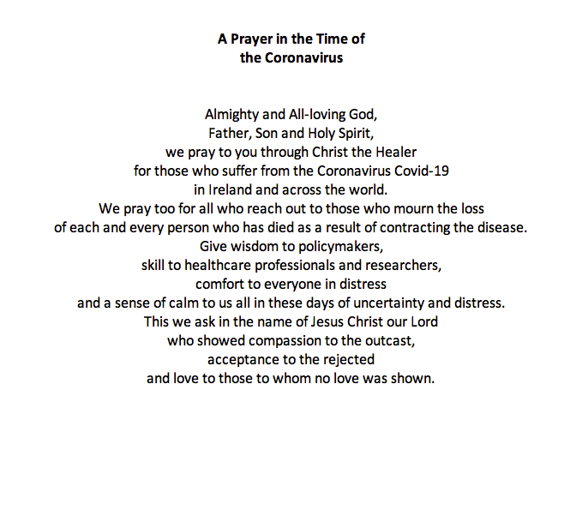

World Meeting of Families Prayer
God, our Father,
We are brothers and sisters in Jesus your Son,
One family, in the Spirit of your love.
We ask you to bless Killasser and Callow – Our Parish.
Bless us with the joy of love.
Make us patient and kind,
gentle and generous,
welcoming to those in need.
Help us to live your forgiveness and peace.

Protect all families with your loving care,
Especially those for whom we now pray:
[We pause and remember family members and others by name].
Increase our faith,
Strengthen our hope,
Keep us safe in your love,
Make us always grateful for the gift of life that we share.
This we ask, through Christ our Lord,

