***Offertory Donations:***

Sunday 16th: €1,235.



Thanks for all your contributions.

**Bohola/Shraheens Newsletter**

**Stephen O’Mahony PP – 094-9384115/086-8226405 –** [**boholaparish@gmail.com**](mailto:boholaparish@gmail.com) **(email for newsletter)**

<https://www.mayo.ie/news/category/connect/parish-news/bohola-parish-news/>

**Pentecost Sunday – 23rd May 2021**

###### Masses for the Week

|  |  |  |
| --- | --- | --- |
| **Saturday, May 22nd.** | **8.00pm Vigil** | **Private Intention.** |
| **Sunday, May 23rd.** | **9.30am**  **11.30am** | **For all the People.*\****  **Fred Conlon & Mary Commons, Listrisnane, & James Commons and his wife, Mary*.\**** |
| **Wednesday, May 26th.** | **10.00am**  **7.00 – 9.00pm** | **John & Winifred McNicholas, Ara.*\****  **Exposition of the Blessed Sacrament (private prayer).** |
| **Friday, May 28th.** | **8.00pm** | **Kate & John McEvey & deceased of Jordan & McEvey families.*\**** |
| ***Mass will be celebrated privately on other weekdays.*** | | |
| **Saturday, May 29th.** | **8.00pm** | **For all the People.** |
| **Sunday, May 30th.** | **9.30am**  **11.30am** | **Peter & Peggy Filan & deceased family, Rathruane.*\****  **Tom & Teece O’Neill & deceased of O’Neill & McNicholas families.*\**** |
| ***The 9.30am Sunday Mass will be live-streamed on the Bohola Post Facebook Page every Sunday.***  ***Any other Masses are put online when requested. (Marked with * above)***  ***All Masses will be broadcast on the 105.5 FM Radio channel.*** | | |

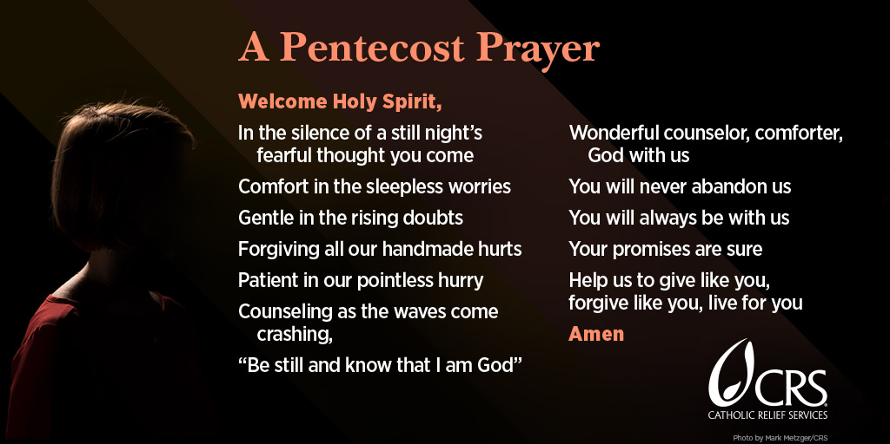

***Priesthood in Achonry Diocese:*** Pentecost Sunday — May 23, 2021 …. *“As the Father sent me, so am I sending you.”* Will you let the Holy Spirit lead you to your true vocation in the Risen Lord…perhaps as a priest or consecrated religious? Speak to your local priest, call your Diocesan Vocation’s Director or email the National Vocations Office on *info@vocations.ie*. For further information contact our Vocations Director, **Fr Paul Kivlehan, The Presbytery, Ballaghaderreen, Co. Roscommon. Tel.094-9860011, Mobile 087-3683535, E-mail** [***pkivlehan@achonrydiocese.org***](mailto:pkivlehan@achonrydiocese.org).

***New Pilgrim Path Website of the Week, May 23rd:*** *Dietrich Bonhoeffer on 'Cheap grace versus costly grace'*… Dietrich Bonhoeffer, the German Lutheran pastor who was executed by the Nazis for resisting Hitler's totalitarian regime, left a rich theological legacy. One of his books, The Cost of Discipleship, is considered a classic of Christian thought. In it, he distinguishes between “cheap grace” and “costly grace.” “Cheap grace,” he wrote, “is the grace we bestow on ourselves...grace without discipleship. Costly grace is the gospel which must be sought again and again.... It is costly because it costs a man his life, and it is grace because it gives a man the only true life.” To watch a short and beautiful visual distillation of this teaching, visit: [***www.newpilgrimpath.ie***](http://www.newpilgrimpath.ie).

***Papal Cross Awards:*** Our thanks to Elle Lockie, Laughtadurkan, Hazel Brennan, Midfield and Emma Biesty, Kiltimagh, all students in St. Louis Community School, Kiltimagh, who have provided the prayer cards you will find at the back of the church and at the candelabra at Our Lady’s statue. The prayer to Our Lady is very appropriate for the times we live in so please take one for yourself and for a friend or friends. This is part of the girls’ Papal Cross Award project so well done to them and we wish them every success.

***Galilee Spirituality Centre Events, May and June:*** Booking and link for courses *info@galilee*.

*Mary for our Time, with Mary O’Connor and Ian Neylon (online):* Letting Mary, mother of Jesus, emerge from scripture in a new light. Learning from her, how to engage in the opportunity and challenge, that she holds out to us, in opening our lives to God and humanity today. Wednesday next, May 26th, 7.30 to 9.00pm. €5. All Welcome.

Mary & Ian are a husband and wife team. They each have experience in secondary and adult education and have been involved in retreat teams with teenagers and adults and worked in spirituality, human development, counselling and facilitation for many years in the UK. Both have had an extensive involvement with the Society of Mary (Marists) as religious and currently as lay members.

*Herb and Flower Growing for Healthy Living with Richard Kennedy:* Galilee Spirituality Centre Quiet Garden, Wednesdays June 9th and 16th, 7.30pm. Cost €5. This series was interrupted in March last year – so we finally hope to be able to hold the second two evenings! It will be relaxed, fun and practical – with time for planting and growing. *NB booking is essential for these evenings. They are dependent on the COVID restrictions and we may have to postpone at short notice.*

Richard Kennedy is a gardening expert and owner of Courtdale Horticulture, and a Christian lay minister. He will combine these roles to lead us in a journey of discovery in the world of gardening and spirituality.

*The Poetry of Loss (before we go back…) with Anne Francis (online):* A morning to acknowledge the losses of the past year through poetry and reflection. June 19th, 10.30am to 12.30pm. €10 All welcome.

Anne Francis is Director of Galilee Spirituality Centre.

***Rural Social Scheme Vacancies:*** There are currently vacancies on the Rural Social Scheme in the Kiltimagh / Bohola / Midfield area. The Rural Social Scheme provides a supplementary income for low-income farmers and fishermen/women.

*To participate in the scheme*, you must be: 25 years or over and getting Farm Assist ***or*** if you are actively farming or fishing (this means that you must meet the criteria set out below), you may qualify for the scheme if you are also getting one of the following social welfare payments: [Jobseeker's Allowance](http://www.welfare.ie/en/Pages/1057_Jobseekers-Allowance.aspx); Jobseekers transitional payment; [Disability Allowance](http://www.welfare.ie/en/Pages/da.aspx); [One-Parent Family Payment](http://www.welfare.ie/en/Pages/278_One-Parent-Family-Payment.aspx); [Widow's, Widower's or Surviving Civil Partner's Contributory Pension](http://www.welfare.ie/en/Pages/Widowers-Pension-Contributory.aspx) or Widow's, Widower's or Surviving Civil Partner's Non-Contributory Pension; Increase for a Qualified Adult under 66 years of age as part of your spouse, cohabitant or civil partner's [State Pension (Non-Contributory)](http://www.welfare.ie/en/Pages/248_State-Pension-Non-Contributory.aspx).

If you are eligible but do not wish to participate in the RSS, your dependent spouse, civil partner or cohabitant can take the available place. Please contact Caroline on *087-2107385* for further information.

***Moy Davitts 50/50 Draw:*** Huge congratulations again to Joyce McMahon, Foxford on winning €458 in the Moy Davitts 50/50 draw last Saturday morning. A huge thank you to everyone who supported last week's draw, it is greatly appreciated. Tickets are available in the usual retail outlets and by clicking [*https://smartlotto.ie/Bohola-moy-davitts*](https://l.facebook.com/l.php?u=https%3A%2F%2Fsmartlotto.ie%2FBohola-moy-davitts%3Ffbclid%3DIwAR2-SMSQVJnLPM1gbMk8VYcVq5QSNWsE5b18UD-SHwPhuifGrX08SNDlJc8&h=AT0MiLZlj4q4DBPOl03vVXSokuVERXZawyK8tGPOdkMD6iUtbbGAIDrP1wUMXoHHwBpf8OCfEYLll7lUaWyYzni7elqLyyDX1hxrkiRT4iLddt75pWrUPCYemDN43SvOspaI&__tn__=-UK-R&c%5b0%5d=AT1bnP92vRmesJAH-zh16Oyc956taFyWxM0_3VLfj4QSf9SmpZw5cpQ61Vc5tvJdChYPj7SPty0LDMmT-1CuL0y1Dj6Ia-SpXR1Lif8cNpBMb3zmcNd83NlOLtCy4LEd6sxibGw9D72uG7DGqfgmtrvFR5ZcIPXTwnc_aJIQcIYHHlU6GWM4y_sHX7uH).

***Castlebar VTOS (MSLETB) Places Available:*** Students may study for a range of Courses/Awards all certified by QQI Level 5: Apprenticeship Preparation, Culture and Heritage, Hospitality Studies, Business Administration, Language and European Studies, Tourism and Business Studies, (ECDL) (European Computer Driving Licence). Care of the Elderly and Intellectual, Disability. Modules also on offer. Email *pauladonnellan@msletb.ie* for further information.

***Living Well*** is a free online group programme delivered over six workshops (2.5 hrs x 6). It is delivered by trained leaders, most of whom are also living with a long-term health condition. You will develop self-management skills and confidence to live well with your health conditions.*Next programme commences on Wednesday, 26th May.*

You must register in advance as places are limited to 10/12 participants. Please note you do not have to disclose your health condition on the programme. Please contact Liam Gildea on *087-3490393* or by email at [*liam.gildea@mayocil.ie*](mailto:liam.gildea@mayocil.ie)*.* Please see the following link for more information about the course: [www.hse.ie/livingwell](http://www.hse.ie/livingwell).

***COVID-19 Support Line for Older People:***Professional staff are available to answer queries and give advice and reassurance where necessary. The support line is open seven days a week, 8am to 8pm. The contact number is ***0818-222024***.

***Covid-19 Collect and Deliver Service:*** Local Link Mayo is offering a collect and deliver service in existing Local Link routes throughout Mayo from pharmacies and local shops, delivering shopping and critical medical supplies to the elderly, the vulnerable and sick. If you need such support or know someone who does, contact Local Link Mayo on ***094-9005150*** between 9:00am and 5:00pm (M-F) or email [*mayo@locallink.ie*](mailto:mayo@locallink.ie).

***Turn a regular sofa into a sofa bed***

***simply by forgetting your wife’s birthday!***