January 2023

Levelling Access

Mapping Arts and Disability Provision
in
Clare, Galway City and Mayo

Contents

Executive Summary

- Introduction

- Context

- Mapping Clare

- Mapping Galway City

- Mapping Mayo

- Consultations and Survey Findings

- Conclusion

- References

Appendix 1: Additional National and International Models and Resource Organisations

Acknowledgements

Boga Boga Integrated dance project: Tara Brandel and members of Brothers of Charity, Ennis. Photo credit: Maurice Gunning

List of Abbreviations

ADI Arts & Disability Ireland
ADNP Arts and Disability Networking Pilot
ATU Atlantic Technological University
BoCSI Brothers of Charity Services Ireland
BoCSC Brothers of Charity Services Clare
BoCSG Brothers of Charity Services Galway
CRPD Convention on the Rights of Persons with Disabilities
DET Disability Equality Training
EDI Equality, Diversity and Inclusion
EHRD Equality, Human Rights & Diversity
ETB Education & Training Board
GMIT Galway-Mayo Institute of Technology (now ATU)
GRETB Galway and Roscommon Education & Training Board
HSE Health Service Executive
ID Intellectual Disability
LECP Local Economic and Community Plan
MADN Mayo Arts and Disability Network
MSLETB Mayo, Sligo and Leitrim Education & Training Board
QQI Quality and Qualifications Ireland
UoG University of Galway

Executive Summary
Levelling Access – Mapping Arts and Disability Provision in Clare, Galway City and Mayo was commissioned by Mayo County Council Arts Service in partnership with local authority arts offices in Clare and Galway City. It was awarded funding from the Arts Council’s An Invitation to Collaboration scheme. Open to local authorities, this scheme incentivises their partnering with expert local, regional and/or national collaborators to address particular aspects of arts development they consider to be of strategic significance.

Ensuring that people with disabilities can access the arts on their own terms has led to exciting and innovative solutions that are having a significant and positive impact on not only the stakeholders but also the wider society. This report explores arts and disability provision in Clare, Mayo and Galway City, profiling projects and programme pathways. It highlights current and potential barriers to sustaining and developing arts and disability provision. It also considers a framework for future development that is flexible and can be adapted for different local authority contexts and guide progress for different stakeholders.

Every local authority serves a distinctive local context and region, which is reflected in their arts and disability programmes. The mapping profiles current arts practice from a representative range of artists, groups and other arts and disability service providers within each region.

The Context

This report aligns arts and disability provision with relevant international, national and local policy and legislature that underpin the rights of persons with disabilities to have equal opportunity to participate fully in arts and culture. All public bodies subscribe to a Public Sector and Human Rights Duty that is reflected in their policies and planning. For example, the Arts Council’s Equality, Human Rights and Diversity policy and strategy (EHRD), 2019, commits to supporting the rights of people with disabilities to have full and equal access and opportunity to the arts in Ireland. Its follow-up Equality, Diversity and Inclusion (EDI) Toolkit (2022) assists with this.

The Approach

The mapping study involved a literature review of relevant local, national and international policy, reports and strategy documents. Primary research entailed gathering information through one-to-one semi-structured interviews from a representative range of local stakeholders within each local authority operational area as well as from national bodies. A follow-up online questionnaire, publicly advertised by each partner arts office, provided additional quantitative data on arts and disability practice in four distinct categories: Artist/Arts Practitioner; Arts Organisation; Arts audience/ participant; and Disability Resource organisation.

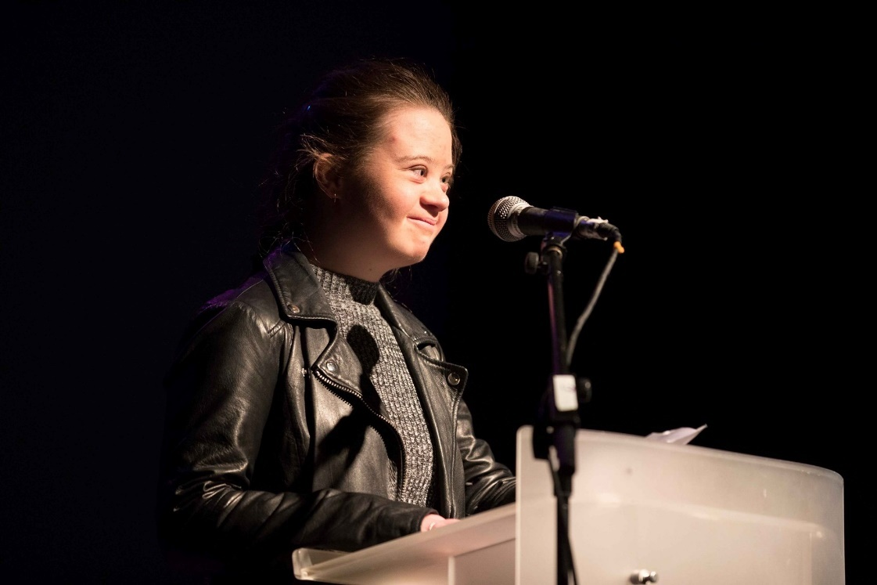
Emma Barrett launching Embrace exhibition and performance showcase at glór Photo credit:Eamonn Ward

The Findings

Local arts services in Clare and Mayo, through their respective Embrace and UPSTART programmes, are leaders in county-wide arts and disability provision. Common to both is an assurance that arts delivery is of the highest quality. For example, each arts office holds a database of arts practitioners experienced in facilitating arts and disability projects, giving Embrace and UPSTART awardees access to a wider selection of arts disciplines for their projects that may otherwise be unavailable.

Both programmes offer a number of programme strands, of varying scale, duration and function that are facilitating greater access. For example, projects of varying length based on partnerships between disability resource organisations and arts practitioners; one-to-one mentoring and professional development for disabled artists; and one-off curated programmes and events.

The report indicates that both these programmes continue to make a significant and positive impact. Having a dedicated arts and disability co-ordinator within each of their local arts offices has brought undeniable benefits. The arts and disability co-ordinators have been instrumental in refining and progressing arts and disability programme strands, accommodating improved access and the quality of the engagement, advocating for and supporting more diverse arts engagement and integrated practice, and helping raise the profile of disabled artists.

Galway City’s higher concentration of arts practitioners and more developed arts infrastructure have enabled partnerships to develop independently. Partnerships between the arts constituency and resource organisations have enabled a range of high-quality innovative arts and disability initiatives in the city that are supported by a range of funders, including Galway City Council.

In all three operational areas, many of the programmes and projects profiled in this report have evolved through a process of trial and error and over a considerable period of time. Responses from various stakeholder perspectives, captured through the online questionnaires and consultations, identified a number of overlapping issues and gaps in access, delivery and arts development.

Many are perennial issues common to the arts constituency in general. What emerged from the mapping was an overarching need to take greater account of equity of opportunity to improving bespoke access, with longer-term investment in the participating artists’ continuing professional development, and with greater integration of arts workspaces within the community.

The Conclusion

Levelling Access - Mapping Arts and Disability provision in Clare, Galway City and Mayo draws attention to a broad spectrum of high-quality arts and disability provision within each of the local authority partner areas. The mapping concludes with a proposed framework for future development that can be tailored to meet the needs of different contexts and set-ups.

The proposed framework builds on past endeavours profiled in the study, most especially the highly successful Arts and Disability Networking Pilot (ADNP, 2008-2010) involving the Arts Council, Arts & Disability Ireland and Mayo County Council (and, with other local authorities joining the network for specific strands of this multi-annual project). The study suggests that any future framework requires buy-in and investment from a variety of stakeholder interests: a consortium of partners who bring specialist know-how, experience, resourcing and financial investment.

The participation of relevant local, national /regional agencies and organisations would bring enhanced inter-agency support for the range of challenges the mapping has drawn attention to. A framework of interrelated elements for future development of arts and disability provision, on any scale, includes: Visibility – Access – Networking - Curation – Education/Training.

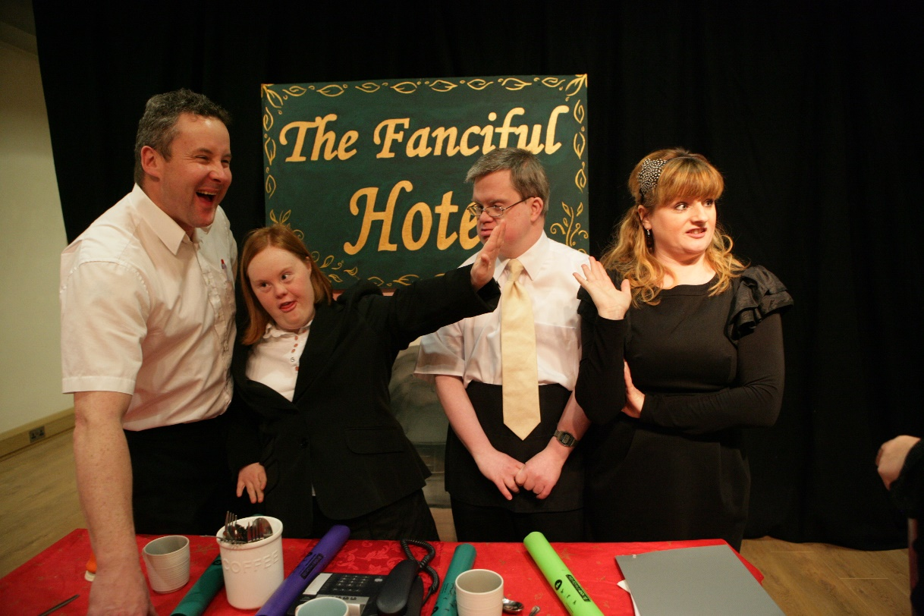
The Fanciful Hotel, Ridgepool Training Centre at Ballina Arts Centre with Niamh McGrath & Mary Curran, UPSTART 2011. Image courtesy of Ballina Arts Centre
1. Introduction

Levelling Access – Mapping Arts and Disability Provision in Clare, Galway City and Mayo was commissioned by Mayo County Council’s Arts Service in partnership with local authority arts offices in County Clare and Galway City.

Levelling Access - Mapping Arts and Disability Provision in Clare, Galway City and Mayo was awarded funding under the Arts Council’s An Invitation to Collaboration scheme, 2021.

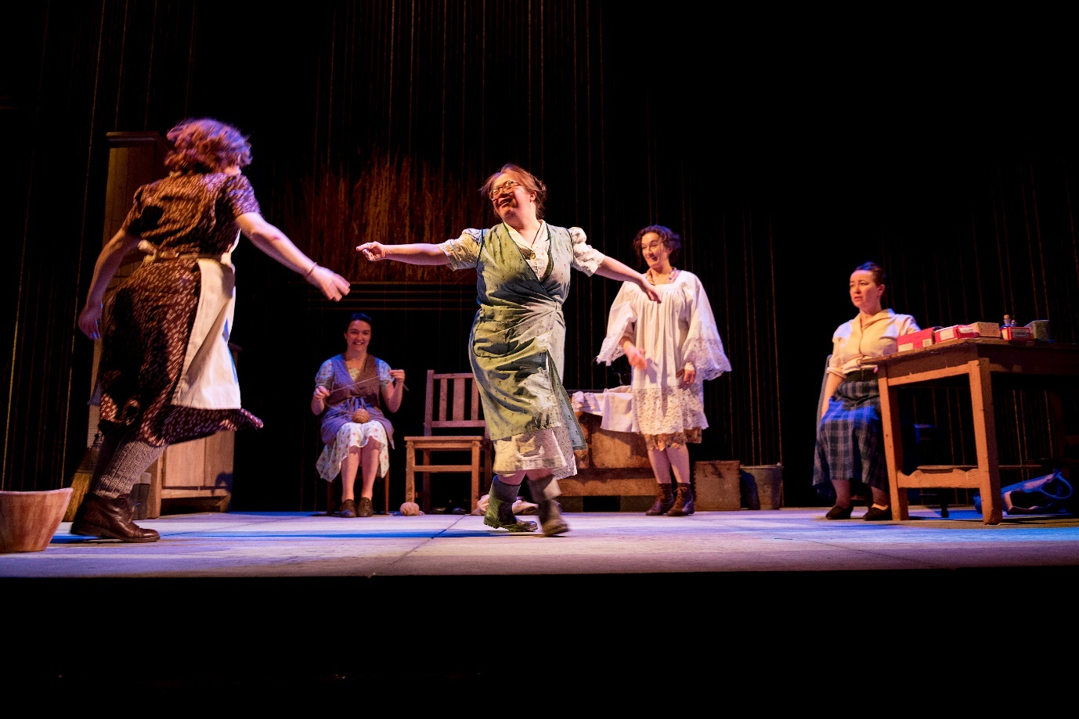
Jennifer Cox, Dancing at Lughnasa by Brian Friel presented by the Blue Teapot Theatre Company. Photo credit: Andrew Downes, XPOSURE

Purpose

The mapping has the following key objectives, to:
- Explore existing practice and initiatives throughout the partner operational areas
- Capture information on potential barriers to sustainable arts practices for people with disabilities and resource organisations
- Highlight some models of best practice (national, international)
- Suggest a framework for the development of future work in arts and disability

Report structure

The report comprises seven sections: An introduction; Section 2, which outlines the terminology used and contextualises the relevant policy framework; Sections 3 to 5, which map former and current arts and disability initiatives in each of the local authority regions; Section 6, which categorises and analyses data gathered from the consultations and survey; and Section 7, which considers the research findings and suggests a new framework for future development in arts and disability that is applicable to any local authority.

Acknowledgements

In mapping arts and disability provision within each local authority area, it is the people you encounter along the way who guide this charting. We are indebted to everyone who took the time to impart their knowledge, experience and insights, and for signposting possible new routes and directions for people with disabilities to access the arts on their own terms.

Section 2: Context

2.1 Introduction

This section sets out the terminology adopted in this report for disability and the arts as they are defined in legislation. Language and terminology are a means of understanding what constitutes the arts and what constitutes disability as two distinct concepts. When they are linked – arts and disability – they are not intended to define or delimit the infinite possibilities of artistic expression in and of their own right.

A selection of relevant international and national policies that uphold the rights of persons with disabilities to enjoy equal access and opportunity in civic life underpins this study.

2.2 Terminology and language

A word on… The Arts

The Arts, as it is legally constituted (Arts Acts 2003), is interpreted as: “any creative or interpretative expression (whether traditional or contemporary) in whatever form, and includes, in particular, visual arts, theatre, literature, music, dance, opera, film, circus and architecture and includes any medium when used for those purposes”. Under the Act local authorities are required to prepare and implement plans for the development of the arts within their functional area. A local authority may provide such financial or other assistance as it considers appropriate for the purposes of: “stimulating public interest in the arts, promoting knowledge appreciation and practice of the arts or improving standards in the arts”.

A word on… Disability

This research refers to the definition of disability as it is stated in the UN Convention on the Rights of Persons with Disabilities (UNCRPD): “to include those who have long-term physical, mental, intellectual or sensory impairments which in interaction with various barriers may hinder their full and effective participation in society on an equal basis with others”. Barriers include attitudes, the physical environment, other forms of accessibility and budgetary limitations. The terms “people with disabilities” and “disabled people” are used interchangeably in the report.

A word on… Arts and Disability

The report uses the term “arts and disability” to cover a broad spectrum of arts engagement, created by and with people with disabilities. Inherently, a core objective of arts and disability as a distinct field of artistic expression is to enable equity of opportunity and inclusion in the arts. That the rights of disabled people to access, practise, or participate in quality arts experiences are facilitated and advocated for, and that the best possible supports are put in place to make this happen.

2.3 Relevant policy and legislature

International

The Convention on the Rights of Persons with Disabilities (CRPD) is an international human rights treaty adopted by the UN in 2006. The CRPD guarantees to protect the rights and dignity of people with disabilities. Its purpose is to ensure that countries (states) uphold the human rights of persons with disabilities that they may have full equality under the law. Countries that have ratified the Convention must take all necessary actions to ensure that people with disabilities are able to exercise their full range of human rights, equal to the rights of others, and that they can enjoy full participation in society. Specifically, Article 30 of the CRPD addresses the rights of persons with disabilities to participate in cultural life, recreation, leisure and sport.

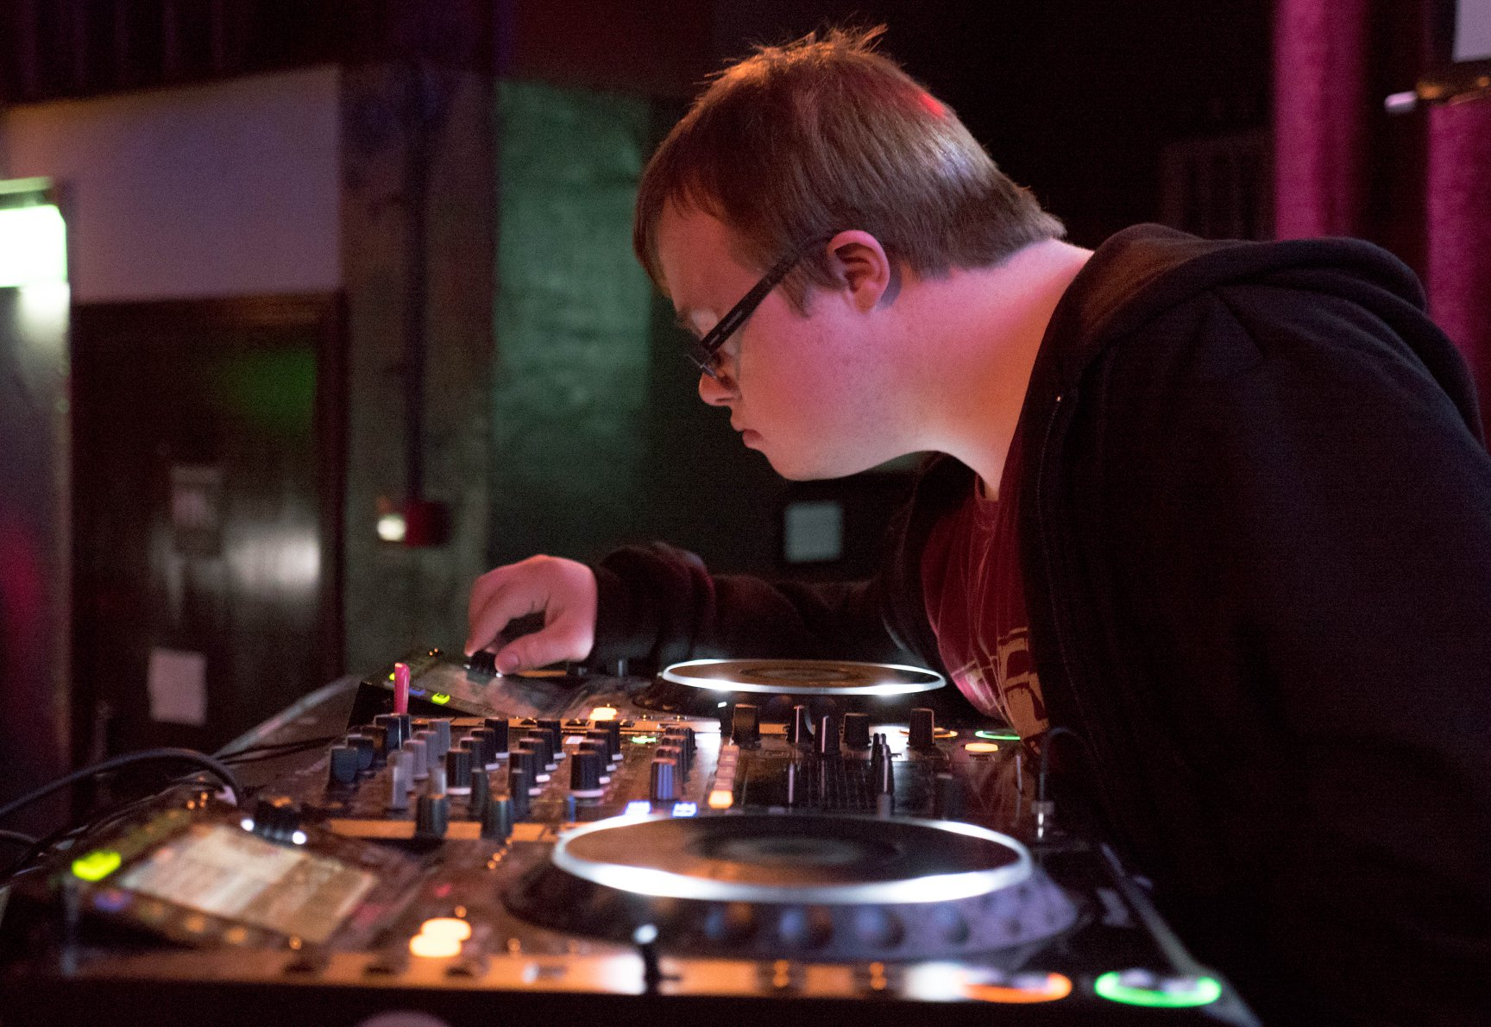
Bounce DJ James O Connell performing at Bounce, Club Night for Adults with intellectual disability, Brothers of Charity Galway. Image courtesy of BOCG

National

The Public Sector Equality and Human Rights Duty – that all public bodies in Ireland are legally obliged to have regard for the need to prevent discrimination; promote equality of opportunity; and protect the human rights of staff and the persons to whom it provides services that are affected by their policies and plans.

Equally relevant is Ireland’s first national cultural policy framework, Culture 2025 – A National Cultural Policy Framework to 2025, published in 2020, by the Department of Tourism, Culture, Arts, Gaeltacht, Sport and Media. A central tenet of Culture 2025 is to place culture at the heart of government policy; to take a whole-of-government approach to embedding the values of cultural and creative self-expression and self-determination within all aspects of public policy. The Department’s Creative Ireland programme is responsible for developing its inter-agency, community-targeted approach to sponsoring creative initiatives countrywide, within every local authority region. Locally, the Creative Ireland programme is overseen by a local authority interdepartmental steering committee that may include representation from the arts, heritage, libraries, enterprise, a community representative, planning, housing and environment.

The Arts Council is the national agency for funding, developing and promoting the arts in Ireland. It is an executive, non-departmental public body, sponsored by the Department of Tourism, Culture, Arts, Gaeltacht, Sport and Media. The Arts Council operates independently from the department – the so-called arms-length principle. As a public body, the Arts Council is statutorily obliged, under its Public Sector Equality and Human Rights Duty, to promote equality, prevent discrimination and protect the human rights of their employees, customers, service users and everyone affected by its policies and plans.

The Arts Council’s Arts and Disability Policy (2012-2016) refers to Article 30 of CRPD, supporting the rights of people with disabilities to have full and equal access and opportunity to the arts in Ireland – as arts practitioner, audience member, arts worker,
arts adviser, or arts educator. It builds on this commitment in its Equality, Human Rights and Diversity Policy (EHRD) of 2019.

The Health Service Executive, HSE, is the publicly funded healthcare system in Ireland, responsible for the provision of health and personal social services. Its parent department is the Department of Health. The HSE is the body responsible for delivering disability services as part of its social care remit. Disability resource organisations are grant-aided by the HSE to deliver a range of services. Many of these organisations operate on a voluntary or non-for-profit basis. As a public body, the HSE is statutorily obliged, under its Public Sector Equality and Human Rights Duty, to promote equality, prevent discrimination and protect the human rights of their employees, customers, service users and everyone affected by its policies and plans.

The HSE New Directions Review of HSE Day Services and Implementation Plan, 2012, is based on the principles of person-centredness, community inclusion, active citizenship and high-quality services and supports. New Directions draws attention to an individual client’s right to choose, to select and plan a programme most tailored to their wishes and to their particular needs. The 12 supports that underpin the model serve to provide a holistic approach in addressing an individual’s specified goals and service needs. One of those supports is “personal expression and creativity”.

Local

Local authorities shape and interpret public policy and priorities at local level within their remit “to promote the well-being and quality of life of citizens and communities” in response to local need and circumstance. Every local arts office establishes strategic arts priorities and goals for the arts, informed through public consultation, that are progressed and implemented within five-year planning cycles.

The local authority arts service, leading the development of the arts at local level, is guided by policy and priorities that are set in City and County Development Plans for furthering economic, social, cultural and environmental development. Local arts planning aligns with the Local Economic and Community Plan (LECP) and its partnership-based, integrated approach, thereby extending the arts’ reach and relevance. This strategically links arts and culture with other cross-cutting priorities (such as disability), and to deepening the connections with local citizens, community groups and agencies to ensure wider, more accessible quality arts engagement for all.

Local arts development is strengthened further through multi-annual Framework Agreements drawn up between each local authority and the Arts Council, towards achieving more targeted and sustainable arts provision. The framework establishes a common purpose, with an agreed range of strategic actions and matching investment, in accordance with the Arts Council arts policy, Making Great Art Work (2016-2025), and the priorities set out in each local arts office’s five-year arts development strategy.

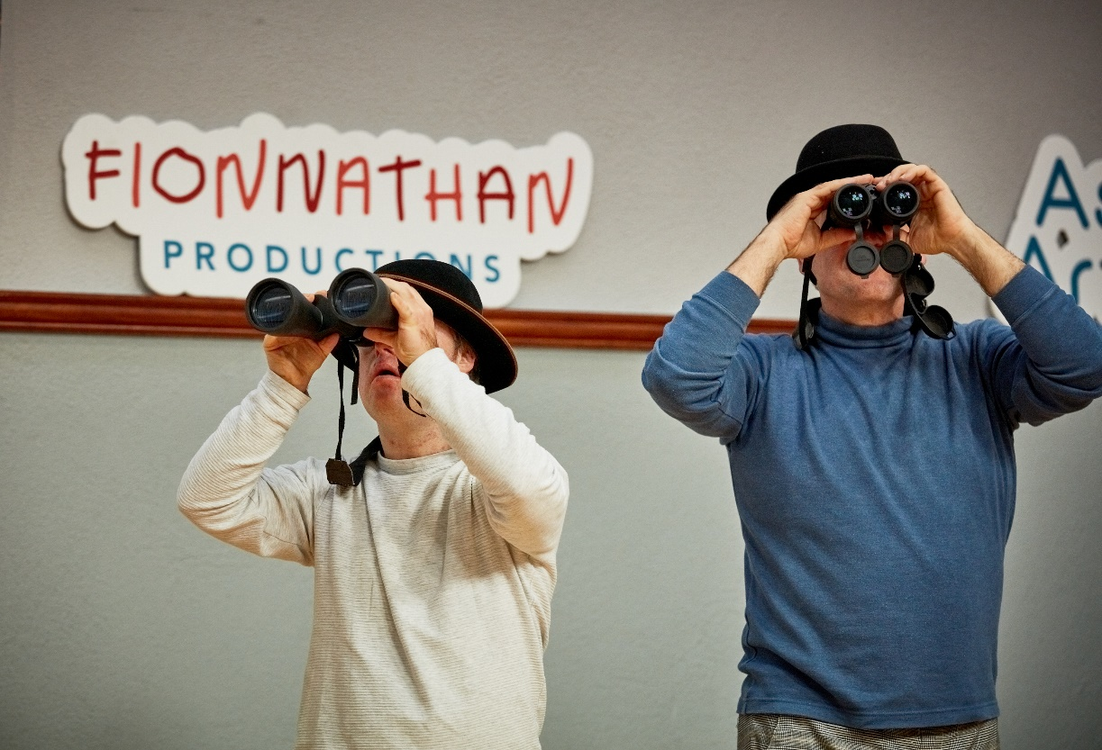
Fionnathan Productions, Fionn and Jonathan Angus, Embrace Associate Artists 2022/2023. Photo credit: Maurice Gunning
Section 3: County Clare

County Clare Arts’ Services vision for the arts is, “through the creativity inherent in County Clare, every person will fully realise their own creative potential and the value of the arts in society”. Their arts development plan, Flourish (2019-2023), sets out three overarching strategic priorities in furthering this:
- Open and accessible [arts] opportunities for all
- Strategic supports for artists
- Continued appreciation and development of the arts

3.1 Clare Arts Service Embrace Arts and Disability Programme

The Embrace Arts and Disability Programme is the most comprehensive and wide-ranging of its kind within the county, inviting collaboration from within the professional arts sector, the HSE and disability resource organisations to achieve its purpose and goals.

Embrace – ‘access to a creative world’

Embrace is a person-centred, participation-focused initiative, the primary goal of which is to provide access to high-quality art experiences based on meaningful engagement between participant artists and professional artists … Everyone, regardless of background, age, gender or ability, should have access to a creative world – as students, participants, artists or audiences.
The programme aims to:
- Offer participants the opportunity to engage in and enjoy inclusive, high-quality,
well-supported residencies and projects across all art forms
- Offer artists at all levels who have a disability the opportunity to develop their arts practices and professional skills
- Offer professional arts facilitators whose arts practice centres on arts and disability the opportunity for employment and the opportunity to develop their professional skills [https://clarearts.ie/programme-areas/arts-and-disability-programme-embrace/]
The Embrace programme is structured to progress each key aim through the range of annual awards on offer to artists and disability organisations, one-off project commissions, and in supporting annual calendar community arts events. A part-time co-ordinator/curator oversees every aspect of the programme to ensure the quality of the arts experience is prioritised. This includes liaising with artists and developing relationships with relevant resource organisations, curating and refining programme content, addressing gaps, and identifying possible progression routes.

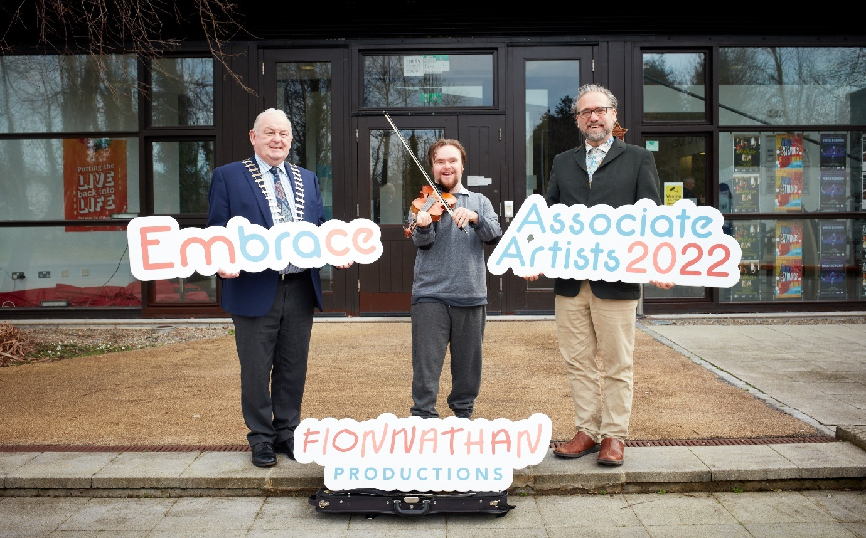

Fionnathan Productions, Fionn and Jonathan Angus, Embrace Associate Artists 2022/2023. Photo credit: Maurice Gunning

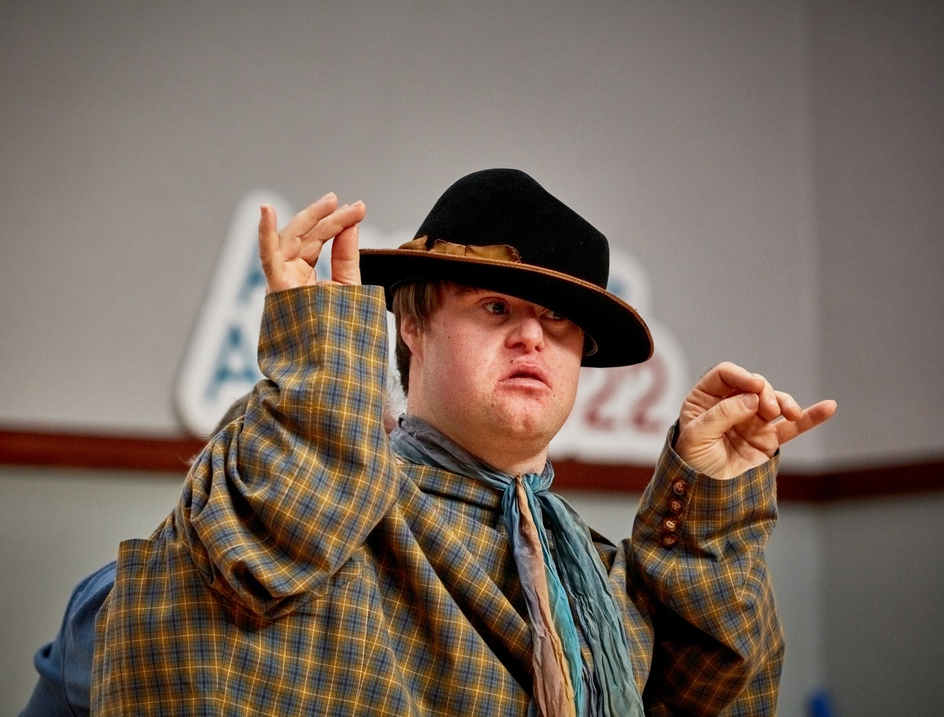

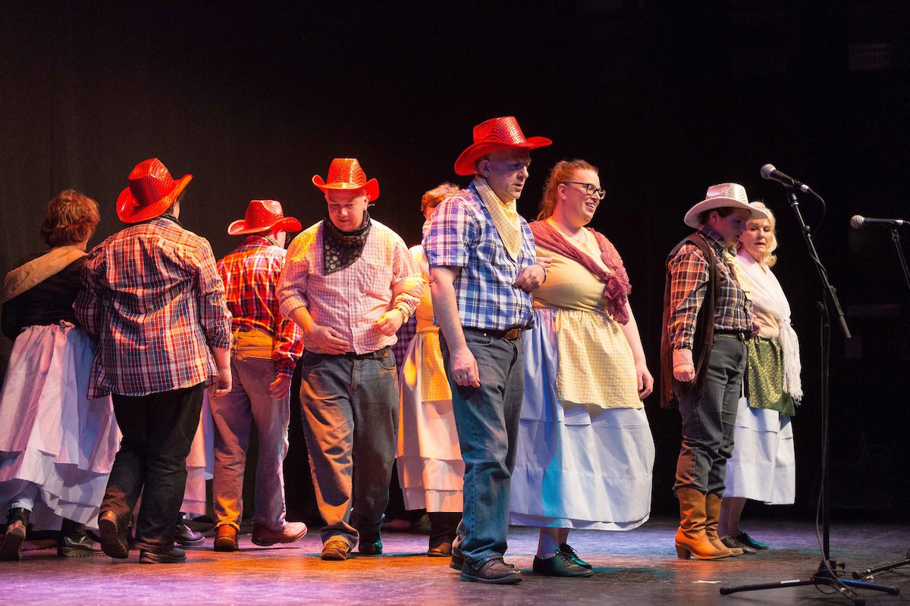
Embrace participants performing at glór theatre Photo credit: Eamonn Ward

Embrace residency award (short-term and long-term)

The annual short-term residency award has been a consistent feature since the commencement of the Embrace programme in 2002. Each year a host organisation, in collaboration with an artist, or artists, selected from the Embrace artists’ panel, may jointly apply for a residency project (totalling 20 hours) within a disability setting. The host organisation provides 50% funding towards the award. Regular recipients include: the Dulick Centre, Ennis; Enable Ireland; Brothers of Charity Services; Clare day care centres; the National Learning Network; Clare Crusaders; and St Anne’s Special School, among others. The level of funding has remained unchanged.

In 2016 and 2017, of the almost 50 art projects delivered within disability organisations in Clare, over 30 of those were short-term residencies. From 2018 onwards, a more competitive element for assessing applications was introduced to ensure the continued quality of arts engagement. In 2021, Embrace delivered arts projects in disability settings – 10 artists in 12 settings, and one client-mentoring project.

Embrace in-house residency is of longer duration. The most recent, in 2019, was awarded to St Anne’s Special School, Ennis, in partnership with mixed media artist Shona MacGillivray, to undertake a participatory art project over the course of two terms within the school year. Mac Gillivray – who has a long association with the Embrace programme and with St Anne’s – documented her residency and presented her working process as part of the Arts in Education National Conference Day.

Embrace One to One Award
This award was devised to meet the needs of individuals who attend day care centre workshops and who demonstrate a need/wish for more focused one-to-one mentoring/teaching support to create new work/and or to develop skills in a specific area.

Embrace Independent Artist Award
This award was introduced to support artists who have a disability who do not attend day care services and who have an independent arts practice. The award is to support the artist in all/any of the following areas, to develop/create new work, develop professional skills and/or purchase equipment/materials. It also offers a fee for a mentor to support the artist through their proposed project/aims.

Embrace Annual Exhibition – work produced during these residencies – is showcased in the annual May exhibition and live performance event co-hosted by glór, Ennis.

Embrace Christmas Event: In December, Embrace participants present a Christmas themed performance showcase for families and friends and care workers. In 2022, the event was changed to a workshop format whereby participants were invited to take part in a Carols Le Cheile, a carol singing workshop with Kate Daly (BA/Irish World Academy, Community Music Facilitator) and a Christmas Crafts workshop led by artists Shona MacGillivray and Nathalie ElBaba. There are plans to develop an Embrace choir.

Embrace Associate Artists

The Embrace professional development awards are available for disabled artists to avail of one-to-one mentoring for artists at different stages of their artistic development.

The recipients of the Embrace Associate Artists inaugural award in 2022 were Fionn and Jonathan Angus, a son and father team operating under their company name, Fionnathan Productions Ltd. The award supports their ongoing professional practice of presenting and delivering workshops and includes mentoring from Galway-based performer Miquel Barceló towards the creation of a multidisciplinary theatre piece in 2023.

The four pillars of their social enterprise company are: arts-media-education-advocacy. Their art work falls into three realms: performance art, music, visual arts. Fionn is a musician, arts practitioner and filmmaker, collaborating with Jonathan, a musician and educator, who has significant experience in the Waldorf/Steiner approach to education, where all subjects are taught through the arts. The duo has performed in more than 20 countries, in venues, school settings and conferences.

Embrace curatorial strand

This strand takes an ambitious and more directed approach to art making that includes:
- Commissioning new works, such as the Vision Symphony, a major musical composition by Dave Flynn, performed by the Irish Memory Orchestra (IMO), in collaboration with visually impaired musicians, in glór, Ennis (2019)

- Introducing integrated projects such as Boga Boga dance project, led by Croí Glan’s artistic director Tara Brandel, involving 90 people participants, 40 of whom identified as disabled, in a partnership with the Brothers of Charity, Clare

- Supporting artist Ronan Murphy of the Dulick Centre to exhibit with Andrew Pike of KCAT Studios at the Courthouse Gallery in Ennistymon in Clare. Dr Dominic Thorpe was invited to curate the exhibition and to offer artistic support to both artists. This support included funding Ronan to visit KCAT in Kilkenny to forge relationships with the studio artists.

- Sharing, disseminating and exchanging practice and projects in the arts and disability field, through seminars like Drawing from the Well, 2018

3.2 Disability services and the arts

Over the years, Clare Arts Service has built strong partnerships with disability organisations countywide as the most effective way of reaching out to people with disabilities to get involved in the arts. HSE-supported organisations – such as the Dulick Centre adult day care service, Ennis; the Brothers of Charity/Clare day care centres; and Clare Mental Health Services – all acknowledge the benefits of the Embrace programme. Involvement in the programme enables their clients to have a wider selection of artforms to choose from, and is facilitated by experienced professional artists, who bring fresh ideas that supplement in-house arts activities and support their quality of life and community inclusion objectives.

3.2.1 Dulick Centre, Ennis

The Dulick Centre, a well-known HSE day care service in Ennis, is valued for the range and quality of its arts programme. The centre is fortunate in having three to four in-house instructors with an arts background who facilitate drama, dance, ceramics, painting, sculpture and arts & crafts. Though the centre is not reliant on Embrace, the programme has introduced to the centre a wider range of artists who work in community settings, resulting in some Embrace artists being engaged by the centre on a regular basis. In 2022, the Dulick Centre undertook six Embrace artists’ residencies – each typically six to eight weeks long with sessions of approximately 90 minutes in duration.

Individual members with an interest in furthering their work are supported through one-to-one artist mentoring, either provided by in-house instructors or through the Embrace programme. For example, Ronan Murphy (ceramicist, digital artist and creative writer) spoke of his development as an artist on local radio; of his one-to-one mentoring with ceramicist Pat Looney, and of how the Dulick Centre, supported by Embrace, enabled him to progress as an artist and for his work to have greater exposure.

A recognised benefit of Embrace is the opportunity it affords Dulick Centre participants to be part of a wider conversation on the arts, particularly through their involvement in the annual glór exhibition and showcase event in May, and wider community events.

3.2.2 Ennis Day Centre, Rehabilitation and Recovery Services, Clare Mental Health Services

The Ennis Day Centre services aim to support its members’ ability to improve their quality of life and live independently. Its arts programme is delivered in partnership with the Embrace programme, giving the centre access to a range of art disciplines and arts practitioners that they would not have otherwise. The centre has worked with the same artist facilitator (selected from the Embrace artists’ database) for two consecutive years, benefiting from the rapport that has been built up between artist and participant, enabling a deeper exploration of art practice. As a result of the Embrace one-to-one music mentoring award, the organisation secured extra funding from the Mental Health Association to continue the work.

3.2.3 Brothers of Charity Services Clare

The Brothers of Charity Services Clare (BoCSC) has a long association with the Embrace programme that supplements its arts activity across the county. Its arts programme, like its other services, is guided by the HSE New Directions policy agenda for progressing community inclusion with a more targeted individualised model of service provision. Since 2020, up to and including 2023, BoCSC projects have received a total of 53 short-term residencies, with seven of their members awarded one-to-one mentoring, from the Embrace programme. BoCSC members participated in the Embrace programme’s special project of integrated dance, Boga Boga, in 2018. The BoCSC rented workshop space from the Clare Arts’ Easi Studios for some of its arts activities in Ennis.

Moreover, BoCSC’s uses drama as a practice-based inclusive research method within its Advocacy and Inclusion Research programme.The BoCSC Advocacy and Inclusion co-ordinator, with a background in drama and community arts training, has facilitated Augusto Boal’s Forum Theatre techniques involving people with intellectual disabilities as a performative approach to research, communicate and present the findings at national and international conferences.

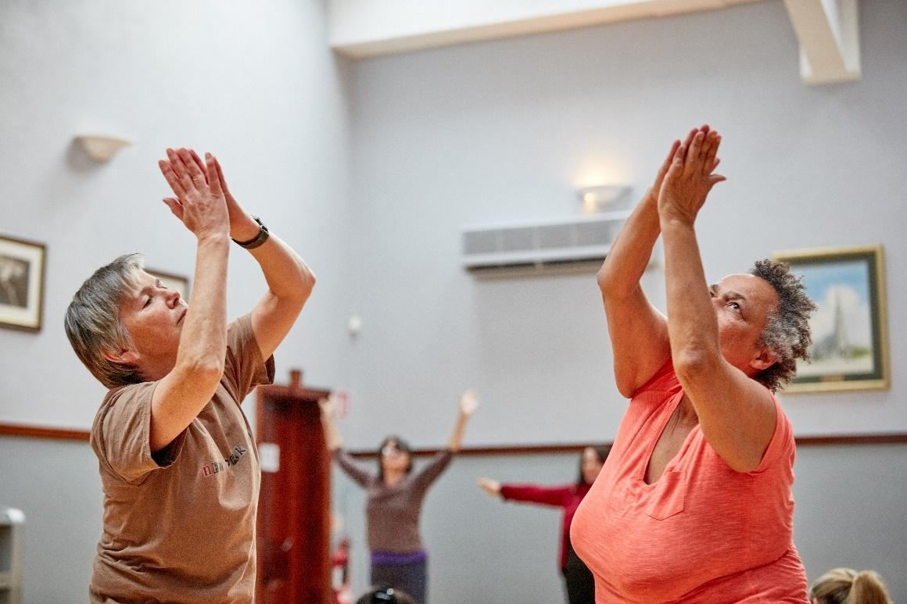
Boga Boga Integrated dance project: Tara Brandel and members of Brothers of Charity, Ennis, Co Clare. Photo credit: Maurice Gunning

3.2.4 Inclusive Arts Studio Pilot Project 2019 – Easi Studios Ennis

The Inclusive Arts Studio Pilot Project was initiated by three artist/promoters, painter Will O’Kane, dramatist Sophie Delaney and ceramicist Pat Looney, with the support of BoCSC, and funded through the Creative Ireland Project Awards 2019 and County Clare Arts Service. Dr Dominic Thorpe (board member of ADI and former tutor of KCAT Studios and the Creative Well Programme, Kildare) was invited by the Embrace Programme to mentor and work with Will O’Kane, Pat Looney and Sophie Delaney at the initial stages of the EASI Studios Pilot Project.

Project aim
To research the setting of an inclusive Arts Studio in Ennis, which would allow access to arts training and participation to those who could not avail of mainstream arts education.

Project objectives
- Deliver arts courses in a number of disciplines
- Document the benefits to participants
- Stage an exhibition at glór, Ennis
- Make study visits to existing centres for arts and disability
- Meet leaders in arts and disability in Ireland
- Consult stakeholders in Clare and set up an advisory group
- Develop plans to continue the work after the Pilot Project ends

The Project
Courses in painting, drama and ceramics, led by each of the artist/promoters, were offered to those attendees of the BoCSC in Ennis who had a proven interest in the arts. The courses were held one day per week for 12 weeks, April-September 2019, at Easi Studios, Ennis. An exhibition of the artwork produced was held at glór Ennis along with a staging of their production, Beginnings.

The project was evaluated both by the participants and their support workers. The artist/promotors made site visits to learn from other well-established arts and disability project models: KCat Arts Centre, Kilkenny; Cumas, Wexford; and That’s Life, Galway.

This pilot project was successful in achieving what it set out to do. Plans were made for it to continue to develop the programme. There were clear indications and supports in place to do so. However, the Covid pandemic intervened in 2020. This pilot warrants further consideration on how best to develop the project.

Section 4: Galway City

Galway’s reputation as a city of the arts draws arts practitioners from every arts discipline to practise and engage with its many arts organisations and festivals. The city is home to a cohort of established arts practitioners, as well as to those studying or emerging from arts courses offered by the University of Galway (UoG) and the Galway campus of Atlantic Technological University (formerly GMIT). This dynamic arts environment nurtures and sustains a range of innovative arts and disability initiatives, enabling people with disabilities to get involved in high-quality arts projects at every level.

A key objective of Galway City Council’s arts development plan, New Directions (2022-2026) is to continue to: “Build a commitment to equality, diversity, inclusion and creative learning to extend and deepen the reach of the arts as relevant, connected and reflective of society, paying particular attention to the ten groups of the public sector equality and human rights duty.”

The city Arts Service contributes funding and networking, mentorship and arts policy support, partnering with a range of local and national institutions and organisations. Partners offer entry to non-art sectors that the city Arts Service may not so readily have access to.

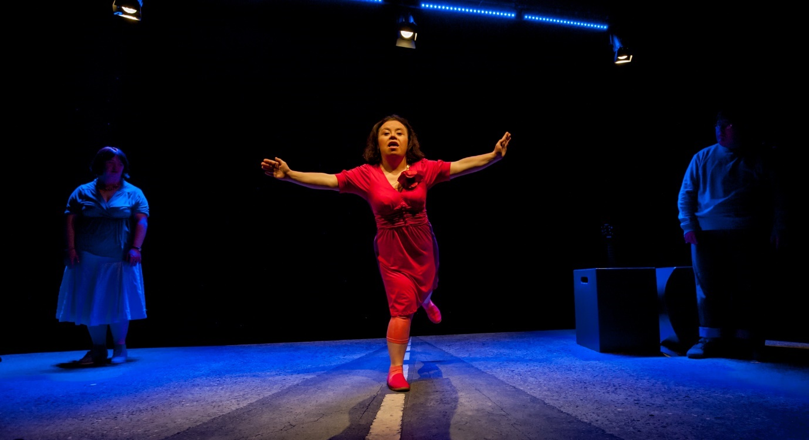
Emer Macken, iD by Blue Teapot Theatre Company. Photo credit: Reg Gordon

4.1 Disability Resource Organisations

4.1.1 Brothers of Charity Services Galway

The Brothers of Charity Galway (BOCSG, established 1952) provides a range of services to people with intellectual disabilities, from pre-school through to school age, for adults and their families within the Galway region. The services are tailored to the level of support individuals require that meet their interests and priorities.

BOCSG supports a number of arts-led initiatives in Galway city such as That’s Life, and the Arts Alive Galway programme.

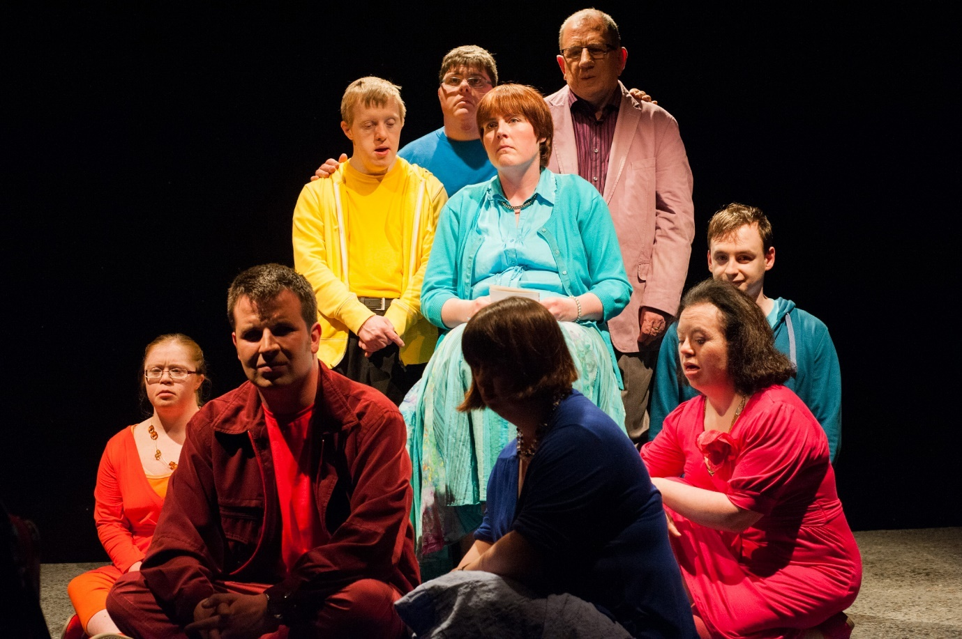
iD devised by Blue Teapot Theatre Company. Sitting left to right, Jennifer Cox, Paul Connolly, Charlene Kelly, Valerie Egan, Emer Macken & Michael Hayes. Standing left to right, Patrick Becker, Kieran Coppinger and Frank Butcher. Photo credit: Reg Gordon

That’s Life – ‘Unleashing creativity’

That’s Life is an award-winning arts and personal development programme of the Brothers of Charity Services, Galway. People with intellectual disability have opportunities to discover and realise their artistic potential through working with established artists and participating in a wide range of high-quality arts programmes. That’s Life art makers create beautiful work that contributes to the cultural and artistic life of their community.

Core values and principles

Individual choice: That’s Life respects individuals’ right to make their own choices. We support participants on individual and collaborative journeys of self-discovery and self-expression.

Quality: That’s Life is committed to achieving the highest possible quality of engagement, artistic product and outcomes.

Connection: That’s Life enables participants to claim their rightful place in the arts and wider community and to make their contribution to the communities in which they live and work.

Creativity: That’s Life aims to unleash the creativity inherent in all participants. We use our creativity to develop new ways of working and to respond to participants’ interests. We bring innovation and flexibility to all that we do. We create safe environments in which participants can explore their creative potential and develop new aspects of themselves.

Enthusiasm: That’s Life believes passionately in everyone’s innate ability and potential. We bring energy, positivity and dynamism to all that we do.

[www.thatslife.ie/]

That’s Life is a fully independent arts programme within the BOCSG. It has a full-time permanent team of three, each with considerable arts experience – in music, to drama and street theatre.

That’s Life is neither a day centre nor a performing arts school. The model is flexible to enable as rich and sustained an arts experience as possible, to facilitate people’s engagement as art makers or as audience members in various ways. Its programme includes visual arts, street theatre/physical theatre, music, creative writing, film and animation. Some sessions are project-based, others ongoing: e.g., taster courses in various arts disciplines; arts development workshops; regular music/techno gigs; and one-off productions of varying scale and ambition.

That’s Life has built relationships with many of Galway’s cultural organisations – the Town Hall Theatre, Nun’s Island Theatre, Galway Arts Centre, the Róisín Dubh music venue, Baboró International Arts Festival for Children, Galway Jazz Festival, and Cuirt International Literature Festival among others (see their website for the full list).

That’s Life arts development strands

That’s Life Gamelan project – an ongoing project that began 11 years ago with the purchase of a Gamelan (Indonesian percussion orchestra). That’s Life provides Gamelan training to musicians, with opportunities to perform. The ensemble has performed at the Southbank Centre, London, where it maintains links with the Gamelan project.

Community participation in public events, such as That’s Life’s annual Club Tropicana gig at the Black Box, Galway, and interactive multi-sensory theatre productions with Galway-based theatre maker Miquel Barceló.

New work commissions, such as its collaboration with the UK-based Mind the Gap company as part of the Galway City and County Arts Services’ Ignite arts commission (cf. Section 5 Mayo).

Taking care of the artist – by supporting visiting arts practitioners with mentoring and professional development. Building a relationship with GMIT (now ATU) in 2019 in inaugurating the annual Centre for Creative Arts and Media (CCAM) / That’s Life Arts Bursary award, to the value of €2,500, that provides a Master’s student with the opportunity for practice-based engagement and training within the That’s Life programme, supported and mentored by members of its team.

Funding: BoCSG funds That’s Life’s operational costs (staffing, creative work spaces and administration). Grants from Galway City Arts Office, project grants from the Arts Council, Creative Ireland, and Galway Roscommon Education Training Board (GRETB).

Arts Alive Galway

Arts Alive – ‘Interacting with the creative community’

Arts Alive Galway is a community-based arts programme in Galway City, set up in 2016, where ten young adults with intellectual disability are offered the opportunity to explore and interact with the creative community that surrounds them. Through engaging with a wide variety of arts media and training, they are supported to develop a good range of key life skills as well as working together to a high standard on creative projects that connect them with the community.

The four-day programme is rolled out by the Brothers of Charity Services Galway and delivered under the HSE New Directions ethos of an individualised service which supports people in their life goals and choices.

The Arts Alive Galway programme has three part-time staff: a theatre maker; a DJ who teaches DJ skills, soundscape recording, live radio broadcast; and a visual artist who workshops paint, drawing, printmaking, textiles, art and design. This broad-based arts programme operates four days a week. From time to time invited guest artists run workshops, and participants sometimes attend courses such as Galway Technical Institute (GTI), GRETB or That's Life.

The staff run every aspect of the programme. The regulation, which is a necessary part of the organisation, is time-consuming. The programme is well received by the participants who are starting to progress out into the community in a number of ways – part-time jobs, volunteering, going to college, performing in community festivals. The staff are interested in taking the arts programme to a higher level. Due to time constraints, they have been unable to apply for Arts Act grants from Galway City Arts Service.

Funding: BoSCG.

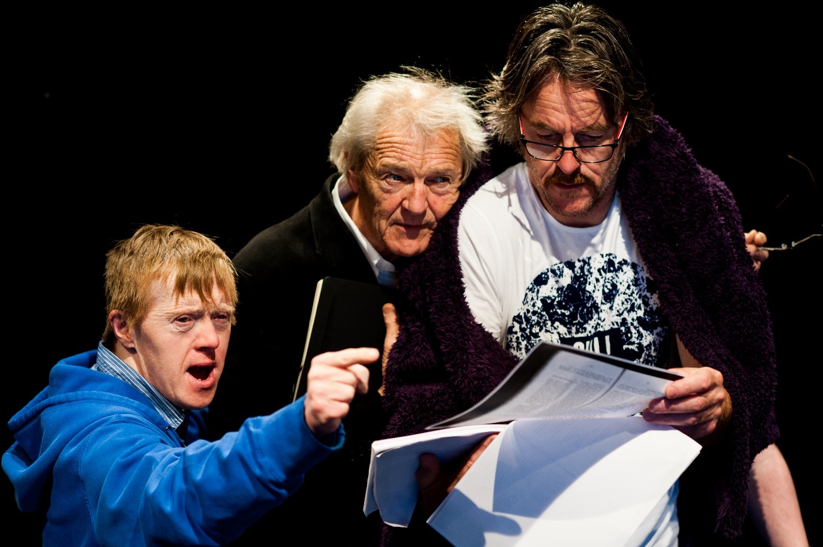
Hidden Theatre Creation R&D, Blue Teapot Theatre Company. Patrick Becker, Rod Goodall & Fred McCloskey, Hidden R&D. Photo credit: Reg Gordon

4.2. Performing Arts Organisations

4.2.1 Blue Teapot Theatre Company

Blue Teapot Theatre Company – ‘Bold, diverse and nurturing’

Blue Teapot is a bold, diverse, Irish theatre company working with artists with intellectual disabilities.

It works to radically transform theatre practices by telling stories through the lens of disability, paving the way for inclusive practices to become the norm. By pushing the boundaries of what is possible, it celebrates creativity and challenge the narrative about intellectual disability. The focus and commitment are centred on three priorities:
Production – creating brave, challenging, intrepid theatre
Progression – nurturing creativity and talent
Provision – owning the space, developing infrastructure and quality outputs [www.blueteapot.ie]
Blue Teapot emerged in 1996 out of drama workshops run by the BoCSG in conjunction with the That’s Life programme. Its transformation to becoming an independent fully-fledged professional theatre company, with its own Quality and Qualifications Ireland (QQI) accredited performing arts school, took time. People had associated the lack of skills with disability and capacity to perform. An initiative to develop a more structured theatre training programme of two-year duration, facilitated by working professional actors (of which Galway has plenty), proved otherwise.

Blue Teapot is a professional theatre company of ten full-time professional actors who produce and write some of their own work. Their performing arts school offers accredited (QQI 1, 2, & 3) three-year theatre training for persons with intellectual disability. Two more informal workshop strands – Bright Soul (for adults) and Sparkle (for teens and young adults) – maintain the link to community. All three strands enable the possibility of progression. Many members of Sparkle joined the performing arts school and some progressed into the company, although those spaces don’t come up too often.

Blue Teapot produced its inaugural arts strategy, Owning the Space, in October 2022.

Funding: BoCSG, Ability West, Galway City and County Arts Services, Arts Council, Creative Ireland, GRETB, philanthropic sources.

4.2.2 No Ropes Theatre Company

No Ropes – ‘Challenging boundaries’

Mairéad Folan is the Artistic Director of No Ropes, a Galway-based company whose aim is to make good theatre, to challenge accepted understandings in society and the boundaries they can impose. It does this through the production of original, innovative and little known dramatic works.
…/…
Each project foregrounds experiences of disempowerment or struggle and the desire for creative solutions, improved understanding and capacity-building through shared experience. No Ropes is interested in lesser-told stories, in what is left unsaid as much as what is said. Though not due to any company policy, the majority of the work since founding has been female artist-led or authored.
The company aims to pose good questions, to encourage or enable the audience to find or supply the answers.
[www.adiarts.ie/artists/showcasing/meet-an-artist/mairead-folan ]

Mairéad Folan founded No Ropes Theatre company in 2015 with the aim of diversifying representation on stage in Irish theatre. Folan has produced and directed theatre in a variety of settings. Her debut as a playwright, with Luke, premiered in the Townhall Theatre’s main stage in 2022, a co-production with Town Hall Theatre and Axis Ballymun. Folan is a recipient of several Arts & Disability Ireland Connect awards: for mentoring (2017 and 2020); and a new work award (2018).
Funding: Galway City Council, Arts Council, Arts & Disability Ireland Connect.
4.2.3 Speckled Egg Dance Company

Speckled Egg – ‘Dancing collaboratively’

Speckled Egg Dance Company are nine dance artists living and working in Galway, in the West of Ireland. They work collaboratively, durationally and interdependently to make and perform their own dance works. Their ambition is to be Ireland’s first full-time professional dance company for dance artists with Down’s syndrome.
[www.speckledeggdance.ie/]

Speckled Egg (established 2014), founded by Rachel Parry, explores new choreography for and with persons with intellectual disability who make dance works either independently or interdependently. They train together, choreograph their own works, perform regularly and lead workshops both locally and further afield. Most of the company members have received training in teaching dance and choreography to both disabled and non-disabled students. Some have taught at third-level education and lead workshops at conferences.

The company members are contributing to a series of choreographic projects, as part of Parry’s practice-based doctoral research at the Centre for Drama, Theatre and Performance, at the University of Galway. Her inquiry is investigating the early choreographic practice of postmodern dance makers Merce Cunningham and Trisha Brown and others, and how they might relate to the choreographic practices of Speckled Egg members. She intends for the research to guide new choreographic approaches to creating dance works for both disabled and non-disabled dance artists.

Speckled Egg does not have its own dance studio space. The company maintains close links with Blue Teapot Theatre Company and Galway Dance Project. It is not directly linked to any disability service provider.

Funding: Galway City and County Arts Services.

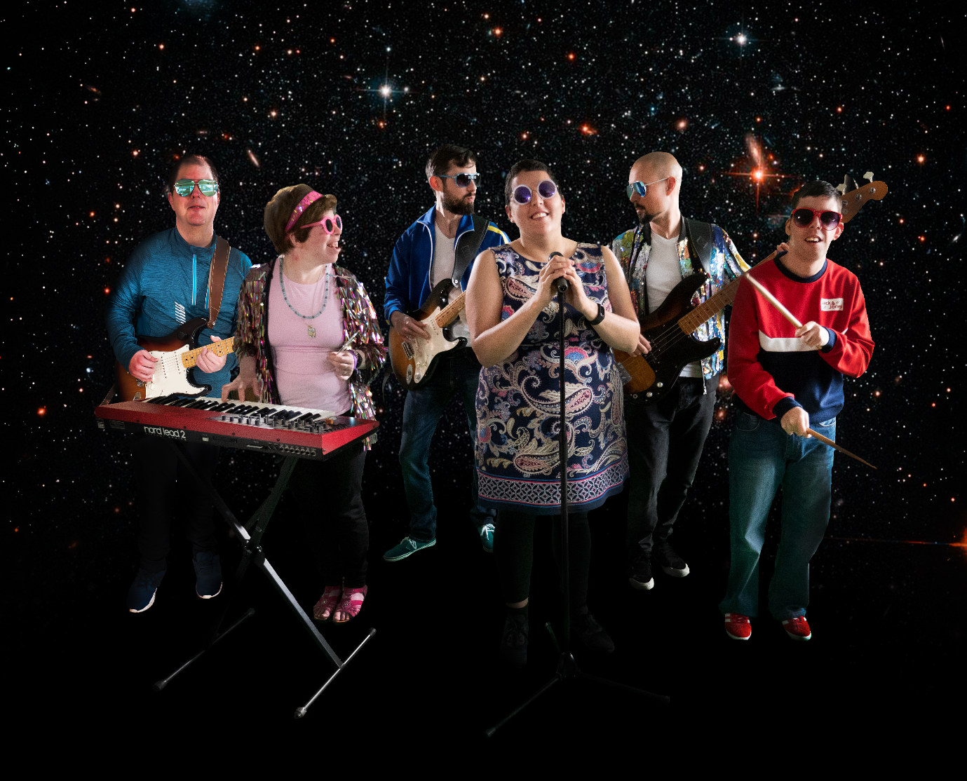
Electric Dreams Band, Brothers of Charity Galway, Left to right: Martin McDonagh, Karen Breen, Aengus Hackett, Elizabeth McCormack, Andrew Madec, Tiago DaSilva. Photo credit: Alison McDonnell-White
Section 5: County Mayo

Mayo County Council’s Arts Service plays a leadership, facilitation and enabling role, in developing and supporting the county’s vibrant arts sector. The work of the service is firmly based on the principles of quality, access, inclusion and sustainability, underpinned by a deep recognition of the central role of the artist and broad participation. Over 500 artists (from a range of disciplines, varying arts practice and stages of professional development) live and work in the county. They are complemented by the broad range of people who manage arts organisations – arts venues, festivals, events – alongside non-professional arts groups and community groups who engage in the arts.

Mayo County Council’s Arts Service has a considerable track record working in arts and disability locally, nationally and internationally. From community arts interventions, which began in the mid to late 1990s, to a series of strategic collaborations with national partners and international arts organisations, that have progressed and enabled greater opportunities for people with disabilities to access the arts over this 25-year span.

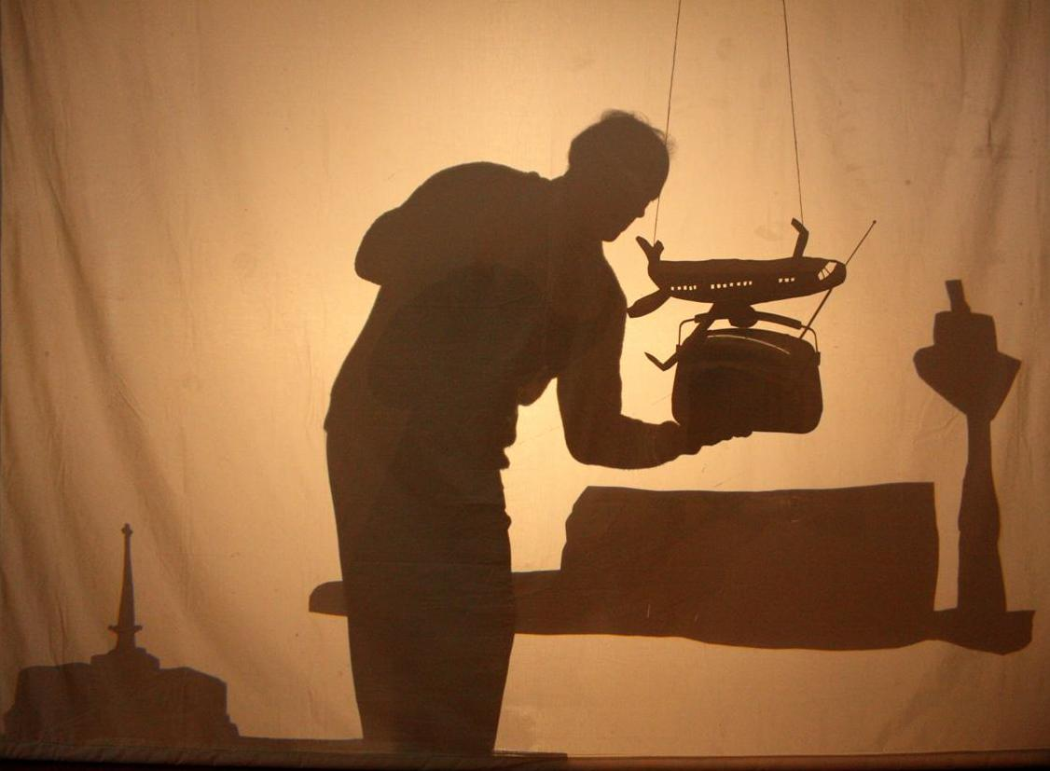
A Moving Adventure, a film by Luisne Art Project (Ballinrobe) & Scannán Technologies (Ballina) with Breda Murphy & Silke Kauther, UPSTART 2016. Image – still from the film.

5.1 Artsquad (1997 – present)

Artsquad – ‘Presenting people with the opportunity to engage creatively’

Established in 1997 with FÁS support, Mayo County Council’s Artsquad has continued to provide excellent training in community arts skills for 15 participants annually. The participants in Artsquad come from a wide variety of backgrounds and work with groups from all communities, providing workshops, training and street theatre.
Artsquad also works extensively with festivals throughout the county.
[/www.mayo.ie/arts/programme/community-arts]

Funded by the Department of Social Protection and sponsored by Mayo County Council, Artsquad is a CE Scheme and is Mayo County Council’s Arts Service’s longest-running arts programme. It was founded on the principle that everybody has a right to be included in and given access to creative actions. Its focus is community arts with a core objective of providing a more sustained experiential arts programme, moving away from short-term, one-off arts projects.

Artsquad operates countywide delivering a weekly (19.5 hours), year-round, part-arts training, part-community/social engagement programme. Artsquad engages a broad spectrum of individuals and groups who are curious about the arts or those who want to reconnect with their arts practice. According to Artsquad’s supervisor, currently, over 40% of Artsquad participants identify as persons with disabilities.

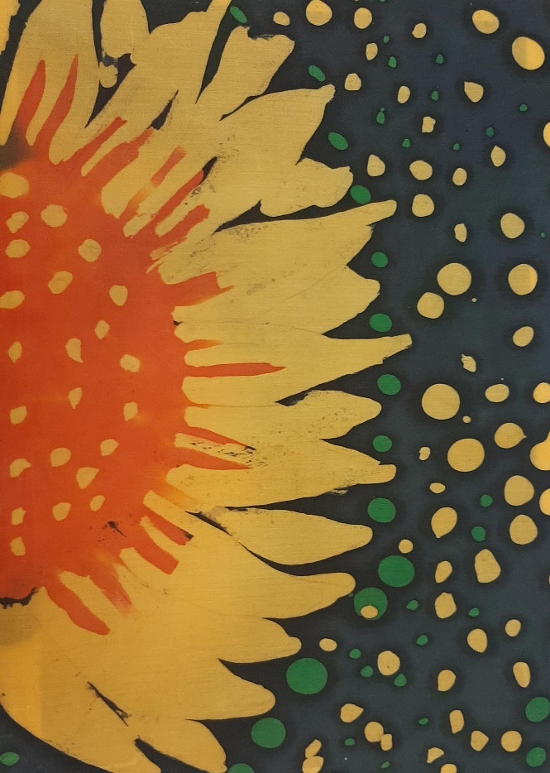
Sunflower, Tara White from Art Feels Like Home Exhibition by The Hub with Claire Griffin at Ballina Arts Centre, UPSTART 2022. Image courtesy of The Hub
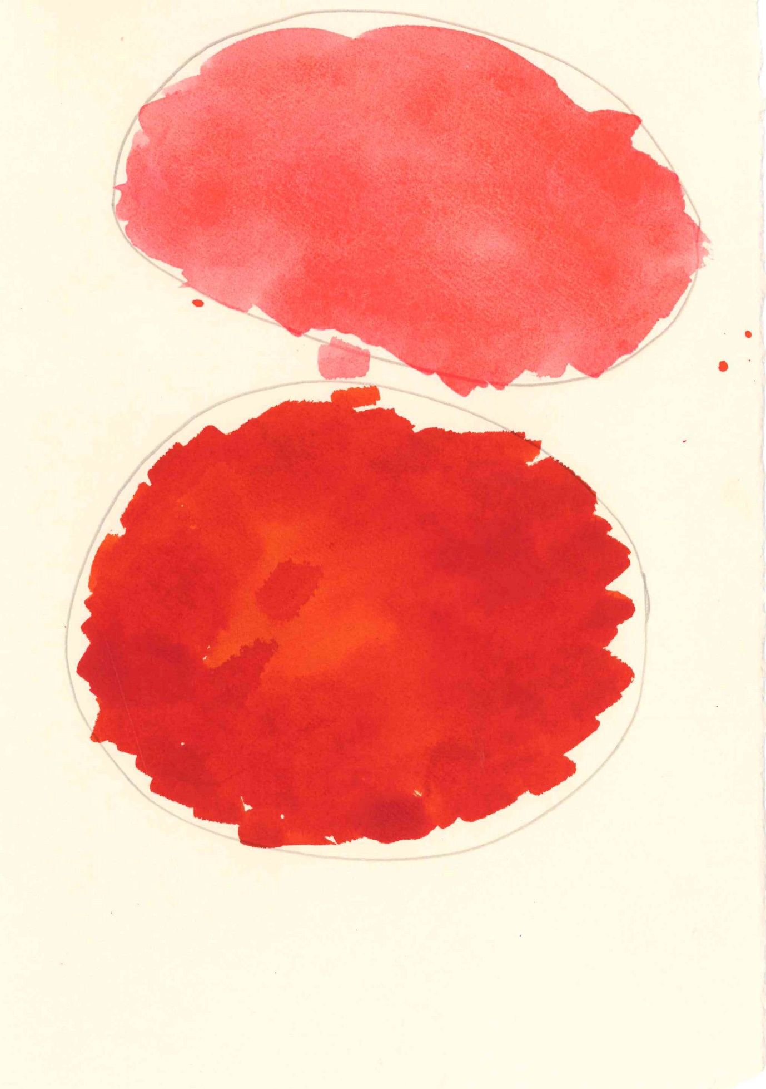
Untitled, Gerry O’Malley, facilitated by Caroline Masterson, Kickstart 2021. Photo credit: Fiona Burns

5.2 Luisne Art Project (2005-present)

Luisine Art – ‘Facilitating creativity rather than determining it’

The aim of the programme has been to establish a long-term art project of quality, which responds to the talents and needs of the participants of the Crann Mór Centre. It recognises the importance of art and creativity as a positive and powerful force in the lives of the individuals.

The project embraces a very particular process and methodology. The artists/facilitators offer support and mentoring in a creative and artistic environment where exploration and creativity are at the heart. Artist participants are enabled through skilled facilitation to experience visual art as creators. The artists are given the space to develop artistically in an organic way. Process rather than product alone has priority. [ www.artluisne.com]

Luisne Art Project is a year-round, one day a week, programme for a group of participant artists that is facilitated by a professional artist and managed by a part-time co-ordinator. TACÚ Family Resource Centre in Ballinrobe provides a community workshop space and administrative support. The project is jointly resourced by Western Care and Mayo County Council’s Arts Service. Each partner is represented on the Luisne Art Project Steering Group.

Artists participating in the project have benefited hugely from having a consistent arts practice year on year. Not only do their arts skills and abilities grow but also they learn from creative exchanges with other arts groups, and build their confidence as artists and their status and pride in the community the programme has engendered. The programme has garnered a number of awards. Two booklets documenting Luisne projects have been published.

Major exhibitions of Luisne art work have been held in Linenhall Arts Centre, Castlebar; Galway University Hospital; National Museum of Ireland – Country Life; Custom House Studios and Gallery, Westport; with smaller exhibits in Ballina, Ballinrobe and Foxford. Though the focus is visual arts, shorter projects in film, animation and dance have been facilitated by the UPSTART programme. Luisne Art Project has collaborated with other arts programmes; e.g., Ridgepool Training Centre and Scannán Technologies project, Ballina, and the Carrowbeg Artists Group/Customs House Studios and Gallery.

Funding: A 50:50 funding partnership between Western Care Association and Mayo County Council’s Arts Service; in-kind support from TACÚ Family Resource Centre, Ballinrobe.

5.3 Arts and Disability Co-ordinator (2008 – present)

Mayo County Council created the part-time position of Arts and Disability Co-ordinator within the arts service team – the first of its kind within the local authority arts service network in Ireland. This post was one of several outcomes resulting from research Mayo County Council’s Arts Service had commissioned on how best to develop a more strategic approach to its arts and disability programme. In addition, the Mayo County Council’s Arts Service initiated a series of focused interventions locally and collaborated on a number of national projects profiling the work of disabled artists (below).

5.4 Altered Images – Accessible Visual Arts Project (2008-2011)

Altered Images – ‘Interactive and inclusive’

Altered Images, a partnership initiative of Mayo County Council Arts Office, South Tipperary Arts Service and IMMA (Irish Museum of Modern Art), is an exhibition of art works from the collections of all three organisations. Accessible, interactive and inclusive in ethos, the exhibition aims to stimulate engagement with the visual arts for the general public and for disabled people in particular.
[ www.alteredimages.ie]

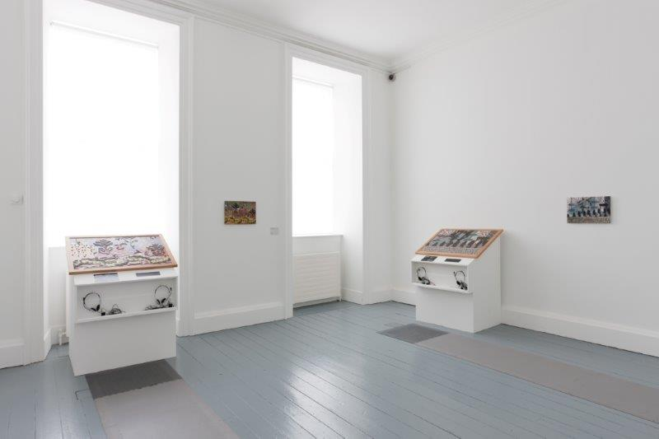
Altered Images, image is of the exhibition at Irish Museum of Modern Art (IMMA). Photo credit: Denis Mortell Photography

The accessibility and interactivity of Altered Images were key to its success. For many (disabled and otherwise), the additional tools (tactile interpretations, audio descriptions, etc.) brought the works to life, making them more accessible and immediate. The exhibition included audio descriptions, three-dimensional interpretations of paintings, sound art and an interactive website. An exhibition catalogue was produced in accessible formats (audio CD, Braille and large print).

Altered Images was a major, ground-breaking visual arts exhibition that toured to the County Museum Clonmel, Tipperary and Ballina Arts Centre, Mayo (2009), to IMMA, Dublin (2010), the Crawford Gallery, Cork and the Regional Cultural Centre, Letterkenny (2011).

Funding: South Tipperary County Council, Mayo County Council, Irish Museum of Modern Art, Arts Council, Department of Environment, Heritage and Local Government
Department of Education, The Department of Arts, Sports and Tourism

5.5 Arts and Disability Network Pilot (2008-2010)

The Arts and Disability Network Pilot (ADNP) was spearheaded by the Arts Council in partnership with Mayo County Council and Arts & Disability Ireland. The project aimed to produce policy on arts and disability, and pilot a capacity building model of good practice that could be replicated in other local authorities. The model had an element of training, an element of access audits and as well as programming and resourcing:

- Disability Equality Training (DET) for arts venues staff in Mayo, and for artists who work with or wish to work with groups of people with disabilities. The training was devised and co-led by Mayo Arts and Disability Co-ordinator and the Director of Arts & Disability Ireland

- Access audits of five cultural venues in Mayo undertaken in 2010

- Programming – an exchange of peer-to-peer learning workshops in 2009, between visiting UK-based companies the Lawnmovers Theatre Company, the Oscar Bright Film Festival, Carrowbeg artists, Westport and the Beehive film group in Ballina

- Resourcing – a practical resource pack, A Shift in Perspective (2010), was produced that addresses access issues in buildings and other kinds of access challenges

The ADNP paved the way for a new funding stream, the UPSTART programme (2010), gave rise to the Ignite commissions of major work by disabled artists in Mayo, Galway and Cork in 2014 and led to the development of Mayo’s Arts and Disability Network (MADN).

5.6 UPSTART (2010-present)

UPSTART – ‘Supporting collaborative art projects’

UPSTART is Mayo Arts Service’s arts and disability annual funding stream for supporting collaborative arts projects between local arts venues, people with disabilities and arts practitioners. Its stated aims are to:
- Incentivise quality artistic collaborations between groups/ people with disabilities, artists, arts venues and organisations within Mayo
- Support opportunities for people with disabilities to develop arts projects in celebration of International Day of Persons with Disabilities, 3rd December

Since 2010, the Arts Service has actively encouraged artists, groups of people with disabilities, venues and arts organisations to come together and collaborate in the development of quality arts initiatives. People with disabilities, from children to older adults, have participated in projects encompassing a wide range of art forms increasing access to opportunities and skills and raising awareness. Arts venues throughout the county have established long-term relationships with artists and groups of people with disabilities and have also played their part in the development of the UPSTART initiative.
[www.mayo-upstart.ie]

UPSTART provides small-scale seed funding to applicants who meet the following criteria:
- Quality of the proposal
- A collaborative approach between venues, artists and people with disabilities
- Involvement of participants in the design and delivery of their project
- Applicant’s track record
- Arts practitioner’s experience working with people with disabilities and Disability Equality Training (DET)

Mayo County Council’s Arts Service has supported per year, up to 2019, an average of 5.1 UPSTART projects, employing 11.6 arts practitioners to facilitate over 47 workshops across six different groups, that have engaged a total of 68.8 participants. The end of project performances/exhibitions/events that are staged in the county have attracted, on average, audiences of over 300 people. For the most part, year on year, these numbers have been consistently maintained throughout the decade.

Regular UPSTART partners such as Ballina Arts Centre; Customs House Arts Studios and Gallery, Westport; Inis Guaire Arts Centre, Belmullet; and Linenhall Arts Centre, Castlebar, provide the specialised arts environment that has been crucial to the success of the UPSTART programme. They have helped forge links between artists and participating non-arts groups, e.g., Western Care, Rehab, the Irish Wheelchair Association. Mayo Irish Wheelchair Association, Down’s Syndrome Ireland local groups, and the St Anthony’s and St Brid’s Special Schools, Castlebar.

An external review, commissioned by Mayo County Council’s Arts Service in 2020, considered how best to maintain the value and ethos of the UPSTART programme and in doing so ensure appropriate support for arts and disability programming in the county. New funding strands were introduced in 2022:
- Individual artist strand – a small award for individuals with disabilities to access taster sessions to focus on their own artistic journey
- Group strand – a larger award aimed at group projects with a professional artist; this supports initiatives with established groups and encouraged first-time applicants

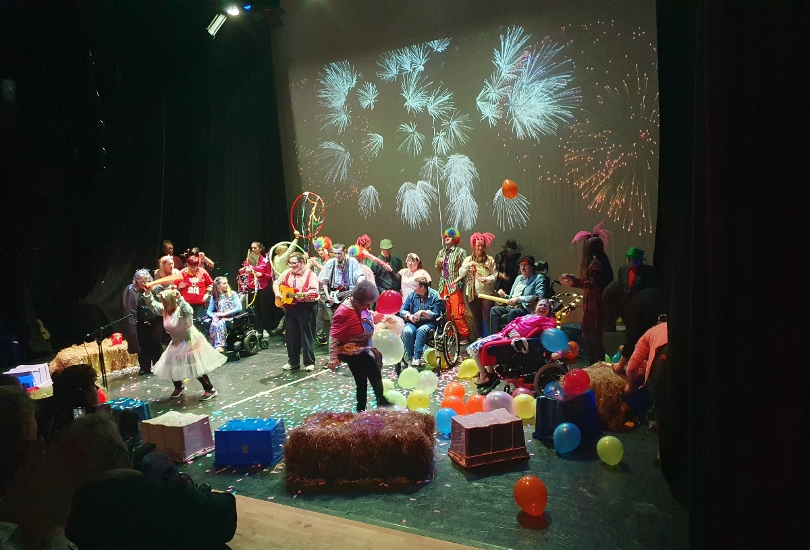
It’ A Circus, Scannán Day Service, Ridgepool Training Centre, Beehive & Bridge, Western Care, Ballina at Ballina Arts Centre with Stephen Doyle, UPSTART 2022. Photo credit: Katriona Gillespie.
5.7 IGNITE – Silent Moves (2014)

Ignite was a partnership between the Arts Council, Arts & Disability Ireland, Cork City Council, Galway City and County Councils, and Mayo County Council. The resulting collaborative commissions in Galway, Mayo and Cork celebrated arts and disability, and were led by internationally recognised artists with disabilities. Each commission represented an investment of up to €60,000, Ireland’s largest investment in Arts and Disability. The work of the ADNP paved the way for the Ignite commissions.

Silent Moves, a film inspired by the silent movie era, was Mayo County Council’s Ignite commission. It was created by visual artist Aideen Barry with choreographer Emma O’Kane and a group of 23 art makers from Ridgepool Training Centre and Scannán Technologies and was based at Ballina Arts Centre. It received its world première in Ballina Arts Centre.

The film received an Ignite Touring Award to go on national tour in 2015 and included screenings at the Townhall Theatre, Galway, Triskel Arts Centre, Cork, (as part of Cork Film Festival), the Irish Film Institute Dublin, and a homecoming in Mayo Movie World, Castlebar. The tour programme included a post-screening “Meet the Makers” session at each venue, featuring some of the project’s participating artists, alongside representatives from Ballina Arts Centre and Mayo County Council’s Arts Service who introduced the film and spoke of their Ignite experience.

Silent Moves received the People’s Choice Award in the Irish Times’ Modern Ireland in 100 Artworks, a publication marking a century of creativity, published in October 2016.

Funding: Arts Council, Arts & Disability Ireland, Cork City Council, Galway City and County Councils, and Mayo County Council.

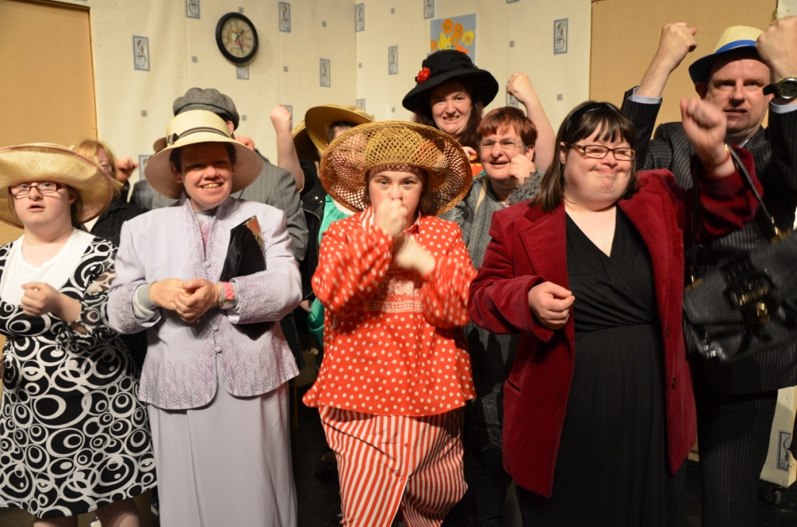
Cast of Silent Moves, Artists from Ridgepool Training Centre and Scannán Technologies at Ballina Arts Centre in 2014. Photo credit: Aideen Barry

5.8 KICKSTART (2020, 2021)

KICKSTART was supported by Creative Ireland and was developed in response to a growing interest in exploring how best to support individuals with disabilities to start their own artistic journey and begin to explore their own creative practice. The initiative provided funding to access taster art workshop sessions with an experienced artist, outside dedicated group activity, and with consideration of the access requirements of the person. Individuals were identified by venues/resource organisations and supported over a two-year period. The support has been incorporated in the individual artists strand of UPSTART.

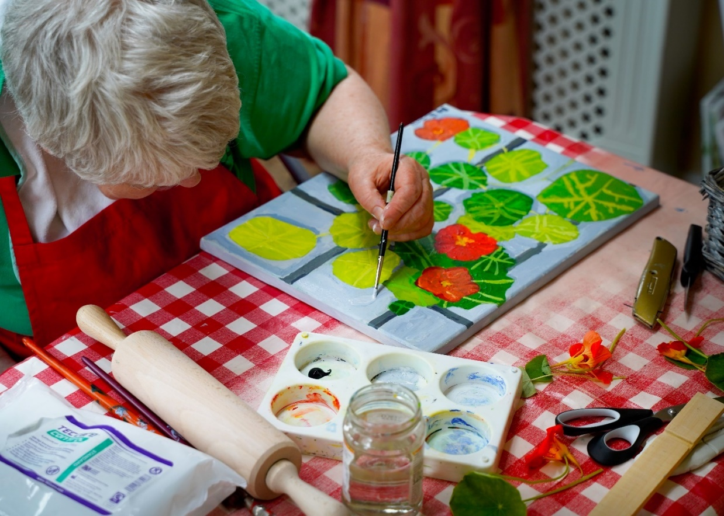
Nasturtium from Window, Mairead Coyne, facilitated by Breda Murphy, Kickstart 2021. Photo credit: Breda Murphy

5.9 Mayo Arts and Disability Network (2019 - present)

In 2019, Mayo County Council’s Arts Service established the Mayo Arts and Disability Network (MADN) in line with strategic aim 2.13 of the Mayo County Council Strategic Arts Plan (2018-2022) to: "Set up a networking group for disability groups and individuals to meet and collaborate."

The network comprises artists, venues and organisations/groups that have participated in various arts and disability initiatives run and funded by the arts service, such as the UPSTART programme.

The pandemic disrupted the development of the network and the group has had limited opportunity to engage and explore opportunities for collaborative development of arts and disability practice in the county.
5.10 Carrowbeg Artists’ Group

The Customs House Gallery and Studios at Westport Quay facilitates once-weekly, year-round arts workshops for a group of six people who attend Carrowbeg Enterprises Centre, run by Western Care. Some participants in the group have been attending since the art project began almost 20 years ago. The current waiting list to join is an indication of its success.

Over the years Carrowbeg Artists’ Group has enjoyed exceptional exposure to the arts. The routine of participating week after week, throughout the year, over time, has enabled the members to progress and gain confidence in their own ability as art makers.

The group –split into two since Covid-19 – is facilitated by professional arts practitioners: an inhouse tutor, and an artist engaged by Western Care. The Customs House Gallery and Studios has availed of the UPSTART programme to expose the group to other art disciplines and introduce new skills (most recently in virtual reality and augmented reality). In 2020, the Kickstart initiative enabled Carrowbeg artist Gerry O’ Malley to work independently of the group, mentored by the Customs House Gallery and Studios in-house tutor. His first solo exhibition, My Way, was held in their gallery.

Art works created by the group are presented alongside works produced by the Customs House Gallery and Studios’ resident artists in their annual summer and winter exhibitions. The 2022 summer exhibition presented the work of 62 artists, including works by six members of Carrowbeg Artists’ Group. Their work, and a number of their collaborative projects feature on the Custom House Studios YouTube channel.

Funding: Pobál, Arts Council, Mayo County Council, Western Care, and Mayo, Sligo and Leitrim Education and Training Board (MSLETB).

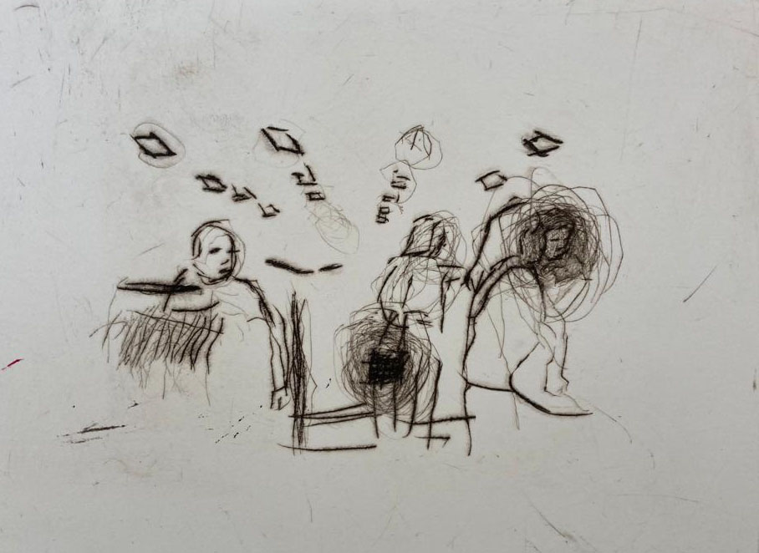
Untitled, Anna Rose Lowry, from Book of Shopping, Carrowbeg Artists’ Group at Custom House Studios with Caroline Masterson & Grainne O’Reilly, Upstart 2016. Photo credit: Caroline Masterson

5.11 Western Care and Ballina Arts Centre

Since 2009, Ballina Arts Centre has facilitated weekly arts sessions collaborating with two Western Care groups: filmmaking with Scannán Technologies, and performing arts workshops (drama, music, dance) with the Ridgepool Training Centre (now known as The Hub) for adults with intellectual disabilities. This long-term collaboration culminated in a series of highly successful and ambitious projects.

Scannán Technologies has produced several documentaries with a number of Ballina-based voluntary groups as well as a feature film and some animation shorts screened in Ballina Arts Centre and at other film festivals. The UPSTART programme has enabled collaboration with a number of professional filmmakers and other artists.

The Hub (formerly the Ridgepool Training Centre) is a Western Care Association Day Service centre based in Ballina, providing a comprehensive range of person-centred services to adults with intellectual disabilities. The centre has completed a number of drama, music and dance projects and performed in a range of productions, some of which have been supported through UPSTART. All productions are performed in Ballina Arts Centre.
(cf. 5.7 IGNITE – Silent Moves)

Funding: Western Care

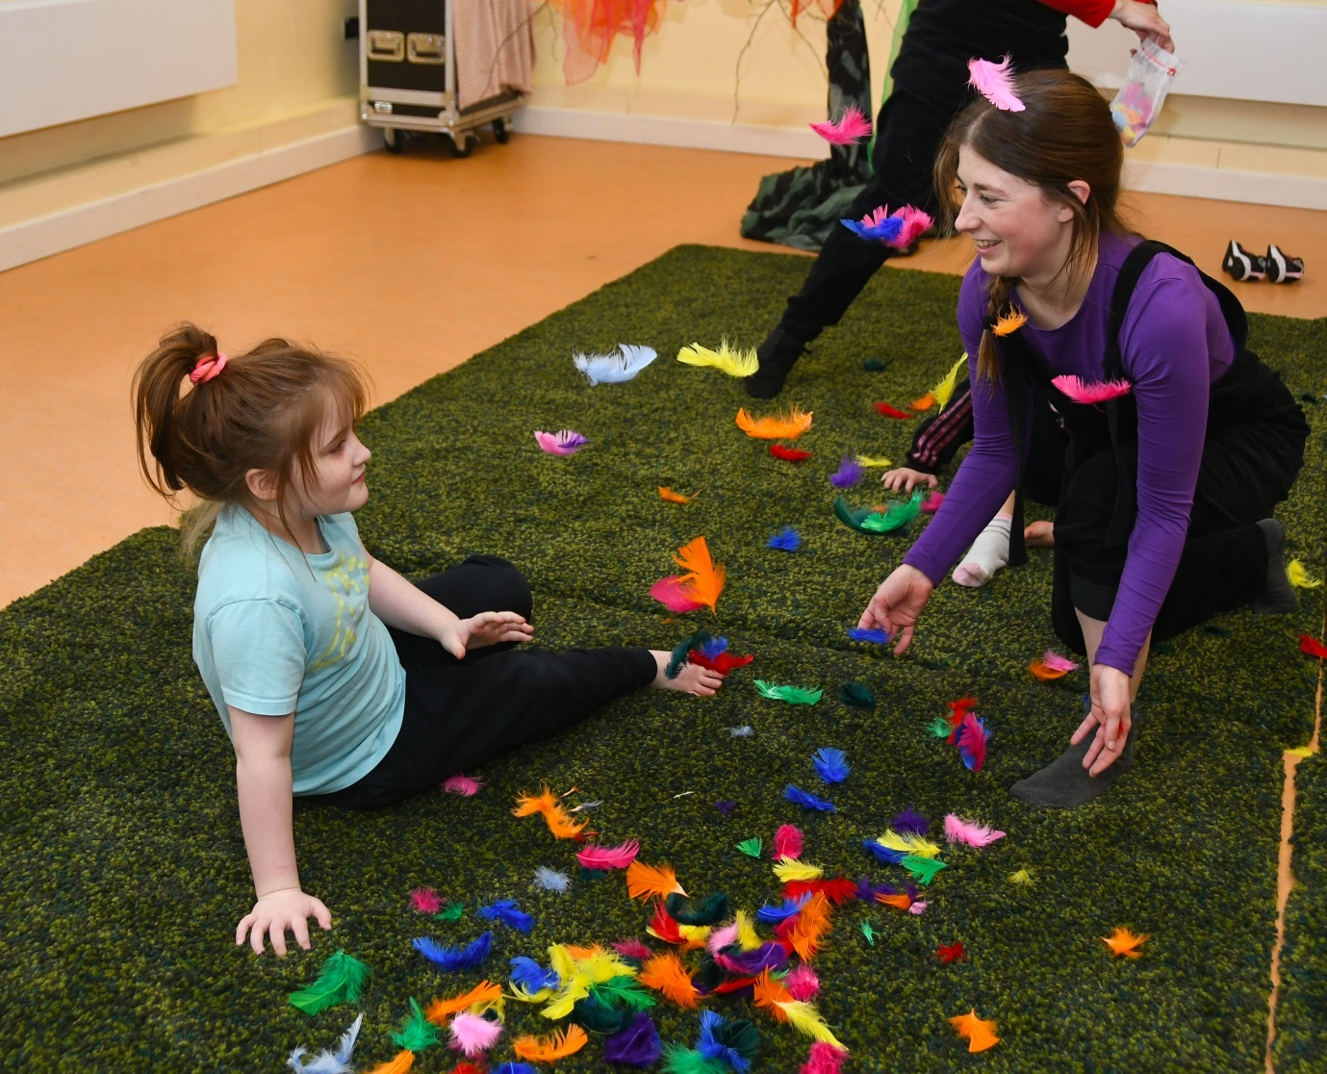
The Wonder Project, St Nicholas Special School for Children, Ballina, Phillida Eves and Linenhall Arts Centre Offsite, UPSTART 2022. Photo credit: John O'Grady.
Section 6: Consultations and Survey Findings

6.1 The Approach

One-to-one consultations were conducted with a range of stakeholders from within each of the three local authority partner areas and with representatives from national bodies. These included artists and arts practitioners, arts centre managers, disability resource managers, care workers, family members, community representatives, funders and policy makers. Around 45 people were interviewed – 98% were conducted via Zoom and email correspondence, the remaining 2% by phone. It was agreed in advance that contributions to the report would be treated confidentially and not attributed.

A follow-up online questionnaire, distributed by each arts office, gathered additional quantitative data under four separate categories: artists/arts practitioners; arts organisations; arts participant/audience; and disability resource organisations. The survey sought to obtain current information on arts and disability provision happening within each local authority area to understand the challenges that disabled people engaging in the arts continue to experience, and to assist in addressing inequities in arts provision for disabled people. A total of 40 responded to the online questionnaire: 60% artist/arts practitioner; 20% arts organisation: 5% arts participant/audience; and 5% disability resource organisation.

6.2 The Findings

The consultations yielded a range of insights and considerations complemented by responses from the online survey. As one consultation contributor said: “There is no one lens to hold up to this. There are all these multiple lens – from a healthcare point of view, from a creative point of view, from a wellbeing, from a storytelling, from an access point of view, and all of these different lenses are being, or could be, held up to this.”

The summary findings are considered from three particular viewpoints; artist/artist practitioner (people with a dedicated making and/or facilitation arts practice); arts organisation; and arts participant (combining results from arts participant/audience and disability resource organisations survey respondents). A synopsis of the main challenges and suggestions for change proffered by participating stakeholders is set out in 6.6 below.

Viewpoint… Artist/Arts Practitioner

Art makers and arts facilitators in film, theatre, dance, visual art, music and storytelling/poetry discussed their experience of creating work and the opportunities afforded them, along with some of the challenges they encountered.

From the survey, visual arts practice had the highest representation (41.67%), then music/sound (29.17%), closely followed by theatre (25%), and film (16.67%). A larger number of visual artists resided in Clare and Mayo, while the predominant locus for the performing artists (theatre, dance, circus, street spectacle) was Galway City. Some 86.96% of the artist/arts practitioner respondents identified as female; 13.04% male; and 43.48% as an artist/arts practitioner with a disability.

There was broad consensus from those consulted that quality arts engagement programmes offered to people with disabilities benefited from being facilitated by experienced professional artists. Programmes such as Embrace and UPSTART have this assurance built into their respective structures: linking their databases of arts practitioners to disability service providers and arts organisations, as highlighted previously.

According to one artist facilitator: “The skill, in terms of facilitation, is about understanding what art practice is. It’s about having some grasp at least that art …comes from the inside out and not the other way around. You are not enforcing: here’s how art is made, here’s the way it is done, here’s the way it must be done.”

Barriers to accessing the arts in the artists/arts practitioner category, Chart 6.1 (below), captures what practising artists and those facilitating projects consider to be the most disabling factors impacting their work.

Chart 6.1: Barriers to accessing the arts
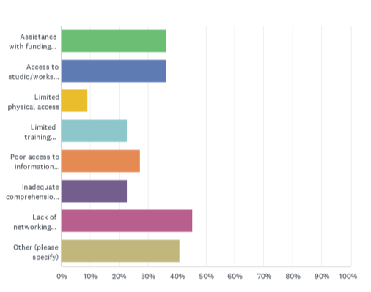

The top four of eight include:
- Lack of networking opportunities 45.45%
- Assistance with funding applications 36.36%
- Access to studio/workspace 36.36%
- Poor access to information on funding 27.27%

Challenge: Networking opportunities
Several arts practitioners interviewed – in particular those facilitating workshops and projects – said they would welcome more peer-to-peer networking opportunities, to exchange and share working methods, and learn from each other. One contributor acknowledged how the annual glór exhibition and showcase of work, produced by Embrace-supported projects, provided one such networking occasion. Mayo Arts Service’s projects supported by UPSTART have a slightly different approach, where the public presentation of artwork produced converges around the International Day for People with Disabilities (3rd December). One respondent suggested spreading the work throughout the year, as there was “a glut of work” being presented at the same time each year, making it impossible to see work produced in other projects.

Experience and knowledge shared through networking can motivate artists’ involvement in arts and disability, help maintain high-quality arts service provision, and generate new directions and growth. One artist facilitator suggested that arts offices schedule once-or twice-yearly café-style meetings and incentivise attendance by paying the artists.

Challenge: Training and resourcing
From the survey, the 50-59 year age range scored highest at 39.13%, followed by 21.74% in the 60-69 and 30-39 age ranges. There was zero response in both the 18-24 and 25-29 age range. Almost 70% of respondents had spent over 10 years working in the arts. While the survey sample number was not large, these results tally with the age range of those interviewed – though several art makers in the 18-24 and 25-29 year age categories were consulted.

The implications of having an older cohort of practitioners were commented on by several respondents. In particular, the perceived dearth of younger arts practitioners facilitating arts projects in community contexts was noted:

“The focus must be very strongly on workers’ rights… nothing will progress until that foundation is strengthened. Where is the next generation of people who are going to do this work?”

Some contributors proposed availing of expertise that currently exists in the sector, that could be passed on:

“Are there ways that we can build a better structure and that includes perhaps training, mentoring, a module in further education. You need supports.” And, by another: “My gold standard is training, education, workers’ rights – that is what we are chasing.”

During the consultations, practitioners frequently discussed how professional arts practitioners perceive the monetary value attributed to their work by non-art sectors, and how sustainable the work is, given the precarious nature of contract work, at times in quite stark terms:

“Maybe we should not be taken for granted. The health service benefits so much from arts organisations and access, and they offer very little money to do it. It’s treated as something to do. All the evidence is there to show that this is immensely valuable in lots of different ways.”

Some of this uncertainty came to the fore during the Covid-19 lockdown period in 2020-2021 as expressed by one artist: “[We have] no status within the system, and it makes it very hard for us to do the work in a sustainable way – no commitment from the system in us but the expectations are huge. Covid proved that the artists were the only ones not paid [by the HSE]”.

Challenge: Funding
From the survey, the majority of funding, over 56%, came from the local authority arts office. Some 26% of funding was allocated from the Arts Council and Creative Ireland. A similar percentage did not receive any funding.

Chart 6.2: Funding awards to artists/arts practitioners within the past five years
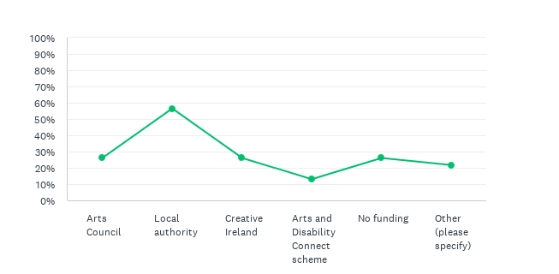

[FN Other sources stated the GoFundMe crowd funding platform and Creative Europe.]

It became evident from the consultations that some arts practitioners were engaged through HSE-run disability organisations, while others were indirectly contracted through their regional education and training boards – resulting from the local fundraising efforts by disability service managers and arts organisations. Funding from local authority arts offices, the Arts Council, ADI and Creative Ireland grant-aid specific projects. Having that imprimatur provides a degree of quality assurance of the arts provision. However, where matching funding is dependent on local fundraising, arts and disability provision does not seem to be on an equal footing. It can prove impossible to fully commit to, or sustain, quality arts and disability provision.

An alternative funding policy for disabled artists was suggested:

“I’m thinking about housing in Ireland and its almost the same with disability. 20% of each new housing estate or development had to go to social housing so everyone could be integrated. So it’s almost the same with arts and disability. Not that someone should get chosen for something because they have a disability, but there should be some percentage allotted for artists with disabilities.”

Generally, artists/arts practitioners were appreciative of the supports offered by the Embrace and UPSTART programmes, provided by Clare and Mayo Arts Services respectively. Artists without funding (in the survey and in consultation) indicated a variety of reasons for being unable to successfully apply for grant aid though their local arts offices. Some felt that communication lines between the local arts office and disabled artists could be more transparent and accessible, e.g., providing individual support with the application process; more lead-in-time for making an application; more accessible information on the application process; and dyslexia access. In other instances, respondents noted that they were unaware of the existence of these funding streams.

Challenge: Access
Access supports for practising artists are specific to individual needs. One artist suggested a more equitable approach would be to include an access budget line as standard in funding application forms:

“There is extra cost for being a disabled artist; I need to pay for my access requirements…/…Access is a very new area with the Arts Council. They are only this year pushing an access line – still a learning curve.”

Some funding bodies have included this already.

Several contributors to some of the longer-term arts and disability projects (15 years or more) felt they would benefit greatly from having their own studio space and, with the right supports in place, to be able to spend as much time as they please pursuing their arts practice.

From one arts facilitator’s perspective: “There’s an absence, from a visual arts point of view, of facilities in that regard. Perhaps you end up with people who are verging on becoming practitioners but are moving from project to project. Because that’s how it done, but maybe what they need is a base and their own studio”.

An artist identifying as disabled said: “Imagine if there were studio spaces that could be open to artists with disabilities and that you could apply for residencies or you could apply for subsidised rent.”

An up-to-date audit of existing and potential accessible studio /work spaces would provide the necessary evidence in helping to determine need and next steps.

Viewpoint… Arts Organisation

Survey respondents within the arts organisation/venue category include performing art organisations, galleries, artform-specific festivals and community arts, with 62.5% of respondents from Galway City (62.5%) and 37.5% from Mayo. The audience/participant range: 75% indicated general public; 50% children and young people; 37.5% disabled people; and 25% older people.

Funding

From the survey, all respondents were in receipt of funding from a range of sources and from various funding strands. Some 87.50% received project funding from their local authority; 62.50% from the Arts Council – 25% strategic funding, 37.5% capacity building, and 25% from Creative Ireland. Other sources of funding 75% included: Brothers of Charity Services Ireland (BOCSI); Ability West; Dept. of Social Protection; Dept. of Education; Galway Roscommon Education and Training Board (GRETB); Mayo Sligo Leitrim Education and Training Board (MSLETB); Erasmus+; and donations. Regional ETBs provide supplementary funding to engage arts facilitators (for up to 12 weeks) for arts and disability projects.

Challenge: Resourcing arts and disability programmes/Incomprehension of need
There was no response from multidisciplinary arts centres or venues to the online survey. Arts centres produce and present a wide range of arts programmes for local community groups, specific sectors and the general public to experience and enjoy. They are considered, by some, to be crucial to progressing the arts and disability agenda:

“Any place that has an arts centre working in conjunction with a disability group seems to have a lot more going on than other areas that don’t. There is an area over here …/… because they don’t have an arts centre there is no third party driving it.”.

However, the study indicated that multidisciplinary arts centres tend to have to limit arts and disability engagement projects to six to eight weeks, as explained by one contributor:

“Blue Teapot and That’s Life Gamelan, that kind of continued delivery – you can see it in the people that they work with – that’s quality, that’s where it needs to be. But a multidisciplinary arts centre that’s serving the whole community can’t be that. It a different thing.”

A similar viewpoint was voiced by a contributor from a single artform organisation:

“It’s continuity of people’s artistic lives. One of the things that frustrated me is that you’d see people start a new project every year with a new teacher and they have to learn the skills for that project each time. It’s like they are always going back to the beginning every time – never any kind of continuity.”

However, as this mapping report has previously indicated, there is precedent, scope and potential to produce more collaborative arts initiatives of varying scale and ambition involving disabled persons (e.g., new work commissions, year-long artists’ residencies…), and with enhanced inter-agency support, and further investment in access supports, arts organisations could have more time to “develop relationships with the organisation and the people who want to engage in the programme, and having more resources to enable that time – so then you can develop a meaningful programme for them”.

Challenge: Equality, Diversity, Inclusion
More than half of survey respondents do not have a stated policy on Equality, Diversity, Inclusion (Chart 6.3 below).

Chart 6.3: Organisations with a stated policy on Equality, Diversity, Inclusion

From the survey, 75% of respondents had not undertaken any formal Equality, Diversity and Inclusion training. Though one respondent added that accessibility was a core value which is “discussed, reflected upon and implemented”. Another had engaged with the Arts Council’s EDI Toolkit – Building a policy for inclusive arts practice, published August 2022. The 12.5% that had undergone Disability Equality Training, and the 2.5% that had undertaken autism awareness and access courses – both indicated that persons with disabilities were part of their target participant/audience group.

The responses to the survey and consultations prompt a consideration of the access requirements that could be incorporated into work practices to enable people to be more included and participate more fully in arts events or activities. Disability Equality Training (DET), devised by Arts & Disability Ireland in partnership with Mayo County Council arts service, is premised on an equity and equality model. DET was delivered to arts organisations in County Mayo, and Galway City and county, in 2010 and 2011 respectively. One arts manager said:

“Disability Equality Training (DET) did a huge amount to break down attitudes around ‘we just couldn’t facilitate work like this’.” A response from one arts venue: “A lot of people did the DET but there has been a lot of staff changes – it needs to be continued – training needs to happen again.”

It was evident from the survey and consultations that understanding access needed to be given more prominence. One suggestion was to insert the word “Access” within the Equality Diversity Inclusion (EDI) framework – to become Equality, Diversity, Access and Inclusion (EDAI).

Challenge: Access
From the survey, regarding the range of access requirements that need addressing, inadequate comprehension of needs scored highest (89.71%). What this may signify for organisations accommodating individual access needs for disabled artists/arts participants will vary. Limited physical access, limited staff training and lack of networking opportunities all held similar scores of 42.86% and “Other” included – funding.

“Some people talk about physical access, and there is a challenge around physical access. But a lot of it is attitudinal as well. ‘Oh, we can’t possibly do that because we can’t’.”

Chart 6.4: What do you consider to be the most disabling factors impacting your work in the arts?

Many arts centres are based in older buildings where physical access can pose challenges. Mayo’s Aras Inis Gluaire/ Erris Arts Centre, for example, a newer build, is considered by several contributors to have “the best access facilities of any cultural venue in the county”, offering the only access to a variety of arts engagement in this relatively isolated region: “If this building wasn’t here there would be no film, no community radio, no musical bank with Music Generation.” Though, like other multidisciplinary arts centres, it, too, is limited by its programming schedule and availability of resources.

Survey respondents indicated the need for greater continuing professional development/progression routes in arts and disability (75%), followed by enhanced inter-agency support (37.5%) and dedicated funding for access and tailored supports (25%).

Enhanced inter-agency support tended to be associated with inadequate comprehension of needs. Clarifying partner relationships with regards to a common vision, shared objectives and expectations are fundamental. The complexity of the relationship between the array of support agencies and arts professionals is considered further from Viewpoint – arts engagement/participation (6.5 below).

Viewpoint…Arts Engagement/Participation

The study considered a range of arts engagement/participation programmes, some initiated by disability service providers, others by arts organisations, and several longer-term collaborative partnerships and special events involving an arts organisation, disability service provider(s), and the local authority arts service. There were as many viewpoints and perspectives expressed on the value of arts participation in the mapping as there are approaches to it:

“Arts and disability I see it as arts and education as well. You have to have a different kind of awareness. You have to be a bit more empathetic, a bit more able to tap into people who won’t necessarily express themselves. But with the right artists and the right care assistant or teachers, it’s a brilliant way for people to be able to communicate and express themselves. It’s so important.”

Another said: “The area of disability and art is huge and the more the arts begin to embed in wellness and enhancement – its profile will move up.”

Challenge: Funding
The HSE’s New Directions policy, as it applies to its disability service providers, focuses on community inclusion, wellbeing and quality of life. Creative self-expression is one of 12 defined routes for implementing this policy (cf. 2.3.2). However, funding does not necessarily follow, as discussed by respondents:

“New Directions encourages us to engage in the arts and develop connections, it’s all about community-based work-how we do it. New Directions has not given us any additional funding.”

And implementing community integration is open to interpretation:

“We are a group using the community hub but we are still very much a disability group – it’s just moving from here down to a community setting. I find that when people go to [community-based] art classes they are with people from different backgrounds, different ages, different abilities, they are having coffee together. That doesn’t happen because of the funding stream coming from disability.”

Some respondents referred to the complexity of the environment that disability organisations operate within and its impact on enabling arts engagement projects to progress. Almost 70% of disability services are run by voluntary non-profit organisations funded under Section 38 or Section 39 of the Health Act 2004. According to some respondents, the precarious nature of Section 39 organisations – where funding is grant aided on a year-to-year basis – can impact services such as arts provision. The Section 39 organisations consulted did not have a core budget line for the arts and, as such, funds for arts activity have to be raised locally. Local day care managers are obliged to continuously fundraise to enable the arts activity to happen alongside all their other daily administrative and operational work commitments:

“If it doesn’t get initiated within the organisation and get a buy-in from more than one person, over the long-term it can feel like you’re pushing from the outside in. That dynamic justifying why a budget has been created. A budget would have been allocated at the discretion of the person who is trying to ringfence funding – from toilet roll to transport. The emphasis was that it needs to come from local funding pots.”

This can lead to tensions as it is impossible to strategically plan or deepen the work, especially for those participants interested in developing their arts practice.

Respondents from disability resource organisations and arts practitioners refer to the challenges of financing arts provision given their limited resources:

“As a disability organisation, we have no funding allocated to us to support the arts. If you haven’t a core budget, you have nothing to stand on at all.”

And in a similar vein:

“Funding is probably the biggest challenge and that has an impact on the artists – in securing the artists for the project.”

From the survey, uptake to the arts participation section and the disability resource organisation categories was low. Some 83% of respondents received their core funding from the HSE, and the remaining from the Department of Education. Issues concerning limited physical access, limited staff training and lack of networking opportunities, each scoring 50%, were comparable to those in the arts organisation category (Chart 6.4 below). Poor access to information regarding funding scored highest in this category resonating with a similar result from the arts organisation viewpoint. The basis of these similar results is unclear. This may be due, in part, to capacity issues; for example, not having sufficient resources to explore other fundraising options.

Chart 6.4: The most disabling factors impacting work in arts participation

Wider choice of art form opportunities and quality arts engagement programmes scored 33.33%. For example, one survey respondent – who identified as disabled – referred to the lack of drama classes. Outside Galway City there seemed to be fewer opportunities to avail of drama and dance classes. Limited transport links and travel were also seen as deterrents One example was given of an arts practitioner having to make a two-hour round trip to facilitate an arts workshop.

The underpinning of arts engagement programmes towards more inclusive community-based arts programmes, improved access/ more tailored supports, and a requirement for baseline funding for arts programmes each scored 16.67%.

Challenge: Placing a value on the arts
Placing a value on the arts; understanding the nature of practice and the processes involved in arts engagement for disabled people and the resourcing of that (e.g., with experienced arts facilitators, support staff, space, time, funding…), is challenging. Accommodating individual interests and providing more choice – in line with HSE’s New Directions policy – requires more resourcing (experienced arts facilitators, support staff, space, time, funding, etc.), as explained: “The arts programme, it’s become more of a guided arts programme, though not entirely guided because there’s always a bit of a tension there between what the services are able to provide and what people themselves want.”

Investing in the arts will reap benefits in the longer term. Investment in the arts is proven to improve self-confidence, greater decision making and quality of life choices for participants. An understanding of where the arts sits within the hierarchy of needs, and the ability to manage the disbursement of valuable, though limited, resources, is crucial to achieving progress in this respect.

One contributor said: “Everybody gatekeeps to a certain extent …/… but the kind of reservation we have encountered in terms of people engaging in cultural activity has been from disability organisations’ perspectives: where they couldn’t do that – they wouldn’t like that, and proving them wrong is a joy. And it takes a lot or resources and a lot of determination and also a huge amount of time.”

Challenge: Resourcing the arts – space and time
Restricted time and limited access to space can frustrate opportunities. This is especially the case for arts makers who demonstrate a strong interest in wanting more arts practice but are curtailed by scheduling, access and incomprehension of needs:

“A lot of those events/workshops were very short-term, two hours a week, over six weeks, and that was it, forgotten about for another year perhaps.”

There are a number of highly successful arts facilitation programmes for small groups of disabled people that have been running for over ten years (described in Sections 3-5 of this report). Continuity and routine are important elements for the participating art makers:

“One of the strengths of having the groups come in every week, all year, is that they respond to a routine in general terms. …/… over time and with repetition and with supports for specific aspects we found that they can engage with a long-term process.”

Yet this programme is one of several, highly regarded, long-term projects, struggling with these challenges. Progress is somewhat constrained due to capacity issues, to not having use of a permanent dedicated space (beyond the scheduled one day per week), along with requisite complementary resourcing to assist that.

The majority of those consulted acknowledged the benefits brought by the local arts service’s dedicated arts and disability funding streams in Mayo and Clare (see comments below). The UPSTART and Embrace programmes are recognised as having influenced and opened a wider arena for disabled people to engage in the arts, with access to a broader range of arts disciplines, encouraging more adventurous exploration of artistic practice, or enabling more in-depth work.

“We would have had groups who were starting off who had never engaged with the arts before and UPSTART was a brilliant way to facilitate that engagement at multi-levels.”

“The benefit of the Embrace programme is that we have access to a much broader range of artists and activities; what that has led to as well. You have become part of the wider conversation.”

Having a dedicated arts and disability co-ordinator (Mayo) and an Embrace arts and disability co-ordinator and curator (Clare) in place plays an important role in achieving this – by advocating for and supporting more inclusive and diverse arts engagement practice and raising the profile of the arts and disability agenda. Although both posts are part-time – two days and one day per week respectively – even within this limited weekly timeframe, considerable progress has been made, largely through strategic partnering.

A perennial conundrum for the local arts service is how best to float off some of the more established projects in the knowledge that they are sustainable in order to free up limited resources and help seed and support new ones. This often requires a careful risk-cost analysis to assess how likely an established project may succeed on its own and the risk that losing such a project would bring versus the importance of bringing new participants into the fold. Better resourcing of arts services, in general, would eliminate some of this challenge.

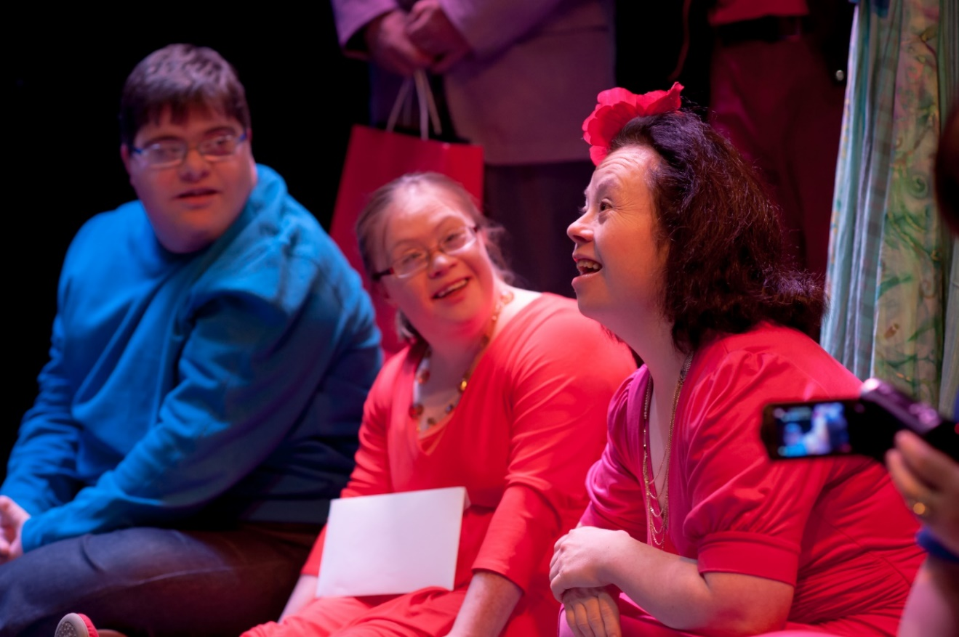
iD by Blue Teapot Theatre Company. Kieran Coppinger, Jennifer Cox and Emer Macken. Image courtesy of Blue Teapot Theatre Company

A synopsis of the main challenges and suggestions for change by participating stakeholders

Viewpoints | Challenges | Changes
Practice  Artist/Arts practitioner | - Lack of networking opportunities  - Assistance with funding applications  - Short-term projects  - Access to studio/workspace  - Poor access to information regarding funding | - Continuing professional development/progression routes in arts and disability  - Inclusive community-based arts programmes  - Integrated open work/studio spaces for arts practitioners of different abilities  - Inclusive funding
Programming  Arts organisation | - Lack of networking opportunities  - Inadequate comprehension of needs/supports  - Limited staff training opportunities  - Limited physical access  - Access to studio/workspace  - Funding | - Continuing professional development/progression routes in arts and disability  - Enhanced inter-agency collaboration  - Dedicated funding for access and tailored supports  - Integrated open work/studio spaces for arts practitioners of all abilities
Participation  Arts Engagement  /participation | - Limited opportunities for individuals  - Inadequate comprehension of needs/supports  - Poor access to information regarding funding  - Limited staff training opportunities  - Lack of networking opportunities  - Limited physical access  - Omission of people with disabilities from collaborative initiatives  - Tokenism | - Improved access/ more tailored supports  - Wider choice of art form opportunities and quality arts engagement programmes  - Improved access/ more tailored supports  - Baseline funding for arts programmes  - Inclusive community-based local arts programmes

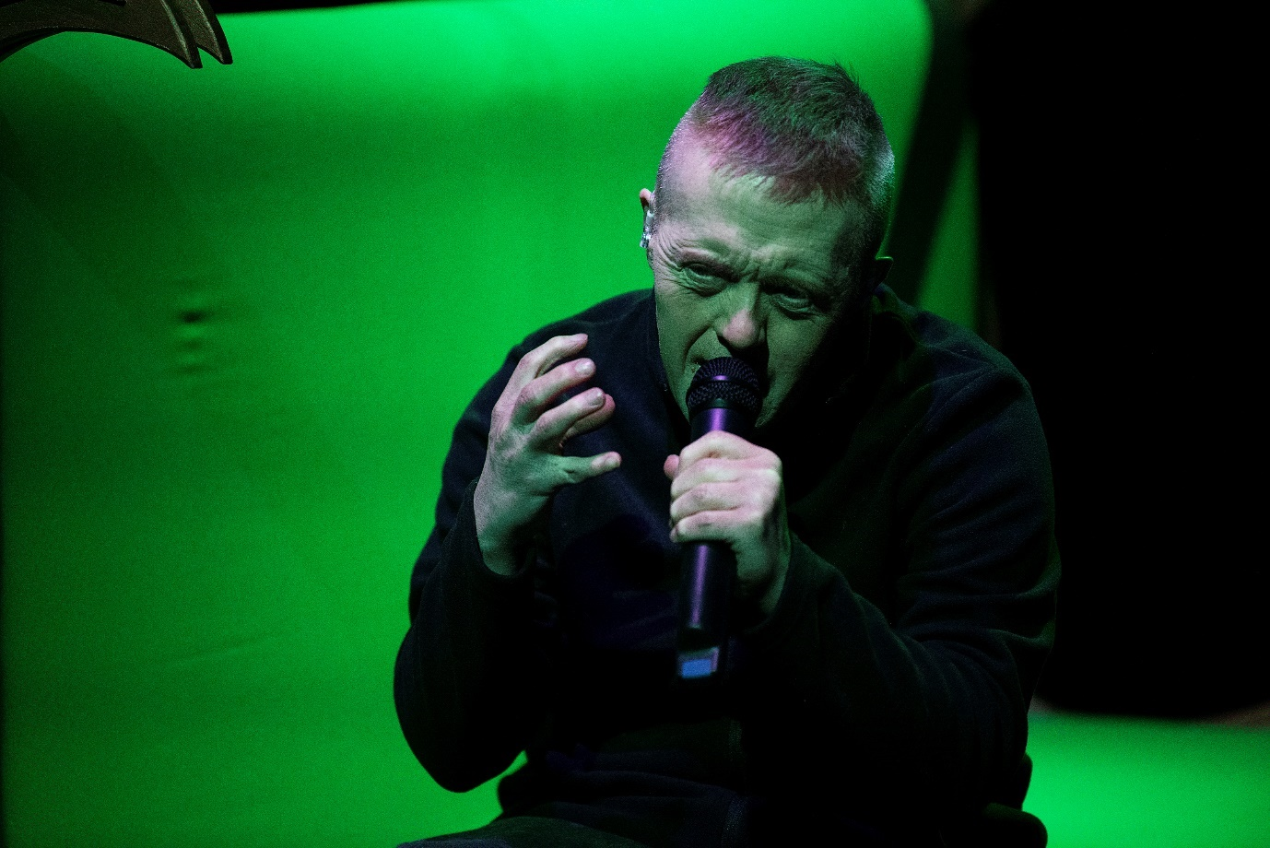Into the Dark Woods, Blue Teapot Theatre Company, Patrick Becker, Into the Dark Woods by Charlene Kelly. Photo credit: Andrew Downes, XPOSURE.

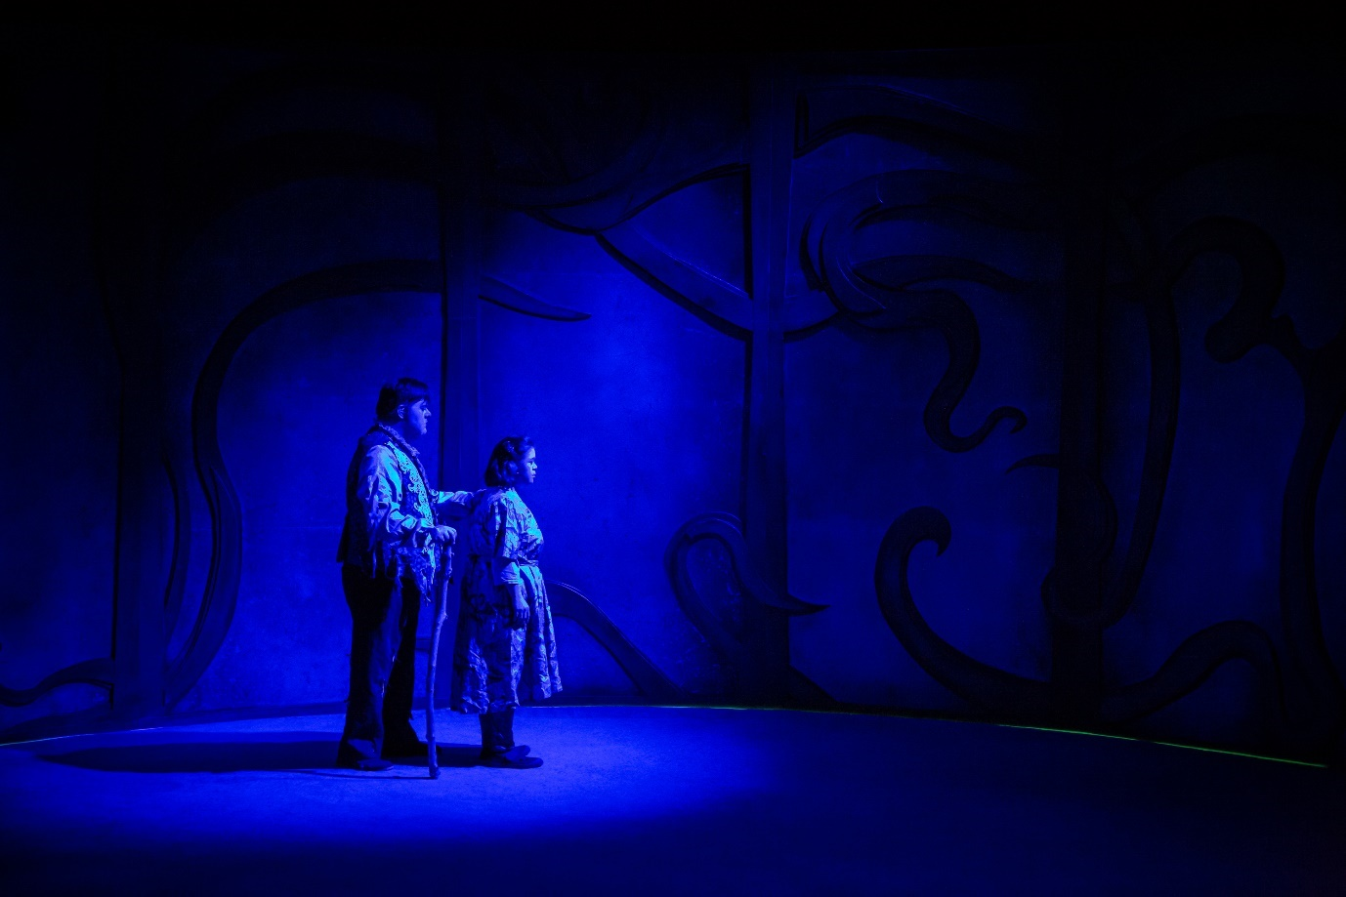Into the Dark Woods, Blue Teapot Theatre Company: Kieran Coppinger & Jennifer Cox, Into the Dark Woods by Charlene Kelly. Photo credit: Anita Murphy
Section 7: Conclusion

This report outlines the strategies that each local authority arts service has evolved over a considerable period of time to achieve the range and reach of arts and disability provision in their area and beyond. Counties Clare and Mayo Arts Services, each with dedicated arts and disability coordinators, have proactively developed structures to accommodate multi-layered arts and disability provision within each of their expansive rural and urban catchment areas.

In the smaller, more densely populated, Galway City, the arts constituency in conjunction with disability resource organisations are innovating and transforming the arts and disability landscape, supported by the City Arts Service and other funders.

All three regions have access to a substantial number of practising artists. Moreover, it is evident from consultations that arts practitioners regularly undertake work and project assignments in more than one of the three local authority areas.

Although much progress has been made in opening up programme pathways to the arts for disabled people, as the study suggests, arts and disability provision requires a comprehensive needs assessment. This includes a particular focus on improving access, better resourcing and greater inter-agency investment to sustain, innovate and mainstream the work.

One anticipated outcome of the mapping is to propose a framework for the development of future work, which is sufficiently flexible for it to be adaptable for any local authority arts office to use. The documenting of arts and disability programme pathways offers perspectives on how former initiatives have paved the way for future development.

What can be learned from these past endeavours? Arguably the Arts and Disability Networking Pilot (ADNP, 2008-2010) and consequent Arts and Disability Network have had a significant impact in laying down a foundation for arts and disability development within Ireland over the past decade or more. The network brought together a consortium of stakeholder partners (local, national and international), with the common purpose of building a capacity model for future development. The model had four interrelated elements: access, training, programming, and a resource/information pack – a model and structure that is still in use. The proposed framework develops from this model.

7.1 Proposing a Framework for Future Development – Areas for Consideration

Partnerships and Collaborations: The study suggests that any future framework (a follow-up phase perhaps of the Levelling Access- Mapping Arts and Disability Provision in County Clare, Galway City and County Mayo) requires buy-in and investment from a variety of stakeholder interests: a consortium of partners who bring specialist know-how, experience, resourcing and financial investment.

The participation of relevant local, national /regional agencies and organisations would bring enhanced inter-agency support for the range of challenges the mapping has drawn attention to. A framework of interrelated elements for future development of arts and disability provision, on any scale, is recommended below.

Visibility: How best to profile the work of disabled artists and groups of art makers; that the work is more visible on national and international arts and media platforms.

Access: Removing barriers to accessing the arts for disabled artists, participants and audiences – physical, attitudinal, intellectual. For example, incentivising access audits in each region, and other considerations such as access to information on funding, different grant application procedures, studio/workspace… in a partnership with Arts & Disability Ireland.

Networks: Networks are vital components for developing and supporting progress. Different networks serving different constituencies or functions, such as skill sharing and knowledge exchange between arts practitioners; the wider arts and disability constituency; partnering with the Public Participation Network (PPN) on more integrated community programmes; and advocating arts constituency membership of relevant European cultural networks. Perhaps a seminar series building on Drawing from the Well would be a suitable follow-up as a regional conference?

Curation: Ambitious programming commissioning of work (of varying scale and delivery) that challenges the status quo; in partnership with national artform development agencies.

Education and training: The mapping identified many continuing professional development opportunities involving mentoring and other one-to-one collaborations. Forging partnerships with regional ETBs and/or third-level institutions and a national arts development agency to lead on continuing professional development/progression routes in arts and disability and availing of the experience and expertise of practising arts facilitators e.g., a training the trainers model in one particular arts discipline.

ADVANCE: Arts & Disability (provision); Visibility, Access, Networks, Curation, Education.
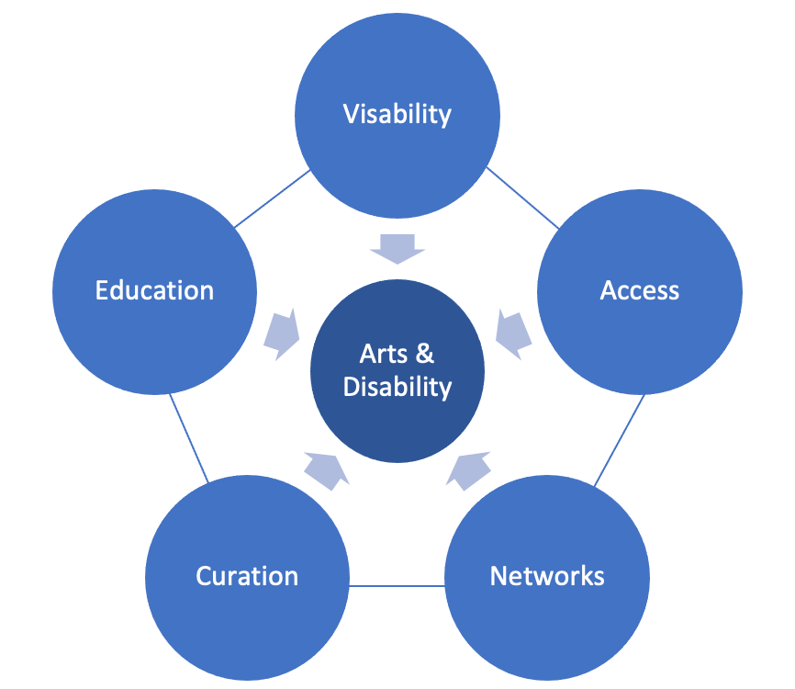

A final word

“For the future development of arts and disability in Ireland there is a need to …/…achieve even greater visibility for the high-quality work of artists and companies with disabilities both in Ireland and internationally. This will involve broadening the range of funders, programmers, curators, directors and producers who want to present and champion the creativity of artists with disabilities. It will also require people with disabilities in Ireland to move beyond the art making and take on some of these roles within the arts so they can influence change at the point where decisions are made. In parallel, there is a need to embed a more holistic approach to accessible arts programming at a local, regional and national level, so audiences with disabilities can experience the best of Irish arts in the wider communities in which they live.”
Pádraig Naughton, Director, Arts & Disability Ireland

References

The UN Conventions on the Rights of Persons with Disabilities: Training Guild (2014)
https://www.ohchr.org/sites/default/files/Documents/Publications/CRPD_TrainingGuide_PTS19_EN_Accessible.pdf

The UN Conventions on the Rights of Persons with Disabilities: Article 30
https://www.un.org/development/desa/disabilities/convention-on-the-rights-of-persons-with-disabilities/article-30-participation-in-cultural-life-recreation-leisure-and-sport.html

The Arts Act 2003
https://www.irishstatutebook.ie/eli/2003/act/24/enacted/en/print

Culture 2025 A National Cultural Policy Framework to 2025
https://www.gov.ie/en/publication/62616d-culture-2025/

Putting People First Action - Programme for Effective Local Government
https://assets.gov.ie/3577/291118175859-d2d605bd596f408f9120ffaa62359e4f.pdf

Local Government Reform Act 2014
https://www.irishstatutebook.ie/eli/2014/act/1/enacted/en/html

Local Economic and Community Plans LECP – Guidelines 2021
https://assets.gov.ie

Health Service Executive (HSE) New Directions Policy – 12 Supports
https://www.hse.ie/eng/services/list/4/disability/newdirections/alignment-of-the-new-directions-12-supports-with-the-interim-standards.pdf

Irish Human Rights and Equality Commission Disability and Discriminations report
https://www.ihrec.ie/app/uploads/2018/09/Disability-and-Discrimination.pdf

Disability Arts International
https://www.disabilityartsinternational.org

Arts Council of Ireland 10-year Strategy: Making Great Art Work (2016-2025)
https://www.artscouncil.ie/arts-council-strategy/

Arts Council of Ireland: Report Diversity and Awards (2020)
https://www.artscouncil.ie/about/Equality,-Diversity-and-Inclusion/Diversity-and-Awards-2020/
Arts Council of Ireland: Equality Inclusion and Human Rights policy
https://www.artscouncil.ie/equality-human-rights-diversity/

Arts Council of Ireland: A Framework for Collaboration (2016)
https://www.artscouncil.ie/Publications/All/A-Framework-for-Collaboration/

Arts Council of Ireland: Paying the Artist Policy Document (2021)
https://www.artscouncil.ie/about/artists-pay-policy/

Arts Council of Ireland: Review of Arts Centres (2019)
https://www.artscouncil.ie/arts-in-ireland/arts-centres/arts-centres-review/

Disability Federation of Ireland
https://www.disability-federation.ie

National Disability Authority: 20 Years of Disability Policy 2020
https://nda.ie/about-us/20-years-of-disability-policy.pdf

Inclusion Ireland
https://inclusionireland.ie/ordinary-lives-equality-and-rights/

Time to Act Report (2021) Authored by On The Move; Commissioned by British Council
https://www.disabilityartsinternational.org/resources/time-to-act-final-results/

Arts & Disability Ireland
www.adiarts.ie

Arts & Disability Ireland: Strategic Plan (2017-2021)
https://adiarts.ie/assets/uploads/2018/01/Leading-Change-in-Arts-and-Culture-ADIs-Strategic-Plan.pdf

Documenting of Artist in Residence project, Shona MacGillivray and St Anne’s Special School, Ennis, Co. Clare (2022)
https://artsineducation.ie/en/project/the-inside-stories/

Clare County Council: flourish – Arts Strategy (2019-2023)
https://www.clarecoco.ie/services/arts-recreation/publications/clare-arts-development-plan-summary-37266.pdf

Embrace Arts and Disability Programme
https://clarearts.ie/programme-areas/arts-and-disability-programme-embrace/
Clare Leader Forum
https://www.facebook.com/clareleaderforum/

Artist Mentoring & Networking Programme Report (March 2010); Niamh O’Connor; Clare County Arts Service https://www.clarecoco.ie/services/arts-recreation/publications/archive/artists-mentoring-networking-programme-2010-23420.pdf
Fionnathon Productions
https://www.fionnathan.com/

Galway City Council: Strategic Arts Plan (2021-2026)
https://www.galwaycity.ie/community-culture

Blue Teapot Theatre Company
https://blueteapot.ie/

That’s Life
https://www.thatslife.ie/

Speckled Egg
https://speckledeggdance.ie

Mayo County Council: Strategic Arts Plan (2018-2022)
https://www.mayo.ie/arts/policies-documents

Mayo Artsquad
https://www.mayo.ie/arts/programme/community-arts

Mayo UPSTART
www.mayo-upstart.ie

Luisne
https://www.artluisne.com/

Altered Images
www.alteredimages.ie

Shift in Perspective: An Arts and Disability Resource Pack (2010)
https://adiarts.ie/organisations/publications/shift-in-perspective/

Custom House Studios & Gallery
https://www.customhousestudios.ie/

Brothers of Charity

https://www.brothersofcharity.ie

Western Care

https://westerncare.com/

National Learning Network
https://rehab.ie/national-learning-network/

Appendix 1:
Additional National and International Models
and Resource Organisations

NATIONAL

Croí Glan Integrated Dance Ltd highlights the value of diverse bodies in creating performance. Working with dancers both with and without disabilities to produce innovative, engaging, high-calibre productions and deliver associated participatory activities.

Main Funders: Arts Council, Cork City Council, Cork County Council, Uilinn Arts Centre www.croiglan.com

KCAT is a multi-disciplinary Arts Centre in Callan Co. Kilkenny, Ireland; dedicated to the fostering and nurturing of creative ambition and professional development in the arts: through access and inclusion; an artist-led ethos; a flexible framework; and stability, continuity and durability.

Main Funders: Arts Council, The Camphill Communities of Ireland, HSE, Erasmus +
www.kcat.ie

Run of the Mill Theatre is a community-based inclusive arts collective in North Kildare coordinated by theatre artist Aisling Byrne. Run of the Mill is driven by a commitment to supporting people with intellectual disabilities to access high-quality experiences in drama and theatre arts as artists, makers and participants.

Main Funder: Kildare County Council
www.runofthemilltheatre.com

The Dublin Access Partnership is a local knowledge network that fosters awareness, education and share resources to improve accessibility and inclusion for people with disabilities to the arts in Dublin. An ADI access initiative.
www.adiarts.ie/organisations/partnerships/dap

INTERNATIONAL

Arts Access Aotearoa | Putanga Toi ki Aotearoa purpose is to increase access to the arts for people who experience barriers to participation as artists, performers, audience members, and gallery and museum visitors. It does this by working in the disability, mental health and Deaf communities, and through a network of community arts organisations called creative spaces. It also works with the professional arts sector to help them improve their access to Deaf and disabled audiences.

Of note is their Access award celebrating the achievements of individuals and organisations providing opportunities for people with limited access to participate in the arts, as artists and audience members. Arts Access Aotearoa Fellowship awards acknowledge the achievements and contribution of a New Zealand artist with a physical, sensory or intellectual impairment, or lived experience of mental ill-health.
www.artsaccess.org.nz

Disability Arts Online is an organisation led by disabled people, set up to advance disability arts and culture through the pages of their journal. Their raison d’être is to support disabled artists, by getting the word out about the fantastic art being produced by artists within the sector. Disability arts online gives disabled artists a platform to blog and share thoughts and images describing artistic practice, projects and just the daily stuff of finding inspiration to be creative.
www.disabilityarts.online

Disability Arts International/artists, run by the British Council, invites Deaf and disabled artists, and both disabled-led and inclusive companies, to create a self-managed online profile to share their work with promoters, venues, curators and programmers across the world.
Artists from anywhere in the world can have a profile.
www.disabilityartsinternational.org/artists

Europe Beyond Access - Supporting disabled artists to break the glass ceilings of contemporary dance and theatre. Across the performing arts and across Europe disabled artists are pushing the boundaries of form, and are presenting audiences, fellow artists and arts professionals with one of the creative opportunities of our time.
www.disabilityartsinternational.org/europe-beyond-access

Kaarisilta ry is a national association in Finland organising activities for people in need of special support since 1987. Kaarisilta's operating concept is based on ethical and aesthetic values, respect for life and the individual. Since 2003 Kaarisilta is the first in Finland to organise vocational training as special education in the fields of visual arts and music. Kaarisilta offers daytime activities, vocational training in music and visual expression, and vocational training as well as training for work and independent living as special education. The main forms of activity are visual arts, crafts, ceramics, music and exercise.
www.dev.kaarisilta.fi/kaarisilta-ry

Room 13 is a charity registered in Scotland, with purpose-built studios in the village of Caol.
It provides young people ages 8-25 with consistent access to high quality creative opportunities, shaped by their own ambitions and collective decisions. Room 13 offers a safe and welcoming space for young artists to work alongside a professional adult artist-in-residence, with free access to tools, equipment and materials. Arts and enterprise go hand-in-hand as each studio has a management team who organise the space and help meet its running costs.
www.room13international.org

Unlimited Access is a European-wide programme designed to support best practice in the commissioning, creation, dissemination and programming of performing arts by deaf and disabled artists. In partnership the Croatian Institute for Movement and Dance, Onassis Cultural Centre (Greece) and Vo’Arte (Portugal), and co-funded by the European Union Culture Programme.
www.britishcouncil.hr/en/programmes/arts/unlimited-access

Acknowledgements

Special thanks to

Mary Brady Independent Arts Consultant & Adviser who undertook the research and preparation of this report

Mayo County Council
Joanne Grehan, Director of Services
Deirdre Finnerty, Head of Community
Ann Marie McGing, Arts Officer
Damien O’Connor, Arts & Disability Coordinator

Clare County Council
Helen Walsh, County Librarian
Siobhan Mulcahy, Arts Officer
Ceara Conway, Disability Arts & Arts in Schools Coordinator

Galway City Council
Gary McMahon, Senior Executive Officer
Ruth Mulhearn, Arts Officer
Kate Howard, Arts Development Officer
James Harrold, Former Arts Officer

Arts Council
Sinead O’Reilly, Head of Local, Place and Public Art

We are deeply indebted to the artists, facilitators, people who work in disability resource organisations and local arts organisations in the three local authority areas who took the time to impart their knowledge, experience and insights, and for signposting possible new routes and directions for people with disabilities to access the arts on their own terms.

https://www.un.org/development/desa/disabilities/convention-on-the-rights-of-persons-with-disabilities.html
Ireland signed 2007 and ratified the CRPD in 2018. It has not yet signed the CRPD optional protocol that allows individuals, groups of individuals or third parties to submit a complaint to the committee, complaints can only be made against a state party that has ratified the optional protocol. See https://nda.ie/publications/others/uncrpd/a-review-of-disabled-persons-organisations-dpos-and-their-participation-in-implementing-and-monitoring-the-uncrpd_nov21_pdf. A review of Disabled Persons Organisations (DPOs) and their participation in implementing and monitoring the UNCRPD.
Section 42 of the Irish Human Rights and Equality Act 2014
Putting People First – Action Programme for Effective Local Government, enacted in the Local Government Reform Act, 2014, strengthened the remit of local authorities to represent and serve the citizen and local communities effectively and accountably
LECP guidelines 2021 along with Sustainability including Climate Change, Poverty, Rurality and Age - p 45 guidelines
Introduced in 2018 and established in A Framework for Collaboration: An Agreement between the Arts Council and the County and City Management Association (2016)
pages 19 & 20 Flourish 2019-2023
There are 31 artists listed on the (2020-2023) Embrace database. The range of arts forms includes theatre, puppetry, dance, storytelling, ceramic, textile arts, music, choral, film and visual art. Over 48% are visual artists
Data source: www.clarecoco.ie/your-council/publications/annual-reports-corporate/annual-reports/ Arts Service section (2016 - 2021)
www.artsineducation.ie/project/the-inside-stories/
See websites for more detailed account www.clarearts.ie/projects/vision-symphony/ ; www.adiarts.ie/event/drawing-from-the-well/ www.clarecoco.ie/services/arts-recreation/arts-office/arts-projects/artsanddisability/
The recruitment process for hiring instructors within HSE day care centres is not linked to any particular discipline.
www.soundcloud.com/clarefm/art-is-for-everyone-artist-ronan-murphy-talks-art-and-galleries?utm_source=www.clare.fm&utm_campaign=wtshare&utm_medium=widget&utm_content=https%253A%252F%252Fsoundcloud.com%252Fclarefm%252Fart-is-for-everyone-artist-ronan-murphy-talks-art-and-galleries
The range of arts disciplines covers: animation, art & mindfulness, book making, dance, drama and theatre, hip-hop, mosaics, music, puppetry, sculpture, stained glass, storytelling, videography and visual art.
BoCSC is a member of the Clare Inclusive Research Group (IR) and affiliated with the national network of IR groups.
Where participants draw stories together and then perform them - stepping into the story, taking roles and offering solutions.
The Community Employment (CE) programme is designed to help people who are long-term unemployed (or otherwise disadvantaged) to get back to work by offering part-time and temporary placements in jobs based within local communities. www.gov.ie/en/service/412714-community-employment-programme/
Data provided by Mayo County Council Arts Service.
An Easy Read version of the questionnaire was available from each partner arts office on request.
Assistance to funding applications- Access to studios/workspaces - Limited physical access – Limited training opportunities - Poor access to information – Inadequate comprehension of needs – Lack of networking opportunities – Other.
In the Arts Council ‘Diversity and Awards 2021 Report’ (pp 9-11) both applicants and recipients who identify as having a disability are underrepresented when compared to the population of Ireland as recorded in the 2016 Census. Applicants who identify as having a disability are under-represented when compared to the population of all counties except for: Kilkenny (where 23% of applicants have a disability compared to 13% of the local population) and Longford (21% compared to 14%). However, it is worth noting that the number of applications, and therefore the sample sizes, submitted by each county varies, and that the sample size for Longford in particular is smaller than for many other counties.- Recipients with a disability are under-represented when compared to applicants in the majority of counties). The only counties from which a higher proportion of recipients than applicants have a disability are: Offaly (25% compared to 13%) and Mayo (16% compared to 13%).
FN Perhaps the low response from arts venues, both to the survey and the consultation invitation may have been due, in part, to the flurry of personnel changes and recruitment drives that were taking place in arts centres (Clare and Mayo) throughout the research period.
Arts Council Review of Arts Centre and Venues, 2019, p 85.
Section 38 organisations (e.g. Brothers of Charity Services Ireland) are funded directly by the state to provide a level of defined services on behalf of the HSE; their employees are classified as public servants. Section 39 organisations (e.g. Western Care, Ability West) are granted-aided by the HSE and provide comparable services to a greater or lesser extent. Section 39 employees are not specifically subject to public service pay scales rates.
The input the local arts office has in relation to arts and disability engagement programmes varies depending on the context as set out in Sections 3-5.
The many outcomes and learnings from this pilot are in evidence in programmes such as UPSTART and That’s life, expediting ADI’s access services and other organisations e.g. IMMA and the ABBEY theatre
ADNP was the forerunner to the Arts Council’s Invitation to Collaboration scheme begun in 2018 - one of the few shared arts investment opportunities involving two or more local authority arts offices, partnering with other national/regional arts bodies and specialist agencies, that enables deeper critical reflection on selected aspects of an arts programming, and provision for particular sectors.
Extract from Country Profile Series: Ireland. https://www.disabilityartsinternational.org/resources/country-profile-ireland/

