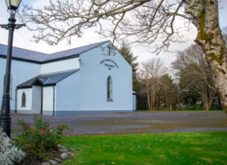 | Church of the Holy Family, Ballycroy  Mass Centre - National School - Innisbiggle  Christopher J. Ginnelly  (098) 49 134 (086) 89 33 278  ballycroyparish@gmail.com  James M Cribben, Geesala (087) 64 69 016  19th – 25th June 2021  www.ballycroyparish.ie
The Year of St. Joseph 2021
Mass at 11am will be Broadcast on our Facebook Page The outside speaker will be in operation if you wish to listen to the mass on the grounds. Special Thanks to Cathy / Nora for operating the live broadcast on Facebook and to Shelly for the beautiful selection of music and hymns.
12th Sunday in Ordinary Time
Sat 8pm Michael McManamon (42nd Ann) Aughness
Sun 11am Bryan – Mary McGuire, Dec’d McGuire Family
(Doona/W)
Sun 12.15 Bangor Church

Tue 10am Jack Murray (26th Ann) Drumslide
Wed 7pm Bangor Church – St John’s Night
Thur 10am People of the Parish – Feast of St. John the Baptist
Fri 7pm Bangor Church
Sat 11am Pete Corrigan (Doona) Month’s Mind Mass

13th Sunday in Ordinary Time
Sat 8pm Mass for 6th Class Children, All welcome
Sun 11am Neil Leneghan (Birthday Rem’), Month’s Mind Mass
and Kathleen (Doona)

Priest Summer Collection: Sincere thanks for the Summer Collection (Green Envelope) taken up last weekend. Please hand in your Summer Collection envelope.
Our Beloved Dead Please pray for the Soul of Maureen Mroczra (Moran) Cleveland, Daughter of Mary Conway – Niece of Dan Conway - Doona. May her Soul Rest in Peace.
Cemetery Masses 2021: Due to Covid-19 and restrictions on numbers, there will be NO Cemetery Masses this Year.
Trócaire: Sincere thanks for the Trócaire Collection this year. A Cheque for E1,100 was sent to Trócaire from the Parish last week.
Sanitising the Church. Next Friday, Bernie S and group 2 will take care of the church. Glan Assured will take care of the church the following week. If you are free at 7.30pm this Friday you are very welcome to come and help.
Guidelines for your safe return to the Church. (Please study carefully)
The dispensation from the Sunday and Holy Day obligation is extended for now.
Entry to the church will be through the Main Door only.
Please keep in mind that the number of people accommodated in our Church for any mass will be 50 people at present Inside the Church Please wear a mask and a steward will direct you to sanitise your hands. A box near the main door is provided for your church collections. No offertory collection. A second steward will direct you to the available seat.
There will be no movement within the Church from entering to exiting in order to minimise risk. Holy Communion will be distributed on the hand only at the end of mass. When you receive communion you will exit the church through the side doors. The church will be sanitised by our Volunteers, and Specialist Cleaners (Glan Assured).
All masses are to be booked by telephone only. Sacristy will only be available to Fr. Chris.
JC Athletic Therapy Opening this Monday the 14th of June. An injury clinic located in Kilcommon GAA Clubhouse in Glenamoy. For people of all ages suffering from any injuries, pain or aches requiring treatment. Get in touch 085-828-1843
Facebook: JC Athletic Therapy .....Instagram: JC Athletic Therapy
Chiropodist Clinic for June Chiropodist Peter Armstrong will attend on Monday 28th June and there will be restrictions due to COVID-19 which will include limiting the number of patients that can be seen and patients needing to wear a face mask. The fee is now €10. To book an appointment please contact Noreen Grealis 086 60 67 899 or Mary Masterson 098 49193 by 6pm on this Friday 25th June.

Lough Derg 2021: Lough Derg regrets that it will not be possible in 2021 to reopen Station Island for the Traditional Three Day Pilgrimage or even for the autumn programme of Day Retreats. Lough Derg will again offer the opportunity to “Do Lough Derg from wherever you are” on 3rd – 5th July. The outdoor Pilgrimage on the Lough Shore Pilgrim Path will also be available as the summer goes on. Further information from Lough Derg office 0(0353) 71 9861518 or www.loughderg.org.

Summer Camp in the School Age Service (After-School) Date: 28th June - 2nd July & 5th - 9th July Time: 2.00pm - 5.30p.m. Age: 5 - 13 years (Primary School) Fee: €40 per week and reduced rates apply for families. Please contact Grace @ 086-3573650 before 16th June.

Religious Catholic TV Channel – SKY EWTN Channel-589 – Daily Mass, Rosary, Reflections, Meditations. Live coverage of the Pope and his travels.
Keeping Children Safe: The Diocese of Killala is fully committed to keeping children safe. If you have any concerns around their safety in any circumstance please contact The Diocesan Liaison Person – Confidential No - 087 1003554. (Please see more information on the notice board).
RSupplementary Pages for Online:
Towards Healing: Free and Confidential Helpline & Counselling Referral Service. Towards Healing is a Support Service, funded by the Catholic Church for Survivors of Institutional, Clerical and religious abuse and provides Helpline Support and Counselling. Free phone: 1800 303416

Hands to the Plow
As adults, we can claim to have seen a lot in our lives. We are experienced in some of the rough parts of life. We have had promises broken, been betrayed and had our share of disillusionment. Our instinct for survival fights fiercely against any threat to our identity and our existence. All of the forces of today's world, all of the sophisticated developments in the field of knowledge and multi-media combine to teach us to love self, to cultivate a strong self-image, to resist and overcome anything that would diminish the quality of our lives. We can become frustrated and even cynical at times, and yet there is a trusting child within each of us - one who is willing to put his/her hand in the one who walked the road to Jerusalem, trust him and follow wherever he would lead.

The readings for the Thirteenth Sunday in Ordinary Time for show us that God wants nothing but life and goodness for us, if only we will let Him rescue us. The first reading explains that God desires life for us, not death. The second reading tells us that God desires abundance for all of his children. And in the gospel, Jesus brings a young girl back to life and heals a woman who has been suffering for years.

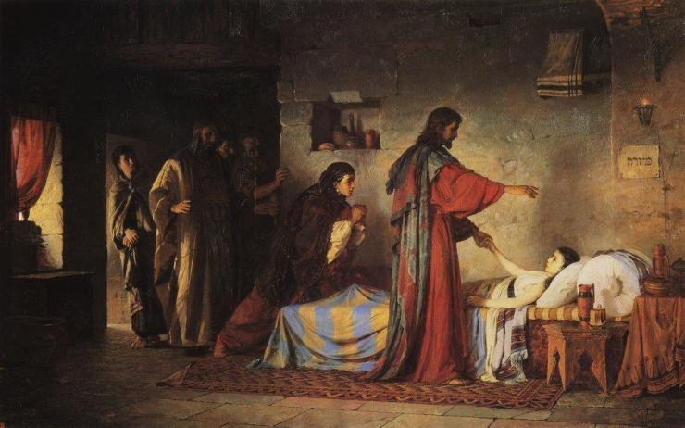‘Do not be afraid; only have faith!’

O God, who through the grace of adoption
chose us to be children of light,
grant, we pray,
that we may not be wrapped in the darkness of error
but always be seen to stand in the bright light of truth.
This week’s readings are full of encouragement. They urge us to live by faith even when we struggle to make sense of life (or, indeed, death). Though we may sometimes find it very challenging to entrust ourselves and others completely to God, ultimately this is what opens the way to new life in him.
The Wisdom author (First Reading) tells us that death – both physical and spiritual – results from Satan’s envy. Death was never part of God’s plan, for we are created for life, and in God’s own likeness.
The psalmist rejoices that God has rescued him from sickness. We, too, are invited to give thanks, trusting in God’s complete care and compassion for each of us. Even if our day ends in sadness, the promise of joy still dawns anew each morning.
St Paul encourages the Corinthians to model themselves on Jesus in their generosity and giving, for they themselves have been given so much. We also should try to keep this balance, trusting God as we consider other’s needs alongside our own riches. (Second Reading)
The Gospel tells of two miracles: the raising of Jairus’s daughter (which we pray today) and the healing of the woman with the haemorrhage. Both are people of great faith, whatever their fears; we see how God’s healing, life-giving power is enabled by their trust.
This week, let us pray that God might increase our own faith each day, helping us to entrust ourselves to him more completely, even when we feel afraid or unsure.

Reminder for everyone aged 40 and over to register for their vaccine We would like to remind everyone aged 50-69 to register for their COVID-19 vaccine through the HSE’s online registration system or on the phone with HSELive We are inviting those aged 50-69 to register from Friday 23 April. However, before we do, we want to remind those aged 60-69 who have yet to register to make sure to register as soon as possible. Everyone in this age group is now eligible to register:
Online registration – information for patients and service users People in this age group who are registering online will need: their Personal Public Service Number (PPSN), their Eircode, an email address or a mobile phone number. A friend or family member can help. If someone is finding it difficult to go online and register or they can ring HSELive for support on 1850 24 1850 or 01 240 8787 from 8am to 8pm, 7 days. If a person doesn’t have a PPSN they can register on the phone with HSElive. Once registered the person will receive their vaccine appointment for the COVID-19 AstraZeneca vaccine. If a person is deaf or hard of hearing, they can text HSELive on 086 1800 661 to register for your vaccination
Covid-19 Collect and Deliver Service: Helping people to stay at home is the new role of Local Link Mayo rural transport services. Local Link Mayo is offering a collect and deliver service in existing Local Link routes throughout Mayo from pharmacies and local shops, delivering shopping and critical medical supplies to the elderly, the vulnerable and sick. If your need of such support or know someone who does, contact Local Link Mayo on 094 900 5150 between 9:00am and 5:00pm (M-F) or email mayo@locallink.ie

Keeping Children Safe: The Diocese of Killala is fully committed to keeping children safe. If you have any concerns around their safety in any circumstance please contact The Diocesan Liaison Person – Confidential No - 087 1003554. (Please see more information on the notice board).

