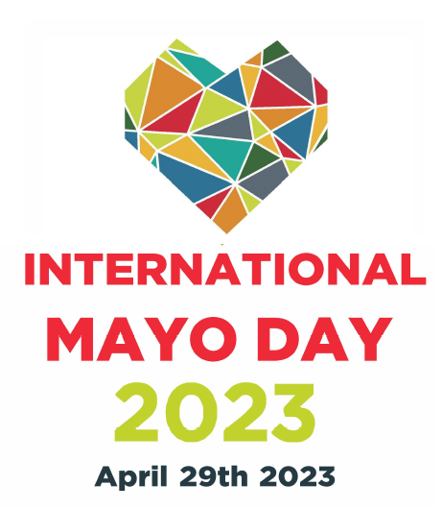

International Mayo Day is aimed at supporting a festival/event which will bring the Mayo Diaspora together to celebrate Mayo Day.

It is a competitive grant process. The fund is limited, and all eligible applications will be evaluated on a competitive basis against the criteria set out in the application.

To be considered for funding, applicants need to demonstrate the following:
- The event / festival will target Mayo Diaspora specifically and use the International Mayo Day Brand to promote the event
- The Event/Festival must be branded using Mayo County Council
- The Mayo theme must be clearly outlined in the event Plan
- The event / festival must generate a minimum of 100 guests
- That the festival/event has a minimum expenditure of €1,000

Apply directly to: communications@mayococo.ie

For general enquiries please contact: Mags Connell at mconnell@mayococo.ie

APPLICATIONS MUST BE RECEIVED BY MAYO COUNTY COUNCIL
BEFORE 5.00PM ON FRIDAY, 31st MARCH, 2023

Section 1: APPLICANT & EVENT / FESTIVAL DETAILS
- Applicant Details
Name of Applicant/Organisation:
Address of Applicant/Organisation:
Applicant legal structure:

- Name and Contact Details of person dealing with application:
Name:
Title:
Correspondence Address:
Email address:
Telephone number
- Festival/Event Details
Name of event/festival:
Dates of event/festival:
Location of event/festival:
Name of company/organisation in ownership of the festival:

Event/festival office address:

Section 2: THE EVENT/FESTIVAL/PARTICIPATIVE EVENT’S APPEAL TO MAYO DISAPORA
The purpose of this section is to give Mayo County Council a strong understanding of (a) your Event/Festival and (b) how it entertains and/or draws County Mayo Diaspora in particular.
- Event/Festival
Tick one category below which best fits your Event/Festival
General
Participative event/festival
Food & Drink
Sports & Outdoors
Education
Other

- About the Event/Festival
Please describe the nature of the festival

- How will the Event/Festival help to celebrate County Mayo’s people, culture, heritage?

Section 3: MARKETING AND DIGITAL CAPABILITY
The purpose of this section is to give details of your marketing plans and to give details of your plans to make the Mayo Diaspora aware of the event/festival digitally.
- How will you promote the Event/Festival?

Section 4: THE ORGANISING & DELIVERY TEAM
The purpose of this section is to give Mayo County Council details of those who will be involved in setting up and delivering the Event/Festival.
- Team & Staffing
Number of Committee/Board Members:
Number of Voluntary Members:
How many volunteers will be engaged during the planning and operation of the festival/event:

Section 5: FINANCIAL DETAILS & FUNDING REQUESTED
The purpose of this section is to establish the actual cost involved in delivering the Event/Festival in 2023.
- EXPENDITURE | Projected Spend 2023

Marketing Costs
Local advertising (Total cost of any Print, Radio, TV or Online advertising)
Design & Print of programmes, brochures, posters, leaflets etc
Public Relations (including PR consultancy, launches, photo calls etc)
Sales Activity
Website Development & Design
Online Marketing including social media
Site branding and signage
Other (please specify)
Total Marketing Costs

Programme& Event Production Costs
Ticketed Events: (e.g. artists/performers fees, travel & subsistence for free events, venue hire & production costs)
Other (please specify)
Total Programme & Event Costs

Marketing
Development
Programme & Event Production
Other (please specify)
Overall Total Expenditure

- INCOME | Projected 2023

Earned Income
Ticket Sales
Other (please specify)
Sponsorship (please specify the funder)
Other (please specify)
Total Income

Accuracy of Information Provided  I/we certify that all information provided in this application, and all information given in any documentation submitted in support of the application is truthful and accurate. | Yes | No
Legal Obligations  I/we have taken steps to ensure that all legal obligations associated with operating the festival/event, including appropriate insurances, have been defined and will be addressed before its commencement. | Yes | No
Freedom of Information

Mayo County Council wishes to advise applicants that, under the Freedom of Information Acts the information supplied in the application form may be made available on request, subject to Mayo County Council’s obligations under law.

You are asked to consider if any of the information supplied by you in this application should not be disclosed because of sensitivity. If this is the case you should, when providing the information, identify same and specify the reasons for its sensitivity. Mayo County Council will consult with you about sensitive information before making a decision on any Freedom of Information request received.

However, if you consider that none of the information supplied by you is sensitive, please complete the statement below to that effect. Such information may be released in response to a Freedom of Information request.

I/we agree that none of the information supplied is sensitive, and any, or all, of the information supplied, may be released in response to a Freedom of Information request. | Yes | No
Two representatives of the organising group have signed the declaration (overleaf) | Yes | No

Declaration of Applicant(s):
We have read and understood the information applicable to the Fund and agree to comply in full therewith. I/we certify that all information provided in this application, and all information given in any documentation submitted in support of the application is truthful and accurate and that I/we have not applied to any other city / county council for funding for this Initiative. More than 1 group member must sign the application.

Signed:

Date:

Name: (in block capitals):

Signed:

Date:

Name: (in block capitals):

On behalf of: (organisation's name):

Apply directly to: communications@mayococo.ie

For general enquiries please contact: Mags Connell, Communications Department, at mconnell@mayococo.ie

APPLICATIONS MUST BE RECEIVED BY MAYO COUNTY COUNCIL
BEFORE 5.00PM ON FRIDAY, 31st MARCH, 2023

