***Offertory Donations:***

Sunday 19th: €645.



Thanks for all your contributions.

**Bohola/Shraheens Newsletter**

**Stephen O’Mahony PP – 094-9384115/086-8226405 –** [**boholaparish@gmail.com**](mailto:boholaparish@gmail.com) **(email for newsletter)**

<https://www.mayo.ie/news/category/connect/parish-news/bohola-parish-news/>

**13th Sunday in Ordinary Time – 26th June 2022**

###### Masses for the Week

|  |  |  |
| --- | --- | --- |
| **Saturday, June 25th.** | **8.00pm Vigil** | **Private Intention.** |
| **Sunday, June 26th.** | **9.30am  *Shraheens***  **11.30am*\* Bohola*** | **For all the People.**  **Willie Moran (100th Anniversary on June 28th) & deceased of the Moran and Evans families.** |
| **Monday, June 27th.** | **10.00am** | **Private Intention.** |
| **Tuesday, June 28th.** |  | **No Mass.** |
| **Wednesday, June 29th.** | **10.00am**  **7.00 – 9.00pm** | **Private Intention………(*Adoration follows until 11.30am)***  **Adoration of the Blessed Sacrament.** |
| **Thursday, June 30th.** | **10.00am** | **Private Intention.** |
| **Friday, July 1st.** | **8.00pm** | **Irene Grady and deceased of Grady & McGuinn families.** |
| **Saturday, July 2nd.** | **8.00pm*\** Vigil** | **Michael & Josephine Manley, their son Tommy & his wife, Maimie, daughter Mary Harte, son Martin and grandson, Dermot.** |
| **Sunday, July 3rd.** | **9.30am  *Shraheens***  **11.30am*\* Bohola*** | **For all the People.**  **Mary Lavin Dunleavy, Altinea.** |
| ***The 11.30am Sunday Mass will be live-streamed on the Bohola Post Facebook Page every Sunday.***  ***Any other Masses are put online when requested. (Marked with * above)***  ***All Bohola Masses will be broadcast on the 105.5 FM Radio channel.*** | | |

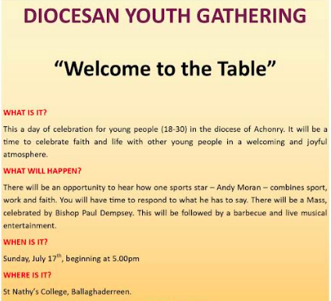

***Youth Gathering on July 17th in St Nathy’s College:*** See details in the panel to the left. Further details can be found at this link: [*https://achonrydiocese.org/youthministry*](https://achonrydiocese.org/youthministry).

There are links to other proposed events as well. You can register on *Eventbrite* or by scanning the QR code below.



***Priesthood in Achonry Diocese:*** The Lord asked his disciples to "Pray the Lord of the harvest to send labourers into his harvest" (Mt 9:38; Lk 10:2). Have you the courage to respond to God’s call? Contact our Vocations Director, **Fr Paul Kivlehan, The Presbytery, Ballaghaderreen, Co. Roscommon. Tel. *094-9860011*, Mobile *087-3683535*, E-mail** [***pkivlehan@achonrydiocese.org***](mailto:pkivlehan@achonrydiocese.org)or contact any local priest for more information.

***St. Vincent de Paul Urgently Requires Volunteers*** to assist in their shops in Ballina - Donation sorters, Till Operators, Merchandisers, Shop Floor Assistants and Social Media assistants. Contact Peter on *085-8759460* or *096-72905*.

***Sixth Class Graduation:*** On Thursday night last, the Sixth Class of Bohola National School (Megan Byrne, Chloe Colgan, Killian Commons, Ciara Conlon, James Duffy, Tom Gostick, Lauren Hale, Wayne Ivers, Leah MacNicholas, Ava McDonnell, Sean Moran, Killian Mulderrig, Ruby O’Brien, Harry Reddington, Joseph Shehu and Jason Walsh) celebrated their end of school Mass with their families and school staff. We thank them for all they contributed to the life of the school over the last eight years and as they move on to pastures new, we wish them every success and blessing in the years ahead. And we wish the staff and all pupils a fun, restful and well deserved Summer break.

***Up Mayo!*** By the time you are reading this (not during Mass of course!) we hope that the Mayo Minor team will have qualified for the All-Ireland final and our good wishes go with the senior ladies team v Dublin this Saturday evening and the men’s senior team who take on Kerry this Sunday in Croke Park.

***Moy Davitts 50/50 Draw:*** Congratulations to John Foy who won a jackpot of €395 in the Moy Davitts 50/50 draw last Saturday. A huge thank you to everyone who supported last week's draw, it is greatly appreciated. Tickets are available in the usual retail outlets and by clicking [*https://smartlotto.ie/Bohola-moy-davitts*](https://l.facebook.com/l.php?u=https%3A%2F%2Fsmartlotto.ie%2FBohola-moy-davitts%3Ffbclid%3DIwAR2-SMSQVJnLPM1gbMk8VYcVq5QSNWsE5b18UD-SHwPhuifGrX08SNDlJc8&h=AT0MiLZlj4q4DBPOl03vVXSokuVERXZawyK8tGPOdkMD6iUtbbGAIDrP1wUMXoHHwBpf8OCfEYLll7lUaWyYzni7elqLyyDX1hxrkiRT4iLddt75pWrUPCYemDN43SvOspaI&__tn__=-UK-R&c%5b0%5d=AT1bnP92vRmesJAH-zh16Oyc956taFyWxM0_3VLfj4QSf9SmpZw5cpQ61Vc5tvJdChYPj7SPty0LDMmT-1CuL0y1Dj6Ia-SpXR1Lif8cNpBMb3zmcNd83NlOLtCy4LEd6sxibGw9D72uG7DGqfgmtrvFR5ZcIPXTwnc_aJIQcIYHHlU6GWM4y_sHX7uH).

***Offertory Envelopes*** for the year beginning next Sunday, July 3rd are available in the church. There are plenty of spare boxes if anybody wishes to be added to the list.

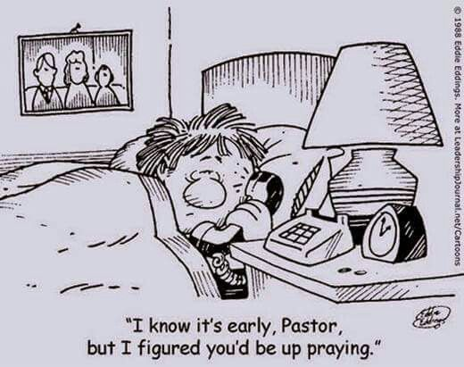

***New Pilgrim Path Website of the Week, June 26th:*** *Learning how to see our Biases….* Jesus came into the world ‘that those who do not see will see’. Self-awareness is a requirement in order to see differently. In a series of six short reflections entitled “Learning How to See”, Franciscan writer and teacher, Richard Rohr, identifies many different types of bias which we can possess without knowing it.

He begins with ‘confirmation bias’, in which “we judge new ideas based on the ease with which they fit in with and confirm the only standard we have: old ideas, old information, and trusted authorities.” As a result, we tend to exclude anything that “doesn’t fit”. Another bias is ‘complexity bias’ in which “our brains prefer a simple falsehood to a complex truth”. Yet another is ‘contact bias’, wherein “a lack of personal and ongoing contact with people who are different from us causes us to fail to see them for who they truly are”. Access these valuable reflections here: [***www.newpilgrimpath.ie***](http://www.newpilgrimpath.ie).

***Interested in the Synodal Process?*** In building hope in our Church and for our World? Why not consider a postgraduate course in theology? The Loyola Institute of Theology at Trinity College will challenge, form and inform you. Now is the time to take the opportunity to become a more informed member of our Christian community. Check out our website for details of courses available and for scholarships offered: [*https://www.tcd.ie/loyola-institute/*](https://www.tcd.ie/loyola-institute/). If you would like to discuss possibilities please email Fáinche Ryan at [*faryan@tcd.ie*](mailto:faryan@tcd.ie) or [*kirwanm6@tcd.ie*](mailto:kirwanm6@tcd.ie).

***Anam Cara Mayo***, the organisation that supports bereaved parents, is holding a Parent Evening on Tuesday, 28th June at 7.15pm in the TF Royal Hotel, Castlebar. This event is free and open to all bereaved parents regardless of the age your child died, the circumstances of their death, or whether their death was recent or not. We now also offer an online support service. Please contact us on [*info@anamcara.ie*](mailto:info@anamcara.ie) or *085-2888888* for any queries. For more information see [*anamcara.ie*](http://anamcara.ie/).

***Knock Market @ the Plaza*** takes place next Sunday, June 26th from 10.00am to 3.00pm. A wonderful day in store for all the family with lots of beautifully hand-crafted gifts made by local crafters from the west of Ireland. Adjacent to Knock Shrine, wheelchair accessible, car park and toilet facilities close by along with great shops and restaurants. Market @ the Plaza takes place on the last Sunday of each month. We look forward to seeing you in Knock.

If you would like to take part in our market, please contact Leonie on *086-8486924* or email [*leoniekilroy@gmail.com*](mailto:leoniekilroy@gmail.com). Follow our Facebook page *@ Knock Market & Events*.

***Home Instead*** provides Home Help to the elderly in their homes safely and happily. They are actively recruiting Caregivers throughout Co Mayo but particularly in the following locations: Louisburgh, Westport, Swinford, Ballinrobe, Cong, Shrule, Kilmaine, Ballyhaunis, Ballina, Castlebar, Knock, Kiltimagh, Foxford, Knockmore, Partry, Ballintubber, Belmullet, Kincon, Crossmolina and Killala.

For further information please email [*info.mayo@homeinstead.ie*](mailto:info.mayo@homeinstead.ie) or phone the office on *094-9044785***.**

***Mayo Tutorial School Irish Course:*** Leaving Certificate Irish preparatory & revision courses in Gaelscoil Raifteirí, Castlebar from 25th to 29th July. Call *087-1179280* or email [*mayotutorialschool@gmail.com*](mailto:mayotutorialschool@gmail.com) for more information.

***Mayo Cancer Support*** provides FREE support services to those affected by cancer. Call *(094) 9038407*.

***GROW Meetings:*** GROW is a self-help group helping people suffering from depression, stress, anxiety, panic attacks, loneliness, shyness etc. Meetings are held every Tuesday night at 8.00pm in Ballina Community Centre. All welcome.

***North West STOP*** offers a *free counselling* service with no waiting lists. Call or text *086-7772009* to arrange an appointment.

***I don’t know who needs to know this***

***but even if a bear wears socks and shoes, he still has bear feet!***