***Offertory Donations:***

This Week: €365.



Thanks for all your contributions.

**Bohola/Shraheens Newsletter**

**Stephen O’Mahony PP – 094-9384115/086-8226405 –** [**boholaparish@gmail.com**](mailto:boholaparish@gmail.com) **(email for newsletter)**

<https://www.mayo.ie/news/category/connect/parish-news/bohola-parish-news/>

**The Ascension of the Lord – 16th May 2021**

###### Masses for the Week

|  |  |  |
| --- | --- | --- |
| **Saturday, May 15th.** | **8.00pm Vigil** | **Private Intention.** |
| **Sunday, May 16th.** | **9.30am**  **11.30am** | **James & Mary Hall, Knockatemple.**  **For all the People.** |
| **Wednesday, May 19th.** | **10.00am**  **7.00 – 9.00pm** | **Private Intention.**  **Exposition of the Blessed Sacrament (private prayer).** |
| **Friday, May 21st.** | **8.00pm** | **Private Intention.** |
| ***Mass will be celebrated privately on other weekdays.*** | | |
| **Saturday, May 22nd.** | **8.00pm** | **Private Intention.** |
| **Sunday, May 23rd.** | **9.30am**  **11.30am** | **For all the People.**  **Fred Conlon & Bridie Commons, Listrisnane & James Commons.** |
| ***The 9.30am Sunday Mass will be live-streamed on the Bohola Post Facebook Page every Sunday.***  ***Any other Mass will be put online if requested.***  ***All Masses will be broadcast on the 105.5 FM Radio channel.*** | | |

***Welcome Back Again!***

*On Wednesday last, Mass was open to the public for the first time since Christmas Day. It was great to be able to welcome a ‘live’ congregation again and a further very warm welcome back to those returning this weekend for the first time since Christmas or before.*

*We are re-opening with greater optimism than after the previous two lockdowns mainly due to the much welcomed roll out of vaccines. However, we must remember that we are still operating in compliance with all public health advice and guidelines and under the consequent ongoing restrictions. You will be familiar with all of these by now but they can be checked out on last week’s newsletter or on our diocesan website at* [*https://achonrydiocese.org/return-to-public-worship/*](https://achonrydiocese.org/return-to-public-worship/)*.*

*Renewed thanks to all our stewards and cleaners who make possible the safe return to public worship. And thanks to everyone for your ongoing patience, understanding and co-operation.*

*Once again, you are most welcome back and we go forward with the fervent wish that the only time church doors will be locked in future will be at the close of day.*

***Recent Death:*** Please pray for the happy repose of the soul of *Angela Murtagh*, Maynooth, Co Kildare, wife of Michael Murtagh, formerly of Carracastle, who died on Thursday last, May 13th and whose funeral takes place tomorrow, Monday, in Maynooth. May she rest in peace.

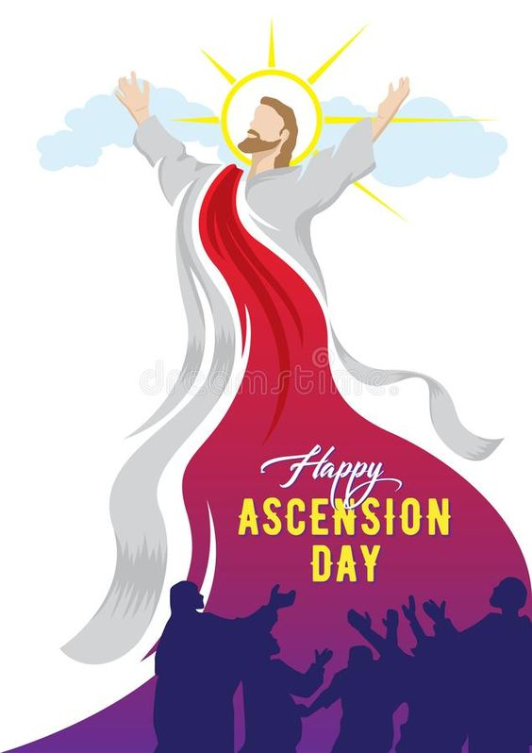

***The Achonry, Clonfert and Galway Virtual Pilgrimage to Knock Basilica*** takes place on this Sunday, May 16th. The pilgrimage season traditionally begins at Knock Shrine on the last weekend of April. This year, weekend pilgrimages will continue to be held virtually on Sunday afternoons. Ceremonies will be streamed live from Knock Basilica and will commence with Rosary at 2.30pm followed by Mass at 3pm.

Live stream will be available on *http://www.knockshrine.ie/watch-live*, the Knock Shrine Facebook page and on their YouTube channel. You are invited to join online from the comfort of home. You may like to include your [*prayer intentions*](http://www.knockshrine.ie/place-petition) in the Mass, to [*light a candle*](http://www.knockshrine.ie/light-a-candle) at Knock Shrine on the day or to remember someone special with an [*annual enrolment*](http://www.knockshrine.ie/mass-enrolment) in the Knock Shrine Friends Association. All of these services are available online on their website.

***COVID-19 Support Line for Older People:***Professional staff are available to answer queries and give advice and reassurance where necessary. The support line is open seven days a week, 8am to 8pm. The contact number is ***0818-222024***.

***New Pilgrim Path Website of the Week, May 16th:*** *An Ecological Examen*… The 500-year old Ignatian Examen is a daily prayer of review - a short reflection back over the day, recalling events and taking note of your feelings. The purpose is to discern the ways in which God has been present to you, the times when the Holy Spirit was drawing you towards life. May 16th to 24th this year celebrates the 6th anniversary of the publication of ‘Laudato Si’, Pope Francis’ powerful call for care for our common home. To mark it, the Jesuits have developed a special ‘ecological examen’ to help individuals and communities undergo a conversion of heart to embrace ecological justice. This inspiring self-guided resource can be accessed at: [***www.newpilgrimpath.ie***](http://www.newpilgrimpath.ie).

***Priesthood in Achonry Diocese:*** Seventh Sunday of Easter — May 16, 2021 – Ascension of the Lord …. *“Go out to the whole world; proclaim the Good News to all creation.”* May Christ be asking you to discern a vocation to proclaim the Gospel as a priest or consecrated religious? Speak to your local priest, call your Diocesan Vocation’s Director or email the National Vocations Office on *info@vocations.ie*. For further information contact our Vocations Director, **Fr Paul Kivlehan, The Presbytery, Ballaghaderreen, Co. Roscommon. Tel.094-9860011, Mobile 087-3683535, E-mail** [***pkivlehan@achonrydiocese.org***](mailto:pkivlehan@achonrydiocese.org).

***Moy Davitts 50/50 Draw:*** Congratulations to Joyce McMahon, Foxford on winning €311 in the Moy Davitts 50/50 draw last Saturday morning. . A huge thank you to everyone who supported last week's draw, it is greatly appreciated. Tickets are available in the usual retail outlets and by clicking [*https://smartlotto.ie/Bohola-moy-davitts*](https://l.facebook.com/l.php?u=https%3A%2F%2Fsmartlotto.ie%2FBohola-moy-davitts%3Ffbclid%3DIwAR2-SMSQVJnLPM1gbMk8VYcVq5QSNWsE5b18UD-SHwPhuifGrX08SNDlJc8&h=AT0MiLZlj4q4DBPOl03vVXSokuVERXZawyK8tGPOdkMD6iUtbbGAIDrP1wUMXoHHwBpf8OCfEYLll7lUaWyYzni7elqLyyDX1hxrkiRT4iLddt75pWrUPCYemDN43SvOspaI&__tn__=-UK-R&c%5b0%5d=AT1bnP92vRmesJAH-zh16Oyc956taFyWxM0_3VLfj4QSf9SmpZw5cpQ61Vc5tvJdChYPj7SPty0LDMmT-1CuL0y1Dj6Ia-SpXR1Lif8cNpBMb3zmcNd83NlOLtCy4LEd6sxibGw9D72uG7DGqfgmtrvFR5ZcIPXTwnc_aJIQcIYHHlU6GWM4y_sHX7uH).

***Rural Social Scheme Vacancies:*** There are currently vacancies on the Rural Social Scheme in the Kiltimagh / Bohola / Midfield area. The Rural Social Scheme provides a supplementary income for low-income farmers and fishermen/women.

*To participate in the scheme*, you must be: 25 years or over and getting Farm Assist ***or*** if you are actively farming or fishing (this means that you must meet the criteria set out below), you may qualify for the scheme if you are also getting one of the following social welfare payments: [Jobseeker's Allowance](http://www.welfare.ie/en/Pages/1057_Jobseekers-Allowance.aspx); Jobseekers transitional payment; [Disability Allowance](http://www.welfare.ie/en/Pages/da.aspx); [One-Parent Family Payment](http://www.welfare.ie/en/Pages/278_One-Parent-Family-Payment.aspx); [Widow's, Widower's or Surviving Civil Partner's Contributory Pension](http://www.welfare.ie/en/Pages/Widowers-Pension-Contributory.aspx) or Widow's, Widower's or Surviving Civil Partner's Non-Contributory Pension; Increase for a Qualified Adult under 66 years of age as part of your spouse, cohabitant or civil partner's [State Pension (Non-Contributory)](http://www.welfare.ie/en/Pages/248_State-Pension-Non-Contributory.aspx).

If you are eligible but do not wish to participate in the RSS, your dependent spouse, civil partner or cohabitant can take the available place. Please contact Caroline on *087-2107385* for further information.

***Living Well*** is a free online group programme delivered over six workshops (2.5 hrs x 6). It is delivered by trained leaders, most of whom are also living with a long-term health condition. You will develop self-management skills and confidence to live well with your health conditions.*Next programmes commence on Tuesday, 18th May and Wednesday, 26th May.*

You must register in advance as places are limited to 10/12 participants. Please note you do not have to disclose your health condition on the programme. Please contact Liam Gildea on *087-3490393* or by email at [*liam.gildea@mayocil.ie*](mailto:liam.gildea@mayocil.ie)*.* Please see the following link for more information about the course: [www.hse.ie/livingwell](http://www.hse.ie/livingwell).

***Covid-19 Collect and Deliver Service:*** Local Link Mayo is offering a collect and deliver service in existing Local Link routes throughout Mayo from pharmacies and local shops, delivering shopping and critical medical supplies to the elderly, the vulnerable and sick. If you need such support or know someone who does, contact Local Link Mayo on ***094-9005150*** between 9:00am and 5:00pm (M-F) or email [*mayo@locallink.ie*](mailto:mayo@locallink.ie).

P

Returning to Church

*A member of the church, who previously had been attending services regularly, stopped going. After a few weeks, the pastor decided to visit him. It was a chilly evening. The pastor found the man at home alone, sitting before a blazing fire. Guessing the reason for his pastor's visit, the man welcomed him, led him to a comfortable chair near the fireplace and waited. The pastor made himself at home but said nothing. In the grave silence, he contemplated the dance of the flames around the burning logs. After some minutes, the pastor took the fire tongs, carefully picked up a brightly burning ember and placed it to one side of the hearth all alone. Then he sat back in his chair, still silent. The host watched all this in quiet contemplation. As the one lone ember's flame flickered and diminished, there was a momentary glow and then its fire was no more. Soon it was cold and dead. Not a word had been spoken since the initial greeting. The pastor glanced at his watch and realized it was time to leave. He slowly stood up, picked up the cold, dead ember and placed it back in the middle of the fire. Immediately it began to glow, once more with the light and warmth of the burning coals around it. As the pastor reached the door to leave, his host said with a tear running down his cheek: 'Thank you so much for your visit and especially for the fiery sermon. I will be back in church next Sunday.'*

*We live in a world today, which tries to say too much with too little. Consequently, few listen. Sometimes the best sermons are the ones left unspoken.*

***Wearing a mask while alone in a car***

***is only helpful if you stole the car!***