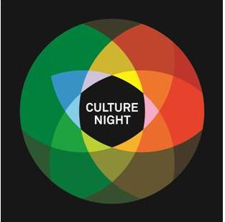
Mayo County Council’s Culture Night Listing and Event Fund
Application Form 2022
Events must take place in County Mayo on Culture Night (Friday September 23rd) and be free of charge.

EVENT LISTING
PART 1 – YOUR GROUP
The details provided must be for the general public to contact you group and will be used for the www.culturenight.ie listing.

Name of Group
Name & Address of venue, outdoor events only.

If online, what platform are you planning to use:

Contact Number for group:
Email address for group:
Website:
Please also supply
- Your Logo (if available)
- Two high resolution Images (for publicity purposes)

PART 2 - YOUR EVENT
This information will be used for the www.culturenight.ie listing.

Event Description
Name of the event
*Time of this event
Is booking required? Please provide details.
*Short description of the event

Name and contact number of a personality, performer or programme participant who could do an interesting interview about Culture Night in your area if required
Potential interviewee
Contact number
*Priority will be given to:
- events that support diversity
- events that ensure late night offerings become a feature of Culture Night in Mayo

EVENT FUNDING
PART 3 – YOUR BUDGET
Please ensure that you have read the Terms and Conditions of the fund.
Some events may not require funding. If there are costs involved in delivering your event, please provide details below.
Applying for funding does not guarantee that your event will be funded.
Events that do not require/receive funding may still be listed on www.culturenight.ie
Please note that the maximum grant available is €500. Smaller amounts can also be applied for.
Please indicate if your event requires funding: Yes No
Expenditure  (for this event only) | Total Cost | Total Requested from Mayo County Council

Total Cost of Event ________________
Please list any additional sources of Support/Income/Funding ________________
Total Requested from Mayo County Council ________________

PART 5 – DECLARATION
Please tick to confirm that you have read the terms and condition and sign.
I/We, the Undersigned, have read and accept Mayo County Council’s Culture Night Event Fund Terms and Conditions.
I/ We declare that the details contained in this application are true and correct to the best of our knowledge and we have the authority to commit to the above conditions.
Name:
Position:
Signature:
Date:
Applications should be made on the official application form and emailed to mayoculturenight@mayococo.ie with the name of your group in the subject line.

For further information please contact:
Orlagh Heverin
Mayo Culture Night Co-ordinator, Mayo County Council.
+353 (0) 94 9064367 | mayoculturenight@mayococo.ie

Deadline for applications – 5pm on Monday 18th July 2022

Culture Night is strategically funded by Mayo County Council and the Arts Council and is supported by Creative Ireland and participating groups & venues in Mayo.
Media Sponsor is Midwest Radio.

