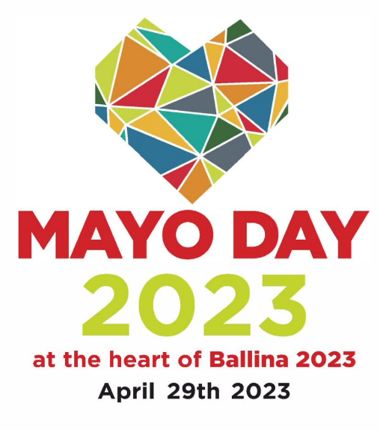  Saturday April 29th 2023  MAYO DAY FOOD VILLAGE  Ballina  Co Mayo  12 noon – 6pm  YOU ARE APPLYING FOR:  - the selection process for an opportunity to sell and/or promote your produce to those attending Mayo Day 2023 in Ballina Town between 12 noon and 6pm on Saturday, April 29th 2023 in a  - 1 No. 2m x 2m food retail space in a covered marquee or gazebo, and  - up to 1 No. table and 2 No. chairs  The final selection of participating food retailers is at the discretion of the event organisers  If you have any questions about this, please email communications@mayococo.ie  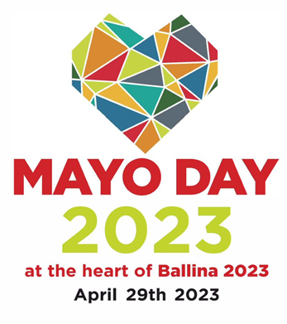 | FOOD RETAIL/PROMOTION STAND APPLICATION FORM
 | Company Name:
 | Contact Name:
 | Address:
 | Telephone Number:
 | Mobile Number:
 | Website Address:
 | Description of Produce (please attach photographs):
 | Facebook (for business):
 | Twitter (for business):
 | Instagram (for business):
 | All participants must be registered as a food business operator with the Health Service Executive. Applications received without the following attachments will not be considered:
 | HSE Registration Letter of Approval attached: | YES |  |  |  | NO
 | Completed HSE Questionnaire attached: | YES |  |  |  | NO
 | EACH EXHIBITOR MAY REQUEST A TABLE AND UP TO TWO CHAIRS. PLEASE INDICATE YOUR REQUIREMENTS BELOW: Please note that requests not indicated below cannot be facilitated on the event day.
 | 1 table | YES |  |  |  | NO
 | Number of chairs | NONE |  |  | ONE |  | TWO
PLEASE LIST ALL ELECTRICAL APPLIANCES TO BE USED AT YOUR STAND, INCLUDING AMPAGE AND WATTAGE FOR EACH. The use of Electrical Appliances not listed here will not be possible. We cannot provide extension leads, please bring your own.

The use of gas or other solid fuel appliances (including but not limited to barbecues) within Food Marquees/Gazebos will not be permitted.
 | How has County Mayo inspired your work/produce?
 | Are you willing to taking part in the promotional campaign in advance of Mayo Day 2023? | YES |  |  |  | NO
 | I wish to apply for selection to participate in Mayo Day 2023 and agree to fully comply with the terms and conditions listed on Page 3 and Page 4 of this application.
 | Signed:
 | Date:

TERMS AND CONDITIONS
- Evidence of your Health Service Executive Registration and Approval must be submitted with your fully completed application form. A fully completed HSE Questionnaire must also be returned with the application form. Applications received without these documents cannot be considered.
- You agree to adhere to the HSE’s General Guidelines for Foodstalls. The HSE Questionnaire and HSE General Guidelines for Footstalls are available at https://www.mayo.ie/MayoDay2023/Apply/Food.
- Producers must have a product for sale at the event (i.e. promotion-only stalls will not be considered except in the case of Brewery/Distillery Applications).
- Food products must be artisan, made by your food business and of a high quality in terms of taste and presentation.
- Photographs of products must be provided with application.
- Spot checks of production premises may be carried out at the discretion of the organisers.
- Evidence of public liability insurance must be submitted with your application form. An insurance broker’s letter will not suffice.
- The selection of applicants for a selling space in the Food Marquee is at the discretion of the Mayo Day 2023 event organisers.
- Each participant shall be fully set up by 10.30am on the event day. Stands may not be dismantled before 5.30pm that evening.
- While public car parking will be available adjacent to the Food Village, please be aware that traffic movements may be restricted between 10am and 6pm on the event day. Participants must adhere to the instructions of event stewards at all times.
- The allocation of stands within the Food Village is at the discretion of the organisers.
- All stands/allocated areas must be finished to a high standard in terms of decoration and presentation and kept neat and tidy always. Special consideration should be given to creatively including the Mayo Day 2023 Brand. Participants must provide their own table covers.
- Approved retail spaces will be in a covered Marquee or Gazebo. All retailers will be supplied with a 2m x 2m space and, if requested on this application form, 1 table and up to 2 chairs. Please note that new requests for furniture on the day of the event will not be facilitated.
- Adequate electrical supply will be provided. Applicants are required to provide a list of all electrical appliances (including lights, laptops, mobile phones, etc) together with ampage and wattage specs for each appliance on the application form. Items not included for on this application form cannot be plugged in during the event. The provision of extension reels is the responsibility of participants. The use of gas or other solid fuel appliances (including but not limited to barbecues) within Food Marquees or Gazebos will not be permitted.
- A potable water source will be provided for the refilling of containers as will an approved facility for disposal of wastewater.
- Exhibitors are responsible for litter control around their stands. Applicants are requested to sign up to the Mayo Day 2023 Green Event Charter for Stallholders. The Mayo Day 2023 Green Event Charter for Stallholders is available at https://www.mayo.ie/MayoDay2023/Apply/Food.
- With the exception of Guide/Assistance Dogs, animals are not permitted in the Food Marquee.

If you have any questions about this, please contact communications@mayococo.ie

Please scan and email your completed application form, with the required HSE documentation, to:

communications@MayoCoCo.ie

Before Friday, March 24th 2023

While we’d prefer email applications, postal applications can be submitted to the Communications Department, Mayo County Council, Áras an Chontae, The Mall, Castlebar, Co Mayo to arrive no later than Friday, March 24th 2023.

