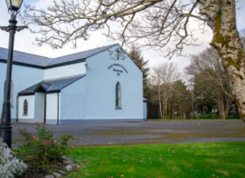 | Church of the Holy Family, Ballycroy  Mass Centre - National School - Innisbiggle  Christopher J. Ginnelly  (098) 49 134 (086) 89 33 278  ballycroyparish@gmail.com  James M Cribben, Geesala (087) 64 69 016  1st Oct - 8th October 2021  www.ballycroyparish.ie
The Year of St. Joseph 2021
Mass at 11am will be Broadcast on our Facebook Page The outside speaker will be in operation if you wish to listen to the mass on the grounds. Special Thanks to Cathy / Nora for operating the live broadcast on Facebook and to Shelly for the beautiful selection of music and hymns.

27th Sunday in Ordinary Time
Sat 8pm Patrick Keane, 1st Ann (Peterborough – Gortbreac)
Sun 11am Dec’d Conway – McManamon Families
Sun 12.15pm Bangor Church

Priests on Retreat: Emergency calls only.
Mon to Fri: Fr. Joe Hogan (Cornboy) on calls 086 0734860

28th Sunday in Ordinary Time
Sat 8pm 1. Michael (21st Ann), Teresa Conway (Tallagh)
2. James, Maureen Grealis (Ballygaravan)

Sun 11am 1. David Gildea, 7th Ann (Newport/Ballycroy)
2. Peter Sweeney (5th Ann) Doona
Sun 5pm St Muredach’s Cathedral Ballina Chrism – Jubilee Mass

Sincere thanks for the Harvest Collection. Please leave your envelope (Green envelope) in the church. Sincere thanks for your contributions to Fr. Chris.
Our Beloved Dead Please pray for the Faithful Departed; Josie Groarke, nee Doran (Swinford), Sister of Christy Doran (Aughness). May her Soul Rest in Peace.

 | Readers | Eucharistic Ministers
Sat 9nd Oct: 8pm | Family | Marian Masterson
Sun 3rd Oct: 11am | Family | Bernie Hough
Sat 9th Oct: 8pm | Family | Noreen Gaealis
Sun 10th Oct: 11am | Family | Mary Sweeney
The World Synod of Bishops in Rome and a National Synod. Pope Francis is planning a world Synod of bishops and people to take place in Rome in 2024. He has requested all Bishops of the world to prepare their people for this Synod. In Ireland, the bishops are preparing for a National Synod in Dublin in 2023. The preparation begins now. Bishop Fleming in our diocese will launch the Synodal Pathway on Sunday the 17th October at 3pm in the Newman Institute in Ballina. Two members of the Pastoral Council and Fr. Chris will represent our Parish. The other 21 parishes will also be represented.
Please take a copy of the Ballycroy National Park – Change of Name Campaign
Guidelines for your safe return to the Church. (Please study carefully)
Masks will still be required and hands sanitised before entry.
A box near the main door is provided for your church collections. No offertory collection. A second steward will direct you to the available seat. There will be no movement within the Church from entering to exiting in order to minimise risk. Holy Communion will be distributed on the hand only at the end of mass. When you receive communion you will exit the church through the side doors. All masses are to be booked by telephone only. Sacristy available only to Fr. Chris.
Sanitising the Church. Next Friday, Glan Assured will take care of the church. Bernie S and Group B will take care of the church the following week. If you are free Friday week at 7.30pm Friday, you are very welcome to come and help.
Congratulations to Scoil Naomh Bhríde for winning the SFI Discovery Science and Maths award. The children have engaged extensively with Science Technology Engineering and Maths (STEM) and earned the highest accolade/award the Primary Science Plaque. Congratulations to the children and Staff.
A new Ballycroy Tidy Towns group has recently been established. They are seeking new volunteers that can help work on various projects across the parish, no previous experience is required. They would also welcome ideas from everyone about new projects or initiatives that can be undertaken in Ballycroy in 2022. To get involved, please contact Matthew on 087 9492583, email ballycroytidytowns@outlook.com or message the Ballycroy Tidy Towns page on Facebook.
TFI Local-Link-Mayo services are operating at 100% capacity but Pre booking is recommended. Remember you can travel to Castlebar and Belmullet return, twice daily. Contact 094 900 5150 or https://locallinkmayo.ie/time-table
The Naíonra is having a Clothing Collection on the 12th October. The items we can take :- Rewearable clothing, Paired Shoes, Handbags, Belts, Towels, Curtains and Blankets. NO DUVETS OR PILLOWS. Please put bags in the first brown wooden shed.
Please contact Grace if you have a query 086 3573650.
Keeping Children Safe: The Diocese of Killala is fully committed to keeping children safe. If you have any concerns around their safety in any circumstance please contact;
The Diocesan Liaison Person – Confidential No - 087 1003554. (Please see more information on the notice board).
Supplementary Pages for Online:
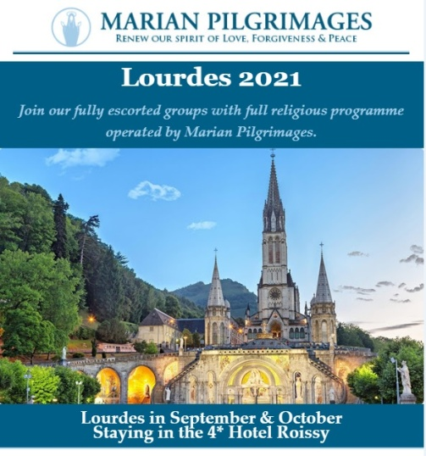

- Free online Living Well Programme – next programmes commences on (Limited places) Thursday 9th of September
- Monday 13th of September
- Tuesday 21st of September
- Wednesday 29th of September
If you are living with a long term heath condition you may be interested in doing the ‘Living Well’ Programme’. This is a six week programme delivered in 2.5 hour weekly. You must register in advance as places are limited to 10/12 participants. Please contact Liam Gildea on 087 349 0393 or by email at liam.gildea@mayocil.ie
Reminder for everyone to register for their vaccine We would like to remind all to register for their COVID-19 vaccine through the HSE’s online registration system or on the phone with HSELive Everyone in is now eligible to register:
A Chance of a Fortune!
Have you an interest in working with people with a learning disability and / or autism??
Western Care Association are recruiting Relief Staff to work in our Services based across Co. Mayo. For further information please visit our website at www.westerncare.com or email hr@westerncare.com

For Mental Health Week, North West STOP invites you to 3 events to get this msg out: it's OK not to be OK & it's absolutely OK to ask for help.
ODD SOCKS DAY 7th October (or between 3rd-10th)
Last year this raised over €10,500 and paid for our Free Counselling Service during Oct, Nov & early Dec. Join in and share with friends / colleagues to make it a success in 2021. For a Fundraising Pack: E: oddsocks4stop@gmail.com or Ph: 071 985 6070.
ANNUAL GENERAL MEETING 14th October, 7.30pm, The Glens Centre, New Line, Manorhamilton. Please confirm your attendance by 7th October if you wish to be included in the minutes. Ph: 071 985 6070
MEMORIAL WALK 15th October, 7pm, Castle Carpark, Manorhamilton. All are welcome to join us in remembering members of our community whom we have cherished and lost. Please dress up warm & wear comfortable shoes.
PREVAILING COVID-19 GUIDELINES WILL APPLY TO ALL IN-PERSON EVENTS.
FREE COUNSELLING AVAILABLE: PHONE / TEXT 086 777 2009.

Western Care Association’s Annual Door To Door Collection is now taking place during the month of September. To donate, find us on Facebook "Western Care Association" or on www.idonate.ie/wcadoor or find the link on our website (www.westerncare.com) and make your donation. If you would like to donate in any other way, (Cheque, Postal Order or Bank Transfer) we would be very happy to talk to you. Please contact Teresa Ward on 094 90 29174 or 087 246 7857 or email: tward@westerncare.com. Your support is greatly appreciated.

Reminder for everyone to register for their vaccine We would like to remind all to register for their COVID-19 vaccine through the HSE’s online registration system or on the phone with HSELive Everyone in is now eligible to register: If someone is finding it difficult to go online and register or they can ring HSELive for support on 1850 24 1850 or 01 240 8787 from 8am to 8pm, 7 days. If a person doesn’t have a PPSN they can register on the phone with HSElive. Once registered the person will receive their vaccine appointment for the COVID-19 AstraZeneca vaccine. If a person is deaf or hard of hearing, they can text HSELive on 086 1800 661 to register for your vaccination
Free Training! Enrolling Now: If you struggled at school, have been long term unemployed, are recovering from or living with an illness or would benefit from extra support, the National Learning Network could be for you. We offer the expertise and time to enable people to flourish. QQI courses include: IT & Business Skills (home and centre based), Sports and Gym Instructor Studies, Fast Track to Employment and more. If you are registered with the DEASP you could be entitled to the free training, Continuous enrolment, payments are protected and people under 26 could gain extra training allowance. Contact: Castlebar@nln.ie; (094) 9022770; Breaffy Road, Castlebar, or see our website www.nln.ie.

Covid-19 Collect and Deliver Service: Helping people to stay at home is the new role of Local Link Mayo rural transport services. Local Link Mayo is offering a collect and deliver service in existing Local Link routes throughout Mayo from pharmacies and local shops, delivering shopping and critical medical supplies to the elderly, the vulnerable and sick. If your need of such support or know someone who does, contact Local Link Mayo on 094 900 5150 between 9:00am and 5:00pm (M-F) or email mayo@locallink.ie
Keeping Children Safe: The Diocese of Killala is fully committed to keeping children safe. If you have any concerns around their safety in any circumstance please contact The Diocesan Liaison Person – Confidential No - 087 1003554. (Please see more information on the notice board).

