***Offertory Donations***

***Weekend 24th/25th:***



*Bohola:*

€795.

*Straide:*

Envelopes - €221.40.

Loose – €39.81.

Restoration Fund - €30.

*Thanks for all*

*your contributions.*

**Bohola/Straide****/Shraheens Newsletter**

**Stephen O’Mahony PP/Adm – 094-9384115/086-8226405 –** [**boholaparish@gmail.com**](mailto:boholaparish@gmail.com) **(email for newsletter)**

<https://www.mayo.ie/news/category/connect/parish-news/bohola-parish-news/>

**27th Sunday in Ordinary Time – 2nd October 2022**

###### Masses for the Week

|  |  |  |
| --- | --- | --- |
| **Saturday, October 1st.** | **8.00pm*\** Vigil *Bohola*** | **For all the People.** |
| **Sunday, October 2nd.** | **9.30am  *Shraheens***  **11.00am  *Straide*** | **Private Intention.**  **Josie (Josephine) Mooney, Aughaward (4th Anniversary).** |
| **Monday, October 3rd.** | **10.00am *Straide*** | **Private Intention.** |
| **Tuesday, October 4th.** |  | **No Mass.** |
| **Wednesday, October 5th.** | **10.00am**  **7.00 – 9.00pm** | **Special Intention………(*Adoration follows until 11.30am)***  **Adoration of the Blessed Sacrament.** |
| **Thursday, October 6th.** | **10.00am *Straide*** | **Private Intention.** |
| **Friday, October 7th.** | **7.00pm** | **Private Intention.** |
| **Saturday, October 8th.** | **11.00am*\****  **8.00pm*\** Vigil *Bohola*** | **Carmel O’Brien, Boleyard (Month’s Mind). Followed by burial of ashes in St Joseph’s Cemetery.**  **Martin & Kate O’Brien, Rathruane.**  **Jim Ruane, Carragowan.**  **Johnny & Mary Jordan, Altinea, & deceased family.**  ***First Communion Enrolment Mass.*** |
| **Sunday, October 9th.** | **9.30am  *Shraheens***  **11.00am*\* Straide*** | **John & Vera Galligan, Ara, and deceased family.**  **John & Celia Walsh, Blanemore.**  ***First Communion Enrolment Mass*.** |
| ***The Bohola weekend Mass will be live-streamed on the Bohola Post Facebook Page every weekend.***  ***Any other Bohola Masses are put online when requested. (Marked with * above)***  ***All Bohola Masses will be broadcast on the 105.5 FM Radio channel.***  ***All Straide Masses can be seen live on www.straideparish.com or www.churchtv.ie/straide.*** | | |

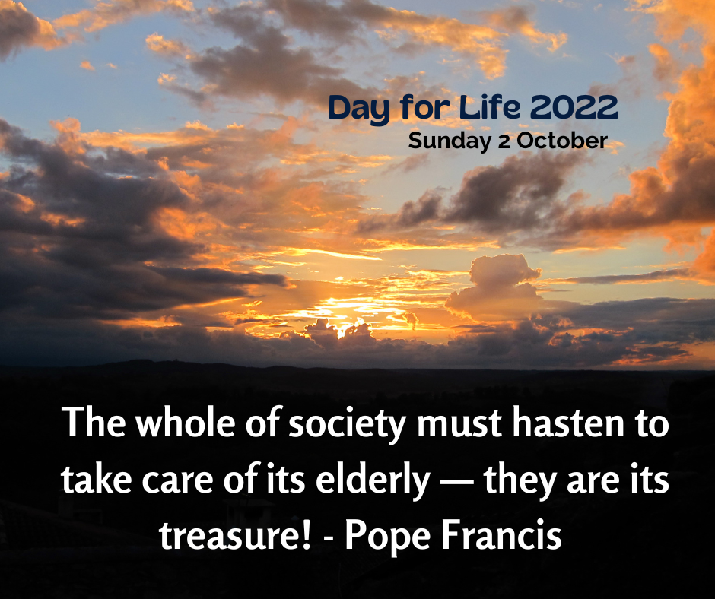***Recent Death:*** Your prayers are requested for the happy repose of the soul of *Jimmy Mc Gowan*, Cordarragh, Kiltimagh and formerly of Carroward, who died on Wednesday last, September 28th and whose funeral took place in Kiltimagh this Saturday. He was the brother of John (Carroward), Tom (Carrowkeel), Peter (Swords, Dublin) and Mary (Santry, Dublin). May he rest in peace.

***Meeting for Parents/Guardians of First Communion Children*** of Straide and Bohola will take place on Thursday next, 6th October in the Sheridan Community Centre, Bohola at 8.45pm.

***Eucharistic Hour of Healing, Prayer and Reflection*** takes place in St. James's Church, Charlestown, this Sunday evening, October 2nd from 6.00 to 7.00 pm. All are welcome.

***Catechism Workshop,*** ***Saturday, 8th of October:*** To celebrate the 30th anniversary of the publication of the Catechism of the Catholic Church we invite you to a Catechism/Youcat workshop at Our Lady’s Shrine Knock on Saturday, 8th of October from 9.15am to 5.30pm. The workshop will be of particular interest to those who plan to start a study group of the Catholic faith in their local area.

For booking please contact: Máirín Ní Shúilleabháin B.A. Div., Coordinator, Adult Studies Catechism of the Catholic Church at *mairin991@gmail.com* or call *087-7950325*. Please bring a copy of Catechism and Youcat. A small donation would be graciously appreciated. Full programme is on the church noticeboard.

***Reflection Day at Holy Hill, Saturday, October 8th:*** It's time to get grounded! Join us for a Day of Reflection at Holy Hill Hermitage, Skreen, Co Sligo on Saturday, October 8th from 10.30am to 4.30pm. The theme will be "Resonating with the Word". One of our strengths in these times is gathering together to grow spiritually. "There you will show me what my soul is seeking." A simple lunch will be served. Donations welcome. Come for all or part of the day. All are welcome.

To register, email [*friendsofcarmeholyhill@gmail.com*](mailto:friendsofcarmeholyhill@gmail.com). Details are also on church notice-boards.

***Talk in Michael Davitt Museum:*** A talk will be given by Eamon O'Cuiv on *Eamon de Valera and the United States Bond Drive* in the Michael Davitt Museum, Straide, on Friday night next, October 7th at 8.00pm. All are welcome and admission is free.

***Hospice Coffee Morning:*** Thank you to all who supported the recent Coffee Morning in aid of Mayo Roscommon Hospice. Thanks to the organisers, those who did the baking and to all who helped out in any way. A total of ***€2,120*** was collected for this very worthy cause. Well done to all!!

***Mayo Stoma Support Group:*** The next meeting of Mayo Stoma Support Group takes place on Thursday next, October 6th at 7.00pm in The Ellison Hotel, Castlebar. If attending, please contact JJ on *(087)2300580* so that numbers can be confirmed for venue management.

***Foxford’s Female Choir, BellaCapella*** are currently accepting new members. If you would like to join us in making music and fun, please contact Sarah Lawrence on *087-7854897*.

***Moy Davitts 50/50 Draw:*** Congratulations to Susan Heneghan who won a jackpot of €435 in the Moy Davitts 50/50 draw last Saturday. A huge thank you to everyone who supported last week's draw, it is greatly appreciated. Tickets are available in the usual retail outlets and by clicking [*https://smartlotto.ie/Bohola-moy-davitts*](https://l.facebook.com/l.php?u=https%3A%2F%2Fsmartlotto.ie%2FBohola-moy-davitts%3Ffbclid%3DIwAR2-SMSQVJnLPM1gbMk8VYcVq5QSNWsE5b18UD-SHwPhuifGrX08SNDlJc8&h=AT0MiLZlj4q4DBPOl03vVXSokuVERXZawyK8tGPOdkMD6iUtbbGAIDrP1wUMXoHHwBpf8OCfEYLll7lUaWyYzni7elqLyyDX1hxrkiRT4iLddt75pWrUPCYemDN43SvOspaI&__tn__=-UK-R&c%5b0%5d=AT1bnP92vRmesJAH-zh16Oyc956taFyWxM0_3VLfj4QSf9SmpZw5cpQ61Vc5tvJdChYPj7SPty0LDMmT-1CuL0y1Dj6Ia-SpXR1Lif8cNpBMb3zmcNd83NlOLtCy4LEd6sxibGw9D72uG7DGqfgmtrvFR5ZcIPXTwnc_aJIQcIYHHlU6GWM4y_sHX7uH).

***What are Your Hopes and Aspirations for Your Community?*** Mayo PPN want to hear your views on how we can make Mayo the best possible place in which to live, work and invest. A Workshop in Claremorris takes place on Monday, 10th October at 7.00pm in McWilliam Park Hotel, Claremorris. For more information and to register, email *mayoppn@mayococo.ie* or call *094- 9064358*.

***Straide Church Rotas for October***

***Readings/Prayers of the Faithful:*** Frances Regan & Declan Hynes.

***Ministers of Communion:*** Maggie McNulty (2nd & 23rd).

Geraldine Hynes (9th & 16th).

Mary Byrne (30th).

***Offertory Collectors:*** Kevin Bogue & Peadar Lennon.

***Opening/Closing Church:*** Bridie Mulroy.

***Kiltimagh Knock United Fundraising Clothing Collection:*** Kiltimagh Knock United's fundraising clothes collection takes place at the clubhouse on Saturday, October 29th from 11.00am to 2.00pm with drop-offs also after 6.00pm every evening from Wednesday, October 26th. Eircode F12HF61. Items accepted are women's, men's and children's clothing, handbags, belts, paired shoes, curtains, bed linen, towels, blankets and soft toys. No pillows or duvets. All support is appreciated.

***Part-Time Further Education:*** New QQI LEVEL 5 Certificate in Early Learning and Care (formerly known as Childcare Level 5) starts in Swinford Further Education Centre in October 2022. For more information, please contact Geraldine Tighe, MSLETB , at *087-7715096* or email: [*geraldinetighe@msletb.ie*](mailto:geraldinetighe@msletb.ie).

***Autumn 2022 Night Classes Mayo College of Further Education, Westport and Castlebar:*** Classes commence on the week of the 3rd of October for both Certified and Hobby courses in Westport and Castlebar. Detailed information and signup on *www.mayocollege.ie* in the night class section.

***Transition to Adult Services in County Mayo:*** An Information Fair for young people with a disability and their families will take place on Wednesday, 26th October from 12:00 noon to 3:00pm in Breaffy House Resort, Castlebar.

***New Pilgrim Path Website of the Week, October 2nd:*** *Transformative Spiritual Exercises ….* Would you like to embark on a prayer adventure? To experience a freedom and peace too often out of reach in the modern world? The 'Spiritual Exercises' are a compilation of meditations, prayers, and contemplative practices developed five centuries ago by St. Ignatius Loyola to help people deepen their relationship with God. The ‘Spiritual Exercises’ are not confined to Catholicism - they have been found invaluable by people of all Christian denominations. They are normally undertaken over 30 consecutive days.

‘An Ignatian Prayer Adventure’ is a modified version of the 30-day retreat. As it is self-guided, it can be undertaken in your own time. Access it at [***www.newpilgrimpath.ie***](http://www.newpilgrimpath.ie).

***Coastal Rosary for Faith & Life in Ireland:*** On Sunday, October 9th, the annual Coastal Rosary will take place at 2.30pm. Join thousands of people from around Ireland to pray the Rosary for Life and Faith at our coasts, grottos, rivers, churches, and other suitable places. Simply sign up a Rosary location at *www.coastalrosaryireland.ie* or text your location to *087-2786552*.

***Workshop for Readers:*** A workshop for Readers will be offered next month, at two venues in the Diocese. It will include reflections on the importance of the Scripture readings in the liturgy, and tips on voice projection and the use of audio equipment in churches. The presenters will be Ms Julie Sharkey and Rev Dermot Meehan. Readers are encouraged to attend at the venue most convenient to them.

*Swinford:* Tuesday, October 18th in the Parish Church at 7.30 pm.

*Tubbercurry:* Thursday, October 20th in the Parish Church at 7.30 pm.

***Mayo Cancer Support*** provides FREE support services to those affected by cancer. Call *(094) 9038407*.

***GROW Meetings:*** GROW is a self-help group helping people suffering from depression, stress, anxiety, panic attacks, loneliness, shyness etc. Meetings are held every Tuesday night at 8.00pm in Ballina Community Centre. All welcome.

***North West STOP*** offers a *free counselling* service with no waiting lists. Call or text *086-7772009* to arrange an appointment.

***Just sold my homing pigeon Ebay for the 22nd time!***