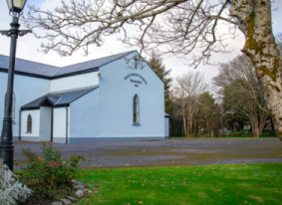 | Church of the Holy Family, Ballycroy  Mass Centre - National School - Innisbiggle  Christopher J. Ginnelly  (098) 49 134 (086) 89 33 278  ballycroyparish@gmail.com  James M Cribben, Geesala (087) 64 69 016  14^{th –} 21st Nov 2021  www.ballycroyparish.ie
The Year of St. Joseph 2021
Mass at 11am will be Broadcast on our Facebook Page The outside speaker will be in operation if you wish to listen to the mass on the grounds. Special Thanks to Cathy / Nora for operating the live broadcast on Facebook and to Shelly for the beautiful selection of music and hymns.
Welcome Back to Church
As most restrictions have been lifted in the church, I invite and welcome people back to Mass, especially families and those who have been absent for a long time. There is now no excuse as the church is a very safe place, with face masks, hands being sanitised and the church is sanitised every week. If it is safe to go shopping, to schools, attend football matches and parties, then it is very safe for you to come to church. I make a special plea to you all – please return to Mass.
33rd Sunday in Ordinary Time
Sat 12.30pm Mass Bangor Church
Sat 6.30pm 1. Margaret Smith – 20th Ann (Cavan)
2. Mary Alice, Jack, Martin, Padraig McHugh, Maureen Hickey,
Petie Sweeney
3. Sonny (Peter) Grealis (24th Ann) Lettra, Dec’d Calvey – Grealis
Families
Sun 11am 1. Patrick – Mary Ellen Grealis (Lettra)
2. John Keane (Nottingham – Knockmoyleen)
Sun 12.15pm Bangor Church
Tues 10am Jodie Berry (Lettra) Dec’d Berry Family
Wed 10am Holy Souls
Thur 10am Katie Leneghan (21st Ann) Dec’d Family (Doona)
Fri 6.30pm Rosie Cafferkey (2nd Ann) – Jim (16th Ann) Aughness
Sat 12noon Island Mass – Michael (23rd Ann) and Anthony Leneghan (11th Ann)
Sat 2.30pm Baptism; Baby Stephen, Parents Seán and Leanne Bradley.
Sat 4pm Baptism Bangor Church

Christ - King of the Universe (Last Sunday of the Church Year)
Sat 6.30pm 1. Bridgie Mary Murphy (nee Conway) Drumslide/New York
2. William Cafferkey (28th Ann) Kate (Aughness)
Remembrance Sunday in our Parish
Sun 11am 1. Pakie Conway (5th Ann) Rosie (Fahy)
2. Nappie – Eddie Corrigan, Dec’d Corrigan Family (Dooreil/Drumgallagh)
Sun 11.45am Rosary – Ballycroy Cemetery. Claggan 12.15pm. Fahy 1pm.

Parish Christmas Cards available.

The following are the names of those who died during the year:
Patrick Keane – Peterborough/Gortbreac 30th September | Petie Corrigan – Doona - 24th May
Pat Calvey – Inisbiggle - 25th Nov | Austin McDermot – Newport - 9th June
Michael Leneghan – Crosshill - 11th Dec | Elizabeth Walsh – Shean - 11th July
Julia Finn – Blenkeragh - 13th Jan | Alice McGowan – Wellingborough/Kildun  2nd July
Neil Leneghan – Doona - 19th Jan | Martin Neenan – Doona - 27th July
Annie Calvey – Inisbiggle - 19th March | Marty Murray – Logduff - 25th Oct
Nora Conway – Tallagh - 27th March
Let perpetual light shine upon them O Lord, for you are merciful and loving

Ballycroy Church Altar Society: Groups for cleaning the church on a weekly rota. Sincere thanks to the ladies for coming forward to support us all.
- Patricia Grealis (L), Mary Sweeney (Tar), Marie McGowan, Joan Campbell
- Bernie Shanaghan (L), Marion Cafferkey, Bernie McGowan, Sineád Carolan
- Kathleen Rowland (L), Ann McManamon, Josaphine Keane, Grace Grealis
- Christana Togher (L), Margaret Keane, Mary Conway, Katie or Nora Campbell

Sincere thanks to Kathleen R and Group 3 for looking after the church.
Next week, Christina and Group 4 will look after the church
Monthly Schedule | Readers | Eucharistic Ministers
Sat 13th Nov: 6:30pm | Family | Christina Togher
Sun 14th Nov: 11am | Family | Peggy Ginty
Sat 20th Nov: 6:30pm | Family | Mary Bradley
Sun 21th Nov: 11am | Family | Marian Masterson
The committee, parents and staff of the Naíonra wish to thank you all for support. Thanks to the ticket sellers and sponsors of prizes. It is much appreciated. HALLOWEEN HAMPER RESULTS:- 1st Prize – Zitta Mulcahy, Mulranny 2nd Prize - Bernie McNeely, Bangor 3rd Prize - Ann Moran, Cushlecka, Mulranny 4th Prize - Siobhan Shepperd, England 5th Prize - Bríd Howard, England 6th Prize – Bernie McNeely, Bangor

Mayo North East Social Inclusion Community Activation Programme in collaboration with MFitness are bringing you 3 FREE Health and Fitness Programme’s. 1.Mens 6 week winter wellness programme in Belmullet starts Monday 8th November 2.Mens Winter Wellness Programme in Bangor Erris starts Tuesday 9th November 3.Womens New Beginnings fitness Programme Bangor Erris starts Monday 8th November. To book a place on any of these programmes call 097 20820/0871840214 SICAP eligibility requirements apply!
Keeping Children Safe: The Diocese of Killala is fully committed to keeping children safe. If you have any concerns around their safety in any circumstance please contact;
The Diocesan Liaison Person – Confidential No - 087 1003554. (Please see more information on the notice board).

Supplementary Pages for Online:
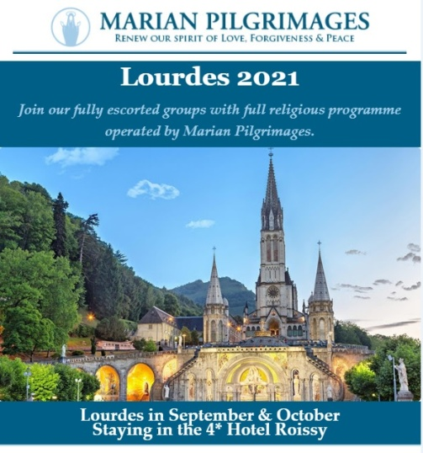

- Free online Living Well Programme – next programmes commences on (Limited places) Thursday 9th of September
- Monday 13th of September
- Tuesday 21st of September
- Wednesday 29th of September
If you are living with a long term heath condition you may be interested in doing the ‘Living Well’ Programme’. This is a six week programme delivered in 2.5 hour weekly. You must register in advance as places are limited to 10/12 participants. Please contact Liam Gildea on 087 349 0393 or by email at liam.gildea@mayocil.ie
Reminder for everyone to register for their vaccine We would like to remind all to register for their COVID-19 vaccine through the HSE’s online registration system or on the phone with HSELive Everyone in is now eligible to register:
A Chance of a Fortune!
Have you an interest in working with people with a learning disability and / or autism??
Western Care Association are recruiting Relief Staff to work in our Services based across Co. Mayo. For further information please visit our website at www.westerncare.com or email hr@westerncare.com

For Mental Health Week, North West STOP invites you to 3 events to get this msg out: it's OK not to be OK & it's absolutely OK to ask for help.
ODD SOCKS DAY 7th October (or between 3rd-10th)
Last year this raised over €10,500 and paid for our Free Counselling Service during Oct, Nov & early Dec. Join in and share with friends / colleagues to make it a success in 2021. For a Fundraising Pack: E: oddsocks4stop@gmail.com or Ph: 071 985 6070.
ANNUAL GENERAL MEETING 14th October, 7.30pm, The Glens Centre, New Line, Manorhamilton. Please confirm your attendance by 7th October if you wish to be included in the minutes. Ph: 071 985 6070
MEMORIAL WALK 15th October, 7pm, Castle Carpark, Manorhamilton. All are welcome to join us in remembering members of our community whom we have cherished and lost. Please dress up warm & wear comfortable shoes.
PREVAILING COVID-19 GUIDELINES WILL APPLY TO ALL IN-PERSON EVENTS.
FREE COUNSELLING AVAILABLE: PHONE / TEXT 086 777 2009.

Western Care Association’s Annual Door To Door Collection is now taking place during the month of September. To donate, find us on Facebook "Western Care Association" or on www.idonate.ie/wcadoor or find the link on our website (www.westerncare.com) and make your donation. If you would like to donate in any other way, (Cheque, Postal Order or Bank Transfer) we would be very happy to talk to you. Please contact Teresa Ward on 094 90 29174 or 087 246 7857 or email: tward@westerncare.com. Your support is greatly appreciated.

Reminder for everyone to register for their vaccine We would like to remind all to register for their COVID-19 vaccine through the HSE’s online registration system or on the phone with HSELive Everyone in is now eligible to register: If someone is finding it difficult to go online and register or they can ring HSELive for support on 1850 24 1850 or 01 240 8787 from 8am to 8pm, 7 days. If a person doesn’t have a PPSN they can register on the phone with HSElive. Once registered the person will receive their vaccine appointment for the COVID-19 AstraZeneca vaccine. If a person is deaf or hard of hearing, they can text HSELive on 086 1800 661 to register for your vaccination
Free Training! Enrolling Now: If you struggled at school, have been long term unemployed, are recovering from or living with an illness or would benefit from extra support, the National Learning Network could be for you. We offer the expertise and time to enable people to flourish. QQI courses include: IT & Business Skills (home and centre based), Sports and Gym Instructor Studies, Fast Track to Employment and more. If you are registered with the DEASP you could be entitled to the free training, Continuous enrolment, payments are protected and people under 26 could gain extra training allowance. Contact: Castlebar@nln.ie; (094) 9022770; Breaffy Road, Castlebar, or see our website www.nln.ie.

Covid-19 Collect and Deliver Service: Helping people to stay at home is the new role of Local Link Mayo rural transport services. Local Link Mayo is offering a collect and deliver service in existing Local Link routes throughout Mayo from pharmacies and local shops, delivering shopping and critical medical supplies to the elderly, the vulnerable and sick. If your need of such support or know someone who does, contact Local Link Mayo on 094 900 5150 between 9:00am and 5:00pm (M-F) or email mayo@locallink.ie
Keeping Children Safe: The Diocese of Killala is fully committed to keeping children safe. If you have any concerns around their safety in any circumstance please contact The Diocesan Liaison Person – Confidential No - 087 1003554. (Please see more information on the notice board).

