***Offertory Donations:***

Sunday 20th: €690.



Thanks for all your contributions.

**Bohola/Shraheens Newsletter**

**Stephen O’Mahony PP – 094-9384115/086-8226405 –** [**boholaparish@gmail.com**](mailto:boholaparish@gmail.com) **(email for newsletter)**

<https://www.mayo.ie/news/category/connect/parish-news/bohola-parish-news/>

**8th Sunday in Ordinary Time – 27th February 2022**

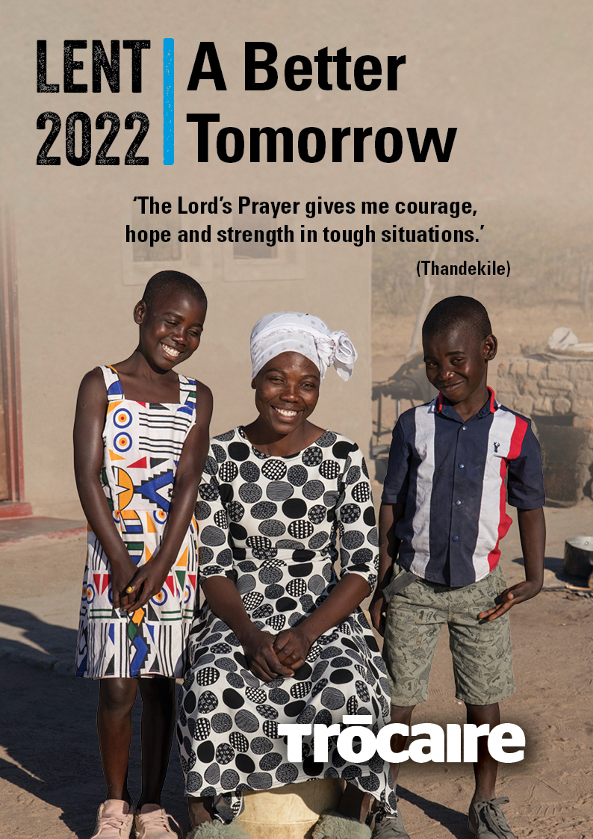

###### Masses for the Week

|  |  |  |
| --- | --- | --- |
| **Saturday, February 26th.** | **7.00pm Vigil*\**** | **Mary Carney (1st Anniversary) and her husband Martin, Lissaniska Estate & Gortnasella.** |
| **Sunday, February 27th.** | **9.30am*\****  **11.30am*\**** | **For all the People.**  **Nancy O’Neill (née Healy), her husband Noel and deceased of Healy family, Gortnasella.** |
| **Monday, February 28th.** | **10.00am** | **Private Intention.** |
| **Tuesday, March 1st.** |  | **No Mass.** |
| **Wednesday, March 2nd.** | **10.00am*\****  **6.00 – 8.00pm** | **Ash Wednesday / Blessing & distribution of ashes. (*Adoration follows until 11.30am)***  **Exposition of the Blessed Sacrament (private prayer).** |
| **Thursday, March 3rd.** | **10.00am** | Private Intention. |
| **Friday, March 4th.** | **8.00pm*\**** | **Menia Aitken, her husband John, their son, George & deceased of the McGloin & Aitken families.** |
| **Saturday, March 5th.** | **7.00pm Vigil** | **Private Intention.** |
| **Sunday, March 6th.** | **9.30am*\* Shraheens***  **11.30am*\* Bohola*** | **For all the People.**  **Mary Walsh, Sheridan Park.**  **Delia Mulroy & Mary Connolly.** |
| ***The 9.30am Sunday Mass will be live-streamed on the Bohola Post Facebook Page every Sunday.***  ***Any other Masses are put online when requested. (Marked with * above)***  ***All Masses will be broadcast on the 105.5 FM Radio channel.*** | | |

***Recent Deaths:*** Please pray for the happy repose of the soul of *John Joe Salter*, Castlehaven, Co Cork, who died on Tuesday last, February 22nd and whose funeral took place in Castlehaven on Thursday. He was the uncle of Barbara Conlon, Toughnane. May he rest in peace.

Your prayers are also requested for the happy repose of the soul of *Pat Harte*, Harrow, London and formerly of Meeltran, Knock, who died recently. He was the husband of Peggy (née Sweeney), formerly of Garrahill, Carroward. May he rest in peace.

***Ministers of Communion Commissioned:*** Congratulations to Noreen Byrne and Mary Sewell who were commissioned as Ministers of Holy Communion at a special ceremony during Mass celebrated by Bishop Paul Dempsey in Charlestown on Thursday evening last. Their training was completed over two years ago but the intervention of Covid-19 prevented this ceremony from taking place. Joe Mullaney was very much in our thoughts as he had also completed the training and was awaiting commissioning before his untimely death in January. May Joe rest in peace and we wish Noreen and Mary every blessing as they take up their new ministry.

***Return of Mass to Shraheens:*** Please note that from Sunday next, March 6th, the 9.30am Mass will be celebrated in Shraheens. The last public Mass celebrated there was on March 8th, 2020. Hopefully, this is another sign that we are beginning to put the pandemic behind us. We remain cautious but also optimistic as we go forward.

***Exploring Priesthood – Zoom with Seminarians and Priests:*** On Tuesday, 1st March at 8pm there will be an opportunity to join in on a Zoom to find out more about priesthood and to hear directly from two young men who are currently studying for the priesthood in our National Seminary in Maynooth. The event is being run by the National Vocations Office. Further information and registration details can be obtained by emailing [*info@vocations.ie*](mailto:info@vocations.ie)*.* Alternatively, you can visit [***vocations.ie/zoom***](http://vocations.ie/zoom)**or contact our Vocations Director Fr Paul Kivlehan on *087-3683535*.**

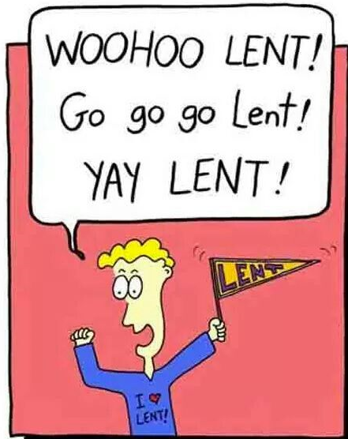***New Pilgrim Path Website of the Week, February 27th:*** *Lent Resources ……….* March 2nd is Ash Wednesday, the beginning of Lent. Lent is a time when we are invited to encounter Christ in the wilderness, free from all the things which distract and anaesthetise us in our daily lives. We need not travel far to enter this place – the wilderness inside us is a place of testing, where the power of false gods is broken. It is a place of encounter with ourselves, with our inner demons and with God. New Pilgrim Path has a host of resources to guide us on this transformative journey. Access them here: [***www.newpilgrimpath.ie***](http://www.newpilgrimpath.ie).

***First Communion Enrolment:*** On Friday evening last, we were delighted to welcome Cillian Boyle, Dylan Egan, Cillian Egan, Sophie McDonnell, Shane McGahon, Conor Mulderrig, James O’Brien, Charlie Reddington, James Reddington, Caoimhe Redmond, Donnacha Rowley, Noah Shannon and Saoirse Treanor for their First Communion Enrolment Mass. Our thanks to all in the home, school and parish who are guiding them along the pathway towards First Penance on April 5th and First Communion on Saturday, May 7th. We wish them every blessing and ask you to remember them in your prayers.

***Trócaire Lenten Campaign 2022:*** Lent is an extremely important time of the year for Trócaire. Trócaire relies heavily on the income that comes in during Lent, through the generosity of parishes and schools, to fund our core work. We are conscious of the many pressures facing people and parishes, and we are greatly encouraged by the ongoing generosity which enables us to continue our lifesaving and life-changing work in up to twenty countries in Africa, Asia, the Middle East and Central America.

This year’s Lenten campaign highlights how Covid-19 has impacted communities in Zimbabwe who were already facing significant challenges due to climate change and food insecurity. We hear the story of Thandekile and her two children, her daughter Nomatter and son Forward, and how Covid-19 has had a devastating impact on their family. We also hear how Thandekile shows courage, hope and strength in the face of these challenges.

We thank you as always for your ongoing support and work for Trócaire and wish you and yours continued good health and blessings this Lent and always. **Trócaire boxes are now available in the church.**

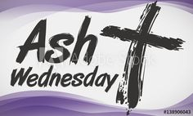***Ash Wednesday*** is next Wednesday and marks the beginning of our Lenten journey, a journey that invites us to reflect upon the things that matter most; the things of the heart that lead us to the fullness of life. We mark ourselves with the sign that reminds us, and proclaims to all whom we meet, that we believe that Jesus is the source of all life.

*Ash Wednesday Mass is at 10am* with the blessing and distribution of ashes. You are also reminded that on the Tuesdays of Lent, Mass will be celebrated at ***7.00am***!

***Lenten Blessing***

*Bless each one of us, Lord, with joy, the joy of spending more time in your presence during this Lenten Season. Bless our homes and families, Lord. Be close to the sick and anxious. Bless our Parish, as we see the purpose of fasting and almsgiving as small sacrifices for us that can make a big difference in the lives of others. Bless us Lord in making this Lenten Season Holy.*

***Reading the Bible - How to Make Sense of it:*** This series on how to read the Bible today continues in The Gateway Hotel, Swinford on Tuesday evening next, March 1st and the final session will be on March 15th from 8.00 to 10.00 pm. It is presented by Fr Eugene Duffy. If you have a bible, bring it with you on the night. Light refreshments will be provided during the break. Admission is free and all are welcome.

***Clann Machua Kiltimagh Present Sive:*** Clann Machua Drama Group present Sive by John B Keane in the Town Hall Theatre in Kiltimagh on this Saturday, 26th February with curtain up at 8.00pm. Saturday night is a special fundraiser for Kieran Cawley Fundraiser and this will be the last chance to see this production before the group hits the festival circuit in March, performing in 8 festivals all over Ireland including Cork, Kildare, Clare, Galway, Sligo and the local Claremorris Festival. Tickets are available on the door on the night.

***Moy Davitts 50/50 Draw:*** Congratulations to Linda Reilly, Islandeady who won a lovely jackpot of €430 in the Moy Davitts 50/50 draw last Saturday. A huge thank you to everyone who supported last week's draw, it is greatly appreciated. Tickets are available in the usual retail outlets and by clicking [*https://smartlotto.ie/Bohola-moy-davitts*](https://l.facebook.com/l.php?u=https%3A%2F%2Fsmartlotto.ie%2FBohola-moy-davitts%3Ffbclid%3DIwAR2-SMSQVJnLPM1gbMk8VYcVq5QSNWsE5b18UD-SHwPhuifGrX08SNDlJc8&h=AT0MiLZlj4q4DBPOl03vVXSokuVERXZawyK8tGPOdkMD6iUtbbGAIDrP1wUMXoHHwBpf8OCfEYLll7lUaWyYzni7elqLyyDX1hxrkiRT4iLddt75pWrUPCYemDN43SvOspaI&__tn__=-UK-R&c%5b0%5d=AT1bnP92vRmesJAH-zh16Oyc956taFyWxM0_3VLfj4QSf9SmpZw5cpQ61Vc5tvJdChYPj7SPty0LDMmT-1CuL0y1Dj6Ia-SpXR1Lif8cNpBMb3zmcNd83NlOLtCy4LEd6sxibGw9D72uG7DGqfgmtrvFR5ZcIPXTwnc_aJIQcIYHHlU6GWM4y_sHX7uH).

***A Pastoral Introduction to* Lectio Divina:** St Patrick’s Pontifical University, Maynooth is offering an online introduction to lectio divina in a pastoral key over the next eight weeks. Alternating between brief presentations which may be accessed at any point, and a fortnightly live lectio, this short course will provide a pathway through lectio divina while participants journey with the Sunday gospels of Lent. More information can be found on *https://aspal.ie/*.

Addressing the challenges of praying together during the Covid-19 pandemic has permitted many to gain confidence in negotiating virtual environments. Building on this confidence, the course, under the guidance of Father Séamus O’Connell, will provide resources and support for the prayerful reading of the Scriptures in a way that will nourish the faith of the individual and inspire the lives of our parish and diocesan communities.

***Victim Assistance*** is the national charity which supports victims of crime and trauma. If you or anyone you know needs support, please call us on *FREEPHONE 1800 277 477*, office *094-9000251* or email [*support@victimassistance.ie*](mailto:support@victimassistance.ie). Visit our website *victim*[*assistance.ie*](http://assistance.ie/) to find out more about us.

***North West STOP*** offers a *free counselling* service with no waiting lists. Call or text *086-7772009* to arrange an appointment.

***COVID-19 Support Line for Older People:***Professional staff are available to answer queries and give advice and reassurance where necessary. The support line is open seven days a week, 8am to 8pm. The contact number is ***0818-222024***.

***Frankly Autocorrect, I’m getting a bit tired of your shirt!***