***Offertory Donations:***

Sunday 17th: €630.



Thanks for all your contributions.

**Bohola/Shraheens Newsletter**

**Stephen O’Mahony PP – 094-9384115/086-8226405 –** [**boholaparish@gmail.com**](mailto:boholaparish@gmail.com) **(email for newsletter)**

<https://www.mayo.ie/news/category/connect/parish-news/bohola-parish-news/>

**30th Sunday in Ordinary Time (Mission Sunday) – 24th October 2021**

###### Masses for the Week

|  |  |  |
| --- | --- | --- |
| **Saturday, October 23rd.** | **8.00pm Vigil** | **Private Intention.** |
| **Sunday, October 24th.** | **9.30am*\****  **11.30am *\**** | **For all the People.**  **Teece & Tom O’Neill & deceased of McNicholas & O’Neill families.**  **Brian & Delia Corrigan and deceased of Corrigan & Walsh families.** |
| **Wednesday, October 27th.** | **10.00am**  **7.00 – 9.00pm** | **Special Intention.**  **Exposition of the Blessed Sacrament (private prayer).** |
| **Friday, October 29th.** | **8.00pm** | **Private Intention.** |
| ***Mass will be celebrated privately on other weekdays.*** | | |
| **Saturday, October 30th.** | **8.00pm Vigil *\**** | **John Kelly (J), Toughnane.**  **Bernard & Bridget McNicholas, Lismirrane.** |
| **Sunday, October 31st.** | **9.30am*\****  **11.30am** | **Mary & James Hall, Knockatemple and deceased of Hall family.**  **For all the People.** |
| ***The 9.30am Sunday Mass will be live-streamed on the Bohola Post Facebook Page every Sunday.***  ***Any other Masses are put online when requested. (Marked with * above)***  ***All Masses will be broadcast on the 105.5 FM Radio channel.*** | | |

***Recent Deaths:*** Please pray for the happy repose of the soul of *Joe Montgomery*, Newtownbutler, Co Fermanagh, who died on Thursday, October 14th and whose funeral took place in Lisnaskea on Monday last. He was the brother of Bernie Horan, Carragowan. May he rest in peace.

Your prayers are also requested for the happy repose of the soul of *Joe Clarke*, Hertfordshire, England and formerly of Carrowntleva who died on Saturday last, October 16th. May he rest in peace.

***Baptisms:*** On Saturday last, October 16th, we were delighted to welcome *Scott Kenneth Aonghus Jordan*, Garrahill, into God’s family. Congratulations to his parents, Damian and Kirsty, his godparents and wider family circle and we wish them every blessing for the future.

On the same day we were delighted to welcome first cousins, *Zoe Sarah Byrne*, Toughnane, and *Tadhg Henry Kelly*, Walkinstown, Dublin, into God’s family. Congratulations to their respective parents, Stephen and Rita, and Brian and Sarah-Lee, their godparents and family circle and we wish them every blessing for the future.

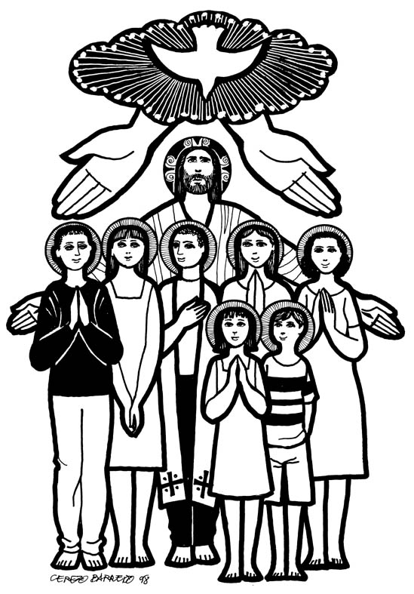***Confirmation*** took place on this Friday, October 22nd, in Bohola church. We congratulate the 26 young boys and girls (Kate Byrne, Megan Byrne, Chloe Colgan, Killian Commons, Ciara Conlon, James Duffy, Rebecca Flaherty, Mollie Gallagher, Hannah Gaughan, Niamh Gillespie, Tom Gostick, Lauren Hale, Wayne Ivers, Ava McDonnell, Kate Louise McGahon, Dylan McHale, Leah MacNicholas, Mary Moran, Sean Moran, Niamh Moore, Killian Mulderrig, Ruby O’Brien, Harry Reddington, Róisín Rowley, Joseph Shehu and Jason Walsh) who were confirmed and also to their parents, sponsors, families and friends who shared in this very special occasion.

Such a celebration doesn’t happen without much hard work and preparation so grateful appreciation to school Principal, Mrs. Teresa Mulligan for all the preparatory work in the background and for the beautiful music and singing on the day. Special thanks to teachers Ms. Patria Jordan and Mr Alan Regan who prepared the candidates so well over the last two years for this Covid-delayed celebration. Thanks also to Mrs Ann Mulroy for her help in so many ways, not least in the production of the beautiful booklet. We are deeply indebted to Rose Reddington for always having the church looking so well internally, to all pupils and Teresa Flaherty who were responsible for the beautiful art work on display and to those on the RSS scheme for all the external preparation on the church grounds. Thanks to John Jordan for all his assistance and to Patricia Reddington for stewarding on the day.

Last but certainly not least we say a very special ‘thank you’ to Bishop Paul Dempsey for being with us and doing the most important job of all – conferring the sacrament on the 26 young people in such a relaxed and meaningful way. We wish the girls and boys every blessing for the future and now that they have made the commitment to full Christian living, we look forward to them playing a full part in the life of the Church.

***Medjugorje Weekend Retreat 2021*** takes place in Knock Shrine from next Friday, 29th to Sunday, 31st October. Admission is by ticket only, costing €30. Numbers are limited to 200. Please contact Bernadette on *086-8196653* to register.

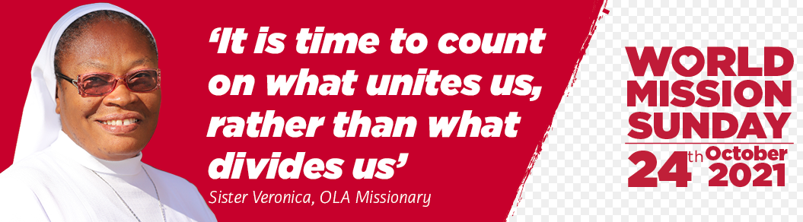

***World Mission Sunday:*** Today, October 24th, is World Mission Sunday, when the Holy Father invites all Catholics to contribute to a special collection for Missio, his charity for world mission. Its theme ‘We Cannot Remain Silent – We cannot but speak about what we have seen and heard (Acts 4:20)’ is twofold. It is a message of hope – Jesus Christ is risen and we cannot keep his love, compassion, and mercy to ourselves. It also challenges us to stand up and speak out on behalf of those who are weaker. All too often, the voices that need to be heard are not the loudest. For them, we cannot remain silent.”

Please support Missio in helping missionaries to work alongside communities throughout the world that are poor or in need, regardless of their background or belief. Join in on this special day that unites Catholics all over the world in prayer and celebration of our Church’s mission to share God’s love with all people. Please call ***020-78219755*** (oﬃce hours) or visit Missio’s website to give a single gift, set up a Direct Debit and Gift Aid your donation, if possible: ***missio.org.uk***. You can easily make a donation through the special envelopes available in church or in your offertory envelope box.

***The Government Announcement on the Lifting of Restrictions*** issued on Tuesday was unsurprisingly as clear as bog water! It states that "Religious services can proceed without capacity limits **but with all other protective measures remaining in place**". It is unclear whether or not these protective measures include social distancing. At this point it looks unlikely that there will be further clarity and it seems that it is up to each individual church to decide on the best way to proceed. With this in mind, there will be a Pastoral Council meeting on Wednesday evening with this issue the only item on the agenda. It is important that we get some idea of the general feeling so please make your views / suggestions known to any council member before that meeting.

In the meantime, we proceed with caution so there will be no change to existing arrangements this weekend and the proposed return of Mass to Shraheens on Sunday next is put back to a later date. The government was clear on some things – wearing of face masks, hand sanitisation and good ventilation remain essential. But perhaps the most important ingredients in moving forward are common sense and the taking of personal responsibility for our own actions.

***A Pastoral Council Meeting*** will take place in the Parish Centre on Wednesday evening next, October 27th at 8.30pm. All members are asked to attend.

***Association of Catholics Talk on Thursday 28th October:*** Pope Francis has consistently prioritised those on the margins. Kate Moynihan CEO of LINC will speak at Association of Catholics meeting at 8pm on Thursday, 28th October on issues affecting LGBTQ Catholics. *Zoom ID 87192847195 Passcode 820533*.

***November*** is the month when we especially remember our departed loved ones. Twelve Masses will be celebrated for our deceased during the month. Envelopes are now available in church which can be returned with the list of your departed and placed in the “Offerings” box at the back of the church or through the letterbox of the Parochial House.

***New Pilgrim Path Website of the Week, October 24th:*** *Transformative Spiritual Exercises …*… Would you like to experience a freedom and peace too often out of reach in the modern world? The 'Spiritual Exercises' are a compilation of meditations, prayers, and contemplative practices developed five centuries ago by St. Ignatius Loyola to help people deepen their relationship with God. Creighton University's 34-week guided online retreat is a way to make the movements of the Spiritual Exercises in the midst of a busy life.

This self-guided journey has been made by hundreds of thousands of people – in seven languages: English, Spanish, Portuguese, Russian, Arabic, Kiswahili and Chinese. The Spiritual Exercises are not confined to Catholicism – they have been found invaluable by people of all denominations and none! You can begin the retreat at any time. Access it at [***www.newpilgrimpath.ie***](http://www.newpilgrimpath.ie).

***Deadline for submissions to the Bohola Post is Saturday next, October 30th***

***(***[***boholapost@gmail.com***](mailto:boholapost@gmail.com)***).***

***The Sheridan Community Centre*** is seeking expressions of interest from people in the community to join its management committee. In these voluntary roles the interested persons will form part of a small group who will oversee and manage the day to day running of the Community Centre.

In order to facilitate the reopening of the Community Center we need to ensure we have a management committee in place. For further information or to express interest please email [***sheridanmccbohola@gmail.com***](mailto:sheridanmccbohola@gmail.com) by November 7th.

The Sheridan Community Center, Bohola will hold its AGM on Sunday, 14th November at 6pm in the Community Center.

***Bohola Community Park*** is hosting a *Social Evening* on Saturday, 6th November in the Village Inn with traditional music by Village Folk from 9pm. All are welcome. The *AGM* is on Sunday, 7th November at 7.00pm in the Community Centre.

***Moy Davitts 50/50 Draw:*** Congratulations to Karen Bowes on winning €363 in the Moy Davitts 50/50 draw last Saturday morning. A huge thank you to everyone who supported last week's draw, it is greatly appreciated. Tickets are available in the usual retail outlets and by clicking [*https://smartlotto.ie/Bohola-moy-davitts*](https://l.facebook.com/l.php?u=https%3A%2F%2Fsmartlotto.ie%2FBohola-moy-davitts%3Ffbclid%3DIwAR2-SMSQVJnLPM1gbMk8VYcVq5QSNWsE5b18UD-SHwPhuifGrX08SNDlJc8&h=AT0MiLZlj4q4DBPOl03vVXSokuVERXZawyK8tGPOdkMD6iUtbbGAIDrP1wUMXoHHwBpf8OCfEYLll7lUaWyYzni7elqLyyDX1hxrkiRT4iLddt75pWrUPCYemDN43SvOspaI&__tn__=-UK-R&c%5b0%5d=AT1bnP92vRmesJAH-zh16Oyc956taFyWxM0_3VLfj4QSf9SmpZw5cpQ61Vc5tvJdChYPj7SPty0LDMmT-1CuL0y1Dj6Ia-SpXR1Lif8cNpBMb3zmcNd83NlOLtCy4LEd6sxibGw9D72uG7DGqfgmtrvFR5ZcIPXTwnc_aJIQcIYHHlU6GWM4y_sHX7uH).

***I’m doing my bit for global warming – I took the door off my fridge!***