***Offertory Donations:***

Sunday 12th: €635.



Thanks for your generosity to both the Offertory and to the priest’s Harvest collection. Late contributions can still be handed in.

**Bohola/Shraheens Newsletter**

**Stephen O’Mahony PP – 094-9384115/086-8226405 –** [**boholaparish@gmail.com**](mailto:boholaparish@gmail.com) **(email for newsletter)**

<https://www.mayo.ie/news/category/connect/parish-news/bohola-parish-news/>

**25th Sunday in Ordinary Time – 19th September 2021**

###### Masses for the Week

|  |  |  |
| --- | --- | --- |
| **Saturday, September 18th.** | **8.00pm Vigil*\**** | **Agnes Walsh & deceased of the Walsh family.**  **Martin McNicholas, Ballyglass & deceased of Brennan & McNicholas families.** |
| **Sunday, September 19th.** | **9.30am*\****  **11.30am** | **Bridie Lavelle, Bohomore.**  **For all the People.** |
| **Wednesday, September 22nd.** | **7.00 – 9.00pm** | **Exposition of the Blessed Sacrament (private prayer).** |
| ***No weekday Masses this week as Fr O’Mahony is away.*** | | |
| **Saturday, September 25th.** | **12 noon*\****  **8.00pm Vigil*\**** | **Teresa O’Brien, Tavanaughkanaffe, (1st Anniversary).**  **John (George) Aitken, Dromintee, Armagh and formerly Barleyhill.**  **Mary Ivers, Althbawn & Patrick McNicholas.** |
| **Sunday, September 26th.** | **9.30am*\****  **11.30am** | **For all the People.**  **Private Intention.** |
| ***The 9.30am Sunday Mass will be live-streamed on the Bohola Post Facebook Page every Sunday.***  ***Any other Masses are put online when requested. (Marked with * above)***  ***All Masses will be broadcast on the 105.5 FM Radio channel.*** | | |

***Today’s Gospel and Care for Creation***

*Competition starts very young in life – we have here a story about jealousies among the first disciples of Jesus. He has just spoken about his death and now they are arguing who is the best of the group. But… He does not get involved in their argument. Instead, He calls a child-the child was a nobody in those days-and greets that child with love. He does not ask us here to become like little children but to welcome them just as they are. He is somehow highlighting something very important – welcome and hospitality. A welcome for everyone in the love of God and in the church. This was his lesson to their jealousies. Our care for all whom we meet. Our care should also extend not just to each other as individuals but to all of creation.*

*We are here to care for and not subdue creation. This requires a change of mind-set. Climate change affects us all; but it affects the poorest and weakest of us most of all. Children, suffering poverty and hunger, families made homeless, farmland made barren or flooded. We have a duty to act to protect these most vulnerable of our brothers and sisters.*

*Take time each day to give thanks for the earth, for the food we eat and the air we breathe. Give thanks for the beauty of creation – the things that nurture not our bodies but our souls. The quiet places we escape to when the busyness of life is too much, the beauty of nature which can brighten our dark days. The more we remember to be grateful for the earth the more we will remember our duty to care for it. Jesus reminded His disciples that they must be humble servants – in our care for creation we are the humble servants of future generations.*

*This week – start making some small changes: refuse plastic in a store; turn off lights you do not need; it won’t change the world immediately but if we all get into this mind-set, things can change.*

*Why care? Because the heart of God goes out to the cry of the earth and the cry of the poor.*

*Donal Neary SJ (Editor of the Sacred Heart Messenger).*

***Emergency Numbers:*** Fr. O’Mahony will be away this coming week from Monday to Friday. Hopefully there will be no need but in case of emergency please contact Swinford (087-1338200), Fr. Convey, Straide (094-9031029/ 087-2566772) or Fr. Quinn, Kiltimagh (094-9381198/087-9082342).

***Medjugorje Pilgrimage (40th Anniversary of Apparition):*** Two pilgrimages are scheduled from 22nd to 29th of September and from 29th of September to the 6th of October. Flights from Knock to Mostar (just 20 mins from Medjugorje) are accompanied by a Spiritual Director. The cost is €765 and includes flights, luxury coach transfers, travel insurance, accommodation and meals. Accommodation is 2 minutes from St James Catholic Church. Further details from Anne Keadin on *086-3766293*.

***Hospice Coffee Morning:*** Again, this year we are unable to have our annual coffee morning . However, if you wish to make a donation, you may do so on [*www.hospice.ie*](http://www.hospice.ie/) Alternatively, if you prefer you may drop a donation into Clarke's shop in an envelope, with your name on it. This will be open until next Friday, September 24th. Any queries, contact Vera on *087-6401155*.

***Bohola Post:*** The deadline for submission of material to the 2021 edition of the Bohola Post is Saturday, October 30th. Get your articles and/or pictures in as soon as possible and all contributions are to be sent by email to [*boholapost@gmail.com*](mailto:boholapost@gmail.com).

***Guided Pilgrimages on the Lough Derg Pilgrim Path*** will be offered on *Sunday 26th September and Sunday 3rd October*, with Mass outdoors, weather permitting. The full route is a 12km loop, with a shorter 8km option**. Advance booking is essential.** For further information, email [*info@loughderg.org*](mailto:info@loughderg.org) or telephone 071-9861518. [*www.loughderg.org*](http://www.loughderg.org/) *Lough Derg Pilgrim Path, Pettigo, Co Donegal. F94 N289.*

***New Pilgrim Path Website of the Week, September 19th:*** *St Francis of Assisi’s Canticle of Creation …*… When St Francis composed the extraordinary Canticle of the Creatures (or Canticle of Brother Sun and Sister Moon), he was blind. Yet, he was able to see more clearly than ever with the inner eye of his mind. With unparalleled clarity he perceived the basic unity of all creation and his own place as a friar in the midst of God's creatures. His unqualified love of all creatures, great and small, had grown into unity in his own heart. He was a centre of communion with all creation. Celebrate this 3rd week of the Season of Creation by praying the words of Francis in an inspiring reading of the Canticle by a 21st century Italian Franciscan. Click here to access: [***www.newpilgrimpath.ie***](http://www.newpilgrimpath.ie).

***Bereavement Support Group- Knock Shrine:*** Life after a family bereavement can feel very lonely. Sometimes spending time with others who know the experience can be helpful. A Bereavement Support Group meets every Wednesday at 11am at the Family Centre, Knock. All are welcome. Further information from Monica Morley at Knock Shrine: *094-9375320*.

***Western Care Association’s Annual Door to Door Collection*** is now taking place during the month of September. To donate, find us on Facebook "Western Care Association" or on *www.idonate.ie/wcadoor* or find the link on our website (*www.westerncare.com*) and make your donation. If you would like to donate in any other way, (Cheque, Postal Order or Bank Transfer) we would be very happy to talk to you. Please contact Teresa Ward on *094-9029174* or *087-2467857* or email: *tward@westerncare.com*. Your support is greatly appreciated.

***Castlebar VTOS (MSLETB) Places Available:*** Students may study for a range of Courses/Awards all certified by QQI Level 5: Apprenticeship Preparation, Culture and Heritage, Hospitality Studies, Business Administration, Language and European Studies, Tourism and Business Studies, (ECDL) (European Computer Driving Licence). Care of the Elderly and Intellectual, Disability. Modules also on offer. Email *pauladonnellan@msletb.ie* for further information.

***COVID-19 Support Line for Older People:***Professional staff are available to answer queries and give advice and reassurance where necessary. The support line is open seven days a week, 8am to 8pm. The contact number is ***0818-222024***.

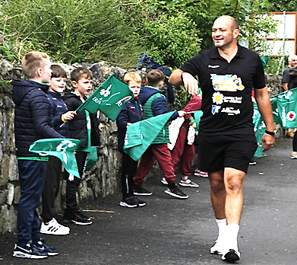***Rory Best walks through Bohola!***

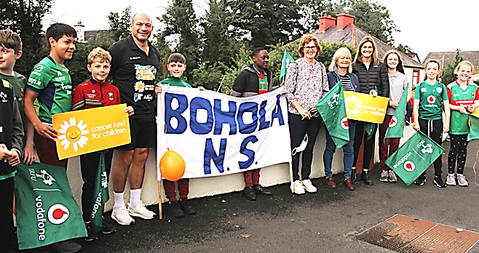

**Imagine a world where YouTube,**





**Twitter and Facebook**

**merge to become known as**

***YouTwitFace.***