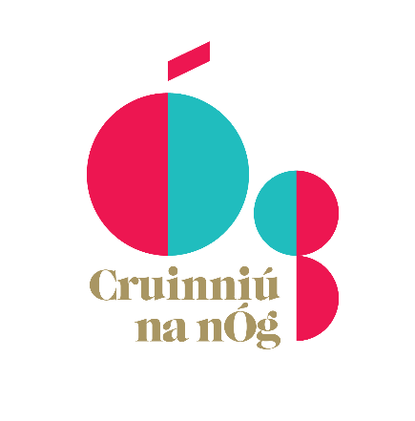

Creative Ireland Funding for Creative projects for Children and Young People
Cruinniú na nÓg 2021

Do you have an idea for a creative project for children and young people? Now you can make it happen! Mayo County Council is seeking proposals for projects to take place on Cruinniú na nÓg, the national day of creativity for children and young people on June 12th.
Artists, crafters, dancers, storytellers, makers, street artists, heritage workers, musicians, re-enactors, coders and workers in science and technology and all manner of experienced creative professionals, in any artform, craft or creative sphere are invited to make a proposal. Traditional skills practitioners or others with an expertise in landscape, flora & fauna/biodiversity, folklife, archaeological heritage, built heritage, history, vernacular architecture or any related field are also encouraged to consider how they might engage with Cruinniú na nÓg and its aim of doing, making, creating. Any practitioner, venue, organisation or community group may make a proposal.
Cruinniú na nÓg takes place on Saturday 12 June 2021 and will be a day of celebrating and encouraging children and young people to take part in cultural and creative events around the county. This will include a mix of performances, demonstrations, coding, theatre, workshops, readings and screenings, special events and much more. Due to Covid 19 restrictions it is likely that most of the events will be online.
Events will be free with plenty of opportunities for young people to get doing, making and creating. Events can take place at suitable locations that comply with Covid 19 regulations proposed by the applicant, but most will probably be online.
A total fund of €15,000 is available to cover the cost of selected events. Austin Vaughan, Mayo Creative Ireland Coordinator is encouraging event proposers to bear this in mind in terms of scale and cost.
“Mayo County Council will cover some of the costs of the selected events including the costs of hiring artists or other culture or creativity sector practitioners and the costs of materials. However, it will not be possible to approve all proposals in which case funding will be allocated to those events which best meet the objectives of Cruinniú na nÓg. The aim is to provide variety in terms of cultural & creative experience, age groups and locations, all of which will be considerations when deciding on applications. We understand that most events will be online this year due to the ongoing pandemic”.
The deadline for receipt of proposals is Friday March 12th at 5pm.
Completed forms should be emailed to avaughan@mayococo.ie or delivered to Creative Ireland, Mayo County Library HQ, The Mall Castlebar. For queries contact Austin Vaughan at avaughan@mayococo.ie or at 0949047922.
Cruinniú na nÓg is an initiative of the Creative Ireland Programme which aims to enable the creativity of every child and young person. Local Authorities are leading on creating a programme of events to showcase and share opportunities for children and young people.

Selection Criteria
- The extent to which the proposed event/project maximises children, youth and community engagement
- The extent to which the proposed event/ project is innovative, cross-sectoral and fosters creativity in children and young people
- The potential scope of the event/project and anticipated target audience, including culturally diverse participants and audience
- The cost of the proposed event/project
- The feasibility of completing the project and running the event on 12th June 2019

Conditions

- All projects must be run/displayed/held on 12th June 2021.

- The project must be online or (if restrictions allow) have a free public event or showing in Mayo.

- Part of the funding may be used to purchase materials / to engage an expert to assist in the creation of new work / to fund an exhibition / or performance of new work.

- Funding provided by Creative Ireland Mayo must be acknowledged in all publicity material associated with the work. Mayo County Council must also be acknowledged. Logos are available from avaughan@Mayococo.ie.

- Failure to acknowledge appropriately may result in funding being revoked.

- Successful applicants will be asked to provide a short written report describing their experiences, audience numbers and the impact of the event/events.

- The selection panel reserves the right not to grant an award if the standard of applications does not satisfy the criteria of the award in full.

- Only proposals with completed applications will be considered.

- Proposals and applications will be held by Mayo County Council for one year.

- All applicants must be compliant with relevant legislation including Children First.

How to Apply
The application form and all supporting material must be completed and submitted by email to avaughan@Mayococo.ie

Closing date for receipt of completed proposals is 5pm on Friday 12th March 2019

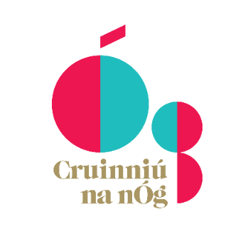

Mayo Cruinniú na nÓg 2019

APPLICATION FORM

Contact Name: _____________________________________________________________

Address: _____________________________________________________________

_____________________________________________________________

_____________________________________________________________

Telephone: _______________ Mobile: _________________ E-Mail:_______________________

Please tick the art form(s) you are seeking funding for:

- Heritage
- Circus
- Coding
- Crafts
- Dance
- Film
- Literature
- Music
- Heritage
- Performance Art
- Storytelling & folklore
- Science and technology
- Traditional Arts
- Visual Arts
- Digital

- Other_________________________________________________

Please give details of any previous experience in project development and delivery.

_________________________________________________________________________

_________________________________________________________________________

_________________________________________________________________________

Title of the project /event for which you are seeking funding

_________________________________________________________________________

Start date: ___________________ End date: ___________________

Please give the fullest information possible about the project/event (maximum 500 words on an additional page) including details and the impact it will have on event participants.

Please attach the following required documents:
Detailed Budget
CVs of project facilitator and/or expert

Please attach any other supporting materials such as:
Examples of previous work with young people aged 0-18
Any documentation that you feel supports your proposal

Total Amount of the Project/Event _______________________________

Total Amount you are requesting _____________________________________

I declare that the information supplied in this proposal is accurate and complete.
I understand that all information provided in respect of the Cruinniú Application will be held electronically for no more than 12 months and it should be noted that the Freedom of Information Act applies to all records held by Mayo County Council.

Signed: ______________________________________ Date: _____________

Completed applications should be emailed to avaughan@Mayococo.ie

CLOSING DATE FOR RECEIPT OF COMPLETED APPLICATIONS
5pm on Friday 12th March 2021

