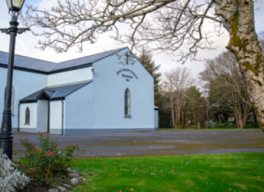 | Church of the Holy Family, Ballycroy  Mass Centre - National School - Innisbiggle  Christopher J. Ginnelly  (098) 49 134 (086) 89 33 278  ballycroyparish@gmail.com  James M Cribben, Geesala (087) 64 69 016  28th Mar – 4th Apr 2021  www.ballycroyparish.ie
The Year of St. Joseph 2021
Mass at 11am will be Broadcast on our Facebook Page
The outside speaker will be in operation if you wish to listen to the mass on the grounds. Special Thanks to Cathy / Nora for operating the live broadcast on Facebook and to Shelly for the beautiful selection of music and hymns.

Holy Week Ceremonies. Holy Week begins this Sunday. We accompany Christ in the last day of his life on earth. The Easter Triduum begins with the Lord’s Supper on Thursday night and continues then to Easter Sunday.

Palm Sunday

Sun 11am 1. Kathleen Corrigan (2nd Ann) Doona
2. Bridget Cleary, Knockmoyleen – London
3. Frank Leneghan – Dec’d Family (Doona), req-J.M. Leneghan Ohio
4. Bridget and Anthony Sweeney, Tony and Anne Walsh (Doohoma)
Please follow the Holy Week ceremonies on Facebook.

Wed 10am Shelia, Veronica McGuire, Dec’d Family

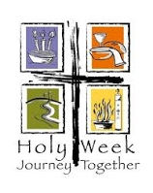Again this year, our celebrations will be very different due to the restrictions in place because of the Covid-19 Pandemic. As a Christian Community we cannot gather together for our usual religious services. The will not prevent us from uniting spiritually and taking time to pray, to reflect and to make this Holy Week a truly enriching experience of the presence of God in out lives. Please follow us on Facebook.

The Easter Triduum (The Three Very Special Days)

Holy Thurs 7pm Patrick, Mary Ellen Grealis (Lettra)
Good Friday 3pm Good Friday Ceremonies
Holy Saturday 8pm People of the Parish
Easter Sunday 11am People of the Parish

People are encouraged to visit the church and pray privately during Holy Week.
Our Beloved Dead Please pray for the Soul of Annie Calvey, Inisbiggle Island who was laid to rest in Ballycroy. May her Soul Rest in Peace.

Further Notices available on our Facebook Page

The Easter Collection for the Priest will be taken up next week. Please leave your envelopes in the box provided in the Post Office or in the Priest’s Letter Box. Sincere Thanks.
The Trocaire collection. Please put your contribution into an envelope marked Trocaire and leave in the Post Office or the Priest’s letter box. Sincere Thanks
The Sunday Church Collection/Envelopes – The church envelopes can be placed in a box marked “Church Envelopes” in the Ballycroy Post Office. Alternatively you can leave your envelopes in the letterbox at the priest’s house. Very sincere thanks for your contributions to the church and priests collections received to date. I also wish to thank AJ Keane and staff in the post office/shop. Thanks to Eoin Sweeney for the collection of envelopes during his visits to his customers.
Chiropodist Clinic for March Chiropodist Peter Armstrong will attend next Monday 29th March and there will be restrictions due to COVID-19 which will include limiting the number of patients that can be seen and patients needing to wear a face mask. The fee is now €10.
To book an appointment please contact Noreen Grealis 086 60 67 899 or Mary Masterson 098 49193.
Ballycroy LOTTO 21 Mar 2021 Winning Lotto Numbers 01 12 15 23 No Jackpot Winner No Match Three Winner Lucky Dip €20 Winner – Kathleen McGinty Play online at smartlotto.ie search Ballycroy. Special offer ongoing, play for 5 weeks and get the fifth week free!! Next week's jackpot is €4,950
Religious Catholic TV Channel – SKY EWTN Channel-589 – Daily Mass, Rosary, Reflections, Meditations. Live coverage of the Pope and his travels.
Keeping Children Safe: The Diocese of Killala is fully committed to keeping children safe. If you have any concerns around their safety in any circumstance please contact The Diocesan Liaison Person – Confidential No - 087 1003554. (Please see more information on the notice board).
Supplementary Pages for Online:
RTE Schedules for Easter
Palm Sunday 28th March –
RTÉ News Channel, 2.15pm, Mass from the Cathedral of SS. Patrick and Felim, celebrated by Bishop Martin Hayes - https://www.churchservices.tv/cavancathedral
Monday – 29th March
RTÉ News Channel, 1030am, Mass, Holy Family Church, Ardfinnan, Co Tipperary - Fr Michael Toomey - https://www.churchservices.tv/ardfinnan
Tuesday – 30th March
RTÉ News Channel, 1030am - Mass, Mary Immaculate Refuge of Sinners, Rathmines Dublin - Fr Andrew O'Sullivan - https://www.churchservices.tv/maryimmacdublin
Wednesday – 31st March
RTÉ News Channel, 1030am - Mass, The Star of the Sea Church, Riverchapel, Courtown, Wexford - Fr Tom Dalton - https://www.churchservices.tv/riverchapel
Holy Thursday - 1st April
RTÉ One, 16.40 (repeated Radio 1 Extra / LW252, 1900) - Mass of the Lord's Supper celebrated by Fr Martin Smith (Chaplain, Carlow IT) with members of RTÉ Cor Linn
Good Friday - 2nd April
RTÉ One / Radio 1 Extra / LW252, 1500-1600 - Solemn Liturgy for Good Friday from Knock Basilica. Chief celebrant is the Rector of the National Shrine, Monsignor Richard Gibbons. The Choir is the Schola Cantorum Basilicae directed by Úna Nolan. The Organist is Mark Keane.
There is also a liturgy in Irish at the same time on Raidio na Gaeltachta: Dé hAoine 02 Aibreán 2021, 15.00 - 16.00 Searmanas na Páise: Searmanas Aoine an Chéasta beo ó Shéipéal Ghobnatan i gCúil Aodha, Co, Chorcaigh.
Holy Saturday - 3rd April
RTÉ One, 1200 noon. Countdown to Calvary (Rpt). Downton Abbey star and Cambridge University theology graduate, Hugh Bonneville, tells the story of the last days of Jesus' life.
RTÉ One / Radio 1 Extra / LW252, 2300-0015 - Easter Vigil Mass from Knock Basilica, which is to be recognised by Pope Francis on 19 March as an International Marian and Eucharistic Shrine. Chief celebrant is the Rector of the National Shrine, Monsignor Richard Gibbons. The Choir is the Schola Cantorum Basilicae directed by Úna Nolan. The Organist is Mark Keane. 2240-2355 on RTÉ One. (Radio will air it with a slight delay at 2300.)
Easter Sunday 4th April
RTÉ One / Radio 1 Extra / LW252, 1000-1100 - Easter Sunday Mass from « La Carità » COVID hospital in Locarno, Switzerland, celebrated by the Archpriest of Locarno, Fr Carmelo Andreatta, with commentary and translation by Fr Thomas McCarthy OP (This Mass will air with a delay on Radio 1 Extra / LW252 in our regular slot at 1100-1200).
Service for Easter Sunday in the RTÉ Studios, Donnybrook.
1100-1145 There is also a Mass in Irish on Raidio na Gaeltachta from 1100-1145. Dé Domhnaigh 04 Aibreán 2021
Aifreann an Domhnaigh ó Shéipéal Ghobnatan i gCúil Aodha, Co Chorcaigh.
12.25-12.55 (approx) Pope Francis' Easter Urbi et Orbi Message and Blessing will follow live coverage of the 1916 commemoration by President Michael D. Higgins

COVID-19 Support Line for Older People: ALONE manage a national support line and additional supports for older people who have concerns or are facing difficulties relating to COVID-19 (Corona virus). Professional staffs are available to answer queries and give advice and reassurance where necessary. The support line is open seven days a week, 8am - 8pm, by calling 0818 222 024.

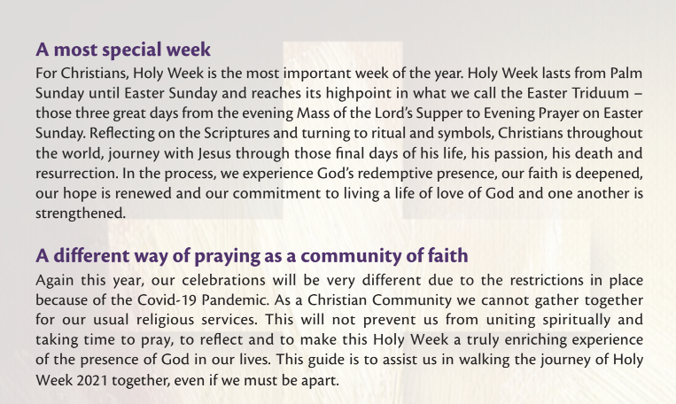

Covid-19 Collect and Deliver Service: Helping people to stay at home is the new role of Local Link Mayo rural transport services. Local Link Mayo is offering a collect and deliver service in existing Local Link routes throughout Mayo from pharmacies and local shops, delivering shopping and critical medical supplies to the elderly, the vulnerable and sick. If your need of such support or know someone who does, contact Local Link Mayo on 094 900 5150 between 9:00am and 5:00pm (M-F) or email mayo@locallink.ie

Religious Catholic TV Channel – SKY EWTN Channel-589 – Daily Mass, Rosary, Reflections, Meditations. Live coverage of the Pope and his travels. Keeping Children Safe –
Keeping Children Safe: The Diocese of Killala is fully committed to keeping children safe. If you have any concerns around their safety in any circumstance please contact The Diocesan Liaison Person – Confidential No - 087 1003554. (Please see more information on the notice board).

