***Offertory Donations:***

This Week: €530.



Thanks for all your contributions

**Bohola/Shraheens Newsletter**

**Stephen O’Mahony PP – 094-9384115/086-8226405 –** [**boholaparish@gmail.com**](mailto:boholaparish@gmail.com) **(email for newsletter)**

<https://www.mayo.ie/news/category/connect/parish-news/bohola-parish-news/>

**First Sunday of Lent – 21st February 2021**

###### Masses for the Week

**Masses listed below will be live-streamed on the *Bohola Post Facebook Page* and broadcast locally on *Radio 105.5 FM*.**

|  |  |  |
| --- | --- | --- |
| **Sunday, February 21st.** | **10.00am** | **Mary Healy, Gortnasella.**  **Johnny & Nora Byrne, Toughnane, daughter Mary & son-in law, Vincent.**  **Bridie & Bill Kelly, Altinea, & their niece, Ann Murphy, Killorglin.** |
| **Wednesday, February 24th.** | **6.00 – 8.00pm** | Exposition of the Blessed Sacrament (private prayer). |
| **Friday, February 26th.** | **8.00pm** | Tommy (Tom) Walsh, Ardacarra and Queen of Peace Nursing Home, Knock (Month’s Mind). |
| *Mass will be celebrated privately on other weekdays.* ***The Mass for All the People of the Parish will be offered during the week.*** | | |
| **Sunday, February 28th.** | **10.00am** | **Deceased of the Healy family, Gortnasella (Michael & Kathleen Healy, Tommy Healy, Mary Healy and Nancy & Noel O’Neill).** |

***Recent Deaths:*** Please pray for the happy repose of the souls of the following:

*Mattie Foy*, Ara, whose funeral took place in Balla on Wednesday last.

*Eileen Boggins (née Lyons)*, Foxford and formerly of Lisgorman and Ardacarra, wife of the late Andy Boggins and brother of the late Mike Lyons, Lisgorman, who passed away on Monday last, February 15th and whose funeral took place in Foxford on Friday.

*Shirley Burke*, Nottingham, England, mother of Diane and Helen Burke, Boleyard, who passed away on Thursday, February 11th and whose funeral will take place in Nottingham at a later date.

*Mary Ansboro*, Stockton-on Tees, England, wife of the late Tommy Ansboro, formerly of Carroward, who passed away in Stockton-on- Tees on Thursday last, February 18th.

*Ann Murphy*,Killorglin, Co Kerry, niece of the late Bridie & Bill Kelly, Altinea, who passed away on Friday last, February 19th.

We extend sympathy to their families and pray they are at peace.

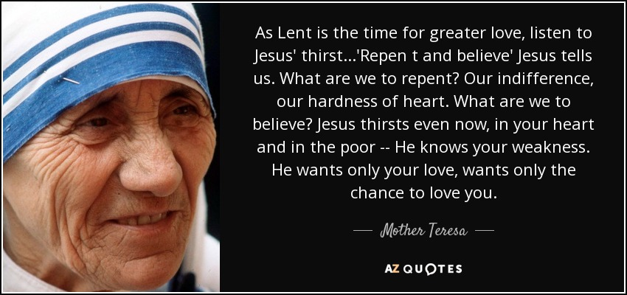***Weekday Masses*** can be live-streamed should there be a demand or if there is a special intention at any time. If there are any other suggestions as to what might be possible in the very restricted circumstances we find ourselves in, just get in touch with any member of the Pastoral Council.

***Praying at Home During Lent:*** The dioceses of Elphin and Clonfert have prepared some online resources for praying at home during Lent. They are available on our diocesan site *https://achonrydiocese.org/lent2021/*.

***Trócaire Lenten Campaign*** this year focuses on the suffering of people who have lost their homes and loved ones to war, and how they are rebuilding their lives through love, friendship and solidarity. There is particular reference to South Sudan where conflict and poverty are a reality for many families. Find out more by visiting [*https://www.trocaire.org/*](https://www.trocaire.org/).

*Trócaire Boxes* are available and can be collected in the church. Donations can also be made online. Please make whatever sacrifice you can to help *Trócaire’s* great work throughout the world.

***New Pilgrim Path Website of the Week, February 21st:*** For Lent, BBC Radio 4 will explore aspects of Ignatian spirituality in their daily Morning Service and Sunday Worship, drawing on ‘Knowing Jesus’, a superb online retreat being offered by the Ignatian Spirituality Centre in Glasgow.

This multifaceted retreat provides daily reflections, an introduction to different ways of praying, stillness and awareness exercises, imaginative contemplation exercises, lectio divina, praying with art (a different image for each day of Lent) and many more. It is available to anyone in the world with access to the Internet who wants to immerse themselves in the spirituality of St Ignatius. For this and other great online Lent resources, visit [***www.newpilgrimpath.ie***](http://www.newpilgrimpath.ie).

***Priesthood in Achonry Diocese:*** “Jesus went into Galilee. There he proclaimed the Good News from God” (Mk 1: 12). Is He asking you to follow Him by proclaiming the Good News to the people in your Diocese as a priest, a deacon or in the consecrated life? Speak to your local priest, call your Diocesan Vocation’s Director or email the National Vocations Office on *info@vocations.ie*. For further information contact our Vocations Director, **Fr Paul Kivlehan, The Presbytery, Ballaghaderreen, Co. Roscommon. Tel.094-9860011, Mobile 087-3683535, E-mail** [***pkivlehan@achonrydiocese.org***](mailto:pkivlehan@achonrydiocese.org).

***The 2021 Western People Martin Sheridan Bursary Awards Scheme*** is now open for applications. €5,000 in funds is available to support athletes from Co. Mayo. Further details and application forms are available by emailing [*martinsheridanbursary@gmail.com*](mailto:martinsheridanbursary@gmail.com). Closing date for completed application forms is **April 16th.**

***Covid-19 Collect and Deliver Service:*** Helping people to stay at home is the new role of Local Link Mayo rural transport services. Local Link Mayo is offering a collect and deliver service in existing Local Link routes throughout Mayo from pharmacies and local shops, delivering shopping and critical medical supplies to the elderly, the vulnerable and sick. If you need such support or know someone who does, contact Local Link Mayo on ***094-9005150*** between 9:00am and 5:00pm (M-F) or email *mayo@locallink.ie*.

***COVID-19 Support Line for Older People:***Professional staff are available to answer queries and give advice and reassurance where necessary. The support line is open seven days a week, 8am to 8pm. The contact number is ***0818-222024***.

***Bealach Nua:*** We are a recovery-oriented family peer support service which offers families/friends of people with mental health challenges an opportunity to engage with family peer supporters through individual, group work, wellness days and information evenings. To access the service, please call *094-9049392*, Fran on *086-0450835* or Noel on *087-9749288*.



***Knock Shrine Online During Lent:*** This year Knock Shrine offers a series of online opportunities for prayer and reflection.

*Awaiting a New Dawn’* Join us online each Friday evening during the month of February as we come together virtually for a period of extended prayer and reflection. Join us live online from 7pm for Rosary, the celebration of the Eucharist and a Holy Hour from Knock Parish Church. See *www.knockshrine.ie/watch-live* and our Facebook page.

*‘Exploring the Word of God through Prayer’ Scripture Reflections:* Every Tuesday night at 8pm, Knock Shrine will show a series of online night prayer with reflections on scripture. Students from St Louis Community School, Kiltimagh, will deliver this series of talks inspired by Scripture. These young people will take their favourite passage of Scripture, something that speaks to them and reflect on it through video, providing their own written narrative and imagery. We are inviting people to join us for these online talks, to end the day in a prayerful and peaceful way and to enjoy a quiet time of reflection through various aspects of Scripture. To join, simply log on to *www.knockshrine.ie* at 8pm each Tuesday evening.

*'Living Christian Faith - Lenten Conversations'*. The talks will be streamed at 8.30pm every Thursday during Lent. Join us at [*www.knockshrine.ie/watch-live*](http://www.knockshrine.ie/watch-live) or on *Facebook @knockshrine*. The next talk on Thursday, 25th February, *'Living Christian Faith as Young Adults'* ……….. A group of young Irish adults, for whom Christian Faith is of great importance, will discuss the strength it gives them and how we can better communicate the joy of the Gospel today.

***Galilee Spirituality Centre:*** *Caring for our Common Home: Coming together with Laudato Sí (Pope Francis’ letter to the world on the environment)* presented by Ms Jane Mellett, Laudato Sí Officer, Trócaire.Action: Getting down to Working for our Future (February 23rd). A short presentation will be followed by questions and a facilitated discussion,7.30 – 8.30pm via Zoom.Co-hosted by the Galilee Spirituality Centre, Pastoral & Faith Development Services (Diocese of Elphin) and Trócaire.Booking: [*info@galilee.ie*](mailto:info@galilee.ie).

***Part-Time Certificate in Religious Education (Primary):*** St Angela’s College, Sligo, invites applications for the following course, beginning Autumn 2021: *Part-Time Certificate in Religious Education (Primary) with Online Delivery*. The course is open to qualified primary school teachers and qualified post-primary school teachers who wish to transfer to primary school teaching. Parents, sacramental preparation teams and parish catechists who have a specific interest in the area of primary religious education may also apply. Closing date for Applications is Friday, 14th May. This date may be extended. For further information and application forms, contact Mary Kearns, Senior Administrator, School of Education, St. Angela’s College, Lough Gill, Sligo. Email *mkearns@stangelas.nuigalway.ie* or visit *www.stangelas.nuigalway.ie*.

***Free Online Living Well Programme:*** The next programmes commence on *Friday, 26th February, Tuesday, 9th March, Thursday, 25th March, Tuesday, 6th April and Friday, 9th April.* on the zoom platform. Limited places. If you are living with a long term health condition, you may be interested in doing the ‘Living Well Programme’. This is a six-week programme delivered in 2.5 hour weekly sessions where you will learn new skills to manage your health condition on a day to day basis. You must register in advance as places are limited to 10/12 participants. Please note you do not have to disclose your health condition on the programme. Please contact Liam Gildea on *087-3490393* or by email at [*liam.gildea@mayocil.ie*](mailto:liam.gildea@mayocil.ie). You can find out more information on the programme on our website: [*www.hse.ie/livingwell*](http://www.hse.ie/livingwell).

***For Lent this year, I’m just giving up!***