Information for Sports Clubs and National Governing Bodies in Sport in Mayo
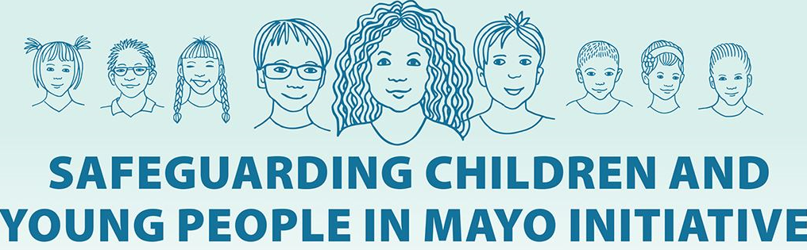
The Safeguarding Children and Young People in Mayo Initiative
The Safeguarding Children and young people in Mayo is a new initiative in Co. Mayo to support individuals and organisations that provide activities for children and young people. The Initiative will provide training and information around the legal requirements of working with children arising from the Children First Act 2015 and Children First National Guidance. It will also provide information , template documents and a series of information sheets in relation to Children First and best child safeguarding practices.
The Safeguarding Children and Young People in Mayo Initiative is a partnership of agencies who are members of the Sub-group of the Mayo Children and Young Persons Services Committee (CYPSC), including Tusla, Western Care, Foroige, Mayo Women’s Support Services, ISPCC, Mayo Sports Partnership, Mayo County Childcare Committee, Claremorris FRC and Mayo Volunteer Centre.
The Safeguarding Children and Young People in Mayo Initiative Poster
It is hoped that groups and individuals in Mayo will show their commitment to child safeguarding by tailoring the poster below and displaying it in areas where parents/carers and young people will see them. Use of this poster is totally voluntary and the Initiative hopes it will be used by organisations to highlight that they are meeting their legal obligations and are committed to best practices in child safeguarding. NB. This Poster does not replace the legal requirement for ELC’s who are Providers of Relevant Services to have their Child Safeguarding Statement displayed publicly also

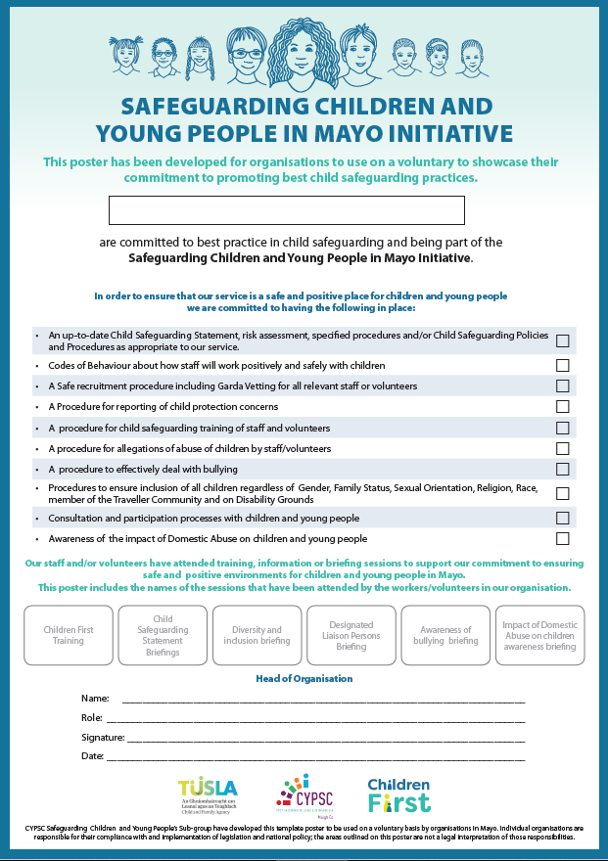

For your information The Safeguarding Children and Young People in Mayo Initiative is offering a number of briefings in relation to Children First and other child safeguarding areas. You may see advertisements in the local paper in relation to this. As you are aware NGB’s and Sports Clubs in Mayo receive Code of Ethics Training through the Mayo Sports Partnership and receive information and child safeguarding templates through their NGB’s and Sport Ireland. The Children First briefings and DLP briefings being offered through this Safeguarding Initiative are targeted at those individuals or groups who may not have access to training and information through other organisations. The briefings are available to anyone who would like to update or refresh their knowledge but cannot be undertaken in place of the specific Sport Ireland Code of Ethics training programmes offered through Mayo Sports Parnership.

Mayo Sports Partnership support the use of the above poster by Sport organisations. Where indicated clubs can outline the training they have received such as Code of Ethics training- Safeguarding 1 (Basic Awareness) Safeguarding 2 (Childrens Officer) & Safeguarding 3 (DLP) on the poster.

The posters and leaflets attached can be supplied in hard copies and are available to any individual or group in Mayo. Please email below for copies or if you require any further information contact - sandra.claxton@tusla.ie or Jarlath.munnelly@tusla.ie.
Other posters and leaflets available are below:
Reporting Procedure Poster
A poster to be used by organisations to outlined their procedure for reporting child protection concerns. It outlines the local social work and Garda numbers so that everyone in an organisation knows what steps to follow.
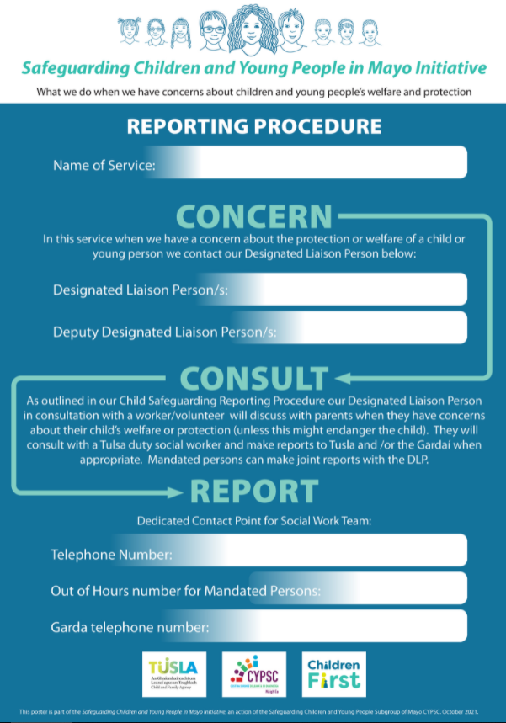

CHILDREN FIRST LEAFLETS

“Children First Leaflet for organisations”
A General information leaflet for organisations/groups, staff/volunteers and members of the public about the requirements under the Children First Act 2015 and Children First National Guidance.
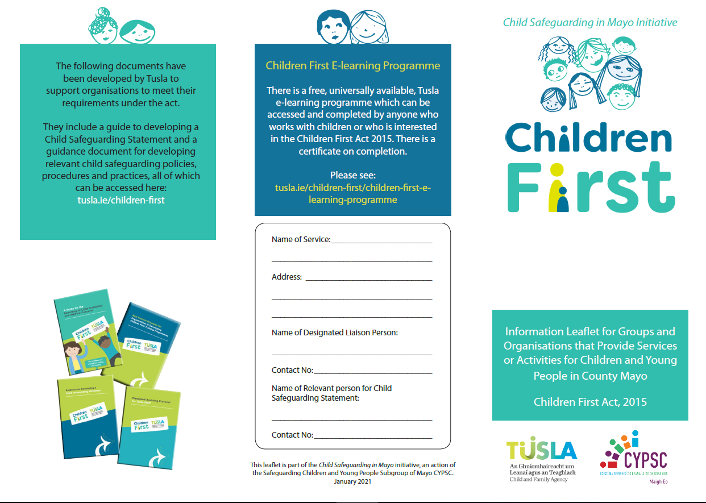
“Safeguarding Children and Young People in our organisation”
A leaflet for organisations to tailor and give to parents/carers, young people to outline their responsibilities as an organisation in relation to Children First.

