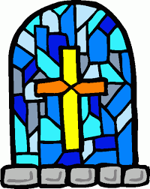
KILLASSER/CALLOW

PARISH NEWSLETTER

Fr. John Durkan (094) 9024761/087 9548532 No 319 E-mail: frjohnd@gmail.com

9th May 2021

OFFERTORY TROCAIRE
Thanks so much for putting your collections through my letterbox. Please continue to do so and thanks for supporting the Priests Collection for myself. It is deeply appreciated! If you want to pay your offertory donation online go to anchonry diocese website and follow the instructions on the web page. The address is www.achonrydioese.org

CORONA VIRUS UPDATE
From the 10th of May, we can now go to weekday mass and week-end mass with up to 50 people. I am inviting all those who used to come to week-day mass to come from the 10th of May.
Mass will be at 10am on Sunday the 16th in Callow- no more mass at 10 in killasser from the 16th of May. I hope we can record that mass and put it up on facebook each week.
No first communions are allowed until the Autumn- the teachers agreed on this with parents ages ago.
So keep safe and pray well!

TO THE PARISH & THE WORLD
The webcam is now working. The address is mcn Media tv/ livestreaming/all-saints-killasser. Anyone can book an intention for any of the masses at the moment. When the Churches do open we may have to restrict that to 1 intention because we will no doubt be restricted in our numbers then.
I got a lovely card from John & Eileen Tuffy in the USA saying they can see the masses on the web-cam loud and clear. Thanks John & Eileen.

MASS INTENTION FOR THE NEXT 4 MONTHS
Sat 8th Killasser 7pm Eddie & Bridie Thompson, Doontas
Sun 9th Killasser 10am Morning Mass
Mon 10th Killasser 10am Morning Mass
Tues 11th Killasser 7pm Evening Mass
Wed 12th Killasser 10am Morning Mass
Thurs 13th Killasser 10am Morning Mass
Fri 14th Killasser 7pm Henry Groarke, Carraweeny & Groarke & Price deceased.
Sat 15th Killasser 7pm Hugh Fitzmaurice, Creggaun
Sun 16th Callow 10am Morning Mass
Sat 22nd Killasser 7pm Mat Rowley, Sean & Kathleen, Cloonfinish.
Sun 23rd Callow 10am Morning Mass
Friday 28th Killasser 7pm Philip Howley 1st Anniv, Carramore-moy, USA.
Sat 29th Killasser 7pm Tom & Mae Tuffy & deceased
Sat 5th June Killasser 7pm Brigid & Thomas Kavanagh, Carramore & deceased Kavanagh & Kilbride.
Sun 6th Callow 10am Patsy Rowley & parents John & Anne Mc Gloin, Cuillonaghton
Sat 10th July Killasser 7pm Mia Ginty, Rubble. Remembering Paraic & Mary Durkan & Durkan & Ginty deceased family members
Sun 18th Callow 10am Cormac Sheil Jnr & Cormac Sheil Snr. Mary Sheil & Maura Sheil.
Sun 25th Callow 10am Patrick Noone, Knockbawn
Patrick & Bridget Timlin, Prebann

PRAY FOR
Nellie Lavelle, Ballyliffin, cousin of Fr John Durkan
Carmel Aylmer, formerly Kirrane, Callow & sister of Pauline Kirrane, who died in Dublin.
Margaret Ward, Doontas & Birmingham, sister-in-law of Evelyn Ward, Doontas
John Dunne, Cloonfinish & Bridgeend, Wales

PILGRIMAGE TO KNOCK
The Achonry Clonfert and Galway virtual pilgrimage to Knock takes place on Sunday 16th of May in Knock Basilica. The pilgrimage season traditionally begins at Knock Shrine on the last weekend in April. This year, we will continue to hold weekend pilgrimages virtually on Sunday afternoons. Ceremonies will be streamed live from KnockBasilica and will commence with Rosary at 2.30pm, followed by Mass at 3pm.
Live stream will be available on our website, the KnockShrine Facebook page and on our YouTube channel. We invite you to join us online from the comfort of home. You may like to include your prayer intentions in the Mass, to light a candle here at Knock Shrine on the day or to remember someone special with an annual enrolment in the Knock Shrine Friends Association. All of these services are available online on our website.

CORONA VIRUS HEPLINE
Corona Virus helpline for older people - 0818 222 024.
If you have concerns or queries about COVID-19 call ALONE’s dedicated support line everyday, 8am to 8pm. To volunteer your help, visit www.alone.ie.

ARMCHAIR AZURE TOURS IN MAYO
Mayo County Council Arts Service in partnership with local arts venues is delighted to announce Armchair Azure, a new series of free Dementia Inclusive Friendly virtual visual art tours. For those living with dementia, the virtual visual art tours are an accessible way of engaging with art online. Tours are one-hour long and are guided by a trained dementia inclusive facilitator who will guide participants through a selection of visual artworks while actively encouraging conversation and responses to each work. People are welcome to share the tour with a family member, a friend or a carer.
Contact Katriona Gillespie at Mayo County Council Arts Service at mayoarts@mayococo.ie or phone 094 9064666. We will be happy to answer your questions.
Tours will take place at 11am on the following dates: April 19th and 26th | May 4th and 17th | June 7th

VILLAGE IMPROVEMENT
Phase 1 of the village improvement is nearly complete. We plan to plant 4 trees along the road adjacent to the football pitch and are inviting anyone or family from the community to sponsor a "remembrance tree" in memory of a loved one. This will cost €400 & covers the cost of the tree, a tree grill, labour & a personalised name plate. If you or your family wish to participate please contact me by Wednesday 5th May. If there are more than 4 interested we will select the 4 participants by a draw. There will be future opportunities to sponsor a tree or bench in the next phase of the improvements. Thanks very much. Paul Hyland

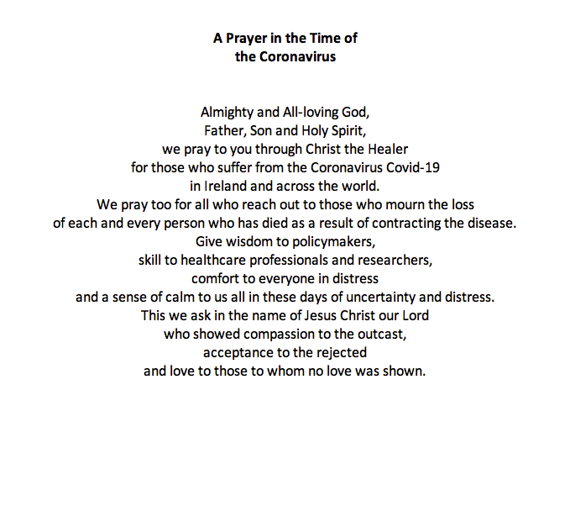

World Meeting of Families Prayer
God, our Father,
We are brothers and sisters in Jesus your Son,
One family, in the Spirit of your love.
We ask you to bless Killasser and Callow – Our Parish.
Bless us with the joy of love.
Make us patient and kind,
gentle and generous,
welcoming to those in need.
Help us to live your forgiveness and peace.

Protect all families with your loving care,
Especially those for whom we now pray:
[We pause and remember family members and others by name].
Increase our faith,
Strengthen our hope,
Keep us safe in your love,
Make us always grateful for the gift of life that we share.
This we ask, through Christ our Lord,

