KILLASSER/CALLOW

PARISH NEWSLETTER

Fr. John Durkan (094) 9024761/087 9548532 No 327 E-mail: frjohnd@gmail.com

14TH SUNDAY IN ORDINARY TIME 4th July 2021

VISIT OF BISHOP PAUL DEMPSEY

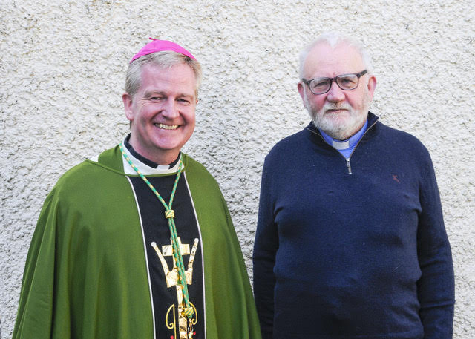

MASS INTENTION FOR THE NEXT 4 MONTHS
Sat 3rd Killasser 7pm Dan & Mary Kate Conlon, John & Maureen and Des, Boleyboy
Sat 10th Killasser 7pm Mia Ginty, Rubble. Remembering Paraic & Mary Durkan & Durkan & Ginty deceased family members
Sat 17th Killasser 7pm Tom Campbell (10th Anniv) & Eileen Campbell ( 1st Anniv), Carrabeg
Sun 18th Callow 10am Cormac Sheil Jnr & Cormac Sheil Snr. Mary Sheil & Maura Sheil.
Sat 24th Killasser 7pm Joe Ward & recently deceased sisters, Annie & Margaret, Doontas
Sun 25th Callow 10am Patrick Noone, Knockbawn
Patrick & Bridget Timlin, Prebann
Sat 31st Killasser 7pm P.J & Aemelia Cronnolly, Doontas.
Sun 1st August Callow 10am Ann Sheerin, Coolegrane
Paraig & Mary Meehan. Cloonfinish
Sat 7th Killasser 7pm Molly, Jim, J.P. & Pat Heaney, Derreen
Thurs 12th Killasser 7pm Maggie Ellen & Martin Loftus & Seamus & Nuala, Gurteen
Sat 14th Killasser 7pm Katie & Martin Quinn, Anniv, Drumada-Joice
Sun 15th Callow 10am Tom & Delia Gallagher, Joe Gallagher. Anniv
Sun 15th Killasser 11.30am Val Hyland, Carramore-Moy, 1st Anniv
Sat 4th Sept Killasser 7pm Bridget Fitzmaurice, Creggane
Sat 11th Killasser 7pm Fr. Jimmy O’Grady, Carrawnea & Los Angeles
Sat 18th Killasser 7pm Kathleen Rudy, Cloonfinish
Sat 25th Killasser 7pm Martin Joe Hegarty, parents Margaret & Frank Hegarty, Carrowliambeg
Sat 23rd Oct Killasser 7pm Michael Mc Nulty, Carrowneden
Sat 6th Nov Killasser 7pm Tom & Bridie Greally, Ballyhaunis, daughter Joan, Featherstone & grandson Martin Brehony

PRAY FOR
Eileen Clarke, Foxford, aunt of Ian Clarke, Oulogue & Mairead Brady, Cloonygowan
Maura Tunney, Redhill, Surrey, U.K, & Cullen
Sabina O’Driscoll, nee Franey, London & formerly Doontas
Nancy Moriarty, sister of Sonny Hanley, Clooncleveragh
Bill (William) Swords, Husband of Bridie Ruane, Cullenaughten
Kathleen Henry– nee Reynolds, sister of Eileen Mc Nicholas, Callow- died in Manchester, formerly Oulogue

OFFERTORY TROCAIRE
Thanks so much for putting your collections through my letterbox. Please continue to do so and thanks for supporting the Priests Collection for myself. It is deeply appreciated! If you want to pay your offertory donation online go to achonry diocese website and follow the instructions on the web page. The address is www.achonrydioese.org.

CORONA VIRUS UPDATE
We can now go to weekday mass and week-end mass with up to 50 people.
Mass will be at 10am on Sunday in Callow- no more mass at 10am in Killasser. I hope we can record that mass and put it up on facebook each week.
No first communions are allowed until the Autumn- the teachers agreed on this with parents ages ago.
So keep safe and pray well!

CONGRADULATIONS TO:
Mary & Sean Durkan (Rubble), who married on 8th July 1971 in Killasser and will soon be 50 years married. They now live in South Yorkshire.

READINGS
We would like people who attend daily mass to think about doing the reading at the mass to help out those who do it all the time.

TO THE PARISH & THE WORLD
The webcam is now working. The address is mcn Media tv/ livestreaming/all-saints-killasser. Anyone can book an intention for any of the masses at the moment. When the Churches do open we may have to restrict that to 1 intention because we will no doubt be restricted in our numbers then.

CORONA VIRUS HEPLINE
Corona Virus helpline for older people - 0818 222 024.
If you have concerns or queries about COVID-19 call ALONE’s dedicated support line everyday, 8am to 8pm. To volunteer your help, visit www.alone.ie.

NATURE MATTERS
Nature Matters is a group of parishioners who have come together to improve awareness of our environment and the importance of biodiversity. New members are always welcome.

I have come to terms with the future. From this day onward I will walk easy on the earth.
Plant trees. Kill no living things. Live in harmony with all creatures. I will restore the earth where I am. Use no more of its resources than I need. And listen to what it is telling me.
M.J. Slim Hooey

