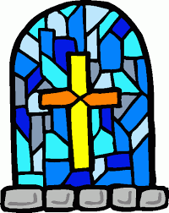
KILLASSER/CALLOW

PARISH NEWSLETTER

Fr. John Durkan (094) 9024761/087 9548532 No 322 E-mail: frjohnd@gmail.com

Feast of the Holy Trinity 30th May 2021

OFFERTORY TROCAIRE
Thanks so much for putting your collections through my letterbox. Please continue to do so and thanks for supporting the Priests Collection for myself. It is deeply appreciated! If you want to pay your offertory donation online go to anchonry diocese website and follow the instructions on the web page. The address is www.achonrydioese.org

FR JOHN JUDGES 40TH ANNIVERSARY
On the 6th of June Fr. John will be celebrating 40 years as a priest. He is saying mass in the church that day at 3pm. Thanks to the webcam a number of his relatives & friends and fellow priests can be able to take part via webcam.
We all know that only 50 people can be in the church for the celebration and that includes his relatives and family. But Fr John is inviting everyone to come and many of you will need to stay outside in your cars if raining and out of them if fine. Please observe social distance at all times. You will be able to hear the mass even though you are outside and it will be livestreamed on the webcam.
I want to thank Fr. John for his kindness to me ever since I came here & his friendship. We all pray that God will continue to bless him richly in his life & in his ministry.

CORONA VIRUS UPDATE
We can now go to weekday mass and week-end mass with up to 50 people.
Mass will be at 10am on Sunday in Callow- no more mass at 10am in killasser. I hope we can record that mass and put it up on facebook each week.
No first communions are allowed until the Autumn- the teachers agreed on this with parents ages ago.
So keep safe and pray well!

MASS INTENTION FOR THE NEXT 3 MONTHS
Sat 29th Killasser 7pm Tom & Mae Tuffy & deceased
Mon 31st Killasser 10am Morning Mass
Thurs 3rd June Killasser 7pm Maura & Kevin Meehan, Killaraght
Fri 4th Killasser 7pm Evening Mass
Sat 5th Killasser 7pm Brigid & Thomas Kavanagh, Carramore & deceased Kavanagh & Kilbride.
Sun 6th Callow 10am Patsy Rowley & parents John & Anne Mc Gloin, Cuillonaghton
Sat 19th Killasser 7pm Sonny & Kitty Hanley, Clooncleveragh.
Sat 26th Killasser 7pm John Holleran, Dunmaynor
Sat 10th July Killasser 7pm Mia Ginty, Rubble. Remembering Paraic & Mary Durkan & Durkan & Ginty deceased family members
Sat 17th Killasser 7pm Tom Campbell (10th Anniv) & Eileen Campbell ( 1st Anniv), Carrabeg
Sun 18th Callow 10am Cormac Sheil Jnr & Cormac Sheil Snr. Mary Sheil & Maura Sheil.
Sun 25th Callow 10am Patrick Noone, Knockbawn
Patrick & Bridget Timlin, Prebann
Sat 31st Killasser 7pm P.J & Aemelia Cronnolly, Doontas.

PRAY FOR
Miceal O’Hara. who died suddenly in Dublin, cousin of Fr John Judge.
Brendan O’Hara, Carramore & Meelick
Joe Dunne, Cartron.
John McDonell, Ballindine, son of John & Josephine McDonell, Lismorane, Callow
Nellie Lavelle, Ballyliffin, cousin of Fr John Durkan
Carmel Aylmer, formerly Kirrane, Callow & sister of Pauline Kirrane, who died in Dublin.
Margaret Ward, Doontas & Birmingham, sister-in-law of Evelyn Ward, Doontas

READINGS
We would like people who attend daily mass to think about doing the reading at the mass to help out those who do it all the time.

TO THE PARISH & THE WORLD
The webcam is now working. The address is mcn Media tv/ livestreaming/all-saints-killasser. Anyone can book an intention for any of the masses at the moment. When the Churches do open we may have to restrict that to 1 intention because we will no doubt be restricted in our numbers then.

CORONA VIRUS HEPLINE
Corona Virus helpline for older people - 0818 222 024.
If you have concerns or queries about COVID-19 call ALONE’s dedicated support line everyday, 8am to 8pm. To volunteer your help, visit www.alone.ie.

ARMCHAIR AZURE TOURS IN MAYO
Mayo County Council Arts Service in partnership with local arts venues is delighted to announce Armchair Azure, a new series of free Dementia Inclusive Friendly virtual visual art tours. For those living with dementia, the virtual visual art tours are an accessible way of engaging with art online. Tours are one-hour long and are guided by a trained dementia inclusive facilitator who will guide participants through a selection of visual artworks while actively encouraging conversation and responses to each work. People are welcome to share the tour with a family member, a friend or a carer.
Contact Katriona Gillespie at Mayo County Council Arts Service at mayoarts@mayococo.ie or phone 094 9064666. We will be happy to answer your questions.
Tours will take place at 11am on the following dates: April 19th and 26th | May 4th and 17th | June 7th

NATURE MATTERS
Nature Matters is a group of parishioners who have come together to improve awareness of our environment and the importance of biodiversity. New members are always welcome.

We're back! Since Easter we've had International Earth Day, National Biodiversity Week and Bee Day. Rather than bemoan the fact that we've missed out on those, let us remind ourselves that everyday is Earth Day, every week is Biodiversity Week and everyday is Bee Day. This week go out of doors and see the last of the primroses, say 'thanks' to the dandelions, listen to the cuckoo, welcome the buttercups, notice the glorious hawthorn hedges in full bloom and remember that, even if we humans are not yet encouraged to sing in choirs, birds are exempt from this Covid regulation! The dawn chorus can be heard every morning throughout this season.

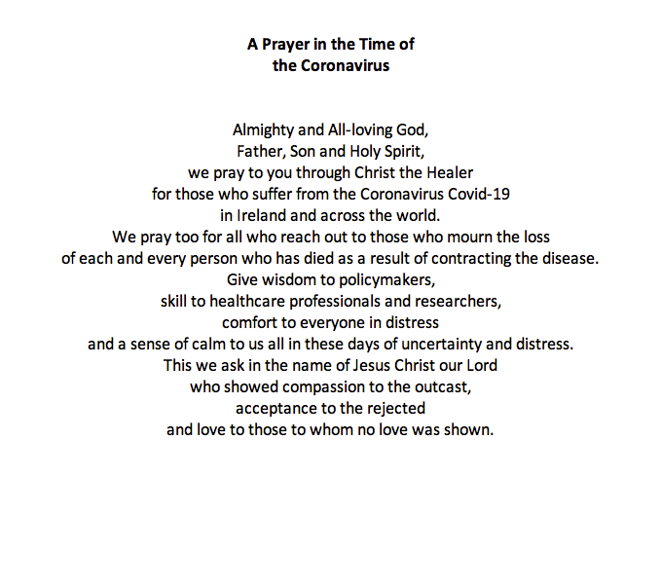

World Meeting of Families Prayer
God, our Father,
We are brothers and sisters in Jesus your Son,
One family, in the Spirit of your love.
We ask you to bless Killasser and Callow – Our Parish.
Bless us with the joy of love.
Make us patient and kind,
gentle and generous,
welcoming to those in need.
Help us to live your forgiveness and peace.

Protect all families with your loving care,
Especially those for whom we now pray:
[We pause and remember family members and others by name].
Increase our faith,
Strengthen our hope,
Keep us safe in your love,
Make us always grateful for the gift of life that we share.
This we ask, through Christ our Lord,

