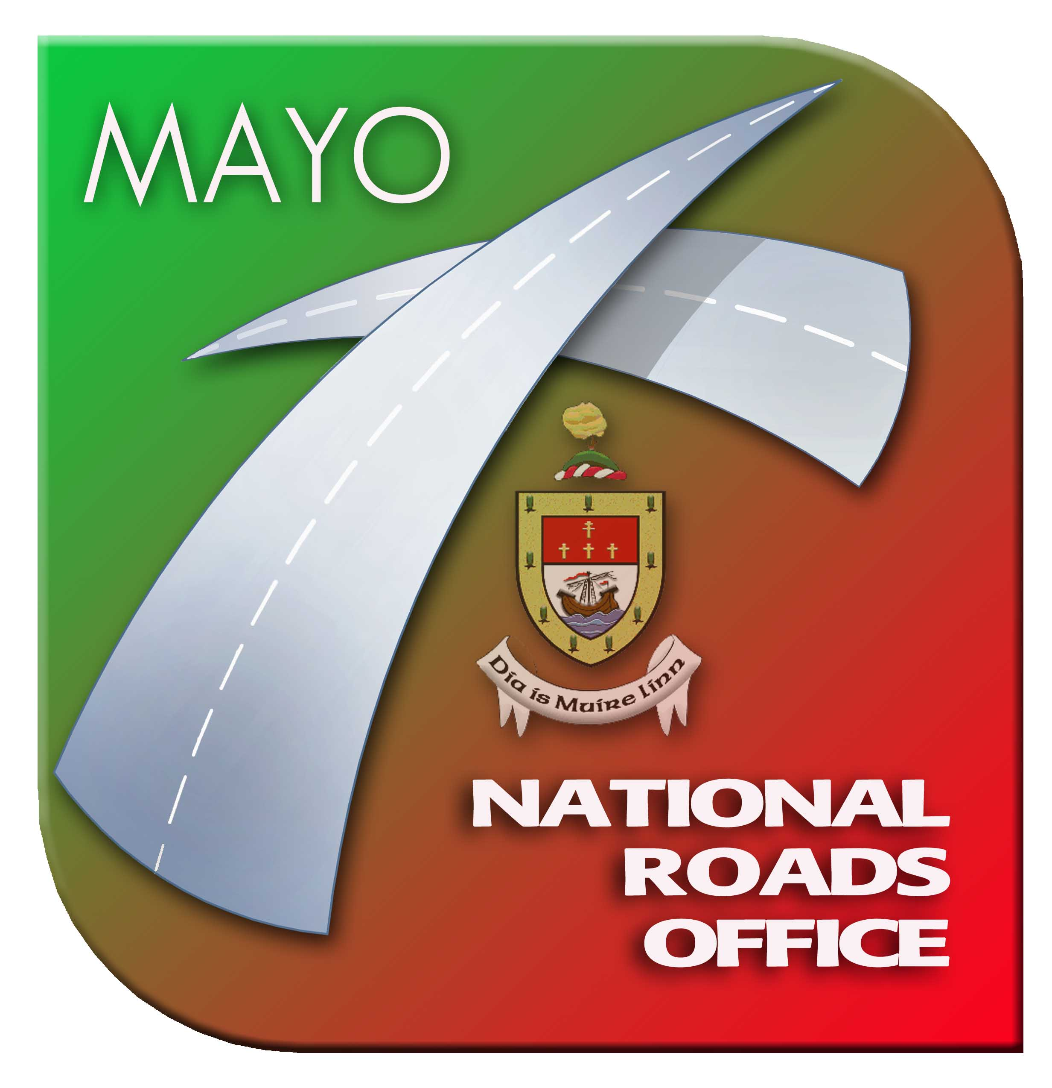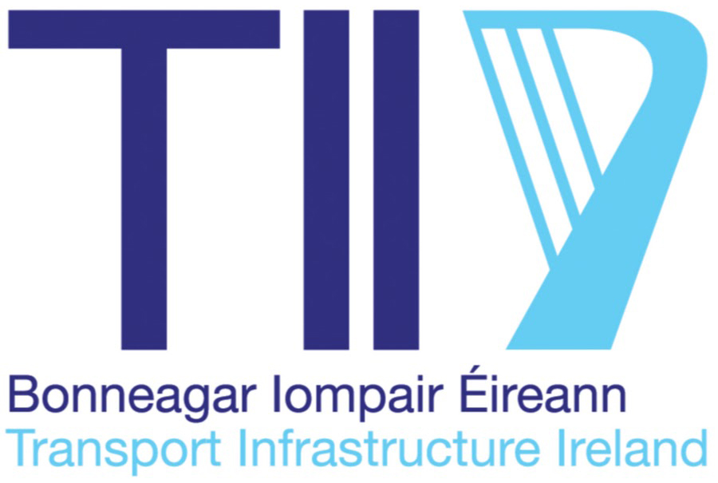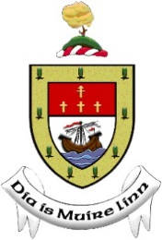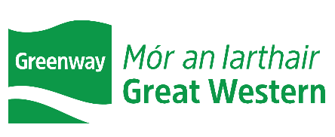

Great Western Greenway - Newport Town
Public Consultation No. 1 - Constraints Study Area
May 2022

Mayo County Council’s National Roads Office, in conjunction with Transport Infrastructure Ireland (TII), is proposing to improve the Great Western Greenway through Newport Town.
Mayo County Council invite residents of the local area, members of the public and other interested parties to participate in Public Consultation No. 1 - Study Area and Constraints for the Great Western Greenway - Newport Town project, which will take place on Wednesday 11th May 2022 in Hotel Newport, Newport from 11am to 7pm.
Your participation in this consultation is important and we would value any feedback which you think should be reviewed by the project team to help inform the development of the project.

Project Objectives
The project aims to:
- Provide a Greenway through Newport from the proposed (as part of the N59 Newport-Derradda Road Project) Great Western Greenway at Knocknageeha townland to the Great Western Greenway at Kilbride townland.
- Provide ancillary infrastructure that gives added value to the route and enhances the user’s practical and emotional experience (e.g. bicycle parking, car parking, trailhead, rest areas, public toilets).
- Improve safety for all users of this route with particular emphasis on vulnerable road users.
- Connect with key nodes in the area, the town centre, community facilities, businesses, housing developments and schools.
- Create a high-quality Greenway of international renown that can promote tourist, recreational and leisure use, as well as for commuting and school trips.
- Provide a facility which is Scenic, Sustainable, Strategic, substantially Segregated and Shared use, offering lots to See and do.

Constraints Study Area
The project team in Mayo National Roads Office has defined a study area and are in the process of identifying artificial and natural constraints within this area, as well as external parameters. These include (but are not limited to) Economic, Engineering and Environmental constraints.

Have Your Say
Public Consultation is now open. Mayo County Council wants to hear your views on the Study Area and Constraints to inform the design of the project.

Please examine the Study Area and let your comments be known by completing the Questionnaire. The questionnaire is available digitally and can be submitted online on Mayo County Council's Consultation Portal at https://consult.mayo.ie/ or alternatively please fill out the enclosed questionnaire and respond by post or scan and email by: Tuesday 31st May 2022.
Further Information
For further details please refer to our website: https://www.mayo.ie/national-roads-office

Or contact us:
Email: pstaunton@regdesign.com
Post: Great Western Greenway - Newport Town Project Team, National Roads Office,
Mayo County Council, Glenpark House, The Mall, Castlebar, Co. Mayo, F23 XF40
Phone: (094) 9064321 or (094) 9064315

Please return your questionnaire or complete it digitally Mayo County Council's Consultation Portal
by 31st May 2022.

Guide to Process
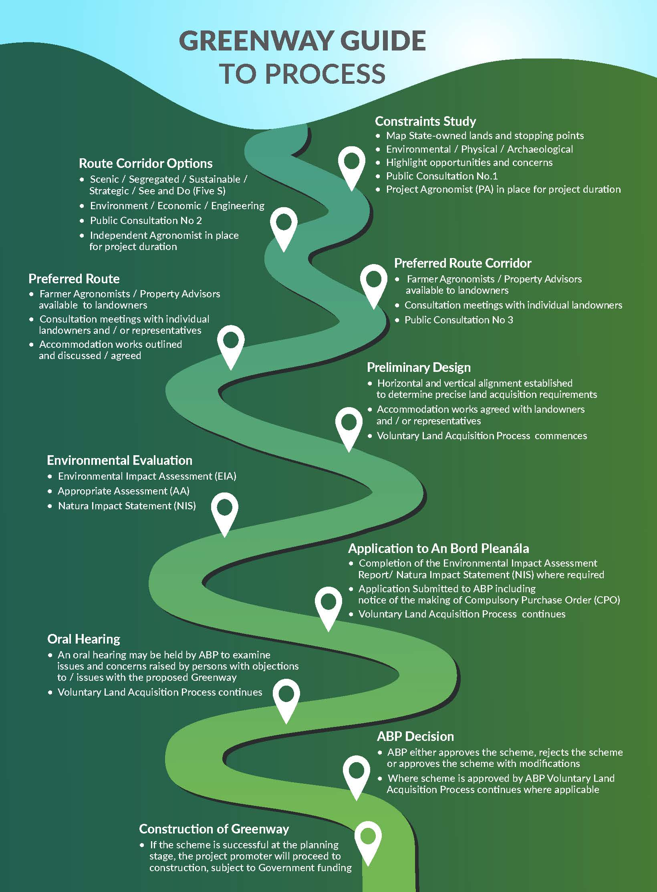
*Extract taken from the Code of Best Practice for National and Regional Greenways:
https://www.gov.ie/en/publication/6b6a0-code-of-best-practice-for-national-and-regional-greenways/

