Thank you and welcome to the OT Virtual 5K! We can’t wait to see how you get on participating in one of the largest ever virtual events in Ireland, and for us to see you as you run your individual route, we’ll need your help with capturing that on camera. Not everyone will have someone in their bubble that can film them while they’re walking or running their 5K, so below are some tips as to how to best film your experience and share that footage with us.

HOW TO FILM YOURSELF
- Please film in landscape i.e. hold your camera on its side. Otherwise we will not be able to use your footage.
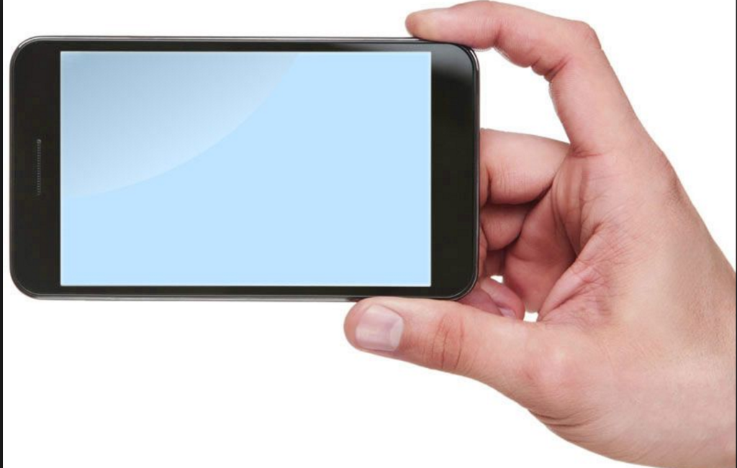
- Use a smartphone, Go Pro or any HD camera.
- Record at the highest quality setting.
- Film in as bright an area as possible.
- Keep the camera as still as possible. Don't pan across or zoom in and out.

WHAT TO FILM
We want to see the start, middle, and finish of your 5K if possible. Some ideas of what to film include:
- Warming up before you start.
- The official ‘start’ of your 5K if you call it out as you begin or have made yourself a starting line.
- The halfway point - we want to see faces and places so show us where you’re doing your 5K in your corner of the country and share how you’re feeling at the halfway point!
- The finish - show us when you cross the finish line or shortly thereafter.
- Lastly, is there someone who has inspired you to take on the OT Virtual 5K? Maybe it’s one of our Leaders or someone closer to home, but let us know why doing the 5K was important to you in 2021.
- ADDITIONAL NOTES - Please make sure of the following:
  - Everyone you capture filming in the background is happy to be on TV.
  - Please do not include music in your footage as we will not be able to include it.
  - Please do not send in the full length of your race as we won’t be able to receive it. Less is more and 2-3 minutes of your day would be great!

HOW TO SHARE YOUR FOOTAGE
- Please send any footage you take before, during, or after your 5K experience to otvirtual5k@gmail.com.
- We recommend sending your video immediately upon completion of filming as upload and sending times will vary based on your location and internet speed.
- Please label your video before uploading it as: OT5K - [Insert your county] - [Insert your full name] – [Insert video number 1, 2, 3, etc. based on how many you have previously sent]
- Example: OT5K - MEATH – JOHN SMITH – VIDEO 1
- By sending us footage or by tagging Operation Transformation on social media you acknowledge that the Story/Video may be used in the Programme. And you hereby grant Vision Independent Productions Limited (“VIP”) all necessary permissions and rights in the Contribution to do so, including for the avoidance of doubt, where minors appear in the Story /Video, that the Parents and / or Guardians are fully aware of the intended use and all of the permissions granted to VIP.

