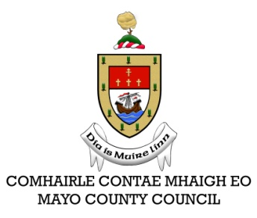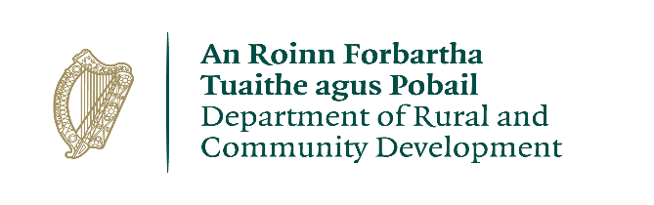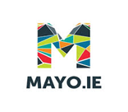
CLÁR Funding 2020
Expression of Interest
Please tick Measure required: | Measure 1 – Support for Schools/Community Safety
 | Measure 2 – Community Recreation Areas
Measure 3 - Community Wellbeing Support:
(a) Meals on Wheels and linked Services
(b) Mobility and Cancer Care Transport
Name of Applicant/ Organisation/Group:
Contact Person:
Correspondence Address:
Correspondence Email:
Correspondence Telephone No.:
Summary of proposed project to be funded: (Please refer to scheme outline for eligible items)
Total cost of project/equipment: |  | €
Amount being sought under this CLÁR application: |  | €

Please confirm that the following items will be in place upon request:

- Match funding is available and ringfenced for the project.
- All necessary permissions are in place.
- Evidence of ownership/lease is available (if applicable).
- The facility is/will be open to the public without appointment.
- The project conforms to the LECP and/or other local or regional plans.
- No funding has been allocated for the same project from any other sources.

Signed: _________________________ Date:_________________________
Position:________________________

Expressions of Interest for Measures 1 and 2 must be submitted by email to the Community and Integrated Development Section, Mayo County Council at community@mayococo.ie and those for Measure 3(a) and (b) should be submitted directly to the Department of Rural and Community Development at CLAR@drcd.gov.ie.
Closing date for receipt of all Expressions of Interest is Friday 7th August 2020.

