Mayo Maps Browser User Guide.
Getting Started
The default language of the service is English; the service opens in a default view with a guide map as the base map. The view is of William Bald’s 1809 map of Mayo. The various tools the service offers are also visible when the page is loaded. Tools related to the map can be seen on top of the map view, in the top left and right hand corners of the screen and on the bottom left (see Green arrows). Other tools are located in the right hand drop down side panel. The user has to open the Layers menu to be able to access and change maps.
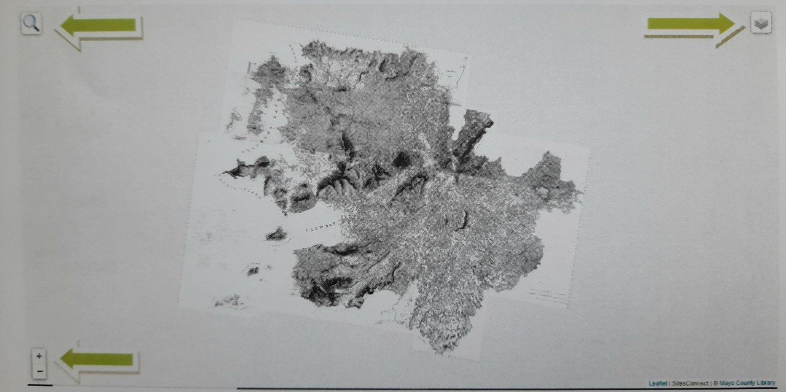
Navigating the map
The map can be navigated by dragging. The user can drag the map by holding down either the left or the right mouse button while moving the pointer. It is possible to zoom in and out by using the zoom feature on the bottom left of the screen or scrolling the mouse wheel.

Map tools
Search
Zoom
Layers

Search
The search function can be found on the top left of the screen. Here the user can search for a town, townland or parish. It has a prediction algorithm which requires at least three letters and after that provides suggestions.

Entering search, eg. Balla
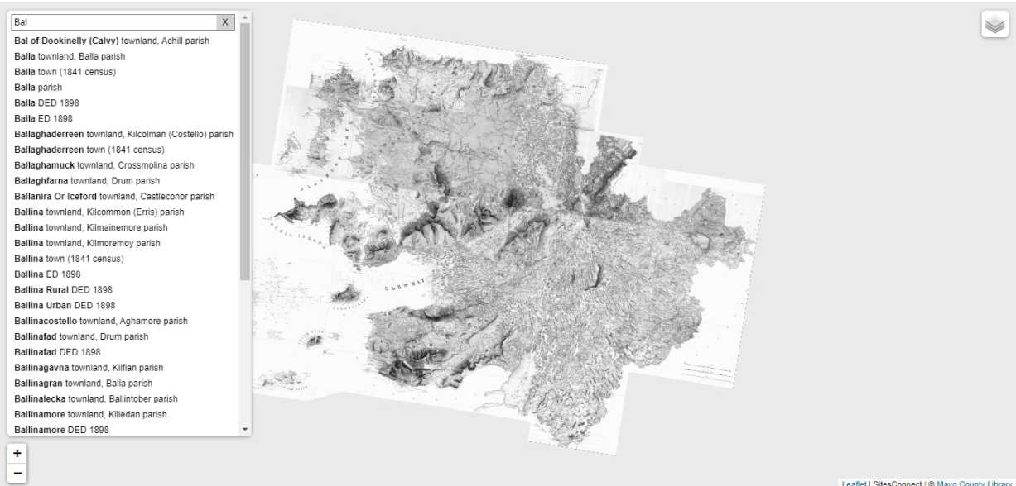

Example showing search results for Balla:
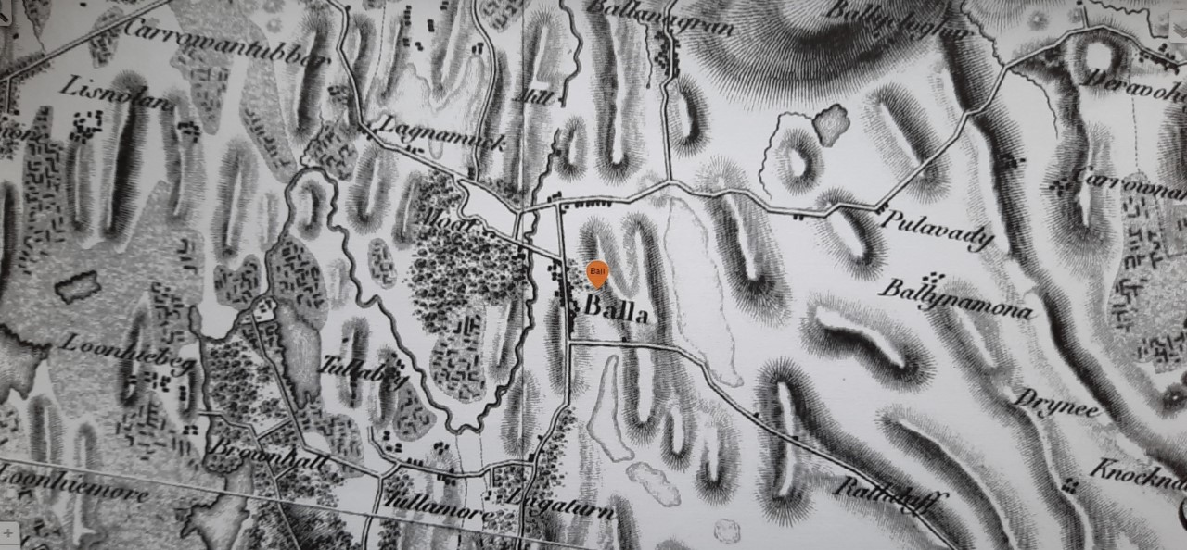
By clicking on the orange icon, options to view maps in and around the area chosen can be accessed. It also opens the links, shown below, to view data from Griffith’s valuation survey books and maps through the Ask About Ireland website and the 1901 Census held at the National Archives. The Irish Tourist Association link will be added soon.

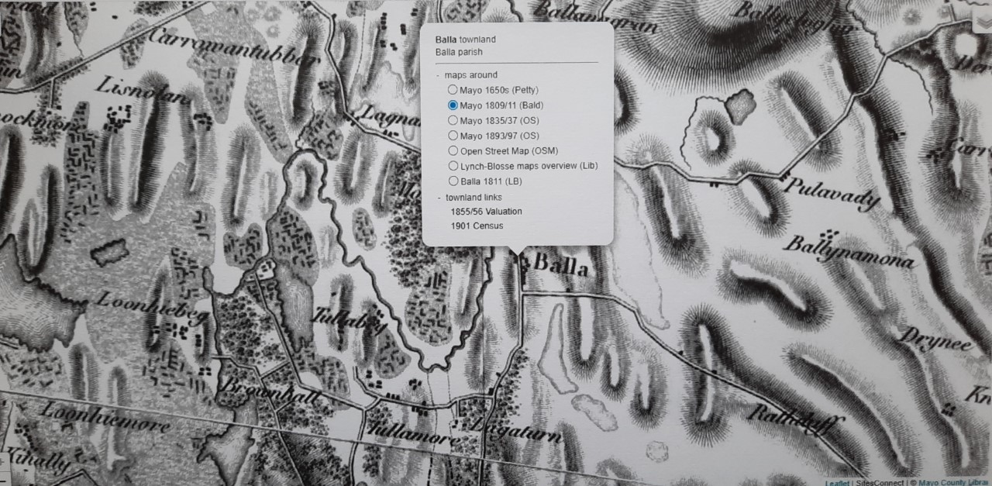

Sample Griffiths Valuation link for Balla:
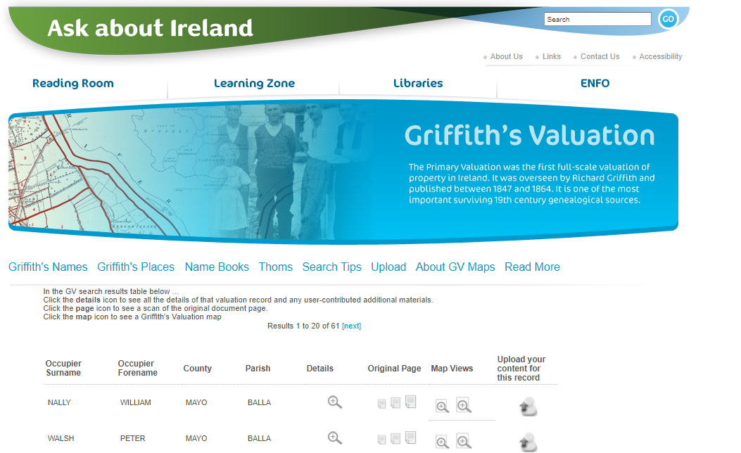

Sample 1901 Census return for Balla:
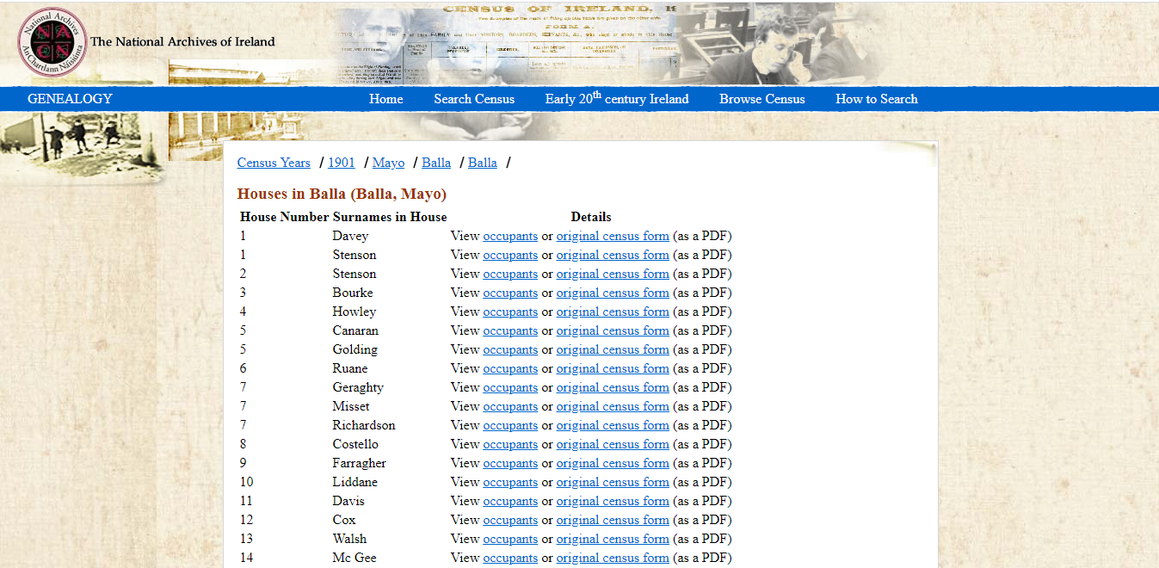

Zoom
When searching for Items from the Markers section of the menu it is advisable to zoom out on the Map to improve the view of the results on the map. In particular this applies to locating Baronies, DED’s and EDs.
Layers
Layers to be viewed in the map view can be chosen from the Layers menu located in the top right of the screen. The Layers option allows the user to view changes to the selected area over a period of time as shown on the various maps.
Example Balla 1835/37 map.
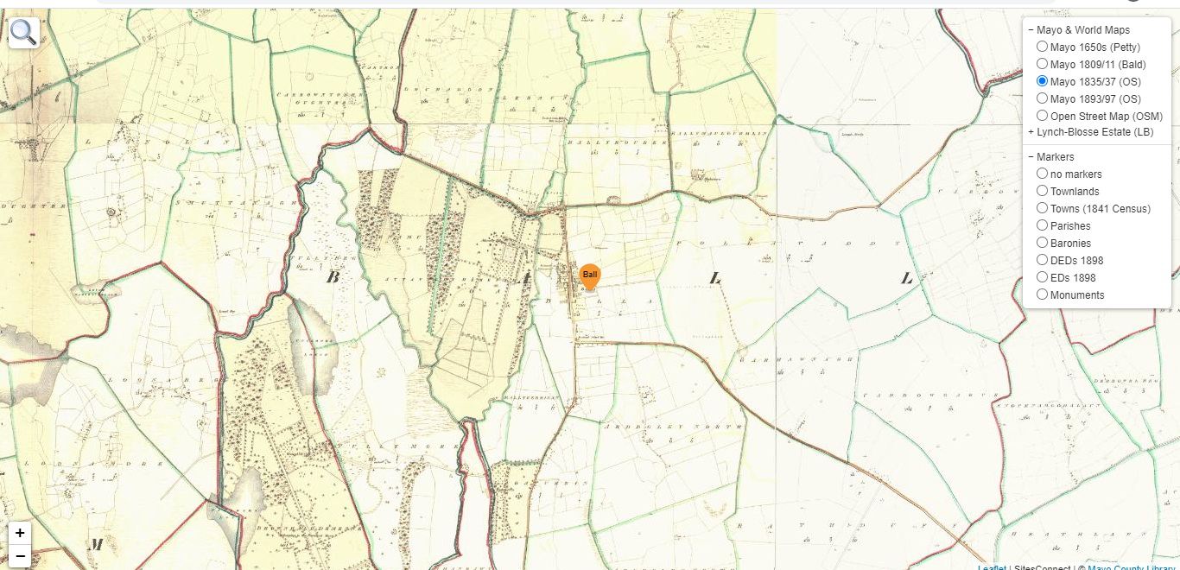
Viewing and changing layers
Different maps and data sets that are shown on the map window are chosen from the layers menu. The user can select a map by clicking on the name or checking the box next to the map name. Multiple items for an area can be viewed by selecting items from the “markers” section of the menu. Only one item from the “Markers” menu can be selected at a time. The items can be closed by unchecking the box.

Example of the Layers Menu.
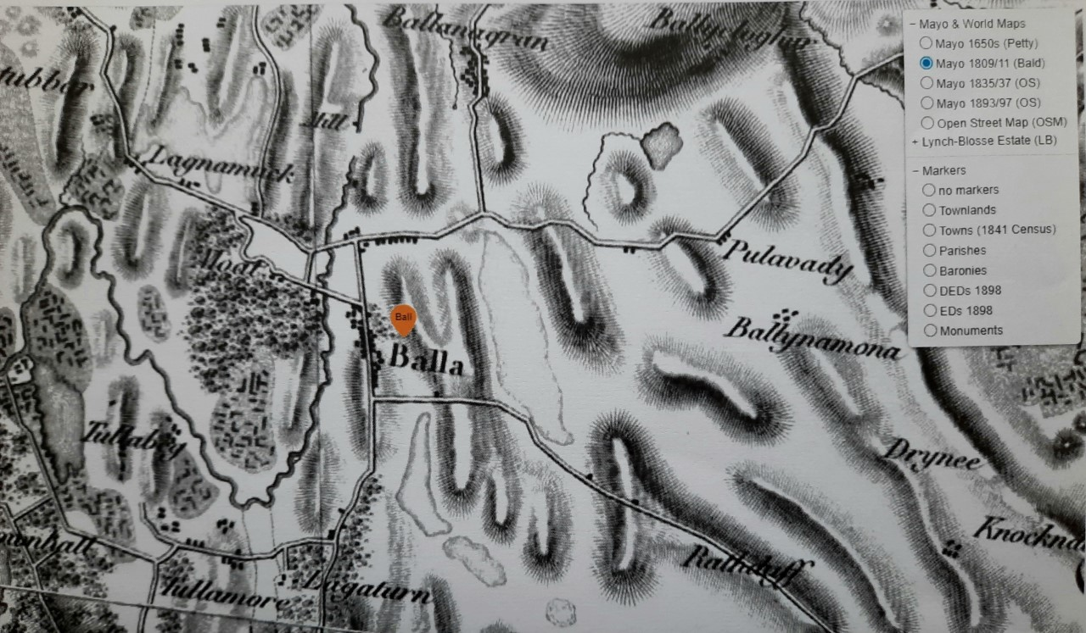
The layers menu also contains the Lynch Blosse Estate maps for the Baronies of Carra and Clanmorris. The Lynch Blosse Map overview option shows the estate maps in the context of other townlands, while an individual Lynch Blosse Map can be viewed by selecting it from the menu. Examples below are for Balla as before.
Lynch Blosse Maps- Overview
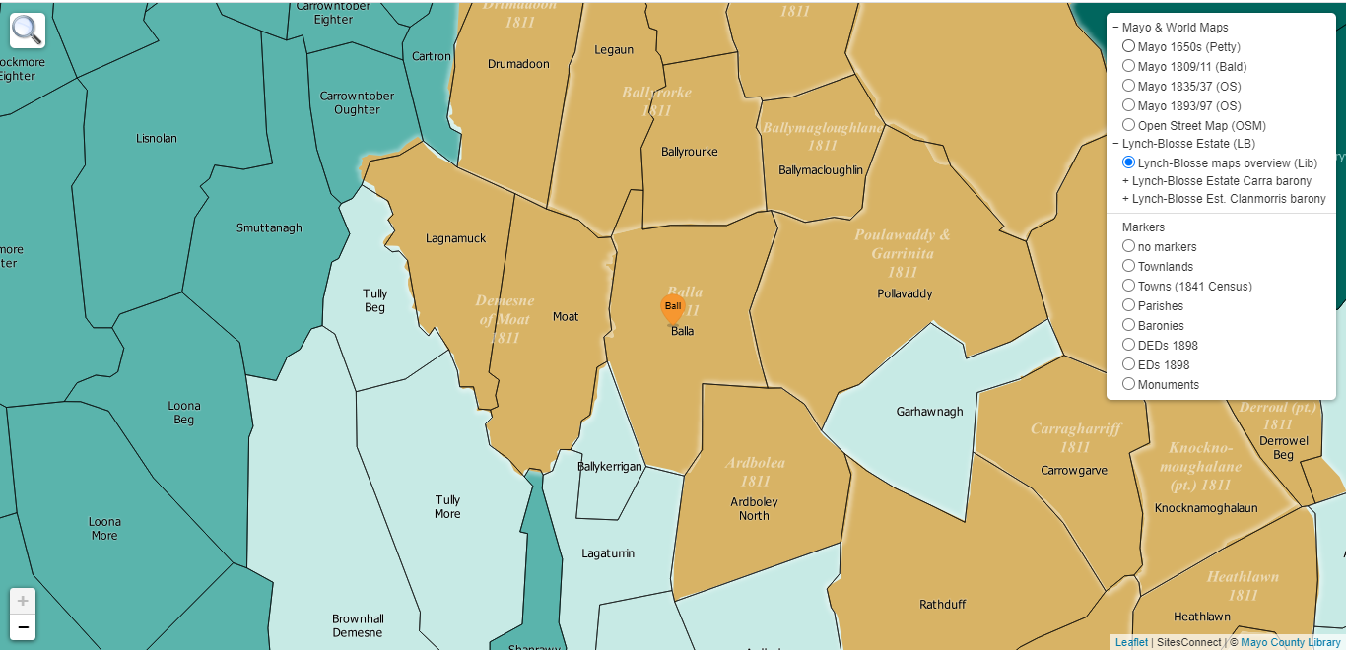

Selecting the Lynch Blosse Map for Balla.
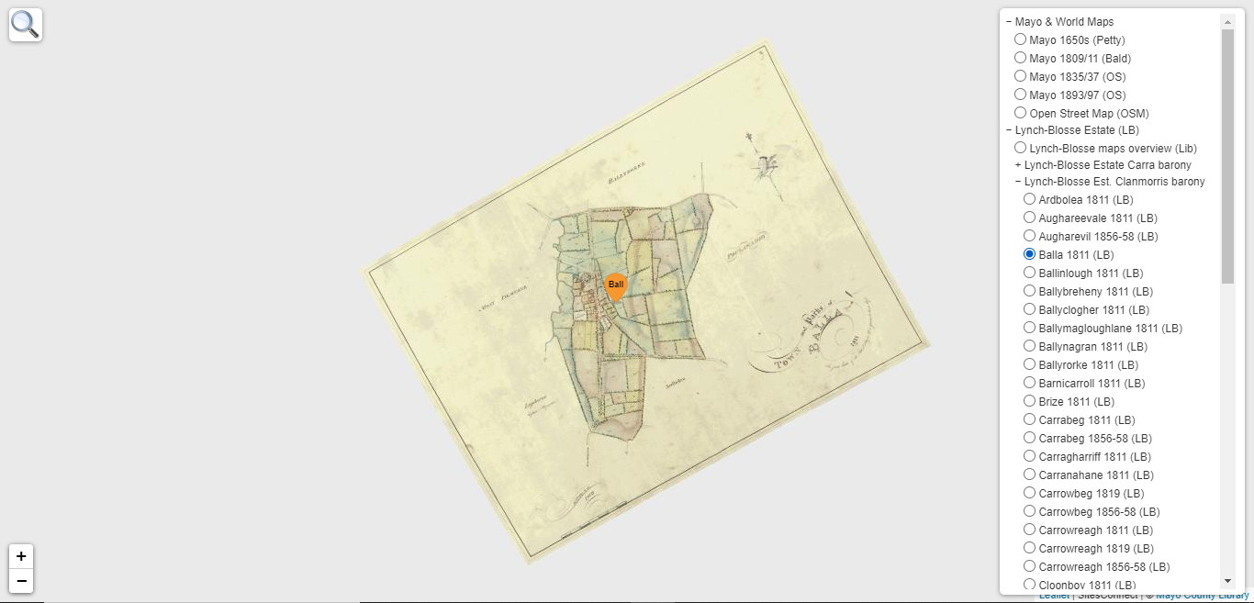

EG. Lynch Blosse Map of Balla.
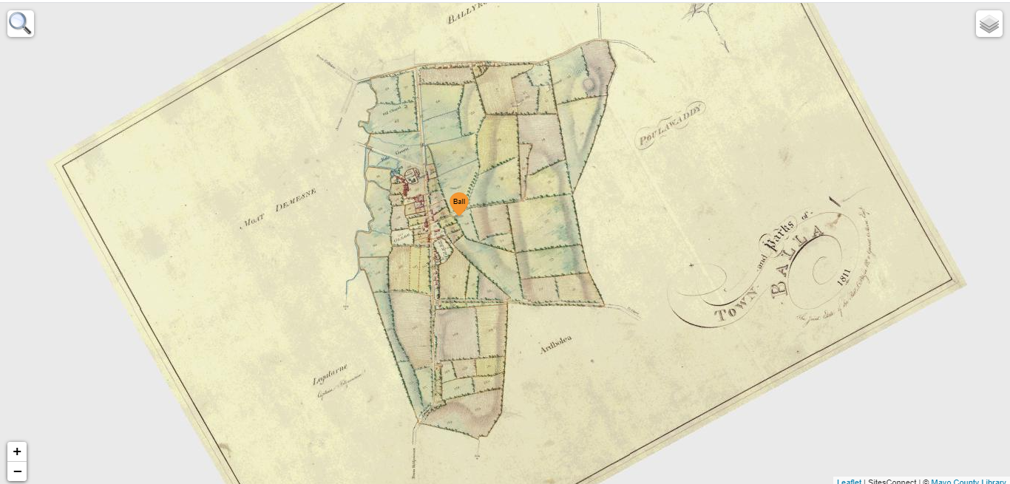

Markers
In addition to towns and townlands the user can search for points of interest listed in the Marker section of the menu. The following are examples of the results from searches using the different options in the Markers section of the menu.
Townlands
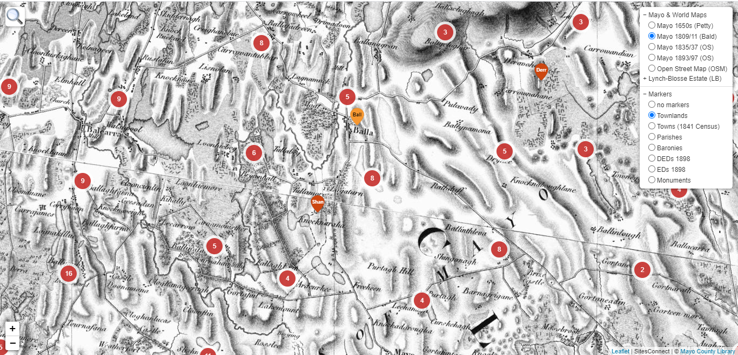

Towns 1841 Census

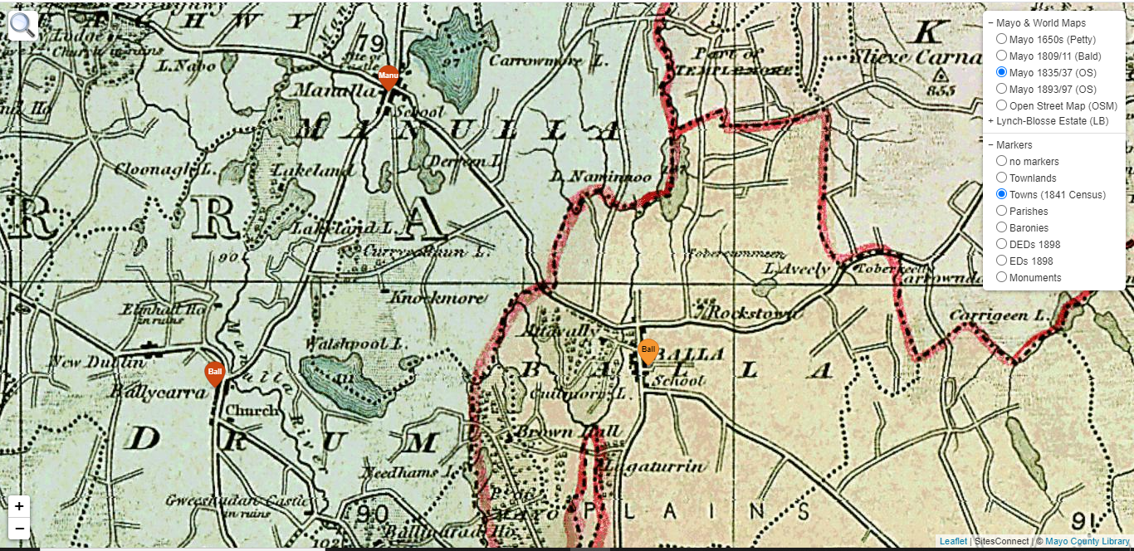

Parishes

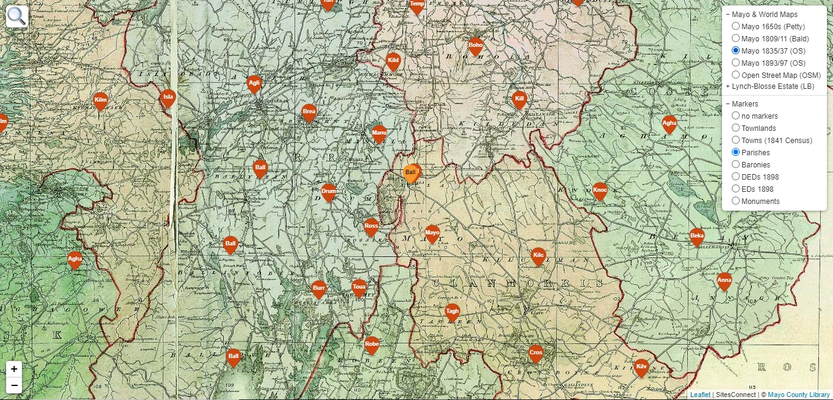

Baronies

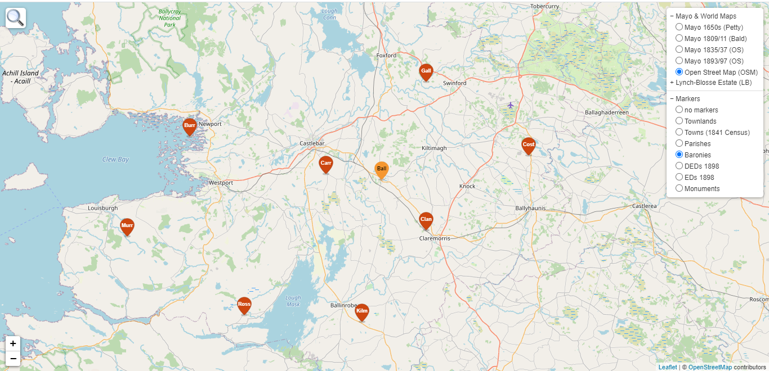

DEDs 1898

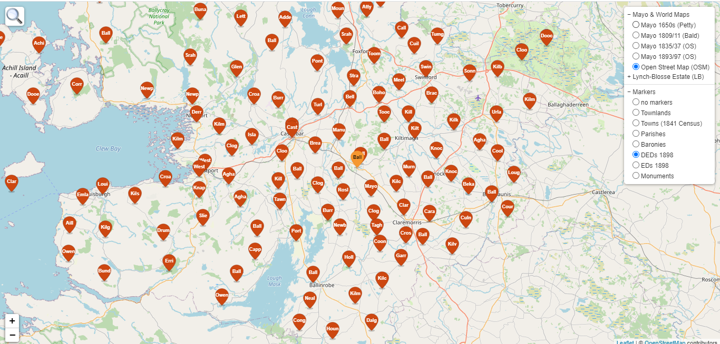

EDs 1898

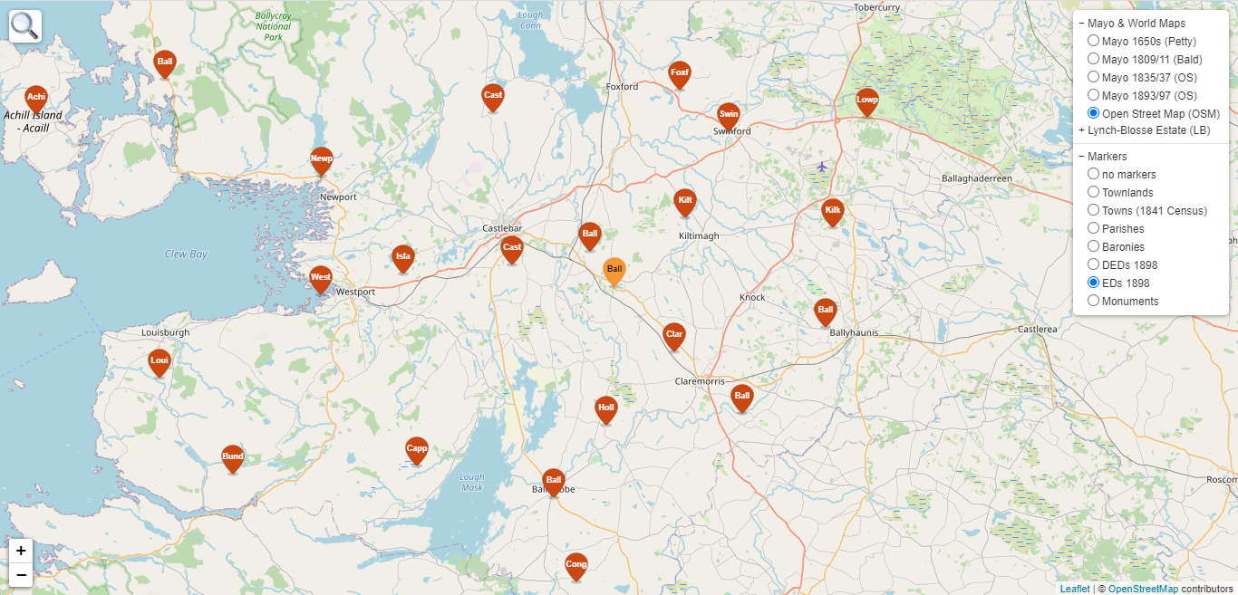

Monuments.

By selecting the monuments option in the menu, the number of items in the area close to eg Balla is shown, in this case 79. By placing the cursor over the number the area is shown in Blue.

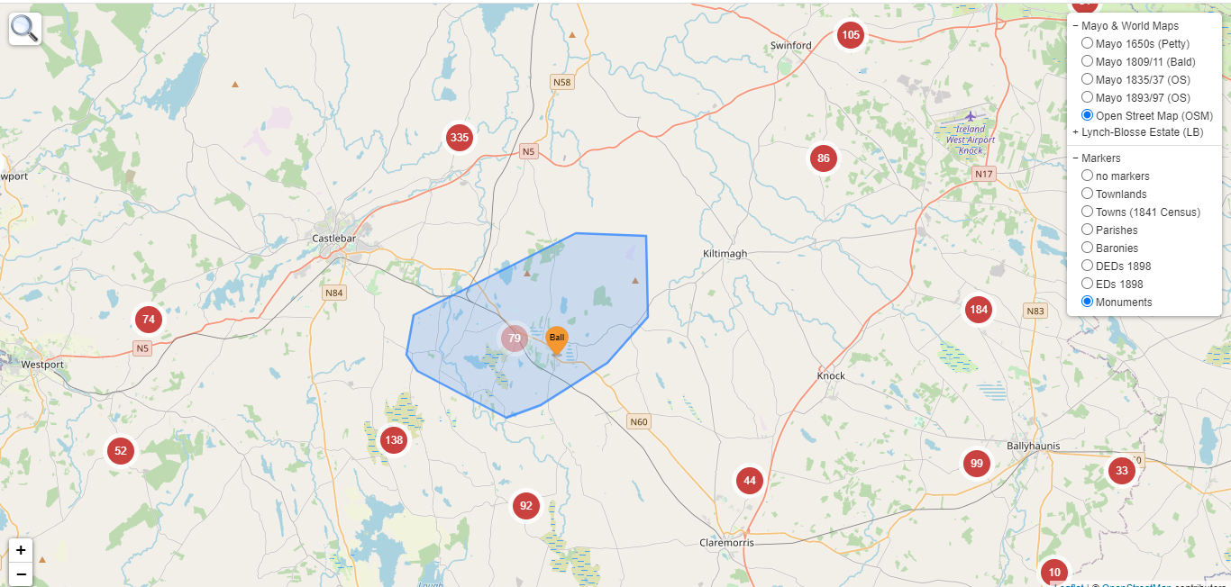

By zooming in the number of monuments closest to the example Balla is narrowed down as shown below.

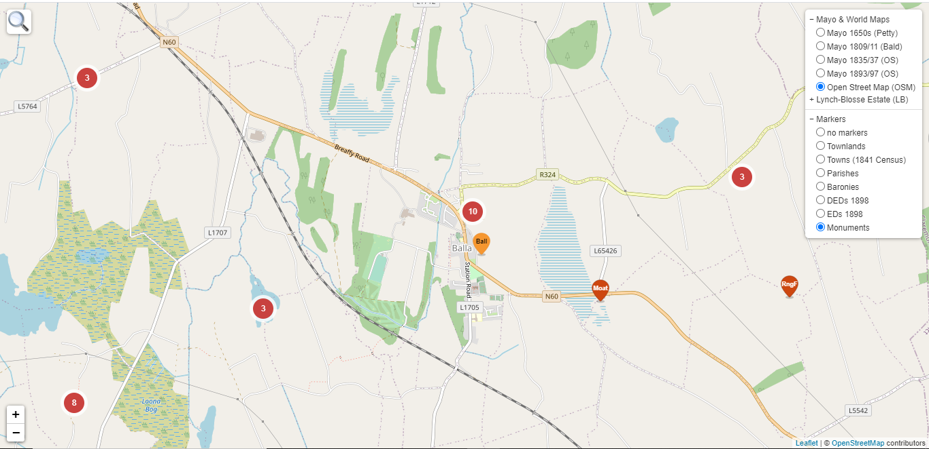

By zooming in closer still the monuments are identified. In this case HW= Holy Well, EccR= Ecclesiastical Remains, Hse= House and Moat=Moated site. A tab will pop up to identify the site once the cursor is placed over the Red marker.
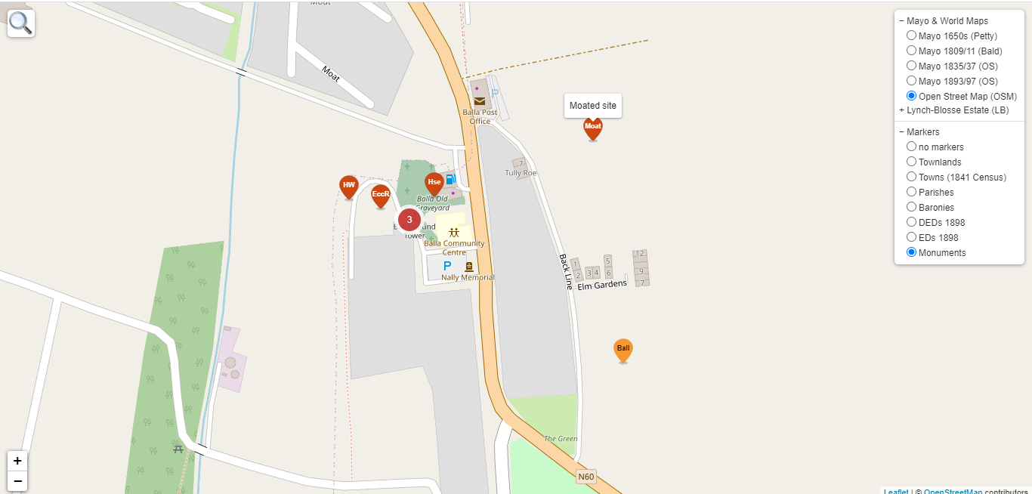

Printing
Printing options can be accessed through the dropdown menu as shown below. Click on the icon at the top right on the screen.
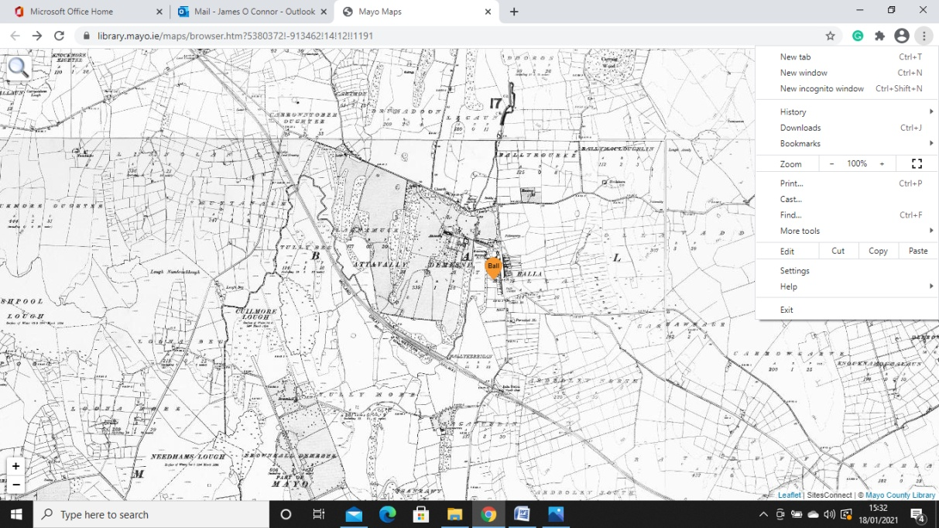
Select paper size.
Select paper orientation.
Select scale.
Print.

Download
There is currently no option available to download maps.

