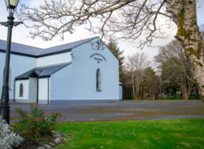 | Church of the Holy Family, Ballycroy  Mass Centre - National School - Innisbiggle  Christopher J. Ginnelly  (098) 49 134 (086) 89 33 278  ballycroyparish@gmail.com  James M Cribben, Geesala (087) 64 69 016  24^{th –} 30th October 2021  www.ballycroyparish.ie
The Year of St. Joseph 2021
Mass at 11am will be Broadcast on our Facebook Page The outside speaker will be in operation if you wish to listen to the mass on the grounds. Special Thanks to Cathy / Nora for operating the live broadcast on Facebook and to Shelly for the beautiful selection of music and hymns.

30th Sunday in Ordinary Time – Mission Sunday
Sat 8pm 1. John (30th) , Kathleen Campbell (9th) (Ballyveeney)
2. John, Rosemary Collins (Galway)
Edward, Nora, Pat, Tom Campbell (Doona)

Sun 11am 1. Alice McGowan (Wellingborough/Drumgallagh)
2. Pat, Nora, Terry, Paddy McGinty, (Dooreil)
Kathleen Curran

Tues 10am People of the Parish
Wed 10am Mass all Welcome
Thur 10am Mass all Welcome
Fri 10am Mass all Welcome

31th Sunday in Ordinary Time
Sat 8pm 1. Johnny Gallagher (Birthday Rem’) - Margaret (Bunmore)
2. Hugh and Mary McManamon, Tallagh

Sun 11am 1. Molly McHugh (9th Ann), Frank, Pat, Jim, Breda, Joe.
2. Margaret – John Calvey, Dec’d Calvey Family (Rosturk)
Sun 12.15pm Bangor Church
November Leaflets for the Dead: The leaflets are out at the main doors of the church. Please take them and return them in an envelope next weekend. Please return your lists before on om the 1st November. The leaflets will be placed in from of the alter from the duration of November, and masses will be offered for the repose of their souls.
Rosary in the cemeteries for November.
Ballycroy Cemetery: Sunday 21st November immediately after 11am Mass (11.45am)
Claggan Cemetery: 12.15pm Fahy Cemetery: 12.45
Mary Cafferkey – Retirement: After many years of service to our Parish Church with Bernie Hough, Mary Cafferkey has retired this week. We own Mary a great debt of gratitude for her faithfulness and dedication to us all. Unfortunately Mary has declined a public presentation on her retirement. Next week on behalf of the parish I hope to make a private presentation to Mary. We wish Mary every blessing , health and good wishes on her retirement.

Bernie Hough has agreed to continue her great work in the church on Mondays. We are very grateful to Bernie for continuing with this work. However extra hands and help will be needed to assist Bernie. So, I have invited the ladies who have been sanitising the church since the beginning of the pandemic to come together and setup an Alter Society. They have agreed and accepted this request. I wish to take this opportunity to thank them for their work during the pandemic.
Group A (Leader) Patricia Grealis, Mary Sweeney (Tarsaughan), Bernie McGowan, Marie McGowan, Joan Campbell.
Group B (Leader) Bernie Shanaghan, Marian Cafferkey, Kathleen Rownland, Grace Grealis, Sineád Carolan, Ann McManamon.

We need more helpers – volunteers. Our aim really to setup 4 to 5 groups – 4 in each group – one group a week in the church.
If you wish to help please ring my Mobile Fr. Chris – 086 8933 278.
Please do not leave this important task to just a few. In order to make up these groups, we need at least 10 people. Thank you.
Time Change of Vigil Mass for the Winter months. From the 1st November to the 1st February, the Vigil Mass on Saturday Evening will be at 6:30pm.
For Parish Pastoral Council members in Erris parishes on Tuesday 26th at 8.00pm in Broadhaven Bay Hotel
Sincere thanks for the Harvest Collection. Please leave your envelope (Green
envelope) in the church. Sincere thanks for your contributions to Fr. Chris.
'Naionra Baile Chruaich's Halloween Disco will take place in Ballycroy Community Centre on Friday 29th of October from 5-7pm. All welcome. ' Draw for hampers on the night, tickets are on sale locally, €2 per line or 3 lines for €5'
 | Readers | Eucharistic Ministers
Sat 23th Oct: 8pm | Family | Mary Bradley
Sun 24th Oct: 11am | Family | Peggy Ginty
Sat 30th Oct: 8pm | Family | Marian Masterson
Sun 31th Oct: 11am | Family | Bernie Hough
Keeping Children Safe: The Diocese of Killala is fully committed to keeping children safe. If you have any concerns around their safety in any circumstance please contact;
The Diocesan Liaison Person – Confidential No - 087 1003554. (Please see more information on the notice board).
Supplementary Pages for Online:
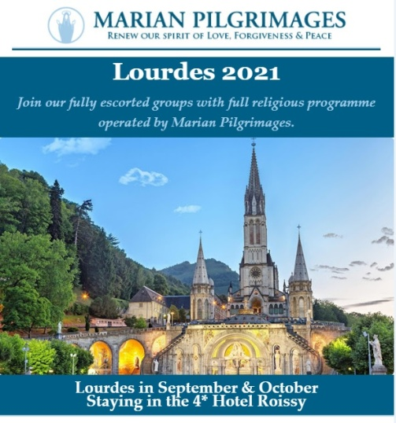

- Free online Living Well Programme – next programmes commences on (Limited places) Thursday 9th of September
- Monday 13th of September
- Tuesday 21st of September
- Wednesday 29th of September
If you are living with a long term heath condition you may be interested in doing the ‘Living Well’ Programme’. This is a six week programme delivered in 2.5 hour weekly. You must register in advance as places are limited to 10/12 participants. Please contact Liam Gildea on 087 349 0393 or by email at liam.gildea@mayocil.ie
Reminder for everyone to register for their vaccine We would like to remind all to register for their COVID-19 vaccine through the HSE’s online registration system or on the phone with HSELive Everyone in is now eligible to register:
A Chance of a Fortune!
Have you an interest in working with people with a learning disability and / or autism??
Western Care Association are recruiting Relief Staff to work in our Services based across Co. Mayo. For further information please visit our website at www.westerncare.com or email hr@westerncare.com

For Mental Health Week, North West STOP invites you to 3 events to get this msg out: it's OK not to be OK & it's absolutely OK to ask for help.
ODD SOCKS DAY 7th October (or between 3rd-10th)
Last year this raised over €10,500 and paid for our Free Counselling Service during Oct, Nov & early Dec. Join in and share with friends / colleagues to make it a success in 2021. For a Fundraising Pack: E: oddsocks4stop@gmail.com or Ph: 071 985 6070.
ANNUAL GENERAL MEETING 14th October, 7.30pm, The Glens Centre, New Line, Manorhamilton. Please confirm your attendance by 7th October if you wish to be included in the minutes. Ph: 071 985 6070
MEMORIAL WALK 15th October, 7pm, Castle Carpark, Manorhamilton. All are welcome to join us in remembering members of our community whom we have cherished and lost. Please dress up warm & wear comfortable shoes.
PREVAILING COVID-19 GUIDELINES WILL APPLY TO ALL IN-PERSON EVENTS.
FREE COUNSELLING AVAILABLE: PHONE / TEXT 086 777 2009.

Western Care Association’s Annual Door To Door Collection is now taking place during the month of September. To donate, find us on Facebook "Western Care Association" or on www.idonate.ie/wcadoor or find the link on our website (www.westerncare.com) and make your donation. If you would like to donate in any other way, (Cheque, Postal Order or Bank Transfer) we would be very happy to talk to you. Please contact Teresa Ward on 094 90 29174 or 087 246 7857 or email: tward@westerncare.com. Your support is greatly appreciated.

Reminder for everyone to register for their vaccine We would like to remind all to register for their COVID-19 vaccine through the HSE’s online registration system or on the phone with HSELive Everyone in is now eligible to register: If someone is finding it difficult to go online and register or they can ring HSELive for support on 1850 24 1850 or 01 240 8787 from 8am to 8pm, 7 days. If a person doesn’t have a PPSN they can register on the phone with HSElive. Once registered the person will receive their vaccine appointment for the COVID-19 AstraZeneca vaccine. If a person is deaf or hard of hearing, they can text HSELive on 086 1800 661 to register for your vaccination
Free Training! Enrolling Now: If you struggled at school, have been long term unemployed, are recovering from or living with an illness or would benefit from extra support, the National Learning Network could be for you. We offer the expertise and time to enable people to flourish. QQI courses include: IT & Business Skills (home and centre based), Sports and Gym Instructor Studies, Fast Track to Employment and more. If you are registered with the DEASP you could be entitled to the free training, Continuous enrolment, payments are protected and people under 26 could gain extra training allowance. Contact: Castlebar@nln.ie; (094) 9022770; Breaffy Road, Castlebar, or see our website www.nln.ie.

Covid-19 Collect and Deliver Service: Helping people to stay at home is the new role of Local Link Mayo rural transport services. Local Link Mayo is offering a collect and deliver service in existing Local Link routes throughout Mayo from pharmacies and local shops, delivering shopping and critical medical supplies to the elderly, the vulnerable and sick. If your need of such support or know someone who does, contact Local Link Mayo on 094 900 5150 between 9:00am and 5:00pm (M-F) or email mayo@locallink.ie
Keeping Children Safe: The Diocese of Killala is fully committed to keeping children safe. If you have any concerns around their safety in any circumstance please contact The Diocesan Liaison Person – Confidential No - 087 1003554. (Please see more information on the notice board).

