***Offertory Donations:***

Sunday 6th: €710.



Thanks for all your contributions.

**Bohola/Shraheens Newsletter**

**Stephen O’Mahony PP – 094-9384115/086-8226405 –** [**boholaparish@gmail.com**](mailto:boholaparish@gmail.com) **(email for newsletter)**

<https://www.mayo.ie/news/category/connect/parish-news/bohola-parish-news/>

**Second Sunday of Lent – 13th March 2022**

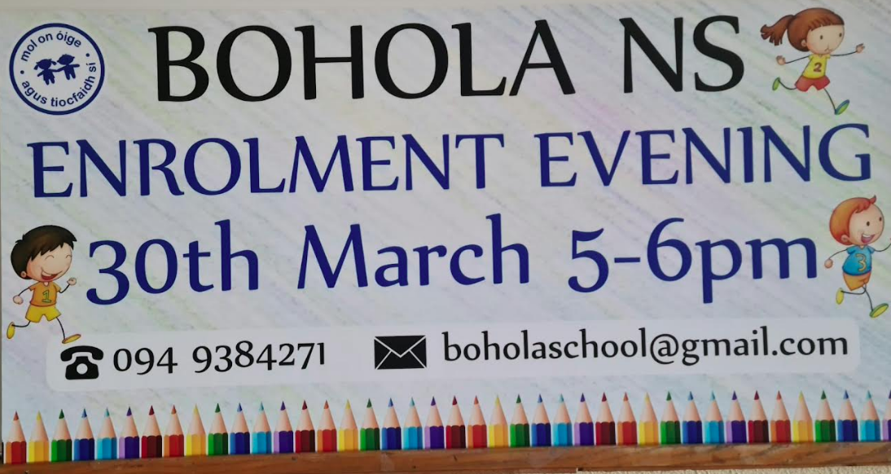

###### Masses for the Week

|  |  |  |
| --- | --- | --- |
| **Saturday, March 12th.** | **7.00pm*\**Vigil** | **Johnny Durkan, Carroward, his wife, Mary and his parents, Matt & Mary Lizzie.** |
| **Sunday, March 13th.** | **9.30am  *Shraheens***  **11.30am*\* Bohola*** | **For all the People.**  **Ann (Nancy) Doyle & her husband John, Sheridan Park.** |
| **Monday, March 14th.** | **10.00am** | **Private Intention.** |
| **Tuesday, March 15th.** | **7.00am** | **Canon Michael Joyce (1st Anniversary).** |
| **Wednesday, March 16th.** | **10.00am**  **6.00 – 8.00pm**  **7.00pm *Shraheens*** | **John & Tom Carroll, their parents Tom & Ellen and Chris & Mollie O’Toole.….(*Adoration follows until 11.30am)***  **Exposition of the Blessed Sacrament (private prayer).**  **Vigil Mass for St. Patrick’s Day.** |
| **Thursday, March 17th.** | **11.30am*\**** | For all our Emigrants. |
| **Friday, March 18th.** | **8.00pm*\**** | **Alfie Carroll, Treenduff (1st Anniversary).** |
| **Saturday, March 19th.** | **7.00pmVigil** | **Private Intention.** |
| **Sunday, March 20th.** | **9.30am*\* Shraheens***  **11.30am*\* Bohola*** | **Sonny McNicholas, Carrowntleva,**  **& deceased of McNicholas & Mullaney families.**  **For all the People.** |
| ***The 11.30am Sunday Mass will be live-streamed on the Bohola Post Facebook Page every Sunday.***  ***Any other Masses are put online when requested. (Marked with * above)***  ***All Bohola Masses will be broadcast on the 105.5 FM Radio channel.*** | | |

***Recent Deaths:*** Please pray for the happy repose of the soul of *Tommy Byrne*, Carrowkeel, who died on Monday last, March 7th and whose funeral took place in Bohola on Friday. May he rest in peace.

Your prayers are also requested for the happy repose of the soul of John McEvilly, who died recently and whose funeral took place in Philadelphia on Friday last, 11th March. He was the first cousin of Maureen Byrne, Carrowkeel. May he rest in peace.

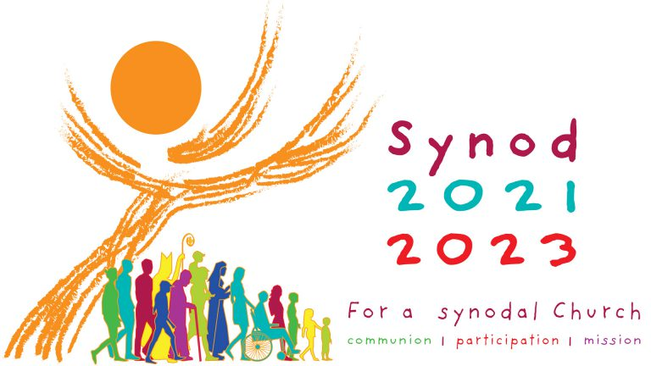***Pope Francis Wants to Know What You are Thinking!*** Pope Francis has invited us all to reflect on what it means to be a member of the Church today. He sees us as a pilgrim people making our way through the world, following the person of Jesus Christ. We are the Pilgrim People of God or a synodal people, that is on a journey together. The Pope is asking us to reflect on what that experience is like: how are we finding the journey? Do we find support as we go? Where is that support found and how could it be improved? Are there people being left behind and how might we reach out to them?

For those who didn’t get the form last weekend, you might think about these questions during the week. You will find a form in the church, where there are some questions which you might answer and return them next weekend. You will also find the form and more information on the diocesan website: [*https://achonrydiocese.org/*](https://achonrydiocese.org/).

***Emigrant Collection on 17th March:*** As a Church and a people we must continue to reach out to those who are affected by emigration. We remember and pray for all Irish people overseas, those who have left our shores for the first time and those who have been away for many years. We remember the families they have left behind and pray that they will find strength and comfort as they cope with the pain of separation. We also remember those who have travelled from foreign lands to begin new lives in Ireland and pray that they will receive the same welcome that we would wish for our own emigrants far from home.

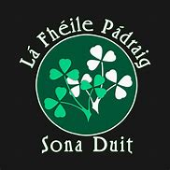We take up the annual collection for Emigrants next Thursday, St. Patrick’s Day. This funding gives essential support to those organisations providing pastoral, practical outreach to the most marginalised and vulnerable groups of Irish people, many of whom are living lives of quiet desperation. It is a very worthy cause so we ask you to give generously in the envelope provided with the offertory collection envelopes.

***New Pilgrim Path Website of the Week, March 13th:*** *Feast of St Patrick ……….* On Thursday of this week, we celebrate the feast of Ireland’s patron, St Patrick, the ‘Apostle of Ireland’. New Pilgrim Path features some beautiful resources – spiritual, poetic, visual and musical – to celebrate the Saint’s great legacy. Access them here: [***www.newpilgrimpath.ie***](http://www.newpilgrimpath.ie). Beannachtaí na Féile Pádraig oraibh go léir! Wishing you all the blessings of St Patrick’s Day!

***Ukraine Collection:*** Bishops have asked that a ***special collection*** would be taken up at Masses on the weekend of **March** **27th** for the People of Ukraine.  There are a number of local initiatives happening around the country but it was felt that the Church should have a collection to show support and solidarity.

***Early Tuesday Mass for Lent*** continues this *Tuesday, 15th at* ***7.00am****.* As it coincides with the first anniversary of the death of Canon Michael Joyce, the Mass will be offered for the late Canon on that morning.

***Bohola NS Enrolment Evening:*** Bohola NS is holding an *Enrolment Evening* for all new entrants on Wednesday, 30th March from 5pm to 6pm. All are welcome to come and have a look around our fantastic facilities.

***The 2022 Western People Martin Sheridan Bursary Awards Scheme*** will soon be open for applications. €5,000 in funds is available to support athletes from Co. Mayo. Further details coming soon! Prospective applicants should be getting their CV in order!

***Moy Davitts 50/50 Draw:*** Congratulations to Allana Reilly who won a lovely jackpot of €528 in the Moy Davitts 50/50 draw last Saturday. A huge thank you to everyone who supported last week's draw, it is greatly appreciated. Tickets are available in the usual retail outlets and by clicking [*https://smartlotto.ie/Bohola-moy-davitts*](https://l.facebook.com/l.php?u=https%3A%2F%2Fsmartlotto.ie%2FBohola-moy-davitts%3Ffbclid%3DIwAR2-SMSQVJnLPM1gbMk8VYcVq5QSNWsE5b18UD-SHwPhuifGrX08SNDlJc8&h=AT0MiLZlj4q4DBPOl03vVXSokuVERXZawyK8tGPOdkMD6iUtbbGAIDrP1wUMXoHHwBpf8OCfEYLll7lUaWyYzni7elqLyyDX1hxrkiRT4iLddt75pWrUPCYemDN43SvOspaI&__tn__=-UK-R&c%5b0%5d=AT1bnP92vRmesJAH-zh16Oyc956taFyWxM0_3VLfj4QSf9SmpZw5cpQ61Vc5tvJdChYPj7SPty0LDMmT-1CuL0y1Dj6Ia-SpXR1Lif8cNpBMb3zmcNd83NlOLtCy4LEd6sxibGw9D72uG7DGqfgmtrvFR5ZcIPXTwnc_aJIQcIYHHlU6GWM4y_sHX7uH).

***Anam Cara Mayo***, the organisation that supports bereaved parents, is holding a Parent Evening on Tuesday 22nd March at 7.15pm in the TF Royal Hotel, Castlebar. This event is free and open to all bereaved parents regardless of the age your child died, the circumstances of their death, or whether their death was recent or not. We now also offer an online support service. Please contact us on [*info@anamcara.ie*](mailto:info@anamcara.ie) or *085-2888888* for any queries. For more information see [*anamcara.ie*](http://anamcara.ie/).

***Lent Workshops 2022:*** Trócaire are hosting Lent workshops again this year. The second workshop on Tuesday next, 15th March will explore climate change through the Laudato Sí platform and our programme of work in Zimbabwe. You can register here on this link for our workshops: [*https://forms.gle/jbb8mxLt8t1NpSzU8*](https://forms.gle/jbb8mxLt8t1NpSzU8). Please register so we have knowledge of numbers attending. In preparation for these workshops please have a look at our resources for Lent on our parish page; [*https://www.trocaire.org/our-work/working-in-ireland/parishes/lent-2022/*](https://www.trocaire.org/our-work/working-in-ireland/parishes/lent-2022/).

***Readers Rotas*:** New Readers Rotas have been drawn up for the Saturday evening Vigil Mass and the 11.30am Bohola Sunday Mass Copies of the new rotas, which take effect from this weekend, can be collected in the sacristy by the individuals concerned. Continued thanks to all our readers and new recruits are always welcome.

***Lough Derg 2022:*** After two seasons of closure, Lough Derg is delighted to announce the re-opening of its Pilgrimage Season on Sunday, 1st May. Details are on poster in church porch or visit *www.loughderg.org*.

***Museum Assistants Required*** to work at the *Michael Davitt Museum* in Straide. Successful applicants will gain experience in Tour Guiding, Research, Administration and Reception. New entrants may also avail of an opportunity to work on international projects. Free Accredited Training will be provided to support your career. Usual Community Employment Eligibility Requirements and Pay Rates apply. Contact John on *087-9371827*.

***West Be Well – Mental Health Support***: The West Be Well group was established in 2020 and collaborates with the HSE, *Connecting for Life* – Ireland’s national strategy to prevent suicide - the Children and Young People’s Services Committee *(CYPSC)* and *Mindspace Mayo*. It is supported by *Healthy Ireland*.

The West Be Well website is a key feature of this platform and has just been completely redesigned with the aim of delivering an enhanced experience for users of the resource. The site contains a wealth of general wellness-related information pertaining to topical issues like health and wellbeing, anxiety, and grief. It also includes a dedicated section about young people and mental health issues. A news and event blog on the site details the latest information on services, supports, resources and events relating to wellness and mental health both at local and a national level. The local support section details a comprehensive directory of services and supports that deal with the many issues that can impact wellness and mental health. The website also has a section dedicated to providing information on emergency supports that can be accessed 24/7 by or on behalf of anyone in crisis. You can access the West Be Well website via *www.westbewell.ie*.

***Connected Health*** is looking to recruit caregivers throughout all areas of Mayo. Paying rates up to €16 per hour plus travel. No experience required as full accredited training will be provided. Apply to [*info@connected-health.ie*](mailto:info@connected-health.ie).

***Visitation Support & Befriending Volunteers:*** Would you be willing to provide companionship to an older person locally? ALONE are seeking volunteers in your area. Full training and support provided. If interested please contact Karen at [*karen.byrne@alone.ie*](mailto:karen.byrne@alone.ie) or call *086-0576401*.

***Victim Assistance*** is the national charity which supports victims of crime and trauma. If you or anyone you know needs support, please call us on *FREEPHONE 1800 277 477*, office *094-9000251* or email [*support@victimassistance.ie*](mailto:support@victimassistance.ie). Visit our website *victim*[*assistance.ie*](http://assistance.ie/) to find out more about us.

***North West STOP*** offers a *free counselling* service with no waiting lists. Call or text *086-7772009* to arrange an appointment.

***COVID-19 Support Line for Older People:***Professional staff are available to answer queries and give advice and reassurance where necessary. The support line is open seven days a week, 8am to 8pm. The contact number is ***0818-222024***.

***Make sure you’re happy in real life, not just on Instagram!***