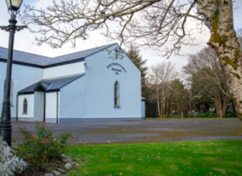 | Church of the Holy Family, Ballycroy  Mass Centre - National School - Innisbiggle  Christopher J. Ginnelly  (098) 49 134 (086) 89 33 278  ballycroyparish@gmail.com  James M Cribben, Geesala (087) 64 69 016  19^{th –} 26th Dec 2021  www.ballycroyparish.ie
Mass at 11am will be Broadcast on our Facebook Page The outside speaker will be in operation if you wish to listen to the mass on the grounds. Special Thanks to Cathy / Nora for operating the live broadcast on Facebook and to Shelly for the beautiful selection of music and hymns.

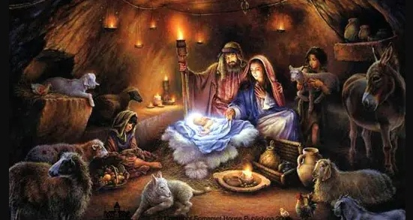

As we come to another Christmas, I extend to you and your loved ones, a very Happy and Peaceful Christmas. A special welcome to our visitors this Christmas time. May this Christmas season bring you closer to all those that you treasure in your heart. Fr. Chris.

I wish to take this opportunity to Thank You for all your help, kindness, spiritual and financial assistance throughout 2021. A special word of thanks to; Peggy Ginty & Social Services, Shelly – Music/Hymns, Cathy and Nora for Facebook broadcasts, Eucharistic Ministers, Readers, Collectors, Counters, Sacristan, Stewards, Financial Council, The Pastoral Committee, Graveyard Committee, Rural Social Scheme. Thanks to our National Schools, Mary Calvey and her Drumgallagh team, Leona Conway and her Scoil Naomh Bhride team, Grace Grealis and the Naíonra, Breege and the Fás team, Order of Malta and the Ballycroy Community Council. A very special Thanks to Bernie Hough and Mary Cafferkey (retired last month) and the Altar Society Ladies for their tremendous help in caring for our church.
Fr. Chris
Fourth Sunday of Advent
Sat 6.30pm 1. Mary, John Conway. Dec’d Conway – McManamon Families
2. Margaret – John Gaughan (Crosshill)
3. Annette Gallagher, 2nd Ann (Knockmoyleen)
Sun 11am 1. Kathleen Conway (13th Ann)
2. Jim O’Boyle (13th Ann) Doona
3. Bridie Leneghan (5th Ann) Doona

Tue 6.30pm 1. Catherine, Willie Keane, Patrick, Michael, John, Anthony,
(Gortbreac)
Wed 10am Mass All Welcome
Thur 10am Mass All Welcome

The Birth of our Lord Jesus Christ - Christmas Season
Fri 2pm Island - People of the Parish
Fri 7pm Bangor Church
Fri 8.30pm Ballycroy – People of the Parish
Sat 9.30am Ballymunnelly
Sat 11am Ballycroy – People of the Parish
No Vigil Mass this Evening

Feast of The Holy Family (Anniversary of our Church)
Sun 11am 1. Patrick Grealis (24th Ann) and Mary Ellen (Lettra)
2. Thomas, Ellen Cleary (Castlehill), Dec’d Cleary and
McManamon Families
Sun 12.15pm Bangor Church

Alter Society Schedule: Sincere thanks to Christina T. and Group 4 for looking after the church last week. This week Patricia G. and Group 1 will look after the church.
Week to 25th Dec | Patricia G: M Sweeney (Tar), M McGowan, J Campbell
Week to 2nd Jan | Bernie S: M Cafferkey, M McGowan, S Carolan
Readers Schedule Nov-Dec |  | Readers | Eucharistic Ministers
Sat 18th Dec 6.30pm |  | Family | Marian Masterson
Sun 19th Dec |  | Family | Noreen Grealis
Fri 24th Dec 8.30pm |  |  | Mary Sweeney - Christina Togher
Sat 25th Dec 11am |  |  | Peggy Ginty – Marian Masterson
Sun 26th Dec |  | Family | Bernadette Shanaghan

Keeping Children Safe: The Diocese of Killala is fully committed to keeping children safe. If you have any concerns around their safety in any circumstance please contact;
The Diocesan Liaison Person – Confidential No - 087 1003554. (Please see more information on the notice board).

Could you please include the following information in your Newsletter for the next 2 weeks in the lead up to our Christmas Market. Much appreciate it.

Give the gift of handmade this Christmas. Knock Christmas Market @ the Plaza takes place Saturday, 18th & Sunday, 19th December. Time: 11am to 4pm. Venue: Pope Francis Plaza, Knock. For bookings see contact information below.
Lots of beautifully hand crafted gifts, handmade by local crafters. Adjacent to Knock Shrine, wheelchair accessible, car park, restaurants, gift shops and toilet facilities close by.
Market @ the Plaza takes place the last Sunday of each month.
We look forward to seeing you on the day.

Contact Leonie @ 086-8486924
E-mail: leoniekilroy@gmail.com
Follow our Facebook page @ Knock Market & Events.

Snippetts:

Eucharist Ministers
- Marian Masterson
- Bernie Hough
- Noreen Grealis
- Mary Sweeney
- Christina Togher
- Geraldine Murray
- Peggy Ginty
- Bernadette Shanaghan

Alter Society Schedule: Sincere thanks to Patricia & Group 1 for looking after the church last week. This week Bernie S & Group 2 will on duty.
Week to 5th Dec | Bernie S: M Cafferkey, M McGowan, S Carolan G2
Week to 11th Dec | Kathleen R: A McManamon, J. Keane, G Grealis G3
Week to 19th Dec | Christina T: M Keane, M. Conway, K ‘or’ N Campbell G4
Week to 25th Dec | Patricia G: M Sweeney (Tar), M McGowan, J Campbell G1
Week to | Bernie S: M Cafferkey, M McGowan, S Carolan
Week to
Week to
Week to
Week to
Week to
Week to
Week to
Week to
Week to
Week to

Monthly Schedule | Readers | Eucharistic Ministers
Sat 26th Nov: 6.30pm | Family | Bernie Hough
Sun 27th Nov: 11am | Family | Noreen Grealis
Sat 4th Dec: 6.30pm | Family | Mary Sweeney
Sun 5th Dec: 11am | Family | Christina Togher
Keeping Children Safe: The Diocese of Killala is fully committed to keeping children safe. If you have any concerns around their safety in any circumstance please contact;
The Diocesan Liaison Person – Confidential No - 087 1003554. (Please see more information on the notice board).

Shranmonragh

