***Offertory Donations:***

Sunday 26th: €520.



Thanks for all your contributions.

**Bohola/Shraheens Newsletter**

**Stephen O’Mahony PP – 094-9384115/086-8226405 –** [**boholaparish@gmail.com**](mailto:boholaparish@gmail.com) **(email for newsletter)**

<https://www.mayo.ie/news/category/connect/parish-news/bohola-parish-news/>

**27th Sunday in Ordinary Time – 3rd October 2021**

###### Masses for the Week

|  |  |  |
| --- | --- | --- |
| **Saturday, October 2nd.** | **12 noon*\****  **8.00pm Vigil*\**** | **Bridie Browne (née Kelly), Kingsbury, London, formerly Lismirrane, followed by the burial of her ashes in St Joseph’s Cemetery.**  **Mary Horan (née Connolly), Ballyvary, (Month’s Mind).** |
| **Sunday, October 3rd.** | **9.30am*\****  **11.30am** | **For all the People.**  **Private Intention.** |
| **Wednesday, October 6th.** | **10.00am**  **7.00 – 9.00pm** | **Private Intention.**  **Exposition of the Blessed Sacrament (private prayer).** |
| **Friday, October 8th.** | **8.00pm** | **Private Intention.** |
| ***Mass will be celebrated privately on other weekdays.*** | | |
| **Saturday, October 9th.** | **11.00am*\****  **2.00pm*\****  **8.00pm Vigil*\**** | **First Communion 2020.**  **First Communion 2021.**  **John & Vera Galligan, Ara, and deceased family.**  **Jimmy Ruane, Carragowan.** |
| **Sunday, October 10th.** | **9.30am*\****  **11.30am** | **For all the People.**  **Private Intention.** |
| ***The 9.30am Sunday Mass will be live-streamed on the Bohola Post Facebook Page every Sunday.***  ***Any other Masses are put online when requested. (Marked with * above)***  ***All Masses will be broadcast on the 105.5 FM Radio channel.*** | | |

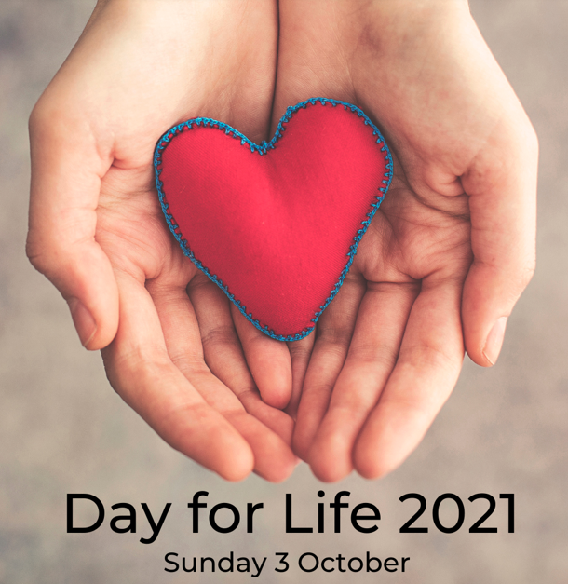***Day for Life 2021:*** This year’s Day for Life is celebrated in Ireland on this Sunday, 3rd October on the theme ‘The Good Samaritan: A Model of Compassion’. Jesus gave us the image of the Good Samaritan as the model for our compassion and our solidarity with those who find themselves vulnerable and who fear being abandoned in their final illness. The Good Samaritan is one who “crosses over”, who “binds up wounds” and who, most important of all “stays with” the person for as long as is required.

In the context of the recent proposal to introduce assisted suicide, both in Ireland and the UK, this year’s Day for Life message invites Catholics to consider a more positive and compassionate response to the care of people who are in the final stages of life. Compassion is often presented as a justification for assisted suicide, but having compassion means “suffering with” someone. Assisted suicide reflects a failure of compassion on the part of society. It is a failure to respond to the challenge of caring for people who are terminally ill, or who have disabilities or dementia, as they approach the end of their lives. Those who assist with a suicide, whatever their motives, co-operate with the self-destruction of another person. It is one thing when life is allowed to take its natural course, with appropriate management of pain and stress, but is not artificially prolonged by burdensome treatment. It is something else entirely, when one person actively and deliberately participates in ending the life of another.

The attitude of Jesus towards the sick and towards those who are in any way marginalised, has much to teach us about the value of time spent caring for one another. Many of us, at times, are called to be carers in our own circle of family and friends. Others may find it possible to care for the carers. The bonds of friendship and solidarity that are developed and strengthened in caring relationships, extend beyond the carer and the one who is cared for to the whole of society.

You can download this year’s full message from *www.councilforlife.ie*.

***New Pilgrim Path Website of the Week, October 3rd:*** *St Francis of Assisi …*… 4th October is the feast of St Francis of Assisi. By any earthly standard, his life was a failure. He had to resign as the head of the Order he founded, as his followers rejected his teaching of absolute poverty. His peacekeeping efforts, when he travelled to the Holy Land and crossed the border to engage with talks with the Sultan of Egypt, failed. His deathbed was attended by only two or three friends. Yet, his legacy is incalculable and completely current. As we end the month-long Season of Creation, we celebrate the patron saint of ecology. An hour-long documentary based on Donald Spoto’s acclaimed biography, St Francis of Assisi: Reluctant Saint, strips away the legends from the life of Francis of Assisi to reveal the true story of a man who has too often been obscured by pious iconography. Watch it at : [***www.newpilgrimpath.ie***](http://www.newpilgrimpath.ie).

***First Communion*** takes place (we hope!) on Saturday next, October 9th for the 2020 class at 11.00am and for the class of 2021 at 2.00pm. It is a very special day for all involved and especially for the children. This year, it marks the end of a very long journey dotted with many false starts along the way. Now more importantly, it should mark the beginning of a new and lifelong special close relationship with the Lord.

***A Pastoral Council Meeting*** will take place in the church on Tuesday evening next, October 5th at 8.30pm. All members are asked to attend. All opinions/suggestions you have on the proposed further easing of restrictions should be related to any member of the Council before that meeting or forever hold your peace!

***Bohola Post:*** The deadline for submission of material to the 2021 edition of the Bohola Post is Saturday, October 30th. Get your articles and/or pictures in as soon as possible and all contributions are to be sent by email to [*boholapost@gmail.com*](mailto:boholapost@gmail.com). More help is always needed so if you can assist in any way with the "Post" please contact us by email. All help welcome.

***Bohola Community Park AGM*** will take place on Sunday, 7th November at 7.00pm in the Community Centre. All are welcome.

***Mayo Roscommon Hospice*** sincerely thanks everyone who made a donation to the collection recently held on their behalf. A total of €480 was collected, all of which goes directly to the Hospice. Thanks again to all.

***Moy Davitts 50/50 Draw:*** Congratulations to Michael Carroll on winning €252 in the Moy Davitts 50/50 draw last Saturday morning. A huge thank you to everyone who supported last week's draw, it is greatly appreciated. Tickets are available in the usual retail outlets and by clicking [*https://smartlotto.ie/Bohola-moy-davitts*](https://l.facebook.com/l.php?u=https%3A%2F%2Fsmartlotto.ie%2FBohola-moy-davitts%3Ffbclid%3DIwAR2-SMSQVJnLPM1gbMk8VYcVq5QSNWsE5b18UD-SHwPhuifGrX08SNDlJc8&h=AT0MiLZlj4q4DBPOl03vVXSokuVERXZawyK8tGPOdkMD6iUtbbGAIDrP1wUMXoHHwBpf8OCfEYLll7lUaWyYzni7elqLyyDX1hxrkiRT4iLddt75pWrUPCYemDN43SvOspaI&__tn__=-UK-R&c%5b0%5d=AT1bnP92vRmesJAH-zh16Oyc956taFyWxM0_3VLfj4QSf9SmpZw5cpQ61Vc5tvJdChYPj7SPty0LDMmT-1CuL0y1Dj6Ia-SpXR1Lif8cNpBMb3zmcNd83NlOLtCy4LEd6sxibGw9D72uG7DGqfgmtrvFR5ZcIPXTwnc_aJIQcIYHHlU6GWM4y_sHX7uH).

***Stoma Support Group Meeting*** takes place in the Ellison Hotel, Castlebar on Wednesday next, 6th October at 7.00pm. For more information, contact J.J. on 087-2300580.

***Radio Maria Ireland*** is an Irish-run Catholic Talk-Radio Station including prayer, catechesis, uplifting music, talks, interviews and testimonies – all commercial free. Listen via TV on Saorview Channel 210 and Freeview Channel; Free App “Radio Maria Ireland”, streaming on [*www.radiomaria.ie*](http://www.radiomaria.ie), via Phone, get live radio feed by calling *01 4373277* (no extra charges apply) or pray with us also on our Facebook Page. Why not drop a line to our Priest Director, Fr. Eamonn McCarthy, or send in your prayer or song requests to us at Radio Maria Ireland, St. Anthony’s Business Park, Ballymount Road, Dublin 22. Please join our growing faith family!

***The Hail Holy Queen Conference*** will be on Radio Maria Ireland at 2pm on Saturday, October 9th. Guest speakers include Bishop John Keenan, Dr Patrick Kenny, Fr Gerry McCloskey and Dr Blythe Kaufman.

***The Coastal Rosary*** will take place at 2.30pm on Sunday, October 10th. Join people from around Ireland to pray the Rosary for Life and Faith at our grottos, churches, at the coasts and other suitable places. We encourage you to gather safely being mindful of Covid-19 regulations. Simply sign up a Rosary location at *www. coastalrosaryireland.ie* or text your location to *087-278 6552*.

***Mental Health Week - North West STOP*** invites you to 3 events to get this message out: *it's OK not to be OK & it's absolutely OK to ask for help.*

*ODD SOCKS DAY* ***-*** 7th October (or between 3rd-10th): Last year this raised over €10,500 and paid for our Free Counselling Service during October, November and early December. Join in and share with friends / colleagues to make it a success in 2021. For a Fundraising Pack, email [*oddsocks4stop@gmail.com*](mailto:oddsocks4stop@gmail.com) or call *071-9856070*.

*ANNUAL GENERAL MEETING*on October 14th at 7.30pm in The Glens Centre, New Line, Manorhamilton. Please confirm your attendance by 7th October if you wish to be included in the minutes. Phone *071-9856070*.

*MEMORIAL WALK*on 15th October at 7pm, Castle Carpark, Manorhamilton. All are welcome to join us in remembering members of our community whom we have cherished and lost. Please dress up warm and wear comfortable shoes.

Prevailing Covid-19 guidelines will apply to all in-person events. FREE COUNSELLING AVAILABLE: PHONE / TEXT *086-7772009*.

***Free online Living Well Programmes in October:*** *Living Well* is a free online group programme delivered over six workshops (2.5 hrs x 6). It is delivered by trained leaders, most of whom are also living with a long-term health condition. You will develop self-management skills and confidence to live well with your health conditions.*Next programmes begin on the following days in October: Thursday 7th, Wednesday 13th, Tuesday 19th and Monday, 1st November*.

You must register in advance as places are limited to 10/12 participants. Please note you do not have to disclose your health condition on the programme. Please contact Liam Gildea on *087-3490393* or by email at [*liam.gildea@mayocil.ie*](mailto:liam.gildea@mayocil.ie)*.* Please see the following link for more information about the course: [*www.hse.ie/livingwell*](http://www.hse.ie/livingwell).

***Free Irish Language Classes*** on Zoom, 1 hour per week for 10 weeks, Wednesdays at 7:30pm from 6th October. Conversation and grammar, suit school-age students, open to the first 10. Contact Declan Prendergast on: [*irishlessons101@gmail.com*](mailto:irishlessons101@gmail.com).

***Mayo College of Further Education, Westport - Autumn 2021 Night Classes:*** Classes commence on the week of October 4th for both Certified and Hobby courses. Detailed information and signup on *www.westportcfe.ie* in the night class section.

***COVID-19 Support Line for Older People:***Professional staff are available to answer queries and give advice and reassurance where necessary. The support line is open seven days a week, 8am to 8pm. The contact number is ***0818-222024***.

***Marriage is just a fancy word for adopting an overgrown male child***

***who cannot be handled by his parents anymore!***