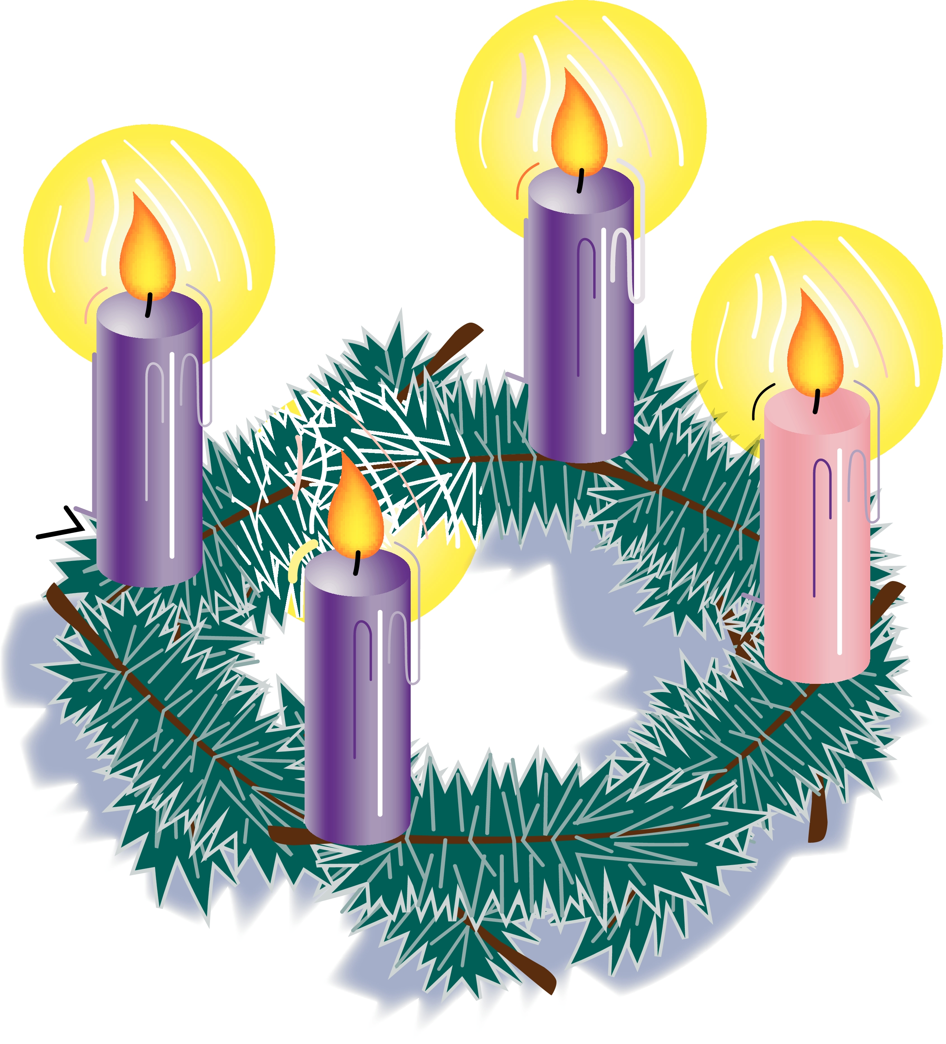



***Immaculate Conception***

***& 9th/ 10th:***

***Bohola:***

€986

***Straide :***

TBA

*Thanks for all your*

*contributions.*

**Bohola/Straide/Shraheens Newsletter**

**Stephen O’Mahony PP/Adm – 094-9384115/086-8226405 –** [**boholaparish@gmail.com**](mailto:boholaparish@gmail.com) **(email for newsletter) pppppp**Newsletter available on *mayo.ie* website and *Straide Parish Facebook* page

**Third Sunday of Advent – 17th December 2023**

###### The Week Ahead

|  |  |  |
| --- | --- | --- |
| **Saturday, December 16th.** | **11.00am  *Straide***  **7.00pm*\* Bohola*** | **Fr. John Smyth (1st Anniversary) & his sister, Teresa (40th Anniv.).**  **Martin & Annie Groarke, Ballyglass and all family & relations, living and deceased.** |
| **Sunday, December 17th.** | **9.30am*\* Shraheens***  **11.00am *Straide*** | **Michael & Catherine Brennan, Boleyard, their son-in-law Jimmy Mullaney & grandson Kieran.**  **Tommy & Molly Walsh, Islandeady and their son Séan, Tralee.**  **Merci Molloy, Dublin & Tavanagh. (11th Anniversary)** |
| **Monday, December 18th.** | **10.00am *Straide*** | **For all the People.** |
| **Tuesday, December 19th.** | **7.00pm*\****  **7.00 – 8.00pm** | **No Mass.**  **Bohola NS Carol Service.**  **Adoration of the Blessed Sacrament in Straide.** |
| **Wednesday, December 20th.** | **7.00pm *Straide***  **10.00am – 12 noon**  **5.00 – 10.00pm** | **Mary Theresa Murray, Ummoon.**  **Adoration of the Blessed Sacrament.**  **Adoration of the Blessed Sacrament. *(Blessed Sacrament Chapel)*** |
| **Thursday, December 21st.** | **10.00am** | **Private Intention.** |
| **Friday, December 22nd.** | **10.00am** | **Private Intention.** |
| **Saturday, December 23rd.** | **7.00pm*\* Bohola*** | **Pat Donellan, London & Clonberne.**  **Eileen O’Toole (née Conlon), Essex, England & late of Tooromeen.** |
| **Sunday, December 24th.** | **5.00pm *Straide***  **7.00pm*\* Bohola*** | **No Morning Mass.**  **The Nativity of Our Lord.**  **The Nativity of Our Lord.** |
| ***The Bohola weekend Mass will be live-streamed on the Bohola Post Facebook Page every weekend.***  ***Any other Bohola Masses are put online when requested. (Marked with * above)***  ***All Bohola Masses will be broadcast on the 105.5 FM Radio channel.***  ***All Straide Masses can be seen live on www.straideparish.com or www.churchtv.ie/straide.*** | | |

***Recent Death:*** Please pray for the happy repose of the soul of *Mary Brennan*, Gortnasella, who died on Friday, December 8th and whose funeral took place in Bohola on Tuesday last. May she rest in peace

***Christmas Confessions:*** *“The Light is on for You”* – There will be a visiting priest in Bohola and Straide churches this Sunday, December 17th from 5pm to 6pm to hear confessions. You are encouraged to avail of this opportunity to prepare for Christmas.

***Bohola NS Carol Service:*** The Staff and Pupils of Bohola NS invite you to their Carol Service next Tuesday, December 19th at 7.00pm in the church. This is a lovely way to begin Christmas week and all are welcome.

***Church of Ireland, Foxford, Carol Service*** with Foxford Brass Band takes place on this Sunday, 17th December at 5.00pm. Everyone is most welcome

***Choral Music at the Museum:*** Enjoy Christmas carols at the National Museum of Ireland – Country Life, on this Sunday, 17th December. The Mayo Male Voice Choir will perform at 3pm and the Cill Aodain Choral Society will perform at 4pm. All are welcome. Admission is free. No booking required.

***Online Advent Calendar:*** Now in its tenth year, the website of the Irish Catholic Bishops’ Conference is hosting its interactive digital Advent Calendar. To mark this special season, this year’s Advent calendar offers resources for school, parish and home and is accessible behind a virtual door that, as per tradition, can only be opened on each day of Advent. Content includes a short video message, seasonal crafts for children and prayers to assist us in keeping Christ at the centre of our Christmas preparations.

Advent (from ‘ad-venire’ in Latin or “to come to”) is the Church season encompassing the four Sundays and weekdays leading up to the celebration of Christmas. Advent is a time of spiritual preparation for the Lord’s coming at Christmas. Advent also prepares us for the second coming of Christ at the end of time. The themes of the Advent Calendar this year are Peace, and Vocations. Visit *https://www.catholicbishops.ie/adventcalendar/*.

***New Pilgrim Path Website of the Week, Sunday, December 17th:*** *The Great ‘O’ Antiphons ….* The O Antiphons are seven responses, or antiphons, that are sung or recited to introduce the canticle of Mary (the Magnificat) at evening prayer from December 17th to December 23rd, the octave before Christmas. These antiphons are based on Isaiah’s prophecies and refer to the different ancient titles given to the Messiah.

We can bring these responses into our own prayers, as simple reminders throughout the day of the one whose coming we are joyfully expecting, as introductions to our own prayers of praise of Jesus, or as words of thanksgiving for God’s faithfulness throughout the ages and our lives. Regardless of how you incorporate these ancient words into your Advent prayer life, let them speak to you. Our Website of the Week introduces these powerful sung prayers and, for each succeeding day of Advent, we will focus on each in turn. To find out more, visit: [***www.newpilgrimpath.ie***](http://www.newpilgrimpath.ie).

According to St Augustine, “The one who sings prays twice”. *New Pilgrim Path* offers superb sacred music choices for each day of Advent. Visit *Daily Music for Advent*.

***Sincere Thanks*** to the parishioners and all on the RSS scheme who helped with the clean-up and transformation of Straide church and church grounds in anticipation of the Christmas season. Your goodwill is greatly appreciated.

***The 51st Edition of the Bohola Post*** is now on sale in all the usual outlets. A snip at €10!

***Anam Cara Mayo***, the organisation that supports bereaved parents, is holding a Parent Evening on Tuesday, 19th December at 7.15pm in the T.F. Royal Hotel, Castlebar. This event is free and open to all bereaved parents regardless of the age your child died, the circumstances of their death, or whether their death was recent or not. We now also offer an online support service. Please contact us on [*info@anamcara.ie*](mailto:info@anamcara.ie) or *085-2888888* for any queries. For more information see [*anamcara.ie*](http://anamcara.ie/).

***Moy Davitts 50/50 Draw:*** Congratulations to the Niland Family, Claremorris who won a jackpot of €292 in the Moy Davitts 50/50 draw last Saturday. A huge thank you to everyone who supported last week's draw, it is greatly appreciated. Tickets are available in the usual retail outlets and by clicking [*https://smartlotto.ie/Bohola-moy-davitts*](https://l.facebook.com/l.php?u=https%3A%2F%2Fsmartlotto.ie%2FBohola-moy-davitts%3Ffbclid%3DIwAR2-SMSQVJnLPM1gbMk8VYcVq5QSNWsE5b18UD-SHwPhuifGrX08SNDlJc8&h=AT0MiLZlj4q4DBPOl03vVXSokuVERXZawyK8tGPOdkMD6iUtbbGAIDrP1wUMXoHHwBpf8OCfEYLll7lUaWyYzni7elqLyyDX1hxrkiRT4iLddt75pWrUPCYemDN43SvOspaI&__tn__=-UK-R&c%5b0%5d=AT1bnP92vRmesJAH-zh16Oyc956taFyWxM0_3VLfj4QSf9SmpZw5cpQ61Vc5tvJdChYPj7SPty0LDMmT-1CuL0y1Dj6Ia-SpXR1Lif8cNpBMb3zmcNd83NlOLtCy4LEd6sxibGw9D72uG7DGqfgmtrvFR5ZcIPXTwnc_aJIQcIYHHlU6GWM4y_sHX7uH).

***Social Bingo*** takes place every Monday in The Sheridan Memorial Community Centre, Bohola. Doors open at 8.30pm. Community fun and a cup of tea is included!

***Epilepsy Ireland*** church gate collection will be taken up in Straide on this Sunday, 17th December. All donations appreciated.

***Mary's Meals Christmas Gifts Campaign:*** With the cost of living crisis, times are that bit harder for us all. The Global School Feeding Movement, Mary's Meals, has launched its Christmas Gifts Campaign - giving gifts that have a real and tangible impact on those in need. From as little as €5.50, which will provide 50 meals for children in their place of education, we can play our part in changing the lives of those most in need. Visit *marysmeals.ie* to download a gift today or call *01-8535163 / 089-4339592*.

***Home Caregivers Urgently Required*** in the local and surrounding areas and are currently being recruited. For further information, please email *cara.hughes@homeinstead.ie* or phone our office on *094 9044785*.

***Free Christmas Advertising for Community Groups with Mayo PPN:*** Are you holding a community event/activity? Email your details with a Jpeg poster to [*mayoppn@mayococo.ie*](mailto:mayoppn@mayococo.ie). We will circulate via the PPN social media platforms to our 1,000 plus community groups registered with Mayo PPN. To register with May PPN, follow the link: [*https://mayoppn.ie/join-mayo-ppn/*](https://mayoppn.ie/join-mayo-ppn/).

***Living Well Programme 2024***: Living Well is a free HSE programme which helps people living with a long-term health condition to manage their condition and improve their overall wellbeing. Anyone with any chronic illness such as diabetes, arthritis, COPD, cardiac illness, anxiety, etc. can benefit from these workshops. The next programme in Westport commences on February 9th (or the online programme will commence on January 30th). The programme is delivered over six weekly workshops (2.5 hrs x 6) by trained leaders. Advance registration is required. To find out more, please contact Liam Gildea on *086-0142675* or by email at *lgildea@southmayo.com*.

***Mayo Cancer Support*** provides FREE support services to those affected by cancer. Call *(094) 9038407*.

***North West STOP*** offers a *free counselling* service with no waiting lists. Call or text *086-7772009* to arrange an appointment.

***Keep calm and jingle all the way!***