***Offertory Donations:***

This Week: €350.



Very much appreciated.

**Bohola/Shraheens Newsletter**

**Stephen O’Mahony PP – 094-9384115/086-8226405 –** [**boholaparish@gmail.com**](mailto:boholaparish@gmail.com) **(email for newsletter)**

<https://www.mayo.ie/news/category/connect/parish-news/bohola-parish-news/>

**First Sunday of Advent – 29th November 2020**

###### Masses for the Week

|  |  |  |
| --- | --- | --- |
| **Sunday, November 29th.** | **10.00am** | **Deceased of McNicholas & Brogan families, Gortnasella.**  **(*Live Streamed on Bohola Post Facebook Page).*** |
| **Wednesday, December 2nd.** | **10.00am**  **6.00 – 8.00pm** | **For all the People.**  **Exposition of the Blessed Sacrament (private prayer).** |
| **Friday, December 4th.** | **8.00pm** | **Private Intention.** |
| ***Mass will be celebrated privately on other weekdays.*** | | |
| **Saturday, December 5th.** | **7.00pm** | **Mary & Martin Lyons, Lismirrane & sons, John, Joe & William and deceased family.** |
| **Sunday, December 6th.** | **9.30am**  **11.30am** | **For all the People. (*Live Streamed on Bohola Post Facebook Page).***  **Private Intention.** |
| ***Live Streamed Sunday Mass on the Bohola Post Facebook Page reverts to 9.30am from next Sunday, 6th December.*** | | |

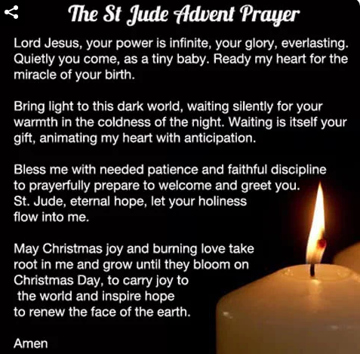***Return to Public Worship***

*Some light at the end of the tunnel at last! The Government announcement on Friday evening allows churches to open again for public worship from Tuesday next, December 1st.*

*In effect, this means that we return to the situation that pertained from July to early October apart from the fact that* ***funerals are limited to a congregation of 25*** *as we are still under Level 3 restrictions. A maximum of 50 is allowed at other Masses and the wearing of face masks is stressed. But it is fair to say that practically all those attending in Bohola prior to the recent lockdown were compliant in this regard. All other guidelines re sanitising, social distancing etc. still apply. A full list of these guidelines is on the notice-board in the church porch*

*As you can see from the Mass schedule above, the timetable for the coming week is similar to what was in place before lockdown. However, the* ***Saturday evening Vigil Mass will be at 7.00pm*** *as was the practice in recent years during the winter months. Please note that the* ***online Mass on Sunday reverts back to 9.30am*** *from Sunday next, December 6th.*

*It will be great to have you all back physically present in the church again but hopefully not all at the same time, for the time being at least!*

***Recent Death:*** Please pray for the happy repose of the soul of *Eddie Reddington*, Cartron, Swinford, who passed away on Wednesday last, November 25th and whose funeral took place in Swinford this Saturday. He was brother-in-law of Rose Reddington and uncle of Teresa Flaherty, Ardacarra. May he rest in peace.

***Pastoral Council Meeting:*** Normal meetings are not allowed under Level 3 restrictions but we hope to organise a Zoom meeting of the Pastoral Council for *Tuesday evening next, December 1st at 8.00pm*. All members will be contacted with relevant details.

***Exposition of the Blessed Sacrament*** will take place again in the church on Wednesday evening next from 6.00pm to 8.00pm. This is a time of private prayer so you are welcome to drop in during that time or at any other time.



***Shine A Light for Hospice:*** Mayo Roscommon Hospice Foundation is asking people to #ShineALightforHospice and to light a candle in their own home to remember a loved one, living or deceased, on this Sunday evening, 29th when the ceremony will be live streamed at 6.30pm on the Mayo Roscommon Hospice Facebook page so people can join in from the safety of their own homes. Funds raised go towards vital palliative care services.

***Mary's Meals*** believes that **no child should endure a day without a meal**. We set up school feeding programmes in some of the world’s poorest communities, where poverty and hunger prevent children from gaining an education. Every school day, we feed 1,667,067 hungry children across 19 countries. It costs just €18.30to feed a child with Mary’s Meals for a whole school year. We have a commitment to keeping our running costs low, with at least 93% of donations being spent on our charitable activities. More information on [*www.marysmeals.ie*](https://eur02.safelinks.protection.outlook.com/?url=http%3A%2F%2Fwww.marysmeals.ie%2F&data=04%7C01%7Cpatricia.friel%40marysmeals.org%7Cdc3fb9a9bf194309cb9a08d87c021c85%7C56bf9bbcbe8c4eb3bb18b7910154a096%7C0%7C0%7C637395695797892144%7CUnknown%7CTWFpbGZsb3d8eyJWIjoiMC4wLjAwMDAiLCJQIjoiV2luMzIiLCJBTiI6Ik1haWwiLCJXVCI6Mn0%3D%7C1000&sdata=WX6iBWU4aXU0mnty4Xr4ZmYIR%2BvG%2FdjPyN4v9OyZb0M%3D&reserved=0). The following link to a short video shows the impact of our work: [*https://youtu.be/F4kq8NWKmnM*](https://eur02.safelinks.protection.outlook.com/?url=https%3A%2F%2Fyoutu.be%2FF4kq8NWKmnM&data=04%7C01%7Cpatricia.friel%40marysmeals.org%7Cdc3fb9a9bf194309cb9a08d87c021c85%7C56bf9bbcbe8c4eb3bb18b7910154a096%7C0%7C0%7C637395695797902141%7CUnknown%7CTWFpbGZsb3d8eyJWIjoiMC4wLjAwMDAiLCJQIjoiV2luMzIiLCJBTiI6Ik1haWwiLCJXVCI6Mn0%3D%7C1000&sdata=FjR9xcMDd6CX%2FuJV5E5c57DLrWNBCotW9UXGnfacFVs%3D&reserved=0).

We have our *Christmas fundraising Campaign*launched this week. It is called *The Big Family Christmas***.** Through it people can donate €18.30 and set a place at our virtual dinner table which gives a hungry child life-changing school meals for a year. People who are setting places as gifts for friends and family, or in memory of loved ones, will get beautiful placemats, featuring their names, to email or print out and pass on. Go to [*www.bigfamilychristmas.com*](https://eur02.safelinks.protection.outlook.com/?url=http%3A%2F%2Fwww.bigfamilychristmas.com%2F&data=04%7C01%7Cpatricia.friel%40marysmeals.org%7Cdc3fb9a9bf194309cb9a08d87c021c85%7C56bf9bbcbe8c4eb3bb18b7910154a096%7C0%7C0%7C637395695797902141%7CUnknown%7CTWFpbGZsb3d8eyJWIjoiMC4wLjAwMDAiLCJQIjoiV2luMzIiLCJBTiI6Ik1haWwiLCJXVCI6Mn0%3D%7C1000&sdata=unGN3aYJ5GdpLDmEoPA1r3EO%2BkoxHwdtBVSjpZvPhZ0%3D&reserved=0).

***Western Care Association’s Christmas Cards 2020*** are now on sale in your local town and area. Pack includes 10 unique cards and envelopes for €6.00. Thank you for supporting Western Care…*Your Mayo Charity!* Contact Teresa Ward on *087-2467857* for further information.

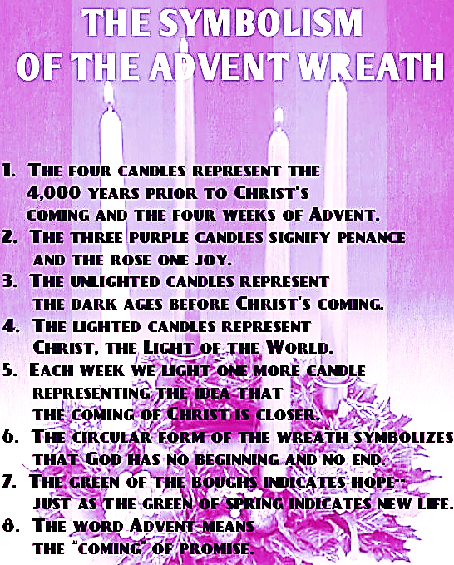

***New Pilgrim Path Website of the Week, November 29th:*** Entering Advent is an appropriate time to reflect on the Messiah’s forerunner. Who was John the Baptist and why has he been so important to artists and patrons over the centuries? 10 films, each about eight minutes in length, explore the life of this pivotal figure through masterpieces in London’s National Gallery and beyond. Access this wonderful resource at: [***www.newpilgrimpath.ie***](http://www.newpilgrimpath.ie)**.**

***Comfort My People: The First Readings of Advent*** with Fr Noel Rooney **-** online programme from November 23rd at [*https://www.galilee.ie/online-programmes/*](https://www.galilee.ie/online-programmes/). In Advent the Church selects readings to draw us more deeply into the mystery of the season. In these four short videos (The Work of your Hands, Comfort my People, Good News to the Poor, Promises to Keep) Fr Noel Rooney introduces each of the first readings, its context and characters, and helps us to connect it with our own Advent journey. *Fr Noel Rooney is a priest of the Diocese of Elphin, currently serving in St Joseph’s parish in Sligo town. Fr Noel studied Scripture in the Biblical Institute in Rome and graduated with a licence in Sacred Scripture (LSS).*

***Advent Invitations for COVID Times - Online Advent Retreat*** with Sr Finola Cunnane*.* Amid the challenges of COVID and 2020 can we hear the words of Isaiah, “See, I am doing a new thing?” Can we hear God’s invitation to listen, hope, uncover and discover the hidden treasures within our being? In this two-part retreat we will pay attention to how we are and open our hearts to Christ’s life-giving invitations for Christmas and beyond. Part 1 recording available [*https://www.galilee.ie/online-programmes/*](https://www.galilee.ie/online-programmes/) from November 30th. Part 2 – Saturday, 5th December from 10.30am to 1.00pm ‘live’ via Zoom. Cost €25. Details and booking: [*info@galilee.ie*](mailto:info@galilee.ie). *Dr. Finola Cunnane, SSL is a St. Louis Sister with wide experience in retreats and education. She has lectured in scripture, theology and spirituality in Ireland and internationally.*

***Priesthood in Achonry Diocese:*** *“O LORD, you are our father…we are all the work of your hands…”* How is God trying to mould you? Is it to be of service to Him as a priest or in the consecrated life? Speak to your local priest, call your Diocesan Vocation’s Director or email the National Vocations Office on *info@vocations.ie*. For further information contact our Vocations Director, **Fr Paul Kivlehan, The Presbytery, Ballaghaderreen, Co. Roscommon. Tel.094-9860011, Mobile 087-3683535, E-mail** [***pkivlehan@achonrydiocese.org***](mailto:pkivlehan@achonrydiocese.org).

***Moy Davitts 50/50:*** Congratulations to Sonya Dempsey on winning €327 in the Moy Davitts 50/50 draw. A huge ‘thank you’ to everyone who supported last week's draw, it is greatly appreciated. Tickets are available in the usual retail outlets and by clicking [*https://smartlotto.ie/Bohola-moy-davitts*](https://l.facebook.com/l.php?u=https%3A%2F%2Fsmartlotto.ie%2FBohola-moy-davitts%3Ffbclid%3DIwAR2-SMSQVJnLPM1gbMk8VYcVq5QSNWsE5b18UD-SHwPhuifGrX08SNDlJc8&h=AT0MiLZlj4q4DBPOl03vVXSokuVERXZawyK8tGPOdkMD6iUtbbGAIDrP1wUMXoHHwBpf8OCfEYLll7lUaWyYzni7elqLyyDX1hxrkiRT4iLddt75pWrUPCYemDN43SvOspaI&__tn__=-UK-R&c%5b0%5d=AT1bnP92vRmesJAH-zh16Oyc956taFyWxM0_3VLfj4QSf9SmpZw5cpQ61Vc5tvJdChYPj7SPty0LDMmT-1CuL0y1Dj6Ia-SpXR1Lif8cNpBMb3zmcNd83NlOLtCy4LEd6sxibGw9D72uG7DGqfgmtrvFR5ZcIPXTwnc_aJIQcIYHHlU6GWM4y_sHX7uH). Best of luck everyone and thanks again!

***Free Online Living Well Programme:*** The next programmes commence in *January* on *Thursday 7th, Tuesday 12th, Monday 18th,* and *Wednesday 20th* on the zoom platform. Limited places. Please contact Liam Gildea on *087-3490393* or by email at [*liam.gildea@mayocil.ie*](mailto:liam.gildea@mayocil.ie). You can find out more information on the programme on our website: *www.hse.ie/livingwell*.

***Helplines***

**ALONE COVID-19 Support Line for Older People:** ***0818 222 024*** (Every day, 8am to 8pm).

***SeniorLine:*** Ireland’s national confidential service for older people. ***Freefone 1800 80 45 91*** (Every day, 10am to 10pm).

***Foxford Friend on Phone Service:*** For information, call Foxford Leisure Centre on ***094-9257684***.

***Brace your elves.***

***Christmas is coming!***