***Offertory Donations:***

Sunday 27th: €1,105.



Thanks for all your contributions.

**Bohola/Shraheens Newsletter**

**Stephen O’Mahony PP – 094-9384115/086-8226405 –** [**boholaparish@gmail.com**](mailto:boholaparish@gmail.com) **(email for newsletter)**

<https://www.mayo.ie/news/category/connect/parish-news/bohola-parish-news/>

**14th Sunday in Ordinary Time – 4th July 2021**

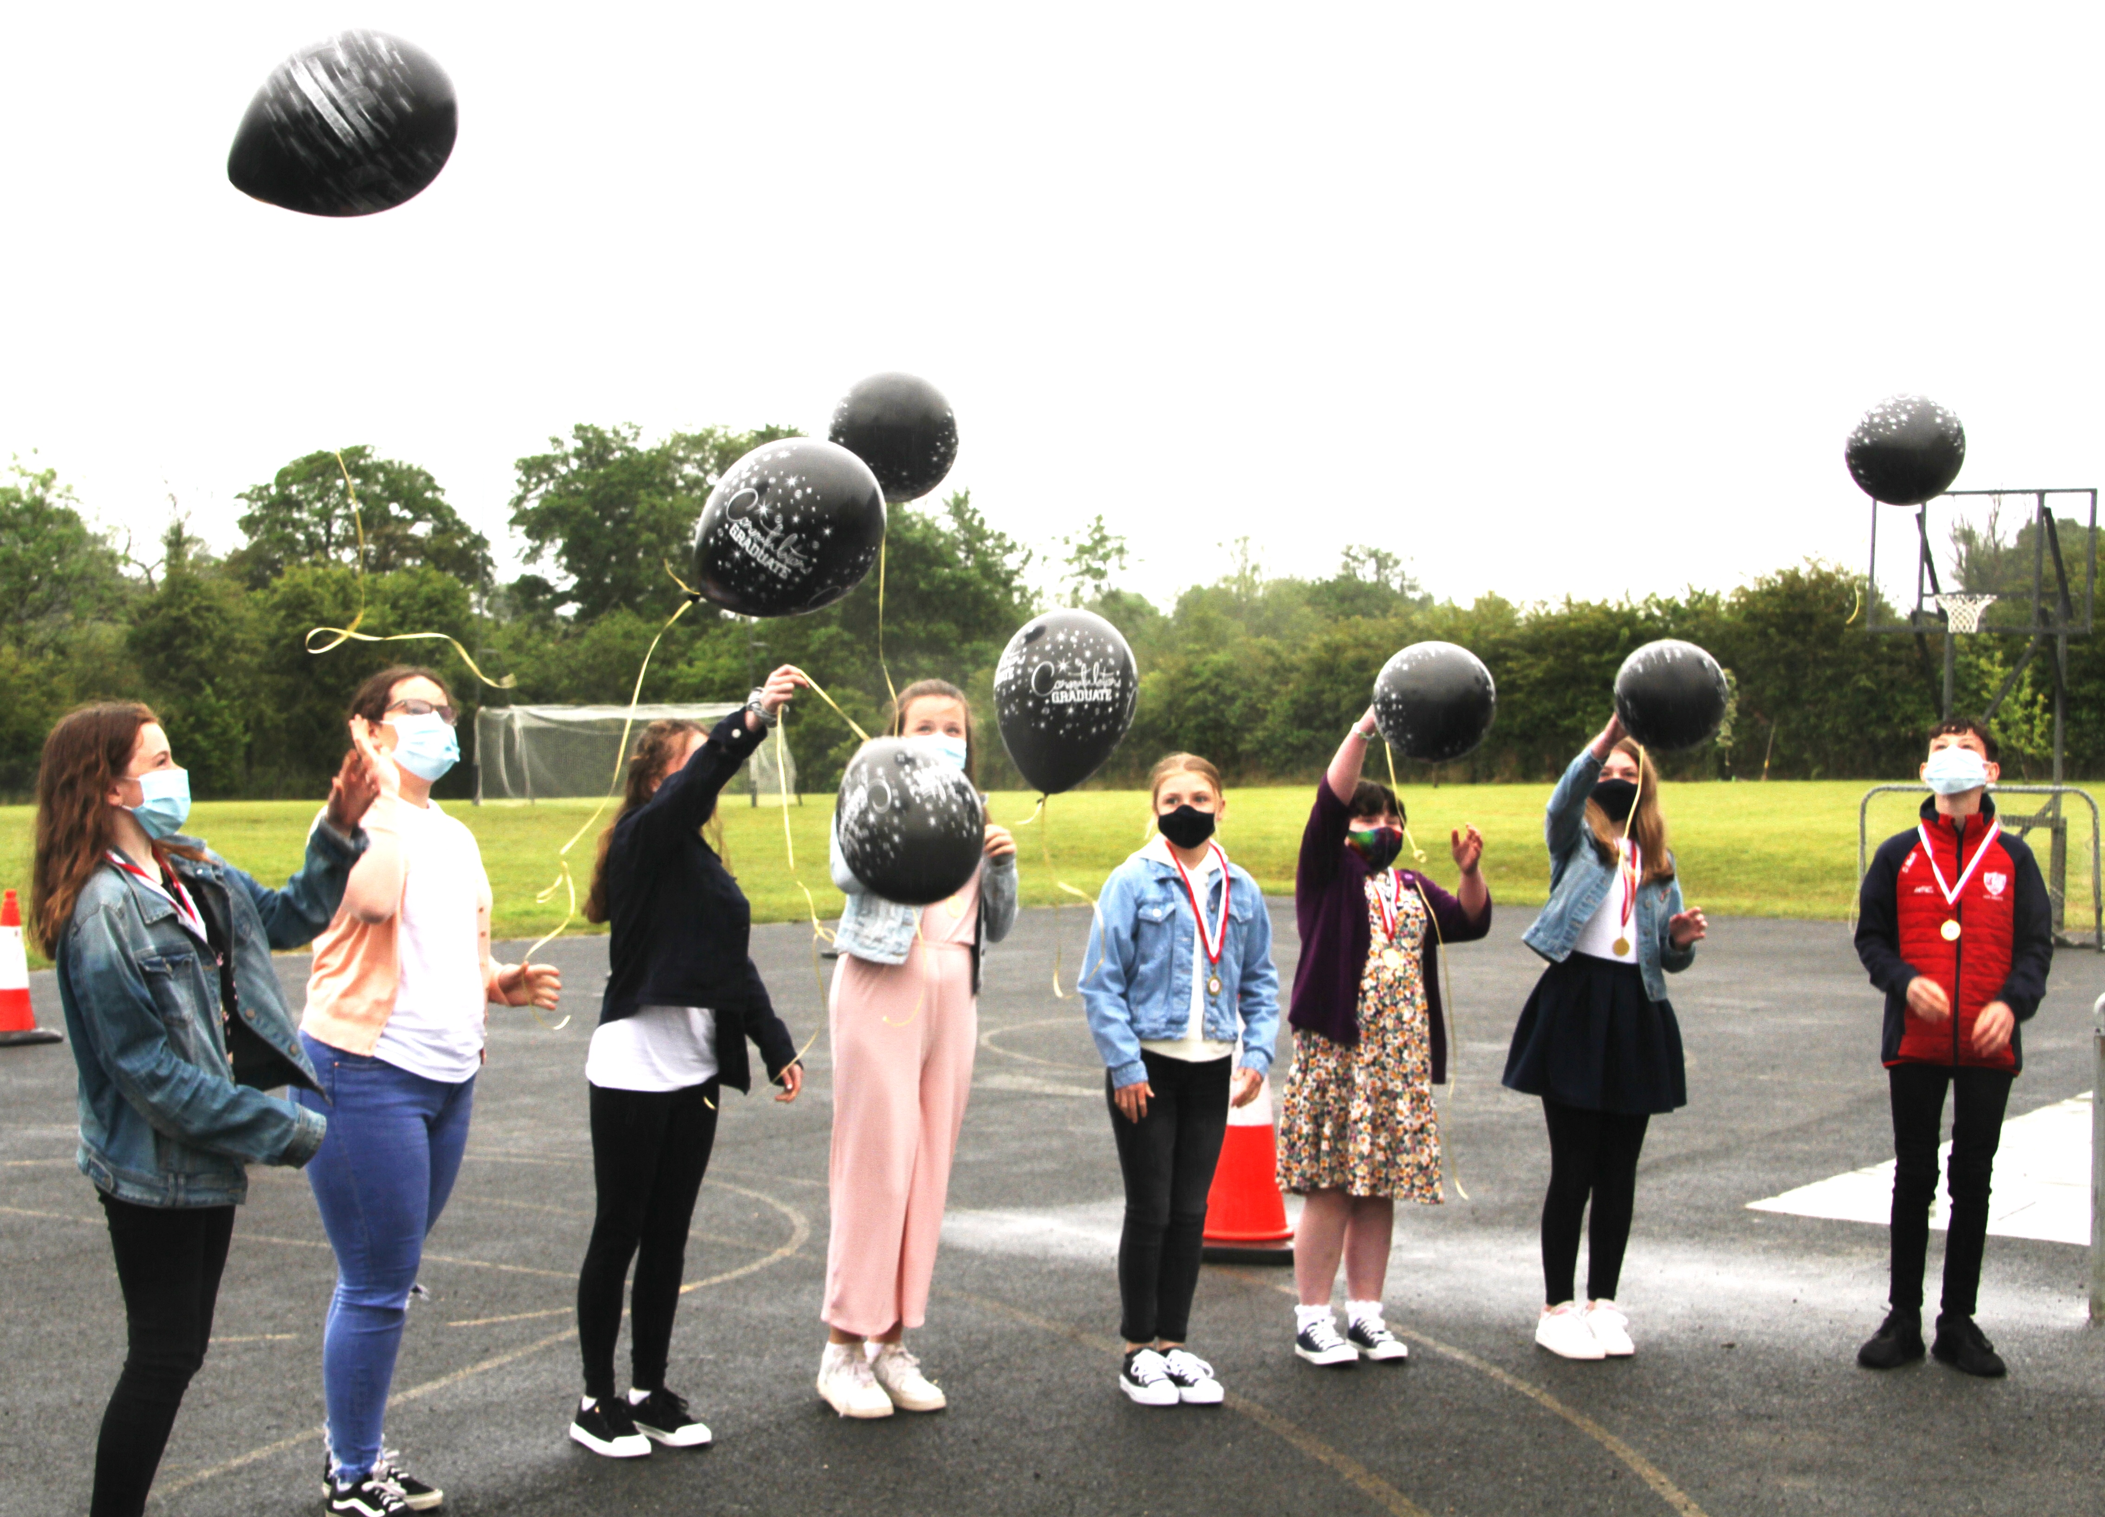

###### Masses for the Week

|  |  |  |
| --- | --- | --- |
| **Saturday, July 3rd.** | **8.00pm Vigil*\**** | **Annie & Martin Groarke, Ballyglass and deceased family.** |
| **Sunday, July 4th.** | **9.30am*\****  **11.30am** | **For all the People.**  **Private Intention.** |
| **Wednesday, July 7th.** | **10.00am**  **7.00 – 9.00pm** | **Private Intention.**  **Exposition of the Blessed Sacrament (private prayer).** |
| **Friday, July 9th.** | **10.00am*\****  **8.00pm*\**** | **Marion Clarke, Bohola & deceased of Clarke & McDonnell families.**  **Ian Pielow, Ballyglass (Month’s Mind).** |
| ***Mass will be celebrated privately on other weekdays.*** | | |
| **Saturday, July 10th.** | **8.00pm Vigil*\**** | **Jerome Howley, Carragolda (Month’s Mind).** |
| **Sunday, July 11th.** | **9.30am*\****  **11.30am** | **Jimmy Mullaney and his son, Kieran, Boleyard.**  **For all the People.** |
| ***The 9.30am Sunday Mass will be live-streamed on the Bohola Post Facebook Page every Sunday.***  ***Any other Masses are put online when requested. (Marked with * above)***  ***All Masses will be broadcast on the 105.5 FM Radio channel.*** | | |

***Recent Deaths:*** Please spare a thought for the 6,771 unborn Irish babies who lost their lives through abortion in 2020 (figures released on Tuesday last) and pray for their parents who no doubt in most cases suffer great pain and anguish. We think especially of the parents of baby Christopher Kiely who was aborted in the National Maternity Hospital in Holles Street following a misdiagnosis in his case.

***Baptism:*** On Saturday last, June 26th, we were delighted to welcome *Kayla Grace McGowan,* Carroward, into God’s family. Congratulations to her parents, Jonathan and Jessica, her godparents and family and we wish them every blessing for the future.

***First Communion Deferred Again!*** Following government announcements (and Leo’s off-the-cuff remarks) on Tuesday, we were left with little choice but to further delay the celebration of First Holy Communion, scheduled for next Saturday, July 10th. To say this is frustrating and a bitter disappointment for children, parents, teachers and all concerned is a gross understatement. It is accepted that the celebration of the sacrament itself in church is not a problem but there was concern about social gatherings afterwards. Locally, I am confident that any planned social event would have been home-based and confined to the extended family circle, in other words responsible and in compliance current safety guidelines.

That said, it would have been irresponsible to ignore public health advice. But it would be easier to accept that advice if it were consistent. For example, weddings are still allowed, 8,000 are allowed into Croke Park this Saturday, 2,500 at the Irish Open golf, hundreds and more at various sporting and other events. No doubt all these events will be run safely and responsibly. One can only assume then that all those attending will go home afterwards and there will be no social gatherings. Yeah, right!!!

It is difficult to shake off the feeling that purely religious events are treated in a cavalier fashion and at best regarded as an irrelevance by the powers that be. But fear not, we will have our day – in church and at the polling station! ...... *S.O’M.*

***New Pilgrim Path Website of the Week, July 4th:*** *Help me to journey beyond the familiar and into the unknown. Give me the faith to leave old ways and break fresh ground with You. Christ of the mysteries, I trust You…*… These are the opening lines of the powerful prayer of St Brendan the Navigator, the 5th century Irish monk who has long and convincingly been credited with the discovery of America, centuries before Columbus. Read the full prayer and watch a short video on the life of this intrepid sailor at: [***www.newpilgrimpath.ie***](http://www.newpilgrimpath.ie).

***RTÉ- Challenging Media Bias on Abortion:*** The Pro Life Campaign is currently running a campaign asking RTÉ to "Stop The Bias". RTÉ is a publicly funded national broadcaster and should therefore represent all people. However, when reporting on the issue of abortion they do not represent different views and options and are totally skewed and biased in manner. They now need to hear from every pro-life supporter on the issue! Sign the instant E-Card from the Pro Life Campaign that asks the Director General of RTÉ to explain and justify expecting pro-life people to continue paying the TV licence given the shockingly biased coverage on abortion. To sign go *to:www.https://prolifecampaign.ie/stopthebias/*.

***COVID-19 Support Line for Older People:***Professional staff are available to answer queries and give advice and reassurance where necessary. The support line is open seven days a week, 8am to 8pm. The contact number is ***0818-222024***.

***Safety Measures:*** As the fears around the Delta variant of Covid-19 increase, we are asked to remind parishioners of the safety measures in church. Please continue to use hand sanitisation, wear face masks, receive Communion on the hand and maintain social distancing. In fairness there is hardly any need to say this as all coming to church in Bohola are to be complimented for your co-operation and compliance with all safety measures. But maybe it is no harm for all of us to remind ourselves to stay alert and not get careless at this critical point. Our continued thanks to all stewards and cleaners who contribute so much to making our church a safe place to worship.

***Sixth Class Graduation:*** In last week’s newsletter some names of the Sixth Class of Bohola National School failed to reach the printed page as we placed on record their graduation ceremony on Tuesday, June 22nd. Apologies are in order and we now set the record straight and congratulate the whole class on reaching this significant point of their learning.

So well done to Kate Byrne, Rebecca Flaherty, Hannah Gaughan, Niamh Gillespie, Kate Louise McGahon, Niamh Moore, Mary Moran, Dylan McHale and Róisín Rowley and once again we wish them well as they spread their wings and move on to another stage of their journey in education.

***Moy Davitts 50/50 Draw:*** Congratulations to Tom Flaherty on winning €504 in the Moy Davitts 50/50 draw last Saturday morning. A huge thank you to everyone who supported last week's draw, it is greatly appreciated. Tickets are available in the usual retail outlets and by clicking [*https://smartlotto.ie/Bohola-moy-davitts*](https://l.facebook.com/l.php?u=https%3A%2F%2Fsmartlotto.ie%2FBohola-moy-davitts%3Ffbclid%3DIwAR2-SMSQVJnLPM1gbMk8VYcVq5QSNWsE5b18UD-SHwPhuifGrX08SNDlJc8&h=AT0MiLZlj4q4DBPOl03vVXSokuVERXZawyK8tGPOdkMD6iUtbbGAIDrP1wUMXoHHwBpf8OCfEYLll7lUaWyYzni7elqLyyDX1hxrkiRT4iLddt75pWrUPCYemDN43SvOspaI&__tn__=-UK-R&c%5b0%5d=AT1bnP92vRmesJAH-zh16Oyc956taFyWxM0_3VLfj4QSf9SmpZw5cpQ61Vc5tvJdChYPj7SPty0LDMmT-1CuL0y1Dj6Ia-SpXR1Lif8cNpBMb3zmcNd83NlOLtCy4LEd6sxibGw9D72uG7DGqfgmtrvFR5ZcIPXTwnc_aJIQcIYHHlU6GWM4y_sHX7uH).

***Bohola Moy Davitts Club Annual: Request for Articles & Photos:***Bohola Moy Davitts G.A.A. club are delighted to launch the publication of a club annual in 2021. The first edition of the annual will focus on the formation of the club in 1974 and the success of the junior men’s team that year. There will also be extensive coverage of the various teams and activities taking place in the club in the current year, 2021. Any articles/photos which you would like to be considered for the annual can be emailed to [*bmdclubannual@gmail.com*](mailto:bmdclubannual@gmail.com). We are especially interested in any photos or memorabilia from 1974.

Please note that all articles must be typed and all photos should be captioned as we can only accept submissions by email this year.

***Finished School and Don't Know What to do Next?*** Are you at home because you don't know how to access further training? NLN Mayo could help you. We train early school leavers, LCA students and people who would benefit from additional supports. Our courses will develop your skills and confidence to open up new opportunities for further training. We offer Sports Industry and Gym Instructor Studies, Employment Skills, Business, IT & Digital Skills courses and more. All our courses are FREE! For more information on the courses available, contact: Castlebar@nln.ie or (094) 9022770, National Learning Network, Breaffy Road, Castlebar.

***The Pit***

A man fell into a pit and couldn't get himself out.

A subjective person came along and said, "I feel for you down there."

An objective person walked by and said, "It's logical that someone would fall down there."

A Pharisee said, "Only bad people fall into pits."

A mathematician calculated how deep the pit was.

A news reporter wanted the exclusive story on the pit.

A self-pitying person said, "You haven't seen anything until you've seen my pit."

A fire-and-brimstone preacher said, "You deserve your pit."

A Christian Scientist observed, "The pit is just in your mind."

A psychologist noted, "Your mother and father are to blame for your being in that pit."

A self-esteem therapist said, "Believe in yourself and you can get out of that pit."

An optimist said, "Things could be worse."

A pessimist claimed, "Things will get worse."

Jesus, seeing the man, took him by the hand and lifted him out of the pit.

***A zoo has been opened with only one animal – a dog.***

***It’s a shitzu!***