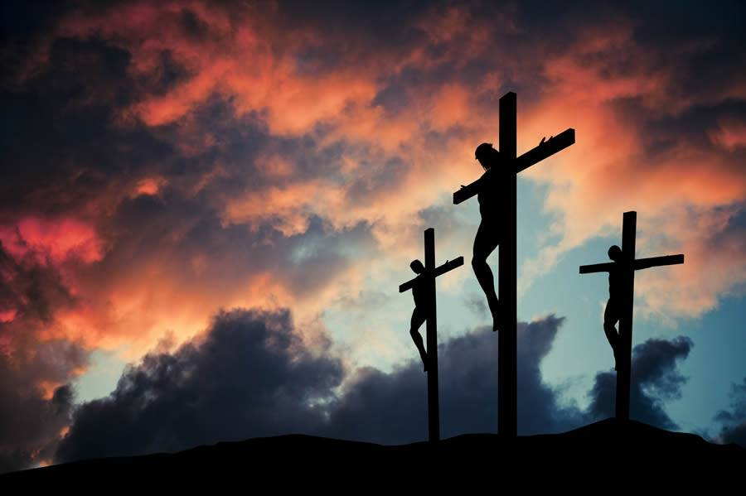

Ballycroy
Holy Week
24th – 31st March 2024

Holy Week Ceremonies – Holy Week begins this Sunday, with the Blessing of the Palm and the Reading of the Passion. We accompany Christ in the last days of his life on earth. The Easter Triduum begins with the Lord’s Supper on Thursday night and continues then to Easter Sunday.

Please make every effort with your family to attend all the Ceremonies.

Church of the Holy Family, Ballycroy
Mass Centre - National School – Innisbiggle
Christopher J. Ginnelly
(098) 49 134 (086) 89 33 278
ballycroyparish@gmail.com
James M Cribben, Geesala (087) 64 69 016
24th March 2024
Mass at 11.30am will be Broadcast on our Facebook Page. Special Thanks to Nora for operating the live broadcast on Facebook and to Shelly for the beautiful selection of music and hymns.
Booking a Mass: If you wish to book a Mass, please ring Fr. Chris on his mobile 086-893-3278
Covid 19: Please be Covid aware and take appropriate precautions

Holy Week

Palm – Passion Sunday
The Palm will be blessed and left at the main doors for the people
Sat 8pm Bangor Church:
Sun 11.30am Ballycroy Church:
1)Thomas Heneghan (Doona/Stevenage)Month’s Mind Mass
2)Peter, Mary, Tommy Leneghan (Doona Crossroads)
3)Nora Conway (3rd Anni) - Tallagh

Holy Week Schedule | Intentions
Mon 25th Mar: 7pm  Mon 25th Mar: 8pm | Bangor - Confessions  Ballycroy - Confessions
Tue 26th Mar: 10am | Nora Daly, Dec’d Family
Tue 26th Mar: 6pm | Chrism Mass in the Cathedral Ballina
Wed 27th Mar: 10am | Mass – People of the Parish (Spy Wednesday)

Holy Thursday (The Last Supper)
Thur 28th March 7pm: Bangor Church
Thur 28th March 8pm: Ballycroy Church - Mary Ellen, Patrick Grealis (Lettra)

Eucharistic Ministers – Renewal on the night

The washing of the feet, the altar of repose

Please hand in the Trócaire Collection this evening (in an envelope marked Trocáire). I’d be very grateful if you could hand in the collection in Notes as this would be very helpful to the counters. Greatly Appreciated.

Good Friday

Fri 12noon Ballymunnelly Church – Stations of the Cross
Fri 3pm Ballycroy Church:
Good Friday Passion, Veneration of the Cross/Holy Communion

Holy Saturday

Easter Fire, Blessing of the Easter Water, the Lighting of individual candles and the Easter Mass

Sat 2pm Island Mass
Sat 7.30pm Bangor Church:
Sat 9pm Ballycroy Church:
1)Margaret Ann Cafferkey (Month’s Mind Mass)
2)Kathleen Corrigan (4th Anni) Petie (Doona)
3)Michael Masterson (9th Anni) Tallagh
4)John, Rosemary Collins, Edward, Nora, Pat, Tom Campbell

Easter Sunday

Sun 9.30am Ballymunnelly Church
Sun 11.30am Ballycroy Church - People of the Parish

Easter Collection for the Priest; Please hand in your Green Envelope for the priest’s collection. Sincere thanks Fr. Chris

Our Beloved Dead: Please pray for the Faithful Departed. Patrick Sweeney (Tallagh/Manchester). May his soul rest in Peace.

Wedding Bells: Congratulations and Best Wishes our Happy Couples.
***David Doran & Emma Grealis 15th March 2024 (Carrane Church)***
***Aisling Cafferkey & Josh Healy 16th March 2024 (St. Muredach’s Ballina)***
***Patrick Campbell & Martina Breslin 9th March 2024 (Sligo)***
We wish them all every blessing and peace.
Altar Society Volunteers invitation: We a looking for more volunteers. Please Call Fr. Chris.
Social Services need Volunteers: Call Noreen 086 6067899/ Peggy 086 1019169
Readers Schedule |  | Readers | Eucharistic Ministers
Sun 24th Mar 11.30am |  | family | Bernie Hough
Sat 30th Mar 8pm |  | family | Noreen Grealis
Sun 31st Mar 11.30am |  | Family | Mary Sweeney
Sun 7th April 11.30am |  | family | Peggy Ginty
Sat 13th April 8am |  | family | Bernie Shanahan
Sun 21st April 11.30am |  | family | Marian Masterson
Altar Society Schedule: Special thanks to Marian Cafferkey, Bernie McGowan, Noreen Ruddy, Caroline Corrigan - G2 for last week
Week to 31st Mar | Kathleen Rowland: Anne McManamon, Josephine. Keane, Grace Grealis - G3
Week to 7th Apr | Christina Togher: Margaret Keane, Mary Conway, Katie Campbell - G4
Week to 14th Apr | Patricia Grealis: Mary Sweeney (Tar), Marie McGowan, Joan Campbell - G1
Week to 21st Apr | Marian Cafferkey, Bernie McGowan, Tracey Conway, Caroline Corrigan - G2
Week to 28th Apr | Kathleen Rowland: Anne McManamon, Josephine. Keane, Grace Grealis - G3
Bangor Card Game: Good Friday Bangor Hall. 8.30pm
Tug of war draw takes places on Sunday March 24th at 8pm in Cafferkeys Bar.
Thank you to all buyers, sellers and sponsors.
Bereavement Programme at Knock Shrine A four week programme on ‘Understanding Grief, a journey towards Healing’ will be held in St John’s Welcome Centre, Knock on April 9th, 16th, 23rd and 30th beginning each evening at 8pm. It will be presented by Monica Morley. Admission is free but booking is essential. Call 094-9375320.
Kiltane GAA bingo Bangor Tues Mar 26th 8PM. Jackpot €900 53 calls or less.
Belmullet GAA & LGFA Bingo will take place in the Broadhaven Bay Hotel on Easter Monday, 1st April at 8pm. Doors open at 7pm.
Bangor Hall Bingo Thurs 28th March at 8pm. Jackpot €700 in 49 calls orLess
Local Link Bus: Ballycroy to Castlebar 07:42, 11:52,15:47: to Belmullet 09:50, 14:00, 18:42
Sunday times Ballycroy to Castlebar 08:27, 12:27,16:47: to Belmullet 10:21, 14:41, 19:51
Keeping Children Safe: The Diocese of Killala is fully committed to keeping children safe. If you have any concerns around their safety in any circumstance, please contact;
The Diocesan Liaison Person – Confidential No - 087 1003554. (Please see more information on the notice board).

